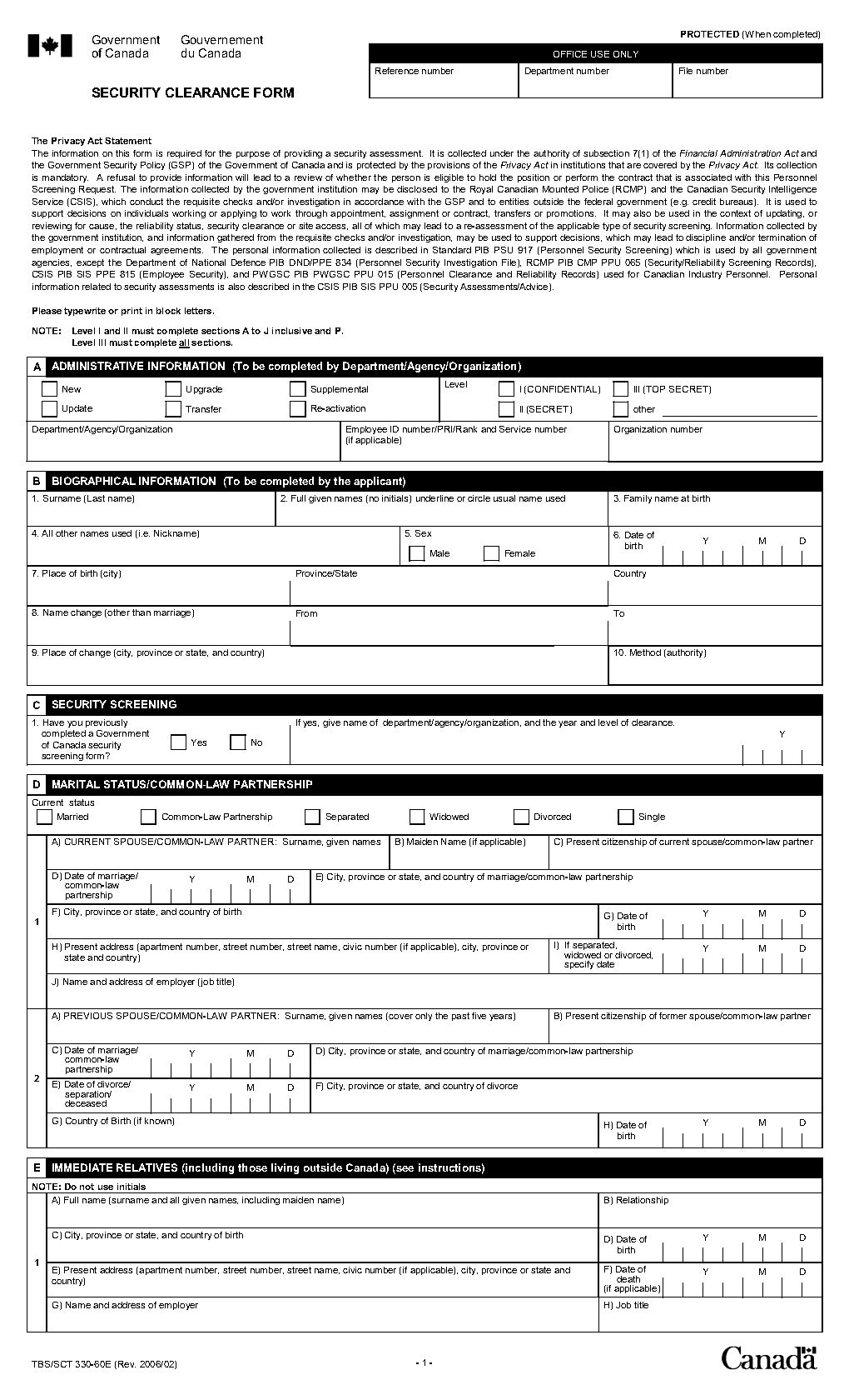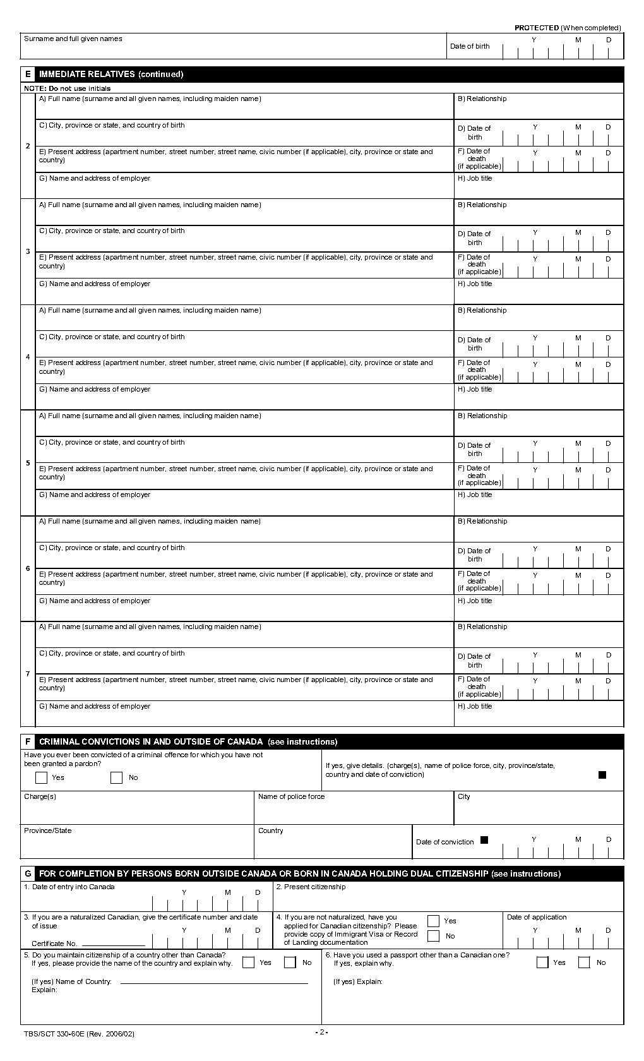

“**Common-law partner**”: a person who is cohabiting with the applicant in a conjugal relationship, having so cohabited for a period of at least one year. This includes persons of the same sex.

To be completed by Applicant.

Sections B to P

Gender X, select both.

To be completed by   
Hiring Official.

Section A

**Immediate relatives:** See next page for instructions.

**Widowed**: Complete #1 as applicable.  
Date of death and last address while living are   
to be included.

**Married or common-law partnership:** Complete #1 as applicable.

**Separated or Divorced**: Complete #2 if applicable within the last five years.

033

ESDC/Service Canada

Technician

1 9 8 5 0 7 2 0

Brother

140 Promenades du Portage, Gatineau, QC, Canada, K1A 0J9

Stearne & Son enterprises, 3 Bank St., Ottawa, ON, K1A 9U8

Gatineau,Québec, Canada

John Timothy Stearne

**Complete as follows :**

Note that maiden name is required for

all female parents.

* All children 18 years or over that you or your spouse/common-law partner have a parental relationship
* Mother and Father
* Brothers and Sisters (including half and step)
* Spouse’s/Common-law partner’s Father and Mother (including half or step relatives in this category)
* Previous Spouse/Common-law partner **in the last 5 years**
* Previous Spouse’s/Common-law partner’s Father and Mother **in the last 5 years**
* If any person is deceased, date of death and last address while living are to be included.
* If any person is estranged, provide as much information as possible and indicate “unknown” where applicable.

When date of entry into Canada is less then 10 years ago, refer to the Out-of-Country Process for additional documentation to be provided.

**Immediate relatives include the following**:

If space allocated is insufficient, attach a separate sheet and provide additional information using the same format.

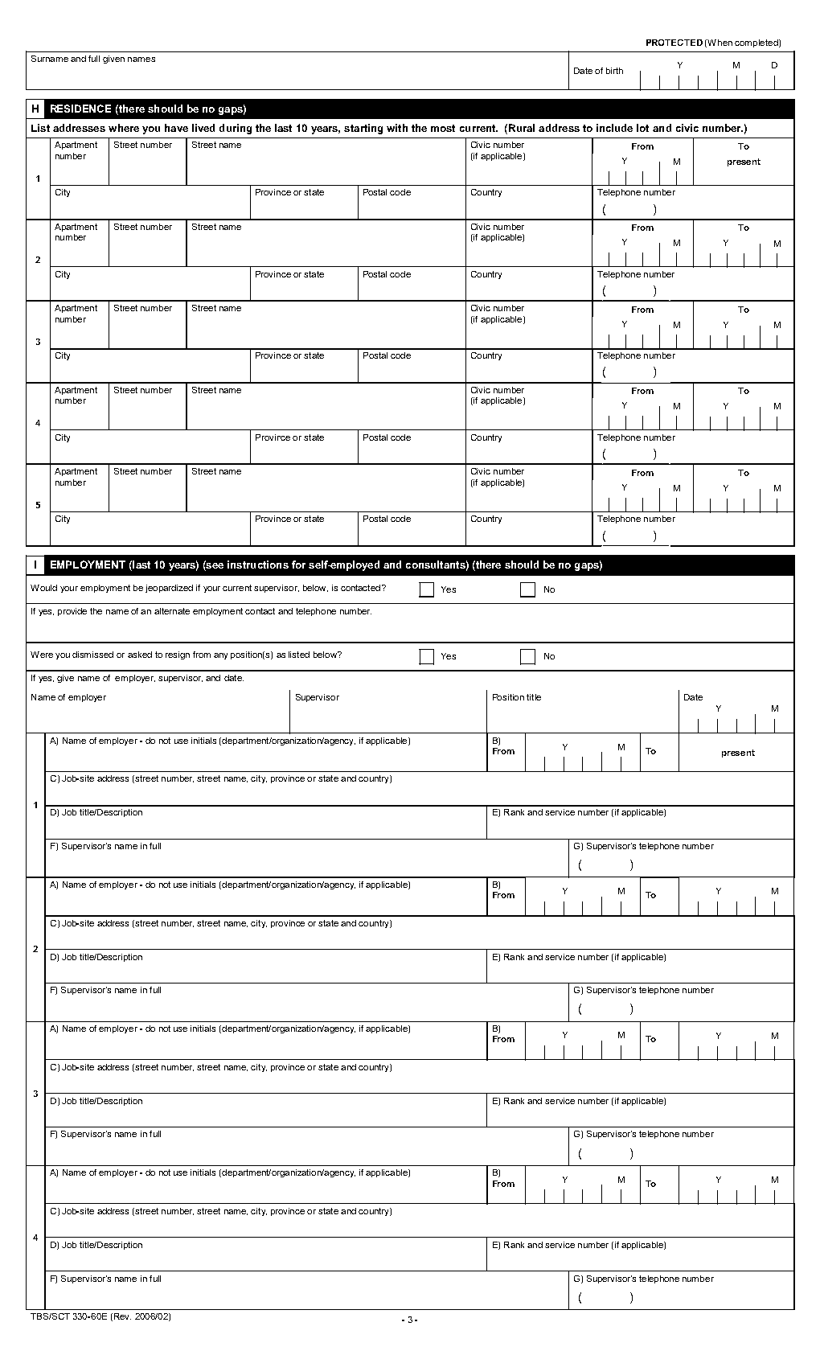

Addresses of the last 10 years starting with the most current, **no breaks or gaps** but dates may overlap.

Include addresses abroad and school residences.

**Employment includes the following**:

* Last 10 years of employment (or up to the age   
  of 16)
* No breaks or gaps but dates may overlap
* Employment abroad
* Time at school or educational leave
* Periods of unemployment are also to be shown

If space allocated is insufficient, attach a separate sheet and provide additional information using the same format.

**Residence(s) abroad:** When the date of entry into Canada is less than 10 years and the period of residence is 6 months or greater, refer to the   
**Out-of-Country Process** for additional documentation to be provided.

**Residence(s) abroad:** When there is an overlap of residences in 2 different countries, you must provide a detailed explanation in a document with your form. This document must clearly explain why you have 2 places of residence, in 2 different countries, on the same date.

2 0 1 4 0 2 2 0 2 0 0 8

Employment and Social Development Canada

140 Promenades du Portage, Gatineau, Québec, Canada, K1A 0J9

**To complete as follows :**

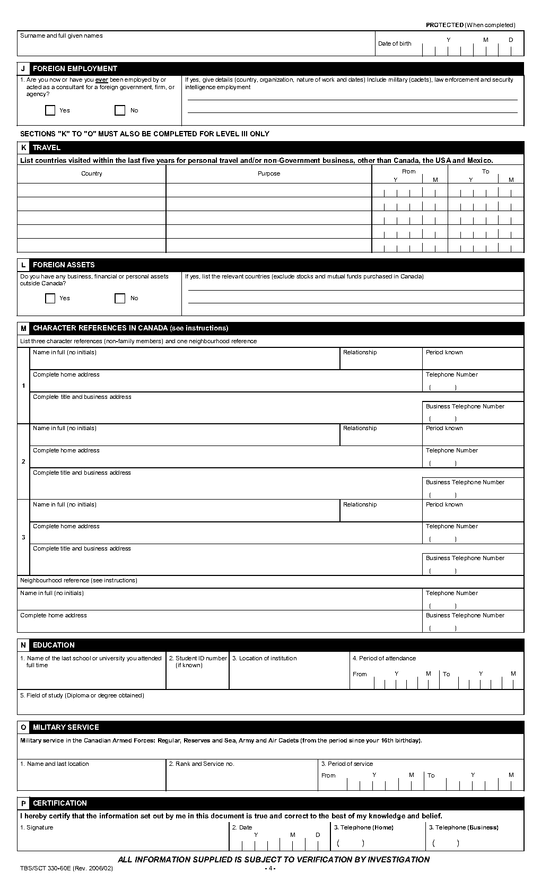

(819) 123-4567

AS-04 012 345 678

Mark Richard

Financial Advisor

If space allocated is insufficient, attach a separate sheet and provide additional information using the same format.

Complete as requested.

Applicant must provide signature.

To be completed by Applicants requesting TOP SECRET clearance ONLY.

Sections K to O

**Neighbourhood reference** is an individual who has known you for over 6 months, preferably at your current address. If not, the individual has been a previous neighbour during the past 5 years.

**Character references** are NOT to include relatives and MUST be residing in Canada.

**Character references** must be colleagues, peers, and friends who have known you well for over three years and should be able to cover your non-work environment and activities.

**For SECRET CLEARANCE,** Skip to Section P.

**For TOP SECRET CLEARANCE,** continue to next section.