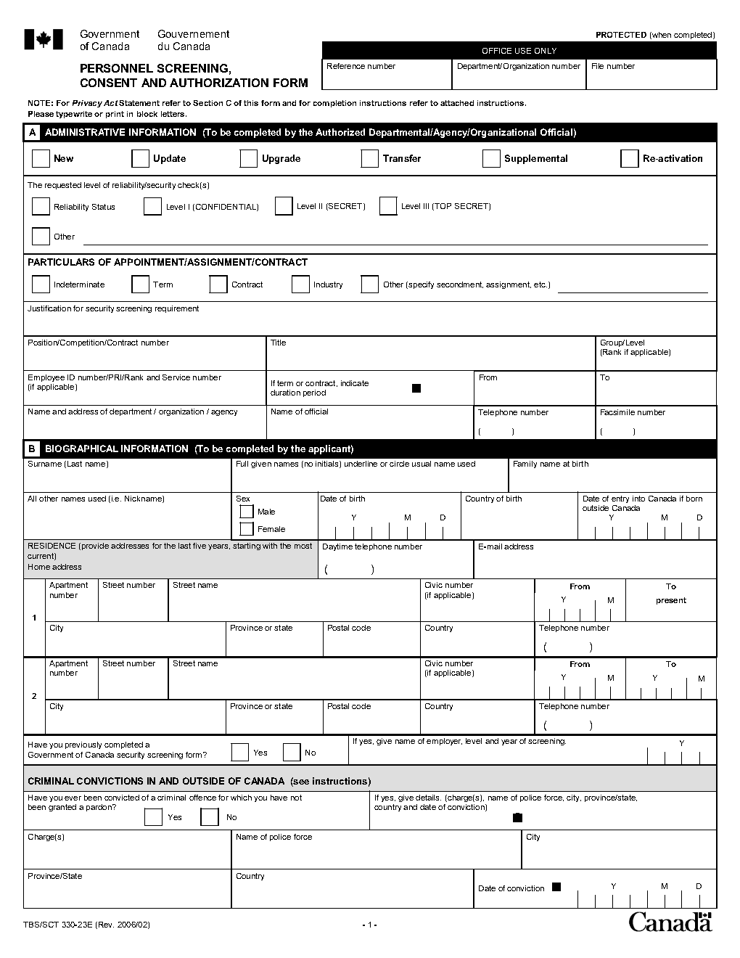

If the space allocated is insufficient, please use another page.

Please indicate if you have completed a security screening form for another organization previously.

If the space allocated is insufficient, please use another page.

**Residence(s) abroad:** When the date of entry into Canada is less than 5 years and/or the period of residence is 6 months or greater, refer to the   
**Out-of-Country Process** for additional documentation to be provided.

Addresses of the last 5 years, starting with the most recent, **no breaks**, but there may be overlaps.

Gender X, select both.

To be completed by Applicant.

Section B

Hiring official.

In the context of a selection process, please provide process number.

For enhanced, select *Other* and provide level.

To be completed by   
Hiring Official.

Section A

Select security level required.

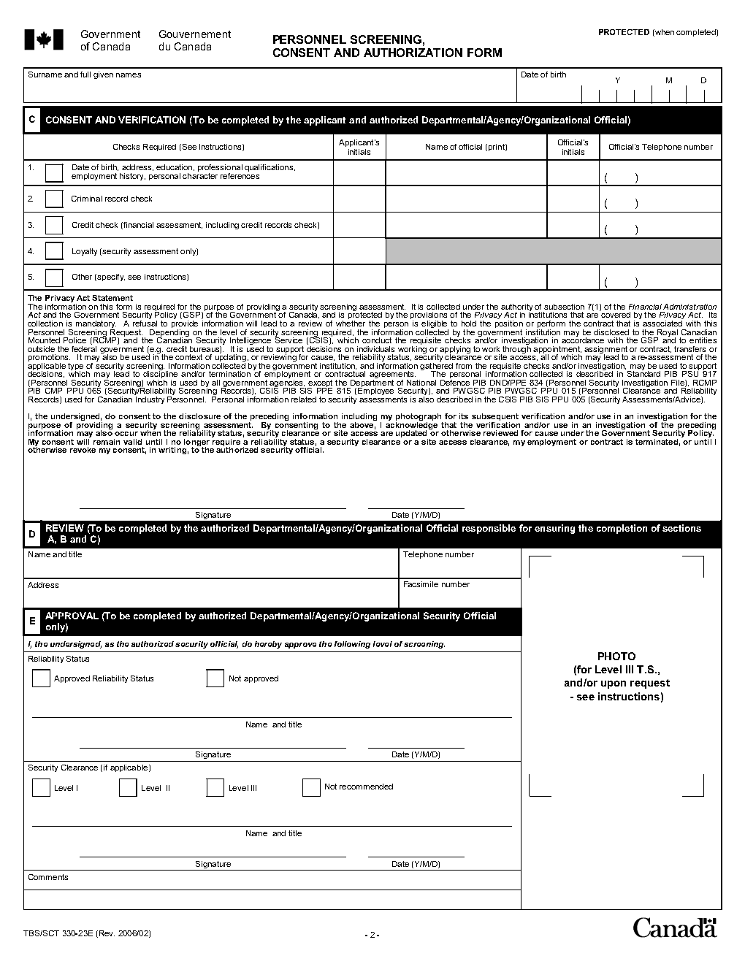

To be completed by the authorized Departmental Security Official.

Sections D and E

Applicant must provide signature.

To be completed by an

Authorized Security Official.

Section C

Applicant must provide consent according to level requested.

Section C

Section C

Hiring Official must provide initials or Entrust signature.