**Cloud update instructions for your Government iPhone / iPad Device (iOS)**

**Note: This guide applies to GOC data enabled mobile devices only**

**Verify if the M365 certificate has been deployed on your iPhone/iPad device.**

**1**

Complete the steps in this section on your iPhone/iPad.

1. Launch the **UEM Client** application.
2. Make sure that the device is **Compliant**.

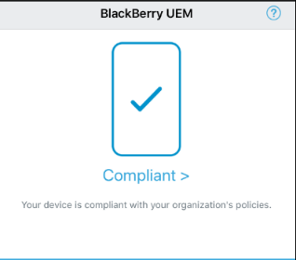

If it is not, please contact the [National Service Desk](http://iservice.prv/eng/imit/nsd/index.shtml) (NSD) and request assistance.

1. Select **Assigned profiles**
2. Look for the certificate name “**M365 Device Verify Client Auth**” OR “**O365 Azure MCAS Device Verify**”. If you have the certificate, proceeds to step 2.

If you do not see the certificate, try refreshing the screen (tap and hold on the screen and swipe down). If the certificate does not appear after a few refreshes, contact the **NSD** and request assistance obtaining the certificate.

**2**

**Install the required applications on your iPhone/iPad device.**

Complete the steps in this section on your iPhone/iPad.

**2a**

Install the managed version of Microsoft Teams. If **Microsoft TEAMS** is already installed on your iPhone/iPad, you need to un-install and reinstall it via the **Work Apps**

1. Uninstall **Microsoft TEAMS** if already installed.

* Tap and hold the **Teams** app for 2 seconds
* An option screen will popup.
* Tap **Delete App**

1. Install **Microsoft TEAMS** via the **Work Apps** application. 
   * + Launch the **Work Apps** application
     + Tap on the **Microsoft TEAMS** icon then tap on the **Prepaid** button.

Install the managed version of **Microsoft Authenticator** on your iPhone/iPad device. If **Microsoft Authenticator** is already installed, you need to un-install and reinstall it via the **Work Apps**

**2b**

1. Uninstall **Microsoft Authenticator** if already installed.

* Tap and hold the **Teams** app for 2 seconds
* An option screen will popup.
* Tap **Delete App**

1. Install **Microsoft Authenticator** via the **Work Apps** application. 
   * + Launch the **Work Apps** application
     + Tap on the **Microsoft TEAMS** icon then tap on the **Prepaid** button.

**3**

**Configure your Multi-Factor Authentication (MFA) with Microsoft Authenticator**

Some steps in this section are performed on your iPhone/iPad and some on your workstation.

**3a**

**Already Registered - You are currently requested to enter your MFA when connecting to TEAMS.**

1. **Sign out** and **close** all active Microsoft applications (Outlook, Word, Teams, eSin, Azure etc…) on any work devices (workstation and Samsung) that you have opened.
2. Click on the following link: <https://myworkaccount.microsoft.com>
3. Select **Update info** in the **Security info** section
4. Select **Add Method**
5. Choose **Authenticator app** and follow setup instructions

**Not yet Registered - You are currently not requested to enter your MFA when connecting to TEAMS**

**3b**

1. **Sign out** and **close** all active Microsoft applications (Outlook, Word, Teams, eSin, Azure etc…) on any devices (workstation and mobile) that you have opened except this instruction document.
2. Click on the following link: <https://myworkaccount.microsoft.com>
3. On the **More information** **required** window, select **NEXT**

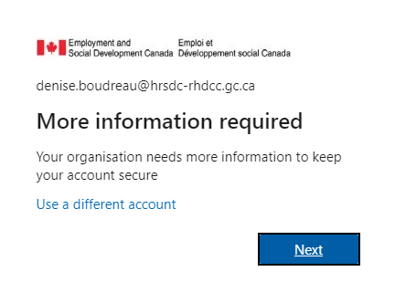

1. 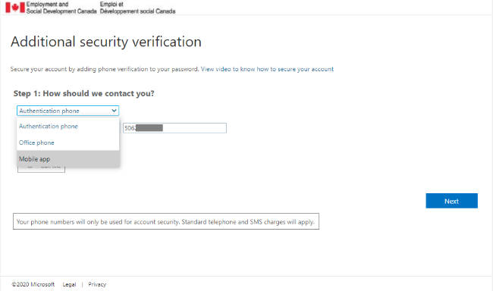On the **Additional security verification** window, select **Mobile App** from the dropdown list
2. The **Additional security verification** window will ask how you want to use the mobile app. Select **Receive Notifications for verification**, then select **Set up**

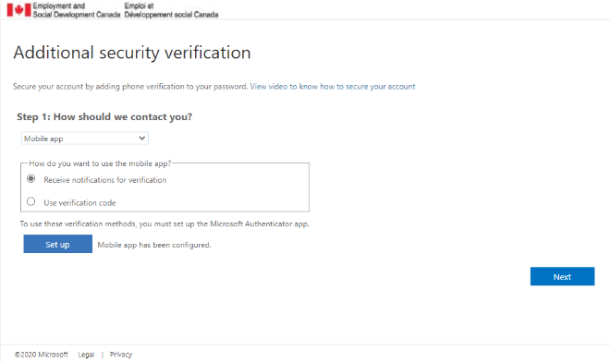

1. The **Configure mobile app** window will open on your computer device. Skip step 1 because you already have the application. Proceed to **Step** **2** (next page).

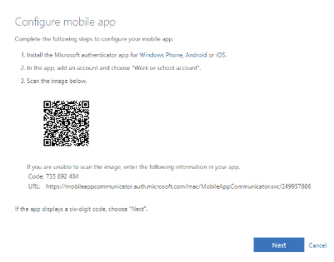

* **Step 2** – On your iPhone/iPad, open the **Microsoft Authenticator** app.

Note: The screen can be different depending on the app version. The app needs access to the camera.

**a**

Click on add new account

(Or click the + sign if you already have an account)

**b**

Click on Work or School account and tap on Scan QR code

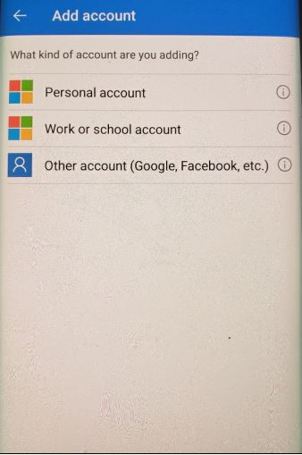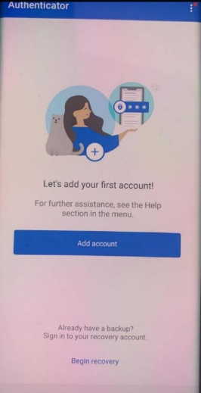

Scan the QR code on your computer.

Your ESDC/EDSC account is now ready

**c**

**d**

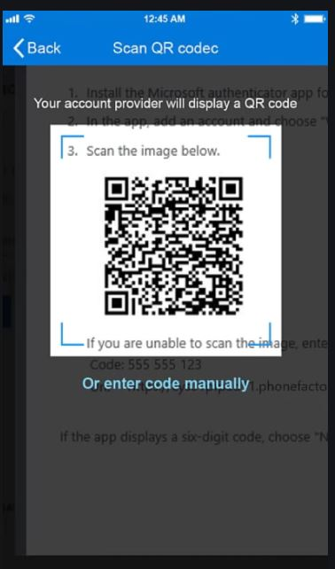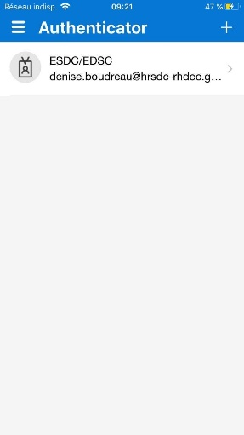

1. Back on your workstation click the **Next** button on the **Configure mobile app** window. The **Additional security verification** window will open.

* 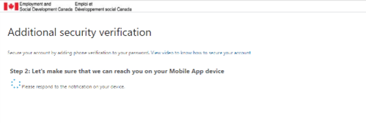On your computer, Select the **Next** button
* On your iPhone/iPad device, you will receive an approval request that you have to approve.

1. The **Additional Security verification** window will request that you enter a phone number as a backup option in case you do not have access to your iPhone/iPad device.

It can be your personal smartphone, home phone number or office phone number.

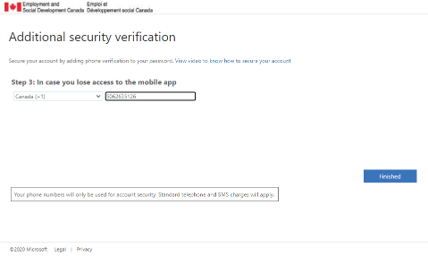

**4**

**Associate the O365 certificate to Microsoft TEAMS**

The steps in this section are done on your iPhone/iPad when you log in to Teams.

1. Launch **TEAMS** and log in using your network username (email address) and password.
2. You will be presented with either the Microsoft Authenticator **Approve** button or a **six-digit** code request. (This will depend on your selection when you configured Microsoft Authenticator)
3. Tap the **Approve** button or enter the **six-digit** code
4. Tap on the “O365 Device Verify Client Auth” certificate in the **Select Certificate** screen.

**Note: You will randomly be prompted to select the certificate when you log in to Teams.**