**Cloud update instructions for your Government Samsung Device (Android)**

**Note: This guide applies to GOC data enabled mobile devices only**

**Verify**

**if the 365 certificate has**

**been deployed on your Samsung device.**

**1**

Complete the steps in this section on your Samsung.

1. Launch the **UEM Client** application. 
2. Make sure that the device is **Compliant**.

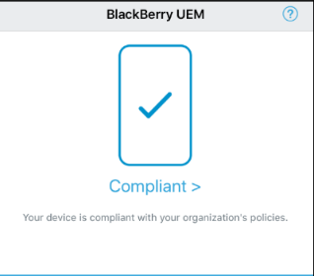

If it is not, please contact the [National Service Desk](http://iservice.prv/eng/imit/nsd/index.shtml) (NSD) and request assistance

1. Select **Assigned profiles**

1. Look for the certificate name “**O365 Device Verify Client Auth**” OR “**M365 Azure MCAS Device Verify**” If you have the certificate, proceed to step 2

**Note**: If you do not see the certificate, try refreshing the screen (tap the two circular arrows at the top right). If the certificate does not appear after a few refreshes, contact the [National Service Desk](http://iservice.prv/eng/imit/nsd/index.shtml) (NSD) and request assistance obtaining an O365 Certificate.

**Install**

**the required applications on your**

**Samsung device.**

**2**

Complete the steps in this section on your Samsung.

Install the managed version of Microsoft Teams. If Microsoft Teams is already installed

**2**

**a**

on the work side, skip to step 2b. If **Microsoft TEAMS** is already installed on

the personal side of your phone, you need to un-install and reinstall it on the work side.

* 1. Uninstall **Microsoft TEAMS** if already installed on the personal side

* + - Tap and hold the **Teams** App for 2 seconds.
    - An option screen will popup.
    - Tap **Uninstall**

* 1. Launch the **UEM Client** application. 

* 1. Select **Assigned work Apps**

* 1. Tap on the **Microsoft TEAMS** icon then tap on the **prepaid** button. The application will install in the Workspace side.

If **Authenticator** is already installed on the **Work** side of you phone skip to step 3.

**2**

**b**

a) If **Authenticator** is already installed on the personal side of your Samsung, you need to uninstall it. (A Google ID will be required.)

* + - Tap and hold the **Authenticator** App for 2 seconds.
    - An option screen will popup.
    - Tap **Uninstall**

* 1. Launch the **UEM Client** application. 

* 1. Select **Assigned work Apps**

* 1. Tap on the **Authenticator** icon then tap on the **prepaid** button. The application will install in the Workspace side.

**Note**:

You can install another version of Microsoft Authenticator on your personal smartphone. You can use either version for your Multi Factor Authentication (MFA)

### 3 Configure your Multi-Factor Authentication (MFA) with Microsoft Authenticator

Some steps in this section are performed on your Samsung and some on your computer device

**Already Registered - You are currently requested to enter your MFA when connecting to TEAMS.**

**3**

**a**

1. **On your computer device, Sign out** and close all active Microsoft applications (Outlook, Word, Teams, eSin, Azure etc…) on any work devices (workstation and Samsung) that you have opened.

1. Click on the following link:  [https://myworkaccount.microsoft.com](https://myworkaccount.microsoft.com/)

1. Select **Update info** in the **Security info** section

1. Select **Add Method**

1. Choose **Authenticator app** and follow setup instructions

**Not yet Registered - You are currently not requested to enter your MFA when connecting to TEAMS**

**3**

**b**

1. **On your computer device Sign out** and **close** all active Microsoft applications (Outlook, Word, Teams, eSin, Azure etc…) on any devices (workstation and mobile) that you have opened except this instruction document.

1. Click on the following link:  [https://myworkaccount.microsoft.com](https://myworkaccount.microsoft.com/)

1. On the **More information** **required** window, select **NEXT**

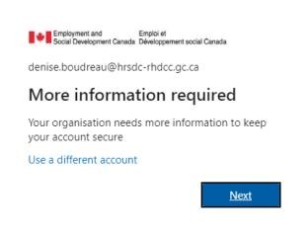

1. On the **Additional security verification** window, select **Mobile App** from the dropdown list

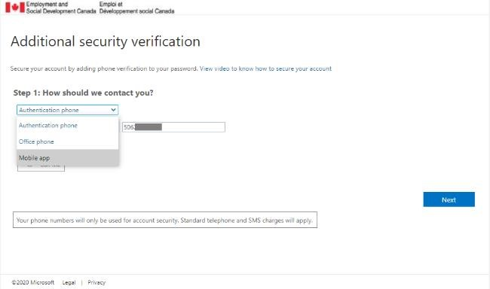

1. The **Additional security verification** window will ask how you want to use the mobile app. Select **Receive Notifications for verification**, then select **Set up**

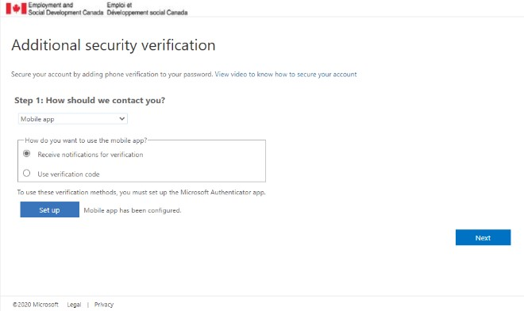

1. The **Configure mobile app** window will opened on your computer device. Skip step 1, proceed with step 2.

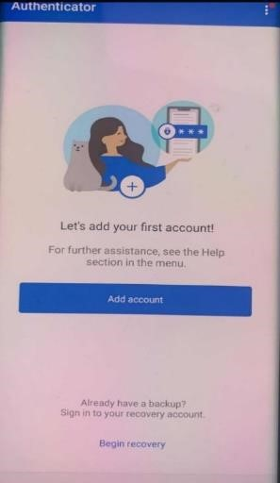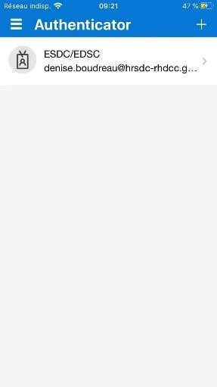

**a**

**b**

**d**

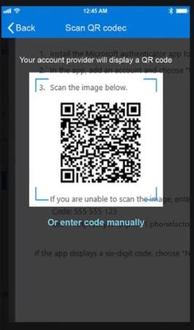

**e**

•

**Step 2**

–

On your Samsung, o

pen the

**Microsoft Authenticator**

app

.

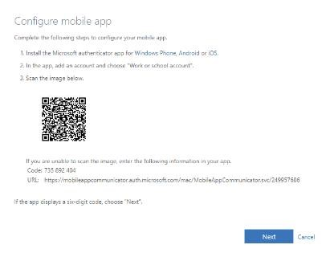

Click on add new account

(

Or

click

the + sign

if you

already have an account

)

Click on Work or

school account

Scan the QR code on

your computer device

Your ESDC/EDSC

account is now ready

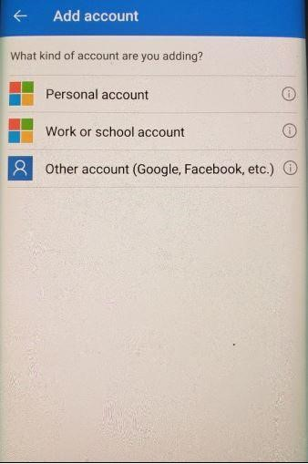

• Back on your computer device, click the **Next** button on the **Configure mobile app** window

g) On your computer device, the **Additional security verification** window will open.

* + - On your Samsung device, you will receive an approval request that you have to approve.

* + - On your computer device, Select the **Next** button

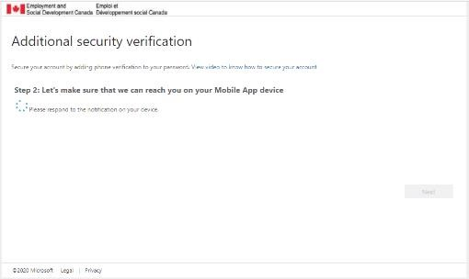

h) The **Additional Security verification** window will request that you enter a phone number as a backup option in case you do not have access to your Samsung device.

It can be your personal smartphone, home phone number or office phone number.

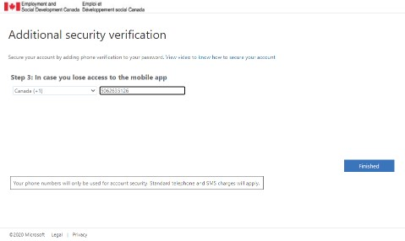

**Associate the O365 certificate to**

**Microsoft TEAMS**

**4**

The steps in this section are done on your Samsung.

1. Launch **Microsoft TEAMS** and login using your network username (email address) and password.

1. You will be presented with the Microsoft Authenticator **Approve** button or a **six-digit** request code. (This will depend on your selection when you configured Microsoft Authenticator)

1. Tap the **Approve** button or enter the **six-digit** code

1. Tap on the “O365 Device Verify Client Auth” certificate in the **Select Certificate** screen.