|  |  |  |
| --- | --- | --- |
| **Data Gateway Guide**  **For Employers, Provinces, Territories and other Partners** | Version 11.5 | |
| **User Guide** | |  |

|  |  |  |  |
| --- | --- | --- | --- |
| Version | Date | Reviewer | Revision Details |
| 1.0 | 2014-12-04 | Client Service Solution and Solution Development, Employment and Social Development Canada | * Initial Document |
| 2.0 | 2015-04-27 | Client Service Solution and Solution Development, Employment and Social Development Canada | Updated for Version 9.5. Changes:   * User Guide template modified * Instructions reviewed and detailed * New Target Programs section * New My Account page |
| 2.1 | 2015-04-30 | Client Service Solution and Solution Development, Employment and Social Development Canada | * Miscellaneous syntax corrections * 5.8.3 Reference / Error Message section: Missing Error Messages paragraph * 5.8.4 Optional Validation Section was missing * Section 7: Contact Us link was incorrect. |
| 3.0 | 2015-10-14 | Client Service Solution and Solution Development, Employment and Social Development Canada | Updated for Version 10.0. Changes:   * All screen captures updated to reflect Canada.ca template. * 5.9 Bullet #1: Contact Us link now located in the Bottom Menu. * 5.12 Bullet #3 removed. The Help link is now in the left menu at any time. * 6.1: Title changed. * 6.1: Text changed to summarize the GoC links of the Top Menu. * 6.1: Table of links and descriptions removed. * 6.2: Title changed. * 6.2: Text added to summarize the purpose of the GoC links of the Bottom Menu. * 6.3 Bottom Menu (Bottom Black Banner): Section removed. |
| 3.1 | 2016-01-26 | Client Service Solution and Solution Development, Employment and Social Development Canada | * Added TIOW and LTD Agreements program under Section 3.1 |
| 4.0 | 2016-10-26 | Client Service Solution and Solution Development, Employment and Social Development Canada | Updated for Version 10.1. Changes:   * All screen captures updated to reflect Canada.ca template. * 2. Target Programs: added 5 more new target programs * 4.5 Upload profile steps: moved the step of entering the number of files * 4.7 Upload step: select more than one file at once instead of one file at a time * 5.9 Bullet #1: Contact Us section now has 3 more programs. Added 5.9.3 and 5.9.4 for Government of Canada Contact Us link * 5.11 Frequently Asked Questions: added 2 more questions * 6.2 Bottom Menu updated |
| 5.0 | 2017-09-27 | Skills, Employment, and Partner Solutions,  Employment and Social Development Canada | Updated for Version 11.0 Changes:   * All screen captures updated to most recent version of GoC Web Template 4.0.25 * 2. Target Programs: added 1 more new target program * 3.1 added new program Global Talent Stream (GTS) * 4.4 added two new screens of Find an Organization and Select an organization with reset Search Filter button for Super Administrator, Administrator and Manager role * 5.9 under 1. updated the Contact Us screen with new program of Global Talent Stream * 5.9 removed 4. 5. 6. since the Contact Us link from the bottom redirect to Data Gateway Contact Us page |
| 6.0 | 2018-04-05 | Skills, Employment, and Partner Solutions,  Employment and Social Development Canada | Update for version 11.1  Changes:   * Updated some of the screen captures. * Added the section 6.0 for the download walkthrough * Changed the Login process for the new secured version * Added important notes |
| 7.0 | 2019-03-07 | Skills, Employment, and Partner Solutions,  Employment and Social Development Canada | Update for version 11.3  Changes:   * Removal of Welcome page. Replaced by Language section. * Updated Upload History Detail section. Added information on new button “Save XML Log” * Fused the 2 guides for DGReceiver. Revised the text to include the 2 users from 2 websites (Public and intranet) |
| 8.0 | 2019-07-12 | Skills, Employment, and Partner Solutions,  Employment and Social Development Canada | Update for version 11.4  Changes:   * Display download buttons also for public but show popup. |
| 9.0 | 2020-06-12 | Skills, Employment, and Partner Solutions,  Employment and Social Development Canada | Update for version 11.5 |

1. Contents

1. Contents 6

2. Target Programs 9

3. Important Security Notes 9

3.1. Who can use the data gateway public web site? 10

3.2. Your user id and password 10

3.2.1. For AppGate Users 10

3.2.2. For Public Users 11

4. Access Walkthrough 11

4.1. Access to the data gateway web site 11

4.2. Language 12

4.3. Login 12

4.3.1. For an AppGate User 12

4.3.2. For a public user 14

4.4. Home page 15

5. Upload Walkthrough 16

5.1. Upload Profile Step 16

5.2. File Type Step (only for LMDA – Accountability program) 17

5.3. Upload Step 18

5.4. Upload Results Page 19

6. Download Walthrough 19

6.1. Download Page – Appgate Users Only 21

6.2. Downloading a file 21

6.3. Deleting one or more files 22

7. Logout 23

8. Features and other pages 23

8.1. Terms of use 23

8.2. Account disabled 24

8.3. Forgot your User ID and/or Password 25

8.4. My Account 27

8.5. Upload History 30

8.6. Upload History Details 32

8.6.1. Upload Information section: 33

8.6.2. Record Information section: 35

8.6.2.1. Reference / Error Message section 35

8.6.3. Optional Validation section 36

8.7. Contact Us 36

8.8. What’s New 37

8.9. Frequently Asked Questions 37

8.10. Help 38

8.11. Site Map 39

9. Government of Canada Links and Menus 40

9.1. Top Menu 40

9.2. Bottom Menu 40

10. More Information 41

1. Target Programs

This user guide is a generic guide in order to use the Data Gateway web site for employers, provinces, territories and other external partners.

The following programs have specific sets of instructions in order to use the Data Gateway. Please visit the [Contact Us](https://srv115.services.gc.ca/contactus-contacteznous.aspx?lang=eng) page in the Data Gateway web site under the section specific to your program for more information:

* Automated Earning and Reporting System (***AERS***)
* [Indigenous Skills and Employment Training Strategy](https://wpazssl-i.sade-edap.prv/IAS-SAI/DGReceiver/contactus-contacteznous.aspx?lang=en&prg=ASETS) (ISETS)
* Report on Hirings (ROH)
* Work Sharing (WS)
* Employer’s Annual Hazardous Occurrence Report (EAHOR)
* Hazardous Occurrence Investigation Report (HOIR)
* CPPD LTD Insurers – Financial Agent
* LTD Insurers Prototype
* Temporary Foreign Worker (TFW) Program – Global Talent Stream (GTS)
* Participant of other programs

1. Important Security Notes

Please ensure that you are connected to the Data Gateway Public Web site at:

* AppGate Users : [https://srv100.services.gc.ca](https://srv105.services.gc.ca/)
* Public Users : <https://srv115.services.gc.ca>

While reviewing the information contained in this document, please verify that the site you are connected to:

* Displays the correct screen shown in the document;
* Operates consistently with what is described in this document.

## Who can use the data gateway public web site?

The Data Gateway Web site can only be used by employers, provinces, territories and other external partners who are entitled to submitting files under specific Government of Canada programs or information exchange agreements.

Your user id and password

You will need to provide a set of credentials to enter the Data Gateway. The set of credentials varies depending from where you are accessing the Data Gateway. If you have access to AppGate and accessed Data Gateway via [https://srv100.services.gc.ca](https://srv105.services.gc.ca/), you will need the same AppGate Credentials. If not, you will need a set of credentials provided to you by your program coordinator.

### **For AppGate Users**

* For this secured version, your **Windows/AppGate credentials** will be necessary, so that you can be authenticated and have access to the Data Gateway.
* Your Data Gateway User ID and Password will be used to link your DG account to your windows credentials, if this was not already done or if your program coordinator did not supply your AppGate Username in your account settings.
* Your user ID and Password linked to your account are monitored regularly and a record of the following is kept: the user’s name, date of login, duration of login, and the files viewed.
* Your Data Gateway User ID and Password will not be required to access your account after that first successful login is made and your account is linked to your Windows account.

**For Public Users**

* Your user ID and Password play a critical part in securing the Data Gateway Public Web site.
* Your user ID and Password must not be disclosed to anyone under any circumstances. Should the security and/or integrity of the user ID and/or password be compromised, or if you suspect that the security and/or integrity of either might be compromised, the user ID and Password must be changed immediately.
* Your user ID and Password are monitored regularly and a record of the following is kept: the user’s name, date of login, duration of login, and the files viewed.
* Your User ID and Password are required to access your account as referred to in the “Authorized Users Only” statement on the Login Page.

# Access Walkthrough

Navigation using the browser’s buttons (i.e. Next, Previous, etc.) is entirely functional in this version. However, it is strongly recommended to use the links in the web site to navigate instead.

Access to the data gateway web site

1. Launch your internet browser (Internet Explorer, Mozilla Firefox, Google Chrome, etc.).
2. Enter the one of the following address depending on your access :

* AppGate Users : [https://srv100.services.gc.ca](https://srv105.services.gc.ca/)
* Public Users : <https://srv115.services.gc.ca>

Language

By accessing the web site this way, the application detects the language of your browser and displays the preferred language. If it fails to do so, it will display in English by default. It is always possible to change the language by using the link located at the top right of each page.

Login

For an AppGate User

Upon your first connection in this version of the Data Gateway, you will be required to provide your username and password. You can use either your Data Gateway or Active Directory (Same as AppGate) credentials.

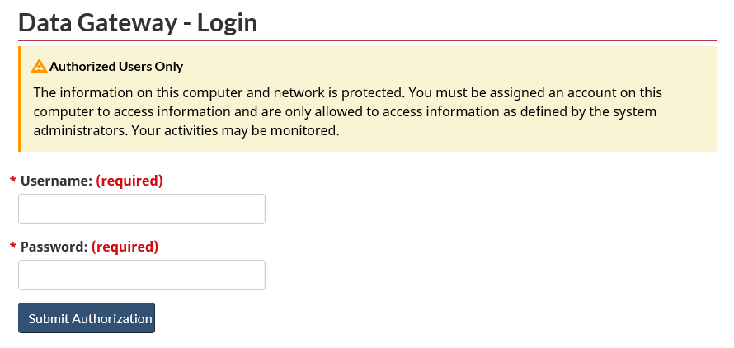

If the information you entered are those of Active Directory and they are valid but do not refer to any Data Gateway account, the system will then ask you for your Data Gateway username and password in order to associate both sets of credentials.

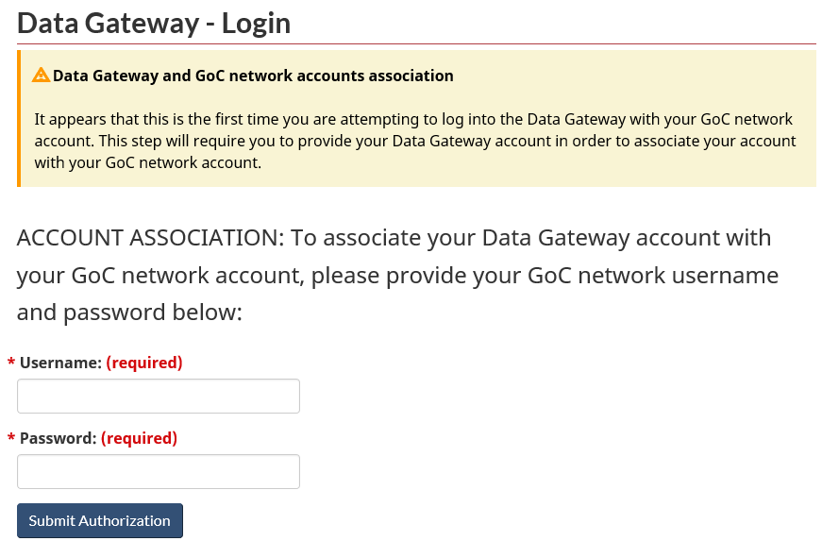

Once done, the system will associate both set of credentials together and from this point on, you will only need your ESDC Windows credentials in order to log into the Data Gateway.

Upon successful login, if it is the first time you are connecting with your User ID in the Data Gateway, you will first be prompted to agree to the [Terms Of Use](http://dialogue/grp/BU6322624/DataGatewayLibrary/Data%20Gateway%20User%20Guide%20-%20DGReceiver.docx#_Terms_of_use).

If one of the program you are uploading files for is requesting that you update your account contact information upon your next login, you will automatically be redirected to the [My Account](http://dialogue/grp/BU6322624/DataGatewayLibrary/Data%20Gateway%20User%20Guide%20-%20DGReceiver.docx#_My_Account_(-New-)) page in order to proceed. You will then need to verify and update your contact information before you get the authorization to proceed with your next file upload. Once completed, you will no longer be prompted to update your contact information.

For a public user

This page will allow you to authenticate using your User ID/Name and password.

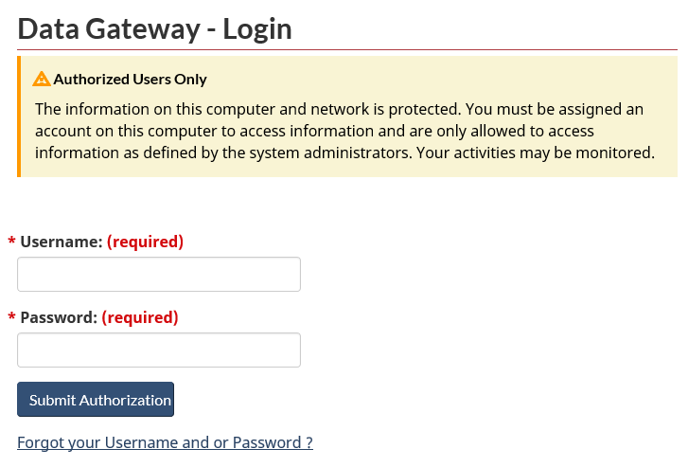

1. Enter your User ID/Name in the Username section. Note that lowercase and uppercase letters are not considered in the user ID.

Enter your password in the Password section. Note that for the password, lowercase and uppercase letters **must be taken into account**.

Select the Submit Authorization button to validate your user ID and password and to log into the system.

**NOTE: If you have forgotten your User ID/Name and/or Password, you can select the** [Forgot your Username and or Password](http://dialogue/grp/BU6322624/DataGatewayLibrary/Data%20Gateway%20User%20Guide%20-%20DGReceiver.docx#_Forgot_your_User) **link.**

Upon successful login, if it is the first time you are connecting with your User ID in the Data Gateway, you will first be prompted to agree to the [Terms Of Use](http://dialogue/grp/BU6322624/DataGatewayLibrary/Data%20Gateway%20User%20Guide%20-%20DGReceiver.docx#_Terms_of_use).

If one of the programs you are uploading files for is requesting that you update your account contact information upon your next login, you will automatically be redirected to the [My Account](http://dialogue/grp/BU6322624/DataGatewayLibrary/Data%20Gateway%20User%20Guide%20-%20DGReceiver.docx#_My_Account_(-New-)) page. In order to proceed, you will then need to verify and update your contact information.

Also, if it is the first time you are connecting with your User ID in the Data Gateway or if your password has just been reset, you will automatically be required to [Change Password](http://dialogue/grp/BU6322624/DataGatewayLibrary/Data%20Gateway%20User%20Guide%20-%20DGReceiver.docx#_Change_password_1) to a permanent one after you agreed to the [Terms Of Use](http://dialogue/grp/BU6322624/DataGatewayLibrary/Data%20Gateway%20User%20Guide%20-%20DGReceiver.docx#_Terms_of_use) (if required) and you updated your contact information via the [My Account](http://dialogue/grp/BU6322624/DataGatewayLibrary/Data%20Gateway%20User%20Guide%20-%20DGReceiver.docx#_My_Account_(-New-)) page (if required).

Upon successful login and after taking action on the steps above (if required), you will be redirected to the [Home Page](http://dialogue/grp/BU6322624/DataGatewayLibrary/Data%20Gateway%20User%20Guide%20-%20DGReceiver.docx#_Home_page_2) in order to start uploading files.

Home page

The ***Home page*** is the starting point to upload your files. This is the main content of the home page, an approximate view of what it looks like once logged in:

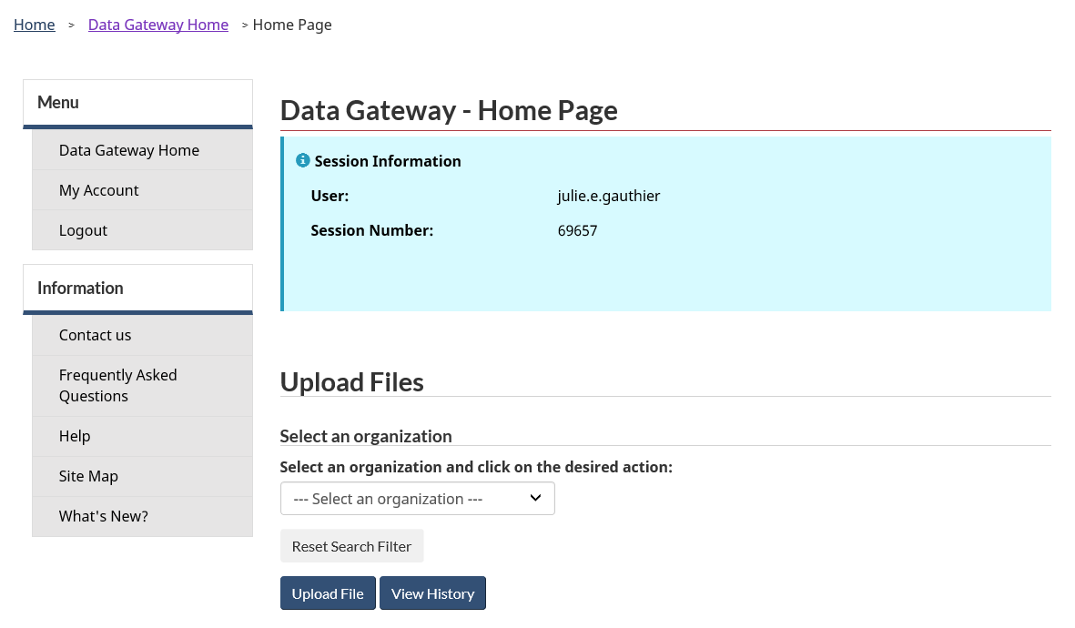

1. Upload Walkthrough
2. **(Super Administrator, Administrator and Manager role only):** To enter an organization name and click Go button to find an organization.

**(Super Administrator, Administrator and Manager role only):** To Click Reset Search Filter button will take you back to Find an Organization screen.

**(Available for users authorized to upload files for more than one organization):** To upload one or more files, verify the selected organization from the drop-down list and select another one if required.

Select the ***Upload File*** button.

You will be redirected to the [Upload Profile Step](http://dialogue/grp/BU6322624/DataGatewayLibrary/Data%20Gateway%20User%20Guide%20-%20DGReceiver.docx#_Change_your_password_1).

Upload Profile Step

This is where you will select the program (application) you will be uploading a file to, and the number of file(s) you would like to upload for it.

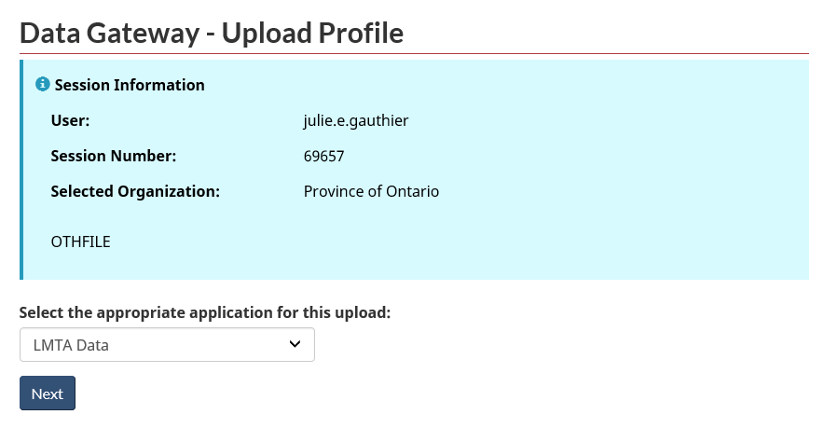

1. Select the appropriate program (***application***) from the drop-down list.
2. Select the ***Next*** button.
3. If you have selected the ***Accountability*** (LMDA users) application, you may be redirected to the [File Type Step](http://dialogue/grp/BU6322624/DataGatewayLibrary/Data%20Gateway%20User%20Guide%20-%20DGReceiver.docx#_File_Type_Step) only if you are required to select between two (2) or more file types before uploading your file. Otherwise, you will be redirected to the [Upload Step](http://dialogue/grp/BU6322624/DataGatewayLibrary/Data%20Gateway%20User%20Guide%20-%20DGReceiver.docx#_Upload_Step_1).

File Type Step (only for LMDA – Accountability program)

This step is required ONLY when the ***Accountability*** application has been selected in the [Upload Profile Step](http://dialogue/grp/BU6322624/DataGatewayLibrary/Data%20Gateway%20User%20Guide%20-%20DGReceiver.docx#_Change_your_password_1) and when the data provider (organization) has more than one file type (System Profile) to select before uploading a file.

If the data provider selected can for example upload a file under *Standard_LMDA* or *Standard_LMDA_GS*, the step below will be required.

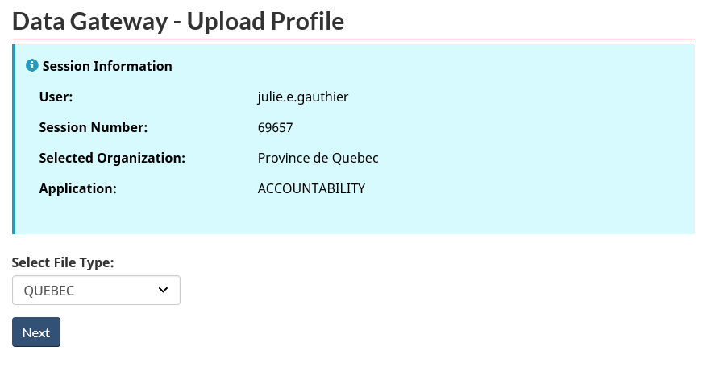

1. Select the type of file you wish to upload and then click the ***Next*** button.
2. You will be redirected to the [Upload Step](http://dialogue/grp/BU6322624/DataGatewayLibrary/Data%20Gateway%20User%20Guide%20-%20DGReceiver.docx#_Upload_Step_1).

Upload Step

This is where you will find and select the file(s) from your local computer in order to import it inside the Data Gateway:

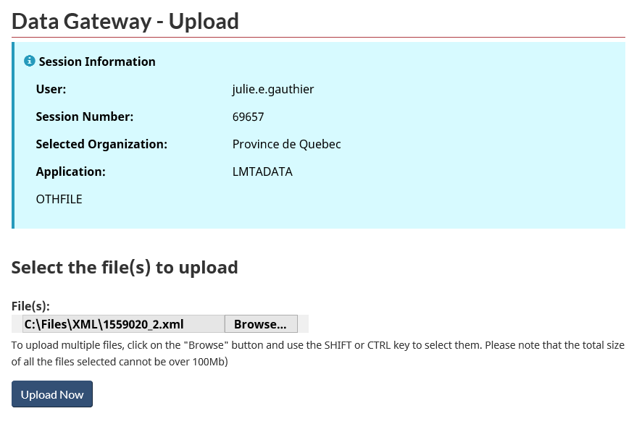

1. If the application you are uploading for has limited the file type it accepts, the accepted file types will be displayed below the file input.
2. Select the ***Browse*** button in order to locate the file from your computer. A new window will appear to help you locate and select the file.
3. Select your file (can select more than one file) and then click the ***Open*** button.
4. The window will close and the path of the file will be indicated accordingly and the file will be ready to be imported into the Data Gateway:
5. Select the ***Upload Now*** button. You will be redirected to the [Upload Results Page](http://dialogue/grp/BU6322624/DataGatewayLibrary/Data%20Gateway%20User%20Guide%20-%20DGReceiver.docx#_Upload_Results_Page).

Upload Results Page

This page will let you know if your file(s) were successfully uploaded or not.

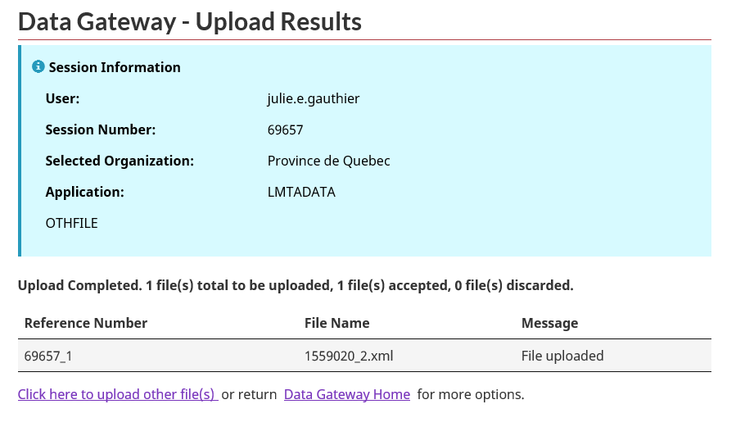

1. To upload other files, click the ***Click here to upload other file(s)*** link. This will redirect you to the [Upload Profile Step](http://dialogue/grp/BU6322624/DataGatewayLibrary/Data%20Gateway%20User%20Guide%20-%20DGReceiver.docx#_Change_your_password_1).
2. Select the ***Home*** link to go back to the [Home Page](http://dialogue/grp/BU6322624/DataGatewayLibrary/Data%20Gateway%20User%20Guide%20-%20DGReceiver.docx#_Home_page_2).
3. Download Walkthrough

If you are an end user authorized to download files and there are files shared for you or your organization, there will be additional buttons displayed in the left menu and on the welcome page.

In the public non-secured version, if you click one of the download buttons (see image below), you will have a popup instructing that you need to login through the secured version in order to download the files. In this case the download process stops here, therefore, you can skip instructions 6.1, 6.2 and 6.3.

In the secured version, by clicking on one of the buttons below, you will be brought to the download page.

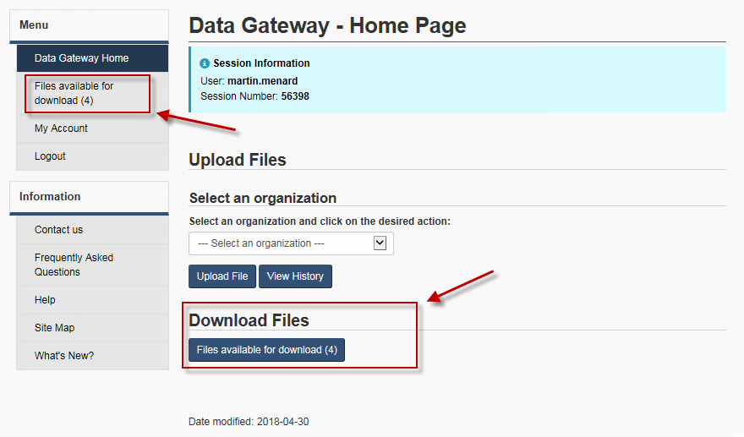

Download Page – AppGate Users Only

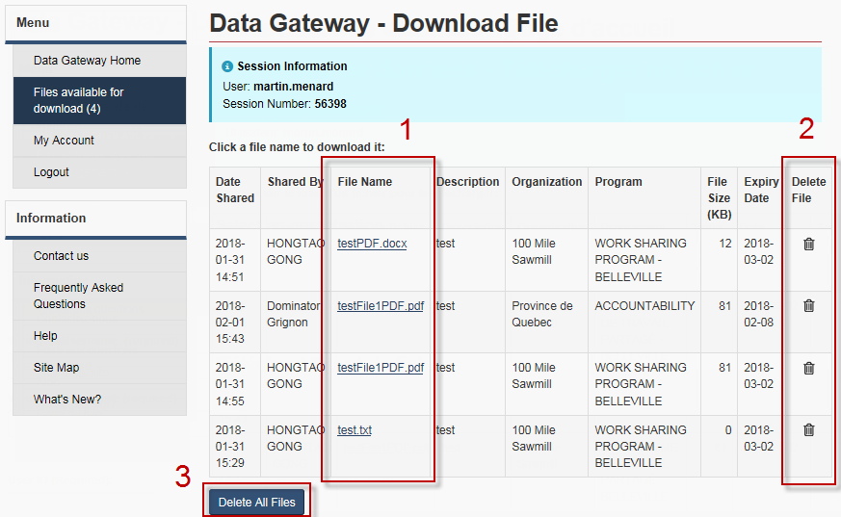

1. **File Name**: To download a file, click on the corresponding file name.
2. **Delete File**: Click on the “trash can” to remove the file from the list. A confirmation prompt will show.
3. **Delete All Files**: Click on this button to empty the list. A confirmation prompt will show.

Downloading a file

Downloading a file is handled differently depending on the browser and its settings, but it is no different from any other site. If you are having trouble downloading a file after clicking the file name, refer to your browser’s help documents unless the website displays an error.

Deleting one or more files

1. As soon as you press the trash can icon, you’ll see this confirm prompt :

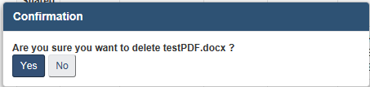

1. By pressing “yes”, the file will be removed from the list and will not be accessible anymore. Pressing on “no” will simply close that window.
2. The “Delete all files” button acts similarly and will display this small windows :

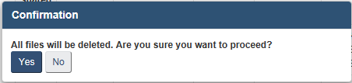

1. By pressing “yes”, the file list will be emptied will be removed from the list and will not be accessible anymore. Pressing on “no” will simply close that window.
2. If no files remain after a deletion, you will be automatically redirected to the welcome page and you will not be able to access this page until another file is shared for you.
3. Logout
4. It is important to logout of the website once you are done by selecting the ***Logout*** link from the left-side menu:

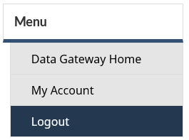

1. Features and other pages

Terms of use

Agreeing to comply with the “Terms of Use” is a condition of using the Data Gateway. Please read it carefully.

This page appears the first time a connection is attempted for a User ID that has not previously agreed to this version of the Terms of Use. Should the Terms of Use be amended you will be required to agree to the amended version prior to using the Data Gateway.

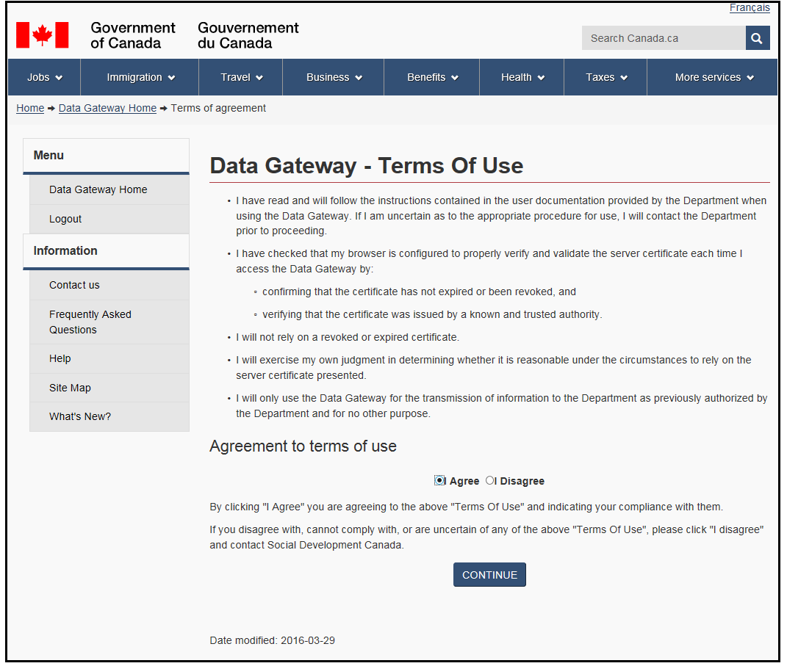

1. To continue, select ***I Agree*** and click on the ***Continue*** button. If you select ***I disagree***, you will automatically be logged out of the web site and you will again be prompted to accept the Terms of Use upon your next login.

Account disabled

If you tried logging in using a non-existing user ID more than **15 times**, your access will be automatically locked and you will be redirected to this page. You will not be able to login again for another **30 minutes**.

Moreover, if you tried logging in using a valid user ID, but an invalid password more than **3 times**, your account will automatically be locked for a period of **30 minutes** and will direct you to this page. You can then wait for the 30 minutes to expire before trying to log in again, or refer to the [Contact Us](https://srv115.services.gc.ca/contactus-contacteznous.aspx?lang=eng) page of the web site for more information in regards to the authorized procedure for your program in order to have your account unlocked and/or your password reset.

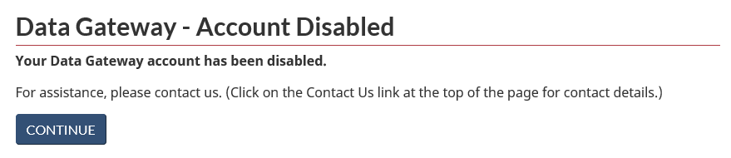

Forgot your User ID and/or Password

**NOTE: You can only reset your password. You cannot retrieve your User ID.**

In order to reset your password, you will need the following:

1. Your **Username/ID**
2. Your **e-mai**l address registered for your account

If you have forgotten your **User code** and/or **E-mail** address registered for your account, refer to the [Contact Us](https://srv115.services.gc.ca/contactus-contacteznous.aspx?lang=eng) page of the web site for more information in regards to the authorized procedure for your program in order to get help in retrieving it.

1. If you have forgotten your Password, you can select the ***Forgot Username and or Password*** link directly from the [Login](http://dialogue/grp/BU6322624/DataGatewayLibrary/Data%20Gateway%20User%20Guide%20-%20DGReceiver.docx#_Page_d’accès_(connexion)) page.
2. Selecting the link will bring you to the page below:

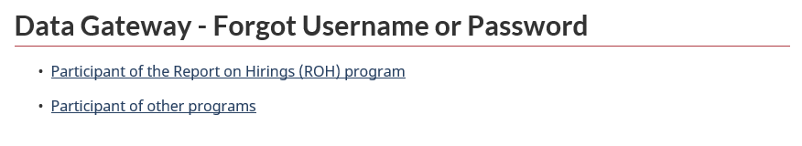

1. Select the **second link** ***Participant of other programs***.

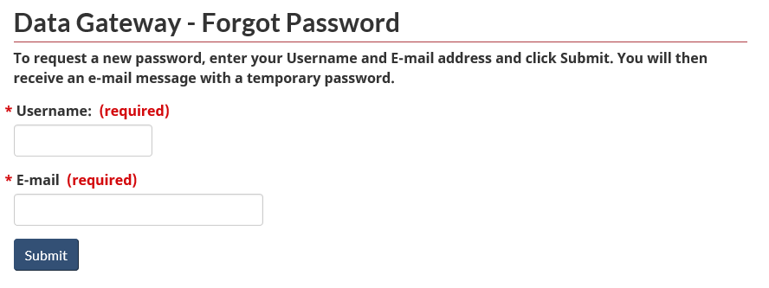

1. Type in your Username/ID in the “***Username***” field.
2. Type in the email address registered for your account in the “***E-mail***” field.
3. Select the ***Submit*** button.
4. If the User ID and E-mail address provided are valid for your account, the system will notify you that you will receive an automated e-mail from the system at the e-mail address provided.

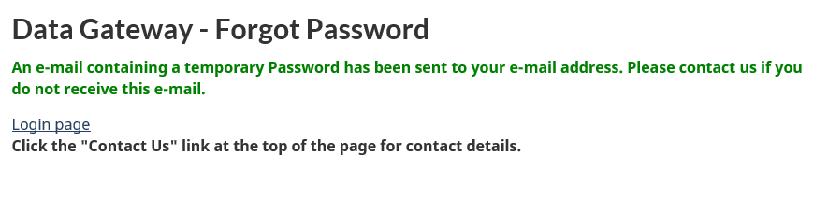

1. Please allow a few minutes for the e-mail message to come into your inbox. This automated e-mail message will contain your new temporary password. If you did not receive the automated e-mail message in your inbox, verify in your Spam folder. If you can still not find any e-mail from the Data Gateway system, refer to the [Contact Us](https://srv115.services.gc.ca/contactus-contacteznous.aspx?lang=eng) page of the web site for more information in regards to the authorized procedure for your program to contact them. The e-mail message will come from the sender **nc-sys-data_gateway-passerelle_donnees-gd@hrsdc-rhdsc.gc.ca** (DO NOT reply to the sender) and will look like the following:

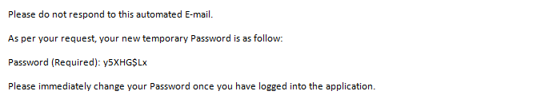

1. If the User ID and/or E-mail address provided above are found invalid for your account, you will get the following message. Refer to the [Contact Us](https://srv115.services.gc.ca/contactus-contacteznous.aspx?lang=eng) page of the web site for more information in regards to the authorized procedure to contact your program administrator

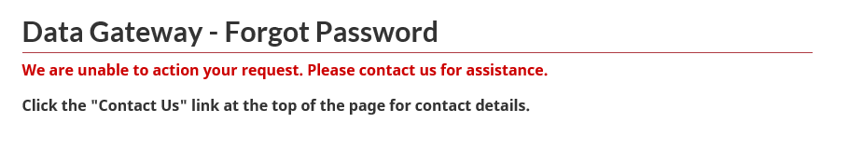

My Account

This page is only available to users authorized to upload files under the programs who have requested access to this feature, which allows you to update your contact information directly inside the Data Gateway.

The access to the My Account page is determined by the ***My Account*** link located in the left menu once you are logged in. If the link does not appear after your login, then you are not authorized to use this page:

1. Select the ***My Account*** link from the left menu. You will be redirected to the My Account page:

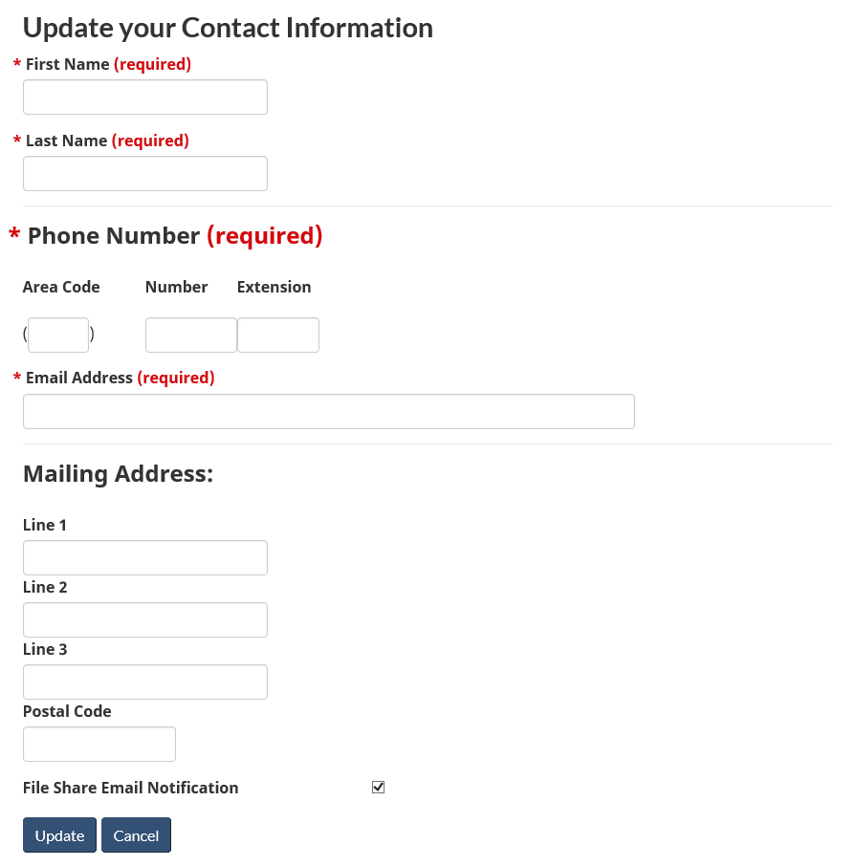

1. Verify and update your contact information. The following fields are mandatory. If they are currently missing, you will need to provide it before saving the form:

* First Name
* Last Name
* Phone Number (including Area Code)
* Email Address

1. Once your contact information is verified and updated, select the ***Update*** button to save your changes or to confirm the existing information.
2. Selecting the ***Cancel*** button will dismiss any change made to your contact information and redirect you back to the [Home Page](http://dialogue/grp/BU6322624/DataGatewayLibrary/Data%20Gateway%20User%20Guide%20-%20DGReceiver.docx#_Home_page_1). If you are required by one of your programs to update your contact information before navigating any further in the web site, selecting the ***Cancel*** button will refresh the page and will again, request you to verify and update your contact information before you continue.

**IMPORTANT:** It is possible that one of the programs you are uploading files under has requested that you verify and update your contact information at your next login (only once). In this case, at your next login you will automatically be redirected to the My Account page in order to proceed. You will then need to verify and/or update your contact information and confirm it before you are authorized to navigate any further in the web site. A warning message will appear at the top of the My Account page:

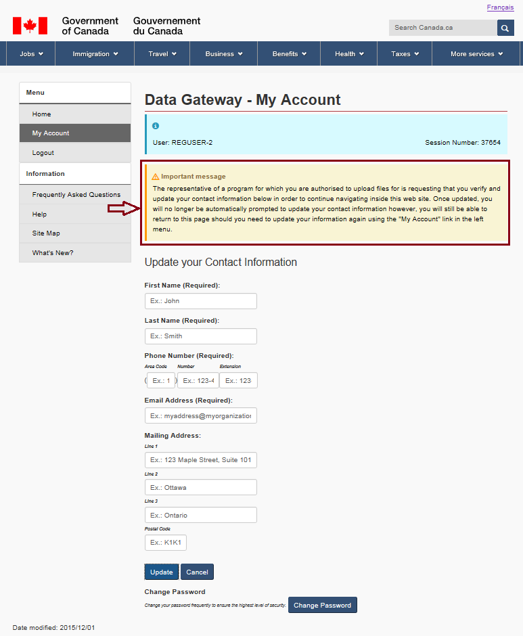

1. You can also change your password from this page by selecting the ***Change Password*** button at the bottom of the page. This will redirect you to the [Change Password](http://dialogue/grp/BU6322624/DataGatewayLibrary/Data%20Gateway%20User%20Guide%20-%20DGReceiver.docx#_Change_password_1) page.

Upload History

1. From the [Home Page](http://dialogue/grp/BU6322624/DataGatewayLibrary/Data%20Gateway%20User%20Guide%20-%20DGReceiver.docx#_Home_page_1), select your organization from the list and then select the ***View History*** button:



1. You will be redirected to the Upload History of the organization you have selected. This page will display records from the last 180 days:

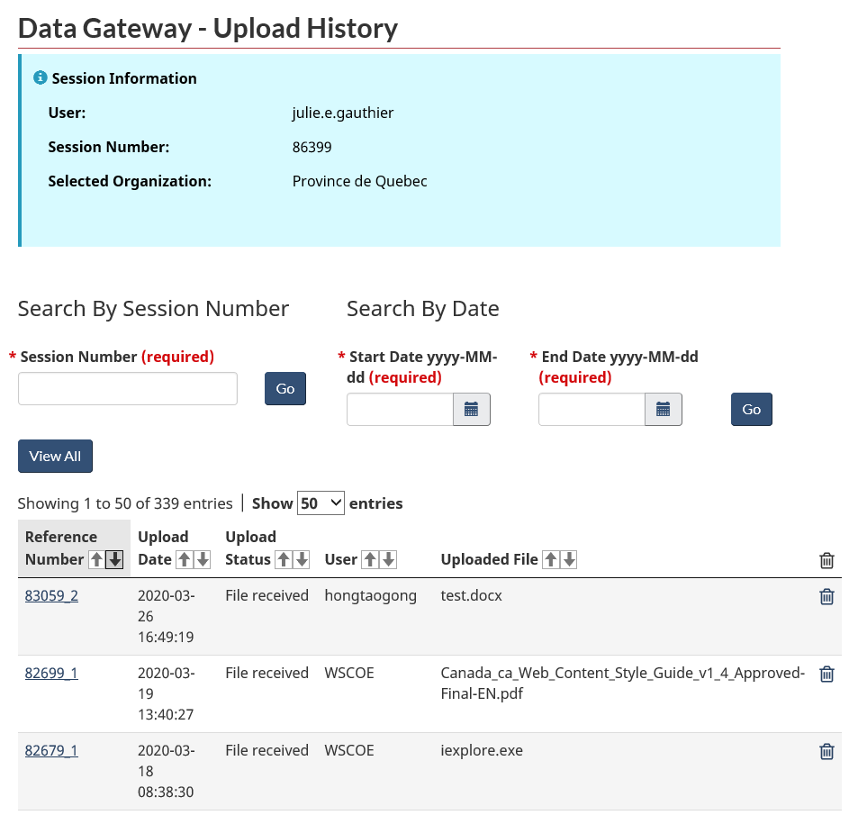

1. Enter the Session Number, and then click Go to find specific records.

**Note:** Only the reference numbers corresponding to the selected organization can be seen on this page.

1. Enter the Start Date (no older than 24 month) and the End date (no older that 24 month), and then Click Go to find records uploaded during these dates.
2. Click on any reference number to view the detailed description of a specific file upload. This will redirect you to the [Upload History Details](http://dialogue/grp/BU6322624/DataGatewayLibrary/Data%20Gateway%20User%20Guide%20-%20DGReceiver.docx#_Upload_History_Details) page.
3. If an organization has a long history of uploaded files, the history will be spread on multiple pages. You can access those pages by clicking on the page number on the top or bottom of the upload history table. In addition, a scrollbar will be displayed at the bottom of the upload history table if the contents are too wide for the screen.
4. You can delete a file sent by clicking the ***Delete*** icon (small trashcan) appearing at the end of the file’s row if it can that can be deleted. The files that can be deleted are files, which have not been sent for processing, empty files or invalid files.

Upload History Details

This page provides you with the details of a specific upload and is essentially useful to programs validating the files uploaded (Accountability, ALMP, AERS and NIIS) in order to verify any rejected record and the reasons pertaining to rejections.

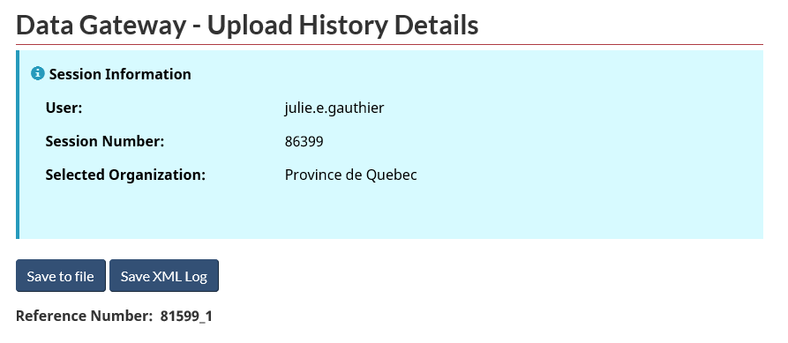

1. If you want to save the history details to a file, click on the ***Save to file*** button and follow the instructions. The history details will be saved in the comma delimited text file. The ***Save to file*** button does not download the actual file upload, it only downloads the report as seen on screen.
2. Alternatively, it is possible to save the details in a XML file by pressing the ***Save XML Log*** button. Note: This button is not available for all applications.

Upload Information section:

This section contains information about the file uploaded:

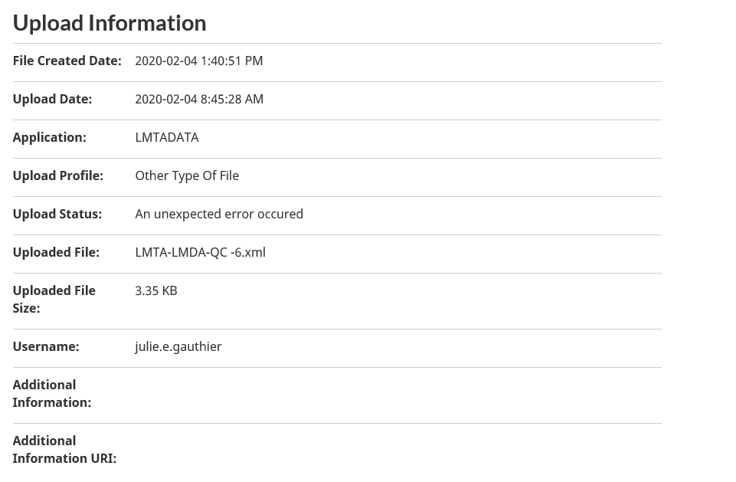

**Upload Date**: The date the upload was done.

**Application**: The application (program) for which the file was sent

**Upload Profile**: Profile or type of file of the uploaded file.

**Upload Status**: Indicates where the file is in the whole upload process. The status can be as follow:

* An unexpected error occurred
* Fatal error file rejected
* File Accepted
* File Download Confirmed by user
* File Downloaded by user
* File Upload Initialized by user
* File has been copied to the application queue
* No valid record found
* Partial File Accepted
* Partial upload not allowed
* The file could not be copied to the application queue
* The file transfer failed
* The validation results couldn’t be inserted in the database
* The validation results were successfully inserted in the database

For the AERS participant only:

* Accepted
* Pending
* Pending with errors
* Rejected - Do not resubmit
* Rejected - Please correct and resubmit

**Uploaded File**: Name of the file uploaded.

**User Name**: Name of the user having uploaded the file.

**Additional Information**: Additional information or comments for the upload.

**Additional Information URI:** External link to additional information about this upload (e.g. a link to a report built with the data of the uploaded file).

Record Information section:

This section contains information about the records processed within the file uploaded:

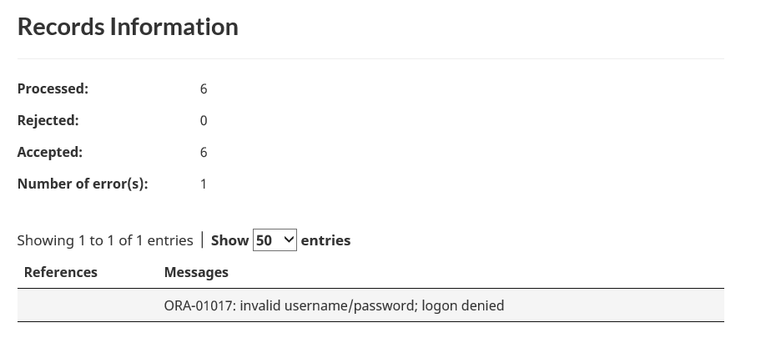

**Processed**: Number of record processed (read) by the backend application or program.

**Rejected**: Number of record rejected by the backend application or program.

**Accepted**: Number of record accepted (valid) by the backend application or program.

**Number of error(s):** Number of error found in the file. Since more than one error can be found in the same record, the total number of errors will not necessarily match the number of rejected records.

#### Reference / Error Message section

**Reference:** Contains a list of key values to uniquely identify a record in the uploaded file. The value used in this column will depend on the nature of the file uploaded. If more than one value is used as part of the identifier, a blank character will separate them.

**Error Message:** Contains a description of the error found in the record. The messages are from the backend application or program validating the file.

Optional Validation section

For backward compatibility with previous versions of the Data Gateway, an extra section could appear on this page to display the validation information received from the backend application or program.

Contact Us

This page offers instructions on how to contact a specific program.

1. You can access this page from the ***Contact Us*** link in the left-side menu (while logged in or logged out). A list of links to various programs will be displayed:

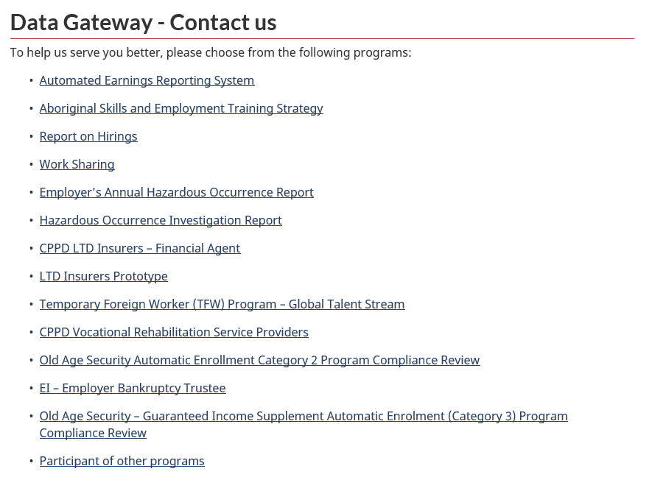

1. Select the link pertaining to your program. You will be presented with the according program’s instructions.

What’s New

This page lists the latest additions/fixes of the current version of the web site.

1. This page can be accessed by selecting the ***What’s New*** link in the left-side menu once logged in:

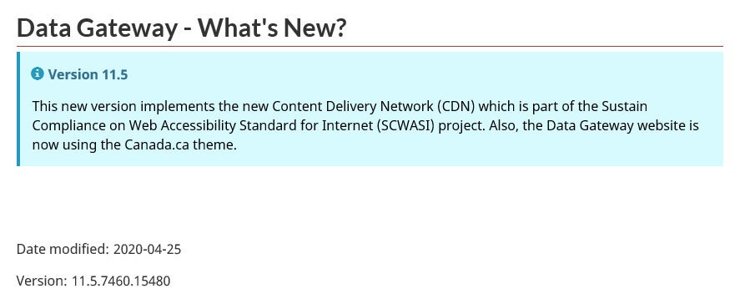

Frequently Asked Questions

This page offers answers to frequently asked questions for a specific program.

1. You can access this page, once logged in, by selecting the ***Frequently Asked Questions*** link from the left-side menu. A list of program links will be displayed:

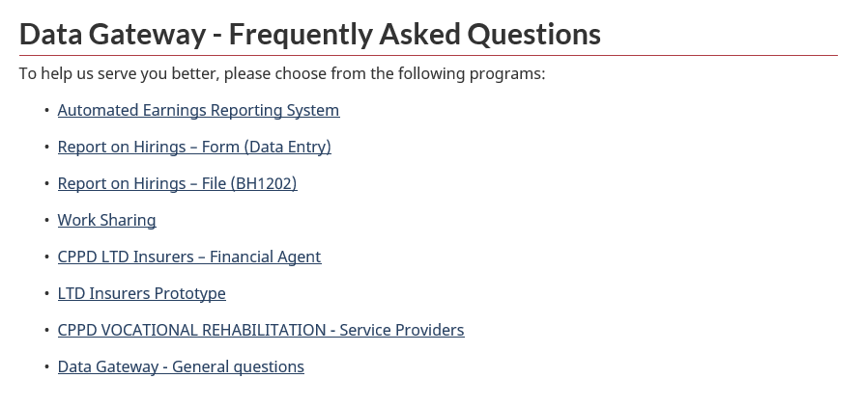

1. Select the link pertaining to your program. You will be presented with the according program’s FAQ.

Help

This page offers help for a specific program.

1. You can access this page by selecting the ***Help*** link from the top menu. If you are logged in, a list of program links will be displayed:

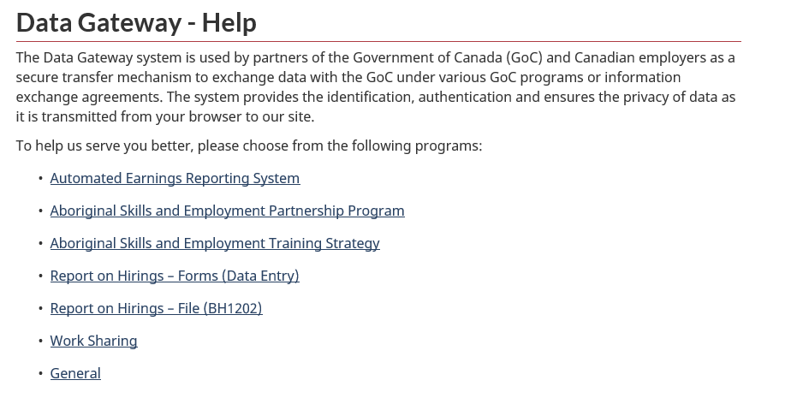

1. Select the link pertaining to your program. You will be presented with the according help.

Site Map

Page listing the pages available on the web site for a specific user.

1. You can access this page by selecting the ***Site Map*** link from the left menu. A list of pages will be displayed according to what you are authorized to access if you are logged in:

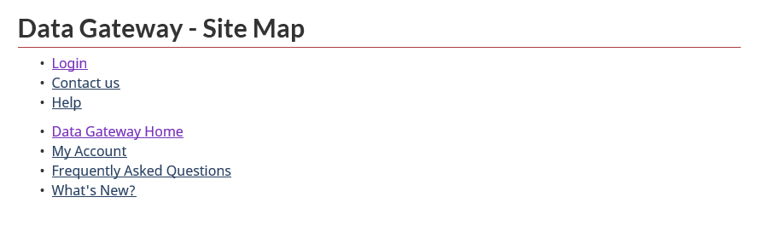

1. Select any link to go directly to the required page. You may not be automatically redirected to the page requested if additional information is required in order to get to the page selected.
2. Government of Canada Links and Menus

Top Menu

The Data Gateway uses the Government of Canada standard toolbars at the top of every pages. All links contained in the top menu are under the control of the Government of Canada and are referring to various sites related to services offered to Canadian citizens.

The ***Français*** link at the top-right of every page will switch the site’s language to French.

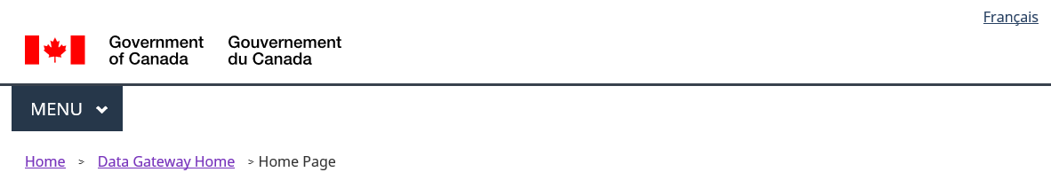

Bottom Menu

The Data Gateway uses the Government of Canada standard toolbars at the bottom of every pages. All links contained in bottom top menu are under the control of the Government of Canada and are referring to various relevant information for Canadian citizens.



1. More Information

If you need more information, please refer to the [Contact Us](https://srv115.services.gc.ca/contactus-contacteznous.aspx?lang=eng) page of the Data Gateway and select your according program.