|  |  |  |
| --- | --- | --- |
| **Data Gateway**  **Administration Web Site**  **(DGAdministration)** | Version 11.5 | |
| **User Guide Document Revision 6.2** | |  |

|  |  |  |
| --- | --- | --- |
| Version | Date | Revision Details |
| 1.0 | 2015-02-17 | * DG: Modified the **Navigation on the web site** section to advise users to use the application navigation links and buttons instead of the browser’s navigation buttons (Back, Previous, etc.) * DG: Added MANAGER role type |
| 1.1 | 2015-04-27 | * DG: New mandatory fields for user edition: Last Name, First Name, Email and Phone Number (including Area Code). Tables updated under Add User and Update User sections. |
| 1.2 | 2016-02-09 | * DG: Revised for Version 10.0 |
| 2.0 | 2016-11-04 | * DG : Revised for Version 10.1 (Major design change) |
| 3.0 | 2017-11-06 | * DG: Revised for Version 11.0 * Removed “Change Your Password” option from Administrative Tasks page * Removed “All Accounts” & “My List of accounts” option from Accounts List page * Removed “Return to Complete List” option from Accounts List page * Modified Left Menu (see screenshots at 4.2.1, 4.2.3 , 4.2.4, 4.3.1 and 4.3.3) * Removed Logout from Left Menu |
| 4.0 | 2018-04-16 | * HG: Revised for Version 11.1 * Added 2.Important Notes * Modified 4.3 Sign In * Added 5.5 Share File to the users |
| 4.1 | 2018-04-17 | * DG: Formatting * DG: Simplified section 5.5 * DG: Added Important Note in section 5.5 |
| 5.0 | 2018-10-19 | * DG: Revised for Version 11.2 * DG: Removal of Important Notes |
| 6.0 | 2019-03-12 | * DG: Revised for Version 11.3 * DG: Replaced Welcome Section with Language Section * Simplified the guide. Removed a few similar Sections |
| 6.1 | 2019-08-07 | * DG: Revised for Version 11.4 |
| 6.2 | 2020-05-01 | * DG: Revised for Version 11.5 |

# Contents

1. Contents 4

2. Important Security Notes 6

2.1. Target audience 6

2.2. Who can use the data gateway administration web site? 6

2.3. Your Username and password 6

3. Web Site Navigation and Personal Account Management 7

3.1. Access the data gateway administration site 7

3.2. Language 7

3.3. Sign In 8

3.4. Invalid Username and/or Password 9

3.5. Account Disabled 10

4. Administrative Tasks 11

4.1. My Administrator Tasks 12

4.2. Unlock Account/Reset Password 14

4.2.1. If the user is using his ESDC/Appgate credentials 14

4.2.2. If the user is using his Data Gateway Credentials 14

4.3. Organizations management 17

4.3.1. Organization Properties 17

4.3.1.1. Organization Section 17

4.3.1.2. Contact Section 18

4.3.1.3. Description Section 19

4.3.1.4. File Type Section 19

4.3.1.5. Program Section 20

4.3.2. Add an organization 21

4.3.3. Update an Organization 22

4.3.4. Display Organization File Upload History 23

4.3.5. Display Organization Accounts 26

4.4. Accounts management 27

4.4.1. Find an Account 27

4.4.2. Account Properties 27

4.4.2.1. Account Information 28

4.4.2.2. Contact Information 29

4.4.2.3. Roles Management 30

4.4.3. Add an Account 32

4.4.4. Update an End User account 34

4.5. Searching for a specific upload 34

4.6. Share a File with external users (if enabled) 35

4.7. Shared File History 39

5. Reports 40

6. Appendix A: Upload Statuses 41

7. Appendix B: Account Types 45

# Important Security Notes

Ensure that you are connected to the ESDC Data Gateway Administration Web site at <http://pdadmin-dgadmin.prv/DGAdministration> by reviewing the information contained in this document. In particular, verify that the site you are connected to:

* Displays screens as shown in this document;
* Operates consistently with what is described in this document.

## Target audience

**This tutorial is for an exclusive usage by Program Administrators.**

**This guide should NEVER be shared under any circumstances with any employer, individual, organization or partner outside of the Government of Canada.**

## Who can use the data gateway administration web site?

The Data Gateway **Administration** Web site can only be used by authorized Service Canada, Employment and Social Development Canada (ESDC) and Labour Program employees, as well as any other federal department under the intranet network supported by Shared Services Canada (SSC).

## Your Username and password

* The Sam Account Name is used by internal workers to log onto the network and their computer, as well as external users through AppGate. Now, this can also be used to log into the Data Gateway.
* If an administrator needs their Data Gateway Account password reset, they can ask another administrator to do it through the Data Gateway or they can open a ticket with the National Service Desk (NSD).
* Your username and password must not be disclosed to anyone under any circumstances. Should the security and/or integrity of the login credentials be compromised or such compromise is suspected, then the username or password must be changed immediately.
* Your Username and Password are monitored regularly. A record of the following information is kept with each login: user’s name, date of login, duration of login, and list of files viewed.

# Web Site Navigation and Personal Account Management

The use of the navigation options available in your browser (i.e. Next, Previous, etc.) is not recommended while using the Data Gateway. Rather, it is strongly recommended to use the menus, links and buttons available in the web site itself in order to navigate.

## Access the data gateway administration site

1. Launch your internet browser of preference (Internet Explorer, Mozilla Firefox, etc.).
2. Enter the following URL address: <http://pdadmin-dgadmin.prv/DGAdministration>.

## Language

By accessing the web site this way, the application detects the language of your browser and displays the preferred language automatically. If it fails to do so, English is the default. It is always possible to change the language by using the link located at the top right of each page.

## Sign In

Upon your first connection in this release of the Data Gateway, you will be required to provide your ESDC Network username and password. Data Gateway username and password are also accepted.

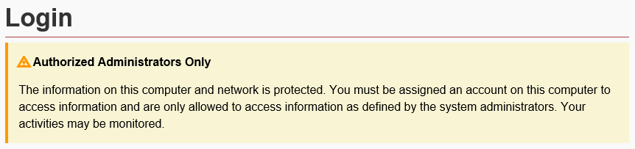

If it is the first time you are logging into the system with your ESDC Network username and password, you will be prompted to type in your Data Gateway username and password in order to associate both sets of credentials.

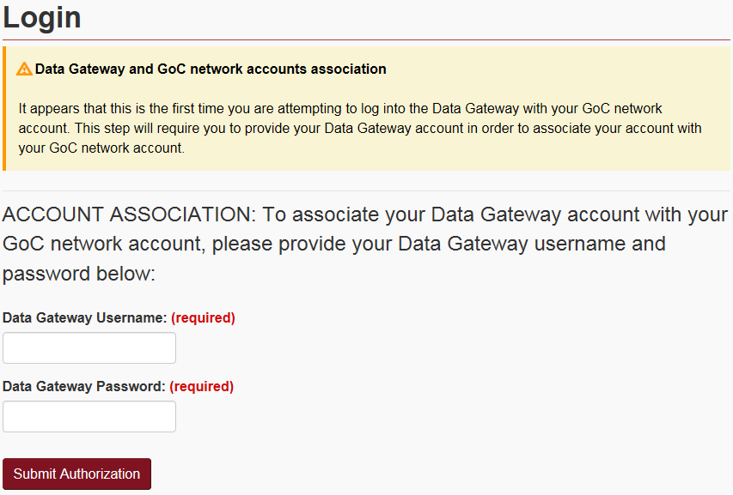

Once done and from this point on, you will only need your ESDC Network credentials in order to log into the Data Gateway.

1. Enter your username in the ***Username*** textbox. Note that the username **is not case sensitive**.
2. Enter your password in the ***Password*** textbox. Note that the password **is case sensitive**.
3. Click the ***Submit Authorization*** button to validate your username and password and to log into the system.

## Invalid Username and/or Password

If you enter an invalid username and/or password, the following error will be displayed:

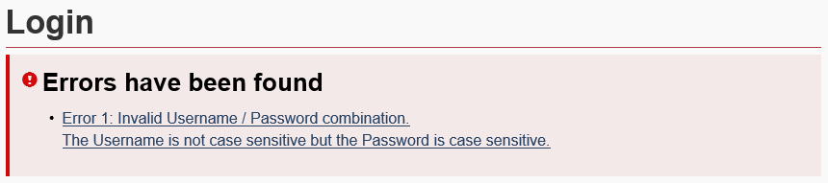

* Try signing in again. Ensure that the username is actually yours, and that you have entered the correct information in the proper fields, keeping case sensitivity in mind when entering the password.
* If you try logging in using a non-existent username more than **15 times**, your account will automatically be disabled for a period of **30 minutes**.
* If you try logging in using a valid username with an invalid password more than **3 times**, your account will automatically be disabled for a period of **30 minutes**.

## Account Disabled

If you tried logging in using a non-existent username more than **15 times**, or if you tried logging in using a valid username with an invalid password more than **3 times**, your access will automatically be locked. In both cases, you will be redirected to this page:

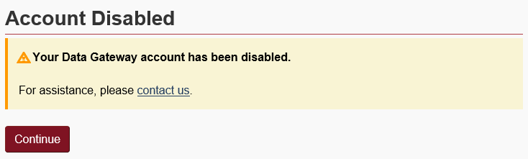

You will not be able to log in again for a period of **30 minutes**.

Once the 30 minutes expires, you can try logging in again or you can simply contact another administrator of the same program so that they can unlock your account and reset your password if required.

# Administrative Tasks

The ***Administrative Tasks*** are the main operations for a Data Gateway Administrator.

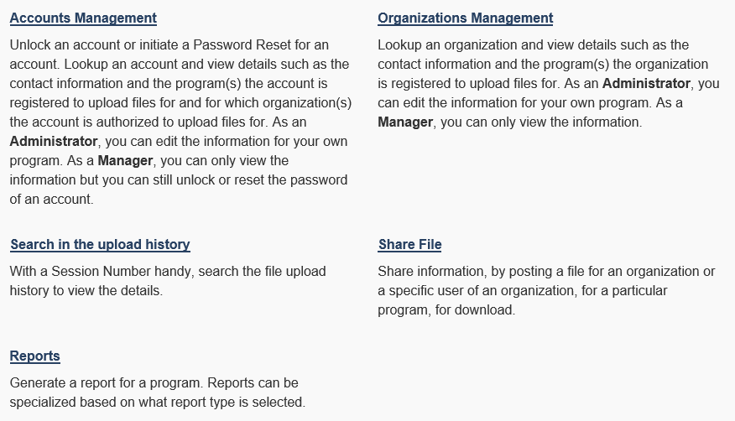

1. To manage accounts in the Data Gateway, select the***Accounts Management*** link.
2. To manage your organizations, select the ***Organizations Management*** link.
3. To search for a specific file uploaded, select the ***Search in the upload history*** link.
4. To share files, select the ***Share File*** link.
5. To browse reports, select the ***Reports*** link.

## My Administrator Tasks

As an Administrator for your program, you are responsible for the support of the organizations, their users and their requests.

In order to understand the relation between ***Organization***, ***Accounts*** and ***Programs*** inside the Data Gateway, here is an overview:

* An ***Organization*** should be unique in the Data Gateway.
* An ***Organization*** may be authorized to upload files for one or more ***Programs***.
* An ***Organization*** may have one or more ***Accounts*** associated with it.
* An ***Account*** is authorized to upload files on behalf of the ***Organization*** they are associated with and this, for one or more ***Programs*** for which the ***Organization*** already has authorization to upload files for.

Let’s take the National Air ***Organization*** as an example.

* + National Air as an organization can upload files for both the EAHOR and HOIR programs.
  + National Air also has two (2) employees working for the organization: John Smith and Jane Doe.
  + Because these two employees are working for National Air, we can authorize them both to upload files on behalf of National Air for both programs.
  + We could also authorize John Smith to upload files on behalf of National Air, but only for the EAHOR program, while Jane Doe would be authorized to upload files only for the HOIR program instead.

The diagram below outlines the relationships:

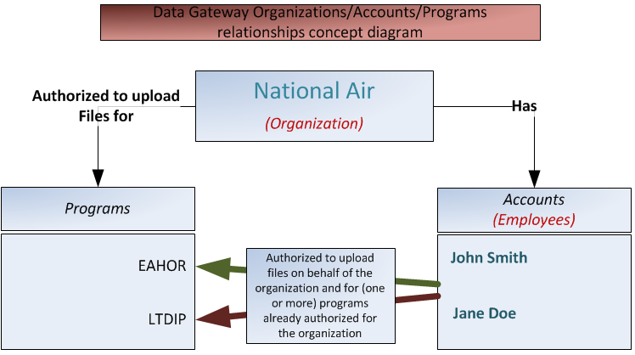

There is a number of tasks you will be required to do using the Data Gateway Administration web site. Here are some situations that you might be tasked with:

1. **An employee of an organization lost their password and/or their account has been locked:**

Unlock User Account/Reset User Password.

1. **An organization wants to upload files to a specific program:**

First, you need to Add an organization (or Update an organization if the organization already exists, but is not already mandated to upload files for this program).

Then, you need to Add an Account and associate it under the Organization above, adding the proper program roles to the account. If the account already exists, then you will need to Update an Account.

1. **An existing organization needs to modify it’s information or it’s available programs:**

Update an Organization.

1. **An existing organization needs to add an additional account (employee):**

Add an Account and associate it under the existing Organization, and add the proper program to the account (or Update an Account if the user already exists, but is not already associated with the organization and the program).

1. **An existing organization needs to modify the information or change the programs of one of it’s account:**

Update an Account**.**

## Unlock Account/Reset Password

There are two types of connections available when a user wants to logs in. The user can use their ESDC/AppGate credentials or the user can use their Data Gateway Credentials.

### If the user is using his ESDC/Appgate credentials

The user must wait 5 minutes before attempting to log in again after 3 failures. No action is required from the administrator or the manager. If for some reason the user forgot their password in between logging into AppGate and logging into Data Gateway, they must call National Service Desk to have their password reset.

### If the user is using his Data Gateway Credentials

**IMPORTANT: A user’s access can be disabled after 15 unsuccessful attempts with a wrong USERNAME. The account will remain locked for 30 minutes. You can confirm the username with the user to prevent this from happening again during their next attempt once the 30 minutes “disabled period” expires.**

**An account will be locked after 3 unsuccessful login attempts with a correct username, but a wrong PASSWORD. The account will remain locked for 30 minutes. You can unlock the account and/or reset the password by following the steps below:**

1. From the Administrative Tasks page, select the ***Accounts Management*** link.
2. Search for the name of the user to see if it exists.

Tips for a better search result:

* You can type parts of the ***last name***, ***first name***, ***username*** or ***email address*** to get better matches.
* Note that the search engine is not case sensitive.

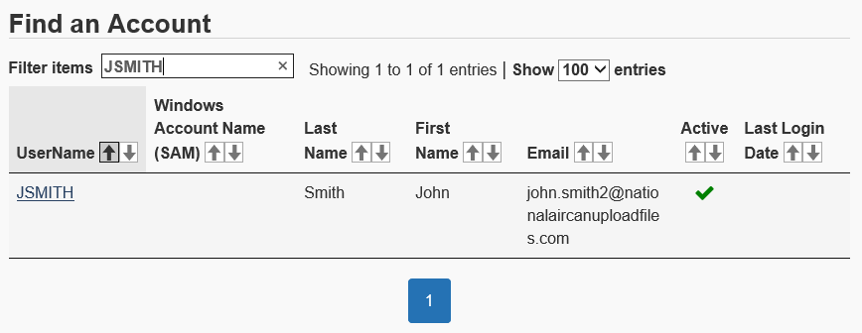

1. Select the link of the username you need. Once the link is selected, the ***Account Information*** section will be displayed. In most cases, a user requesting a password reset may have locked their account as well. The system will let you know about this situation with a message at the top of the page, along with the ***Unlock Account*** and ***Reset Password*** buttons.

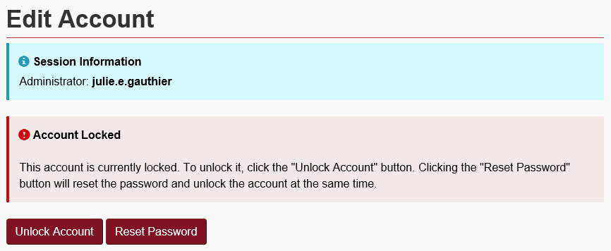

1. If you select the ***Reset Password*** button, a temporary password will appear on screen, highlighted in yellow and the account will also be unlocked at the same time:

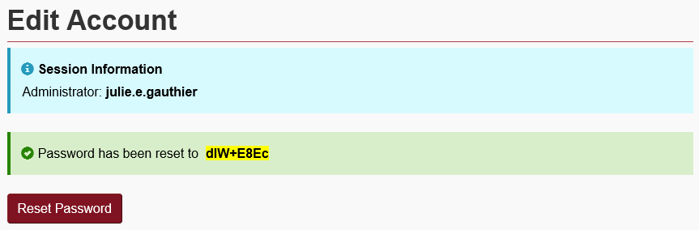

1. Select the entire highlighted password with your mouse and copy/paste it in a message intended for the user.
2. If the user finally has their password and just needs their account unlocked, you can select the ***Unlock Account*** button instead. This will only unlock the account and the password will remain unchanged.

## Organizations management

Organizations are the groups that upload files for internal departments.

### Organization Properties

Whether you create or modify an organization, the Organization page will always look the same. This section of the document expands on each of their fields.

* Note that the XML Validation Options, and the FTP File Transfer sections are only used by the LMDA/WDA program and its organizations. They will not be discussed in this document.

#### Organization Section

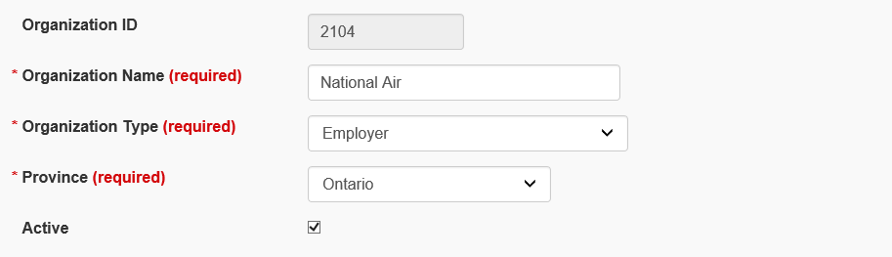

| Field | Mandatory | Description |
| --- | --- | --- |
| Organization ID | N/A | This field contains the organization ID and is automatically provided by the system once saved. You cannot edit this field. |
| Organization Name | Yes | The exact name of the organization. |
| Organization Type | Yes | Select the most applicable from the list. |
| Province | Yes | Select the province/territory where the organization **is located**. |
| Active | No | This indicator allows you to set the organization as active or inactive in the system. It should be checked by default for ‘active’. If not, make sure it is checked. |

#### Contact Section

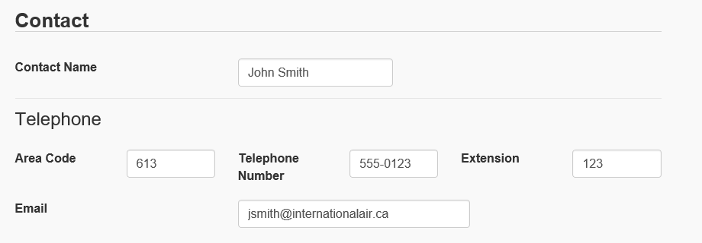

| Field | Mandatory | Description |
| --- | --- | --- |
| Contact Name | No | The full name of the organization’s primary contact. |
| Telephone | No | The area code followed by the phone number and the extension of the main contact. The number in the second box can include hyphens (-) or not. |
| Email | No | Main contact email address. |

#### Description Section

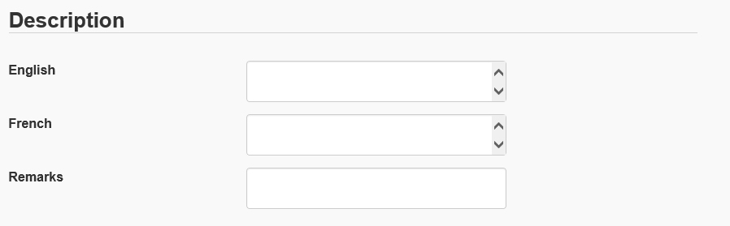

| Field | Mandatory | Description |
| --- | --- | --- |
| Description  (English and French) | No | Add a description for the employer in both French and English. |
| Remarks | No | You may want to add anything relevant here, such as a business number, an agreement number or any other reference number. |

#### File Type Section

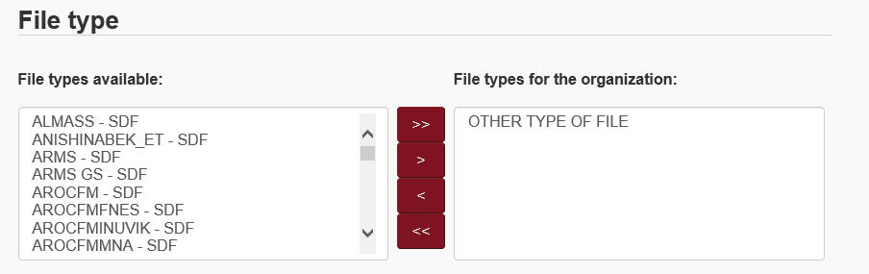

| Field | Mandatory | Description |
| --- | --- | --- |
| File types available | Yes | ***Other Type of File***is the recommended choice. Select the most relevant type from the list on the left and use the right arrow (>) to add it to the list on the right. This selection is for information purpose only. It does not affect the behavior of the system when a file is uploaded by a user of the organization.  **Do not add any other file type** as this creates an additional on screen step for users when they are uploading files by prompting them to select a file types prior to their upload. |

#### Program Section

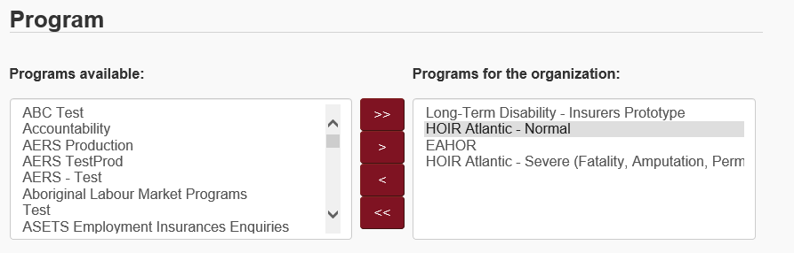

| Field | Mandatory | Description |
| --- | --- | --- |
| Programs available | Yes | Select the program from the list on the left and use the right arrow (>) to add it to the list on the right. If you have multiple programs, use the CTRL or the SHIFT key to select them all at once. Use the double right arrows (>>) to add all the programs from the list on the left into the list on the right without selecting them. |

### Add an organization

**IMPORTANT:** An organization should ONLY be added if it does not exist already. You must ensure that you have searched for the organization’s existence in the system before trying to add it. This will avoid duplicate organizations from being created.

1. From the Administrative Tasks page, select the ***Organizations Management*** link*.*
2. Search for the name of the organization to see if it exists.

Tips for a better search results:

* Type part of the name to get better matches.
* Search for the legal name, as well as any other commonly used business names.
* Note that the search engine is not case sensitive.

E.g.: Looking for ***National Air,*** type for example “***national air***” in the Search box.

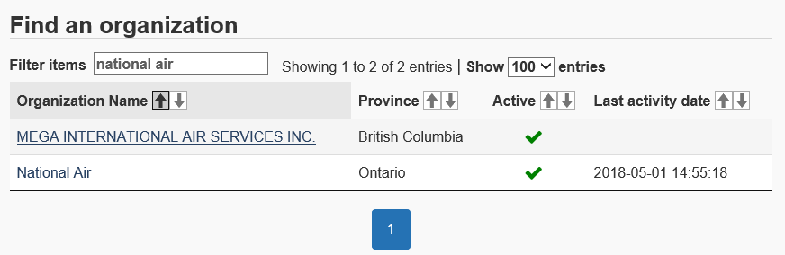

1. If you found the organization in the system, you will want to Update the organization instead of creating a new one.
2. Otherwise, select the ***Add an Organization*** link from the left-side menu:

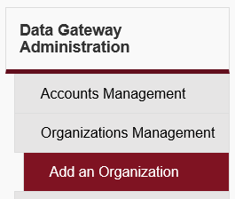

1. Fill the form by referring to the instructions for each field detailed in the previous section of this document. It is recommended to fill out as many fields as possible on this page. Also note that some fields are **mandatory**.
2. Once the form has been completed, select the ***Save*** button to save the form. A confirmation message at the top of the page should state that the record has been successfully added. You may also select ***Cancel*** to cancel the creation of the organization and return to the Organization List page.

### Update an Organization

Update an organization by following these steps:

1. From the Administrative Tasks page, select the ***Organizations Management*** link.
2. Search for the name of the organization.
3. Select the corresponding organization link to view the ***Organization Information*** section and modify the information as required.
4. You can update the fields in the information section.
5. Once the form has been completed, select the ***Update*** button to save your changes. A confirmation message at the top of the page should state that the record has been successfully updated. You may also select ***Cancel*** to cancel the changes in order to reload the page back to the previous information.

### Display Organization File Upload History

1. In the Organization Management page, after selecting an organization, a new link should now be visible in the left-side menu. Select the ***Organization Upload History*** link:

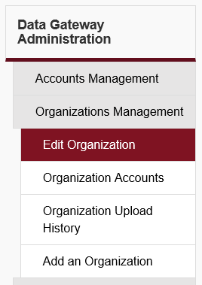

1. On this new page, a list of all uploaded files will appear for this organization. Please refer to Appendix A: Upload Statuses for more information on the upload status column.
2. Select the ***Reference Number*** of a file uploaded in order to display more details about the file (file name, file size, list of errors, etc.).

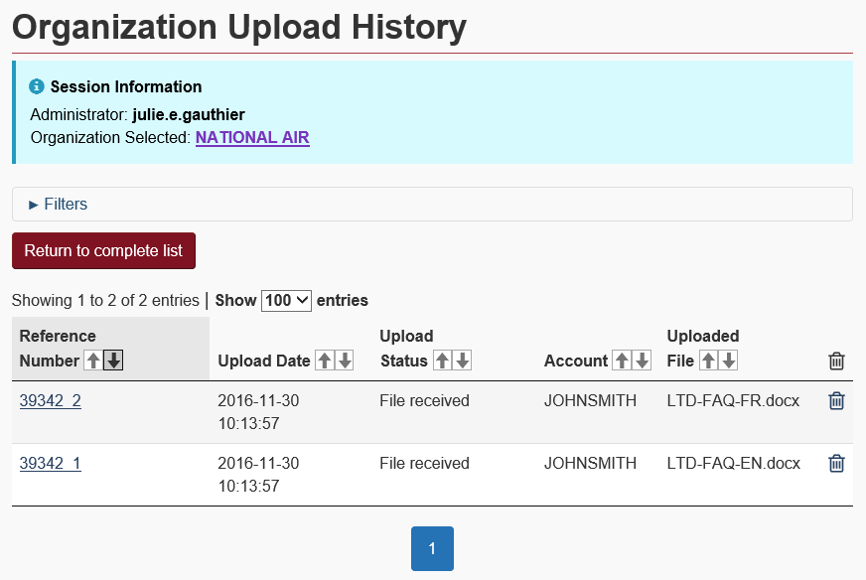

1. The Upload History Details screen will now be displayed for the file selected.

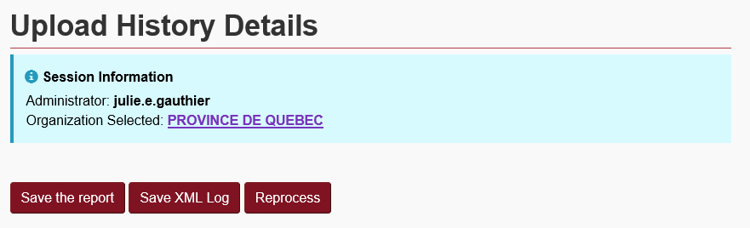

1. The ***Upload Information*** section contains details about the file itself.

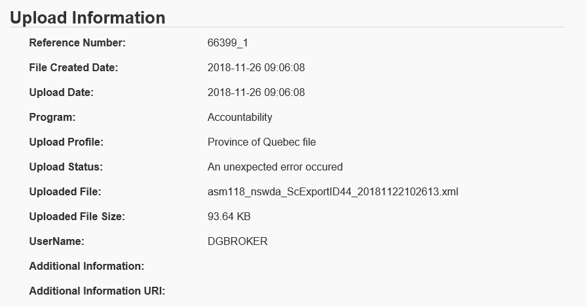

1. The ***Records Information*** section only applies to the following programs: ***ROH (Ceridian)***, ***AERS***, ***LMDA*** and ***ALMP***. These programs files are validated when processed. Once the files are received by the organizations, the processing and validation results are posted back for the user to see. The number of records processed, rejected, accepted and the total number of errors appear in this section. In addition, when errors are recorded, details appear in a table under this section.

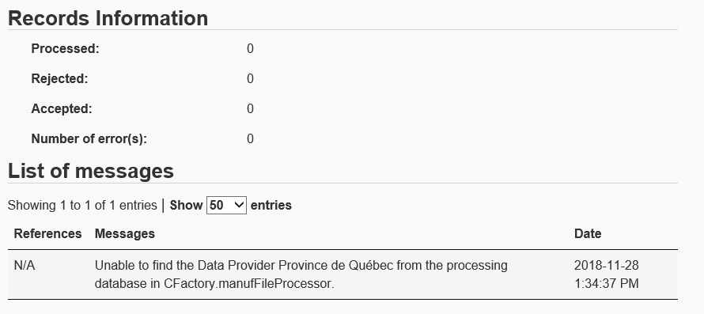

1. You can keep a copy of the upload report by selecting the ***Save the report*** button. This will create a file from the report of upload information as seen on the current screen. Selecting the button will initiate the browser to prompt you if you want to open the report or save it on your computer.
2. Alternatively, it is possible to save the details in a XML file by pressing the ***Save XML Log*** button. Note: This button is not available for all applications.
3. If you want to get a copy of the file uploaded by the organization, select the ***Download the file*** button. When selecting this button, the browser will ask you if you want to open the file or save it on your computer.

**IMPORTANT: A file with sensitive information (Protected B) in it should not be kept on a workstation. You may look at the file and once done, you must either delete it from your workstation or save it into an authorized departmental repository intended for Protected B information.**

### Display Organization Accounts

To take a look at the list of accounts of an organization, follow the steps below:

1. From the Administrative Tasks page, select the ***Organizations Management*** link.
2. Search for the name of the organization.
3. Select the corresponding organization link to view the ***Organization Information*** section.
4. Select ***Organization Accounts*** from the left-side menu.
5. The list of accounts for the organization selected will be displayed. From there, you can select one to take a look at its details and update it if necessary.

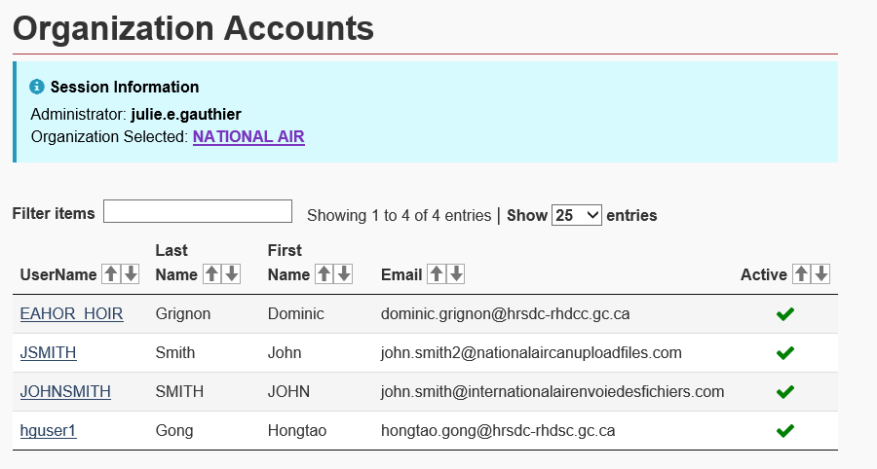

## Accounts management

This section leads to “Find an account” page by default.

### Find an Account

To find an account, you must use the Search field as described in the Administrator Tasks section.

### Account Properties

This section expands on the different account components.

#### Account Information

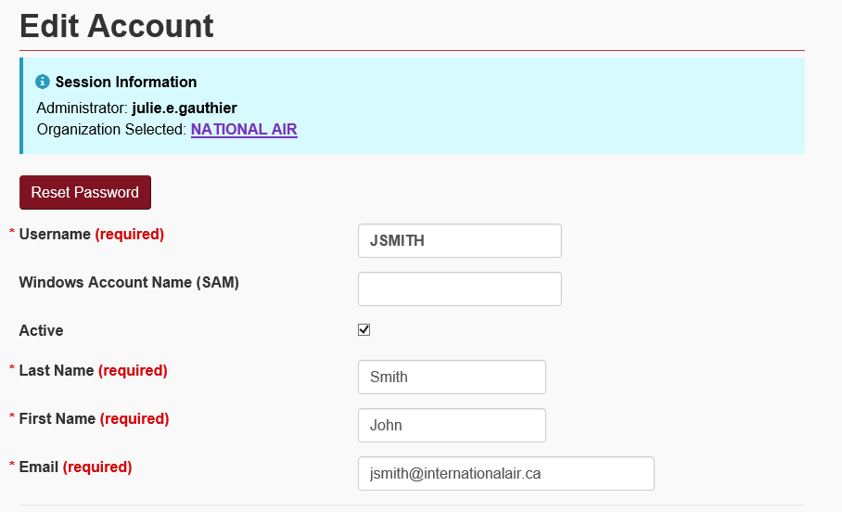

| Field | Mandatory | Description |
| --- | --- | --- |
| Username | Yes | This is the specific username. The username can contain letters, numbers and special characters. However, it cannot contain more than 12 characters in total and cannot contain spaces. Note that the username does not consider lowercase and uppercase characters. |
| Windows Username (SAM) | No | This is the unique identifier for a user on the ESDC network.  When creating an account, it is recommended to fill in this field with the user’s identifier (if they have one). This saves the user from having to do an extra step when signing in. |
| Active | No | This indicated whether an account is active or not. Check the box to set an account to active, allowing the user to sign in to the Data Gateway and upload files. Uncheck the box to set the account to inactive. By default, this box is checked (active). |
| Last Name | Yes | The user’s last name. |
| First Name | Yes | The user’s first name. |
| Email | Yes | The email address associated with the user’s account. The email address MUST be valid, as it can be used by the user to request a password reset directly from the Data Gateway web site. |

#### Contact Information

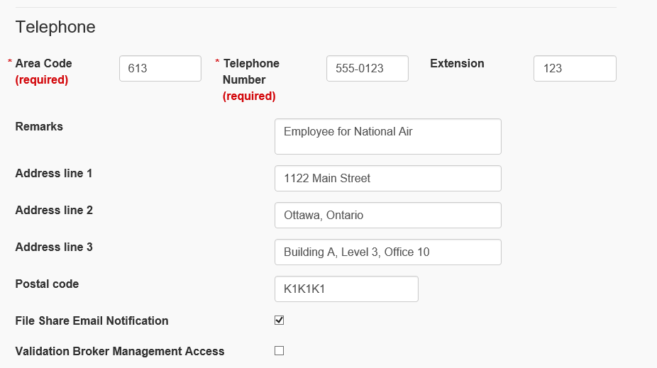

| Field | Mandatory | Description |
| --- | --- | --- |
| Telephone | Yes | The user’s telephone is separated into three (3) sections: the area code, the phone number, and the extension. The number in the second box can include hyphens (-) if desired. |
| Remarks | No | Additional information relevant to the user’s account. |
| Address line 1 | No | This contains the user’s street number, followed by the street name. |
| Address line 2 | No | This contains further information on the user’s address, like a suite, office number, room number, etc. |
| Address line 3 | No | This contains the city name, followed by the province or territory associated to the user’s address. |
| Postal code | No | The postal code associated to the user’s address. Must not contain spaces. |
| Notification Email | No | Indicates if the user will receive email communication when a file is shared with them. |

#### Roles Management

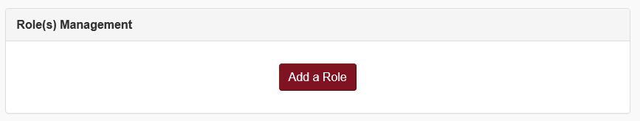

**Adding a role (for Admins only):**

1. After clicking on ***Add a Role***, select a role type from the first drop-down list that appeared. You can select either ***End User, Manager or Adminstrator.***

**NOTE: Never give the Administrator or Manager role type to an account associated with an organization that can upload files in the Data Gateway. Administrator and/or Manager accounts are strictly reserved to Government of Canada employees authorized to manage organizations and End User Accounts for their own program.**

See Appendix B: Account Types for more information on the differences between an Administrator and a Manager account.

1. A second drop-down list will be displayed after your selection.
   1. If you have selected “User”, the second drop-down will be “Organization”.
   2. If you have selected “Administrator” or “Manager”, the second drop-down will be “Program”.
2. Once you have made your selection from the second drop-down list, a third and final list will be displayed.
   1. If you have selected “User”, the final drop-down will be “Program”.
   2. If you have selected “Administrator” or “Manager”, you will have to select a province or territory.

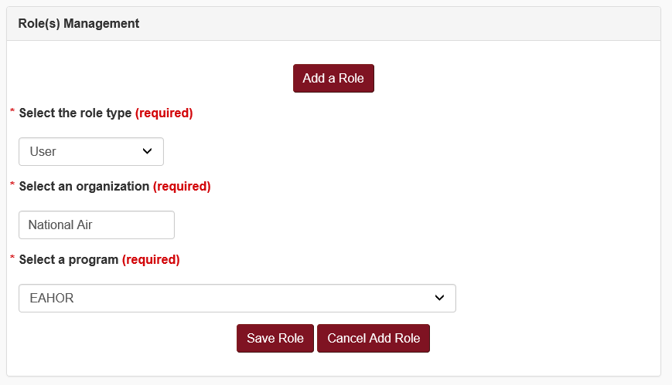

1. Once the form has been completed, select the ***Save*** button to save the information. A confirmation message will be displayed at the top of the page if the save was successful. Note that you may also select the ***Cancel*** button to cancel your unsaved changes.
2. Once done, the new role will appear in the role management section.

**To delete a role:**

**Please note that, while you may be able to see all of a user’s roles, you can only delete those under programs you are administrator to.**

1. To remove all roles at once, select the checkbox in the top left heading (before the ***Role*** column).

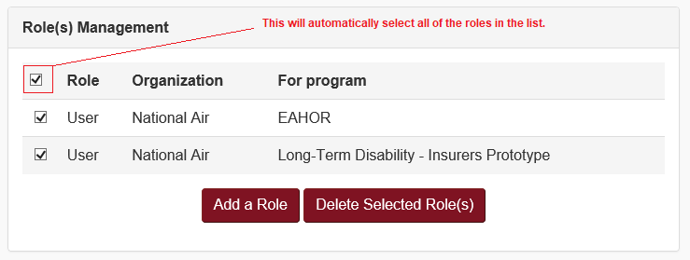

1. Otherwise, select only the checkbox(es) for the role(s) you would like to remove.
2. Hit the ***Delete Selected Role(s)*** button to remove from the list.
3. Once the roles are removed from the list, hit the ***Update*** button at the bottom of the page to confirm the changes. A message at the top of the page will confirm the update.

### Add an Account

**NOTE: An account is required for each employee of an organization who will be uploading files.**

**An account should be created ONLY if it does not already exist. You must ensure that you have searched for the user to see if they exist in the system before trying to create an account for them. This will avoid duplicate accounts from being created.**

Add an account by following these steps:

1. From the Administrative Tasks page, select the ***Accounts Management*** link.
2. Search for the account to see if it exists.
3. If you found the account in the system, you may want to Update the User account instead.

**IMPORTANT: If you found the account, but you see “ROH Online” in the Remarks field, you will need to create a new account with a different username. DO NOT modify an account which has the “ROH Online” remarks under it. These are special accounts.**

1. Otherwise, select the ***Add an Account*** link from the left-side menu:

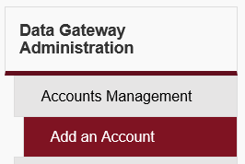

1. Fill the form. It is advisable to fill out as many fields as possible on this page, but note that some fields are **mandatory**.
2. Once the form has been completed, select the ***Save*** button to save the form. A confirmation message will be displayed at the top of the page.
3. You may also select ***Cancel*** to cancel the creation of the account.
4. Once the account has been created and saved, a temporary password will be displayed at the top of the page, highlighted in yellow.

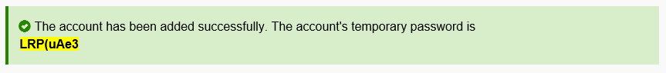

1. Select the entire password with your mouse and copy/paste it into a message intended for the user.

### Update an End User account

You can update an account by following these steps:

1. From the Administrative Tasks page, select the ***Accounts Management*** link.
2. Search for the account to see if it exists.
3. Select the account link.

**IMPORTANT: If the account you would like to update contains “ROH Online” in the remarks field, DO NOT modify it. These are special accounts.**

1. Update the account’s form with the new information.
2. Select the ***Save*** button to save the form.

## Searching for a specific upload

When looking for a specific upload in an organization’s history, all you need is a session number and the following steps:

1. From the Administrative Tasks page, select the ***Search in the upload history*** link.
2. Type in the Session Number in the textbox and hit the ***Go*** button.
3. A list of files associated with the Session Number you entered will now be displayed.

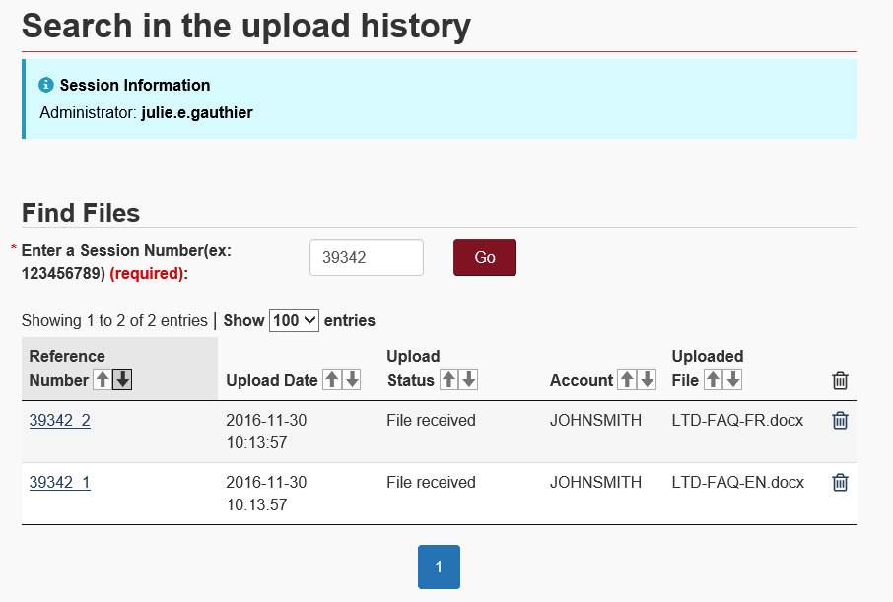

1. Select the Reference Number of a file uploaded in order to display more details.
2. The Upload History Details screen will be displayed for the file selected.

## Share a File with external users (if enabled)

**IMPORTANT: The Share File feature is only available to programs who are subscribed to it. If enabled, external users must use the *DGReceiverSecured* intranet web application in order to download files. This application CANNOT be reached directly from the Internet.**

**External Users must:**

* + - 1. Use the AppGate Secure Solution in order to use the 2-factor authentication mechanism and be granted access to the ***DGReceiverSecured*** intranet web application.
      2. Have a valid Active Directory account and password (for Appgate).
      3. Have an Entrust eGrid or Entrust IDG token (for AppGate).
      4. Have been investigated and authorized an acceptable Reliability Status.

To share files with external users, follow these steps:

1. From the Administrative Tasks page, select the ***Share File*** link.
2. The ***Share File*** page will be displayed.

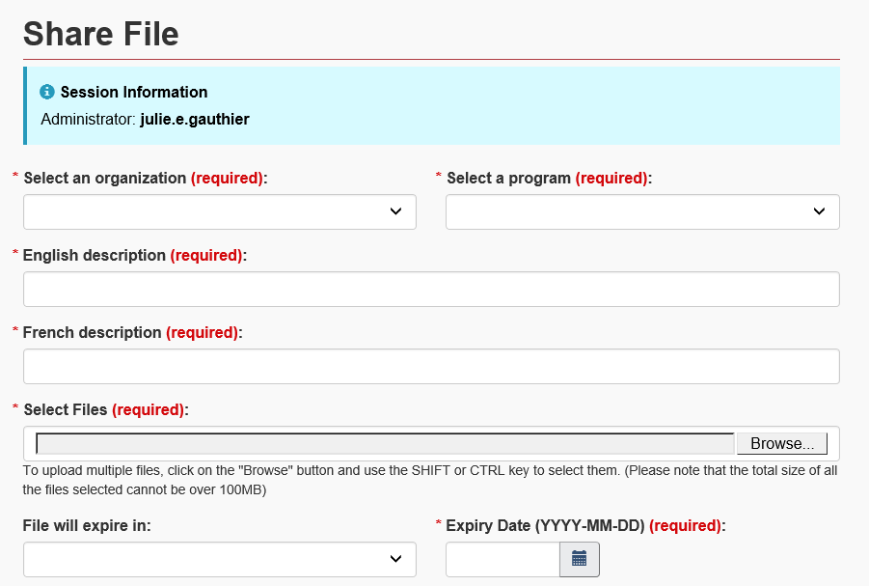

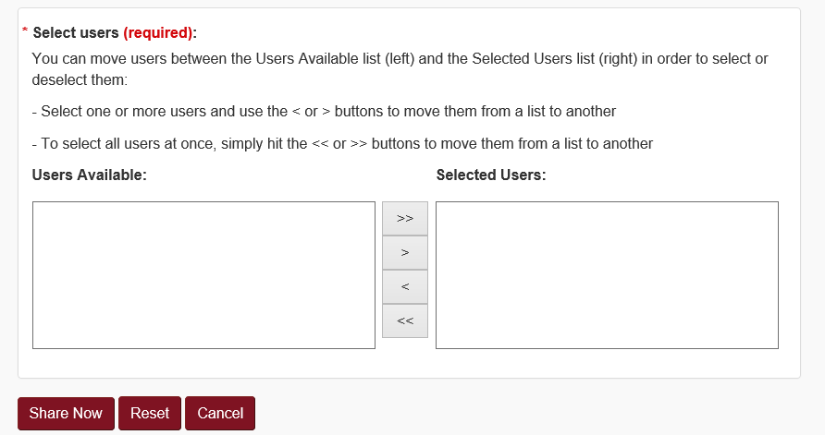

1. Make sure to fill out all of the fields on the page, as each field is mandatory.

***File Expiry Note:***

* In the ***File will expire in (required)*** field, it is possible to select a pre-defined number of days or customize the expiry date using the ***Other (Please specify)*** option.
* If you select a pre-defined number of days from the drop-down list, the ***Expiry Date*** field will automatically be updated to match your selection.
* If you select ***Other (Please specify)*** from the drop-down list, you must manually type or select from the calendar icon a date from the ***Expiry Date*** field.
* The maximum delay for file expiry is 18 months.

1. Click the ***Share Now*** button.

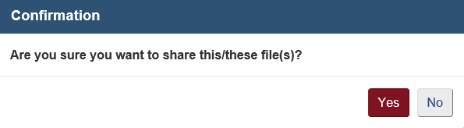

1. Click ***OK*** to confirm the file sharing. If successful, an email will be sent to the users you’ve shared the file with if the email notification option is enabled for them. A confirmation message will also be displayed on the page for your viewing.
2. If there are any errors, the screen will display them at the top of the page in a list format. Each field affected will also display their own error:

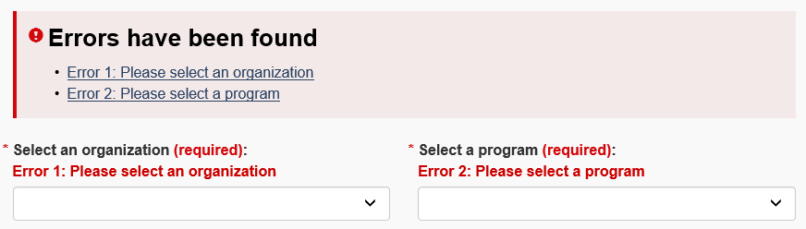

1. Clicking ***Reset*** will reset all fields.
2. Clicking ***Cancel*** will redirect to the home page and cancel the Share File process.

## Shared File History

1. From the left-side menu, select the ***Shared File History*** link.

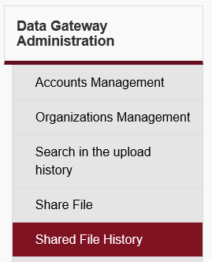

1. All of the shared files will listed in a table format with the following information: File Name, Date Shared, Program, Organization, File Shared With, and Delete.

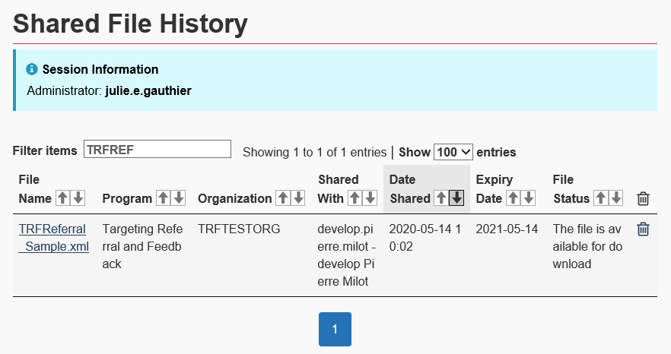

1. Please note that the link for the file’s name and the delete button will only appear for files that have not been deleted or have not yet expired.
2. Select the ***File Name*** of a file in order to display more details. The ***File shared details*** screen will now be displayed for that file.
3. The ***Delete*** button updates the status of the file to ‘deleted’.

## Reports

This section allows you to generate different reports regarding the programs you are managing.

Once you have selected the report type and the wanted filters, the ***Generate Report*** button will appear. When a report has been generated, the option to export it to Excel will be made available.

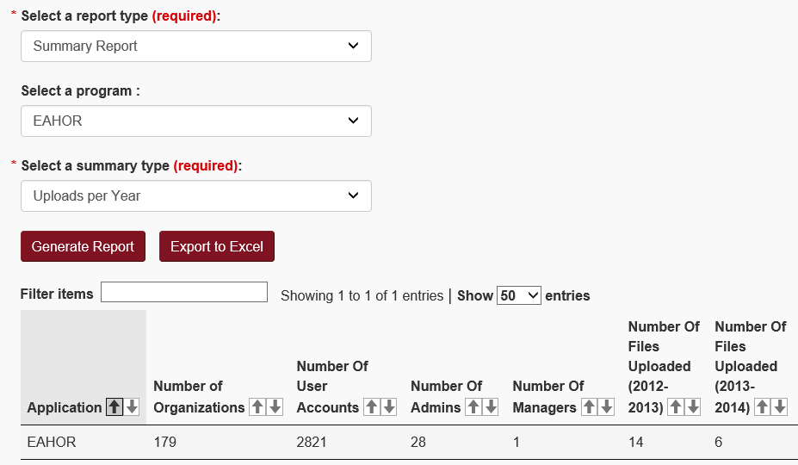

# Appendix A: Upload Statuses

**Most common upload statuses for a file uploaded**

| Status | Applicable to | Description |
| --- | --- | --- |
| File Received | All programs | Indicates that the file has been successfully uploaded to the Data Gateway by the organization, but has not yet been transferred to the client’s repository for further processing. A file with this status will display a ***DELETE*** button at the end of its row (small garbage symbol), allowing the user to remove the file from the Data Gateway before it gets processed. This status will remain until the file is transferred to the client’s repository. How long it remains will depend on the client’s pre-determined schedule (e.g.: Once per hour, day, week, etc.). |
| The file has been received. Validation in progress | All programs | Indicates that the file has been successfully transferred to the client’s repository. The file is now outside of the Data Gateway and in the hands of the client for the next processing steps (e.i.: validation, processing). It is no longer possible to delete a file from the Data Gateway once the file has entered this stage. |
| File Accepted | LMDA, ALMP | Indicates that the file’s processing has been completed and the file has been accepted by the client with no errors. |
| Partial File Accepted | LMDA, ALMP | Indicates that the file’s processing has been completed and that some, but not all, of the records in the file have been accepted by the client. |
| Fatal error file rejected | LMDA, ALMP | Indicates that the processing has been completed and that the file has been rejected. The organization must correct the listed errors and re-upload the file. |
| Accepted | AERS, ROH (Ceridian) | Indicates that the file’s processing has been completed and the file has been accepted by the client with no error. |
| Accepted with errors | AERS, ROH (Ceridian) | Indicates that the processing has been completed and that some, but not all, of the records in the file have been accepted by the client. |
| Pending | AERS, ROH (Ceridian) | Indicates that the processing has been completed and that all records will eventually be accepted. However, one or more files are missing in the upload sequence (files from a previous period) for this file to be accepted. The organization must upload the missing file(s) within 14 days otherwise the file will be rejected. |
| Pending with errors | AERS, ROH (Ceridian) | Indicates that the processing has been completed and some, but not all, of the records will eventually be accepted. However, one or more files are missing in the upload sequence (files from a previous period) for this file to be accepted. The organization must upload the missing file(s) within 14 days otherwise the file will be rejected. |
| Rejected – Please correct and resubmit | AERS, ROH (Ceridian) | Indicates that the file was ***Pending*** for more than 14 days and has been consequently rejected. This file must be re-uploaded as well as all of the missing files it required. |
| Rejected – Do not resubmit | AERS, ROH (Ceridian) | Indicates that the file has been rejected because the data in the file is too old. The file should **NOT** be re-uploaded. |
| An unexpected error occurred | LMDA, ALMP | Indicates that the file is not in the expected layout required in order to process the records in the file and pass the validation. The file must be fixed and re-uploaded. |
| The file could not be copied to the application queue | All programs | Indicates that the file could not be copied from the organization into its own staging folder or that a connection could not be made with the remote client server (AERS). The file should be re-uploaded by the organization. If the problem persists, a support ticket should be opened and assigned to the Data Gateway support team. |
| The file was transferred to the internet server | All programs | Indicates that there was an interruption while the organization attempted to upload the file. This status is short-lived and should not be displayed on-screen. This will usually be preceded by an error on-screen at the time of upload. The organization should verify if the file they are trying to upload is not too big in size. The total size of all files uploaded at once should not exceed 100MB. The organization should also verify that nothing on their side is preventing the file from being uploaded. The file must be re-uploaded by the organization. |
| The file transfer has been started | All programs | Indicates that there was an interruption while the organization attempted to upload the file. This status is short-lived and should not be displayed on-screen. This will usually be preceded by an error on-screen at the time of upload. This may be caused by communication issues. The file must be re-uploaded by the organization. |

# Appendix B: Account Types

**Administrator vs. Manager roles.**

|  |  |
| --- | --- |
| Account Type | Description |
| Administrator | An administrator can manage organizations and accounts for the program(s) they are responsible for. An administrator must be an employee of the Government of Canada and be connected to the ESDC’s network.  An administrator can access the Data Gateway public website to provide external organizations’ end users with technical support. They can also access the Data Gateway administration Intranet site in order to manage accounts and organizations.  An administrator will be associated with one or more provinces/territories, as well as one or more programs. They will then be able to manage organizations and accounts associated with these provinces/territories and programs.  Administrators who adds or updates other administrators and/or managers cannot, under any circumstances, assign a role at a higher level than their own. They also cannot associate another administrator and/or manager with a province/territory or program they are not associated with themselves. |
| Manager | A manager is an administrator with limited rights. A manager must be an employee of the Government of Canada and be connected to the ESDC’s network.  A manager can access the Data Gateway public website to provide external organizations end users with technical support. They can also access the Data Gateway administration Intranet site in order to view and/or update limited contact information for accounts and organizations.  A manager will be associated with one or more provinces/territories, as well as one or more programs. They will be able to view organizations and accounts associated with these provinces/territories and programs.  Limited rights summary:   * Cannot add new organizations or new accounts. * Cannot add/remove/modify organizations file types or programs. * Cannot add/remove/modify account roles. * Cannot view/download files uploaded by organization end users. * Cannot see inactive organizations and accounts. * Can view organizations information. * Can only update the ***Remarks*** field. * Can view accounts information. * Can only update the ***Email Address*** and the ***Remarks*** fields. * Can modify all the fields of they own account. * Cannot modify their own roles. * Can view organizations’ Upload History list. * Can reset an account password. * Can unlock an account. |