Certificate of   
Appreciation

W E HEREBY ACKNOWLEDGE

**CAITLYN GRIFFIN**

for her excellent work performance and   
stellar work ethic in our team.

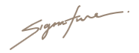

**TAKEHIRO KANEGI DARWIN OGAWA**

 **Manager Team Leader**

