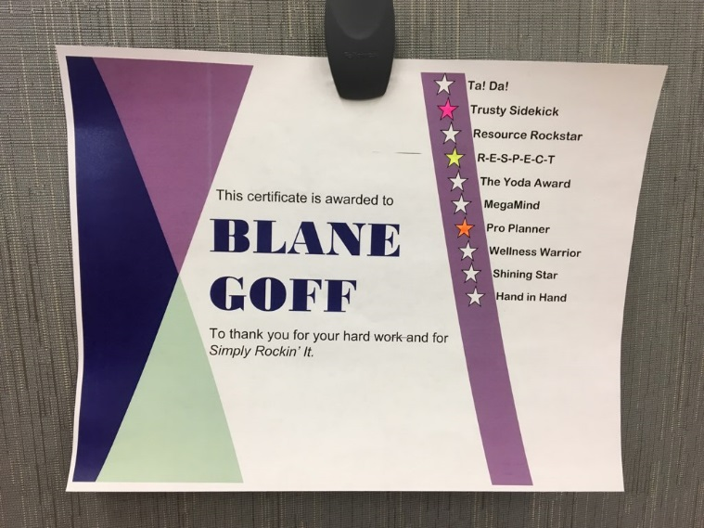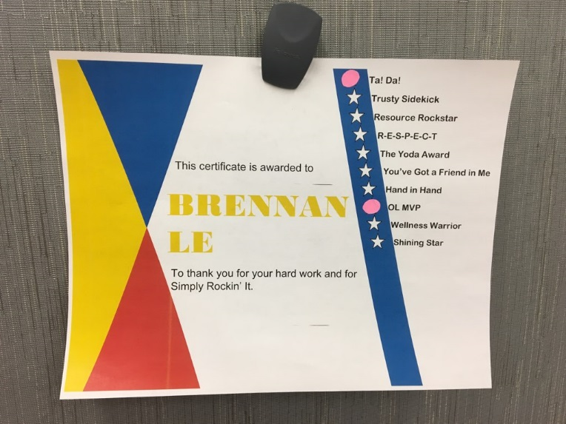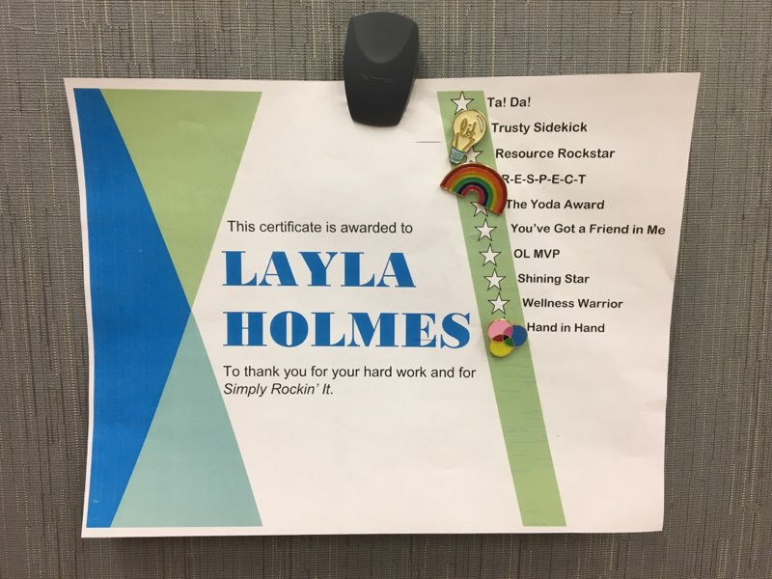

**Most importantly… Use your creativity and have fun with it!**

Use these suggestions or some up with other ways to highlight categories on your own.

**ANNEX E**

Buy some fun pins that correspond to each category!

Buy stickers or make your own out of sticky notes!

Use different coloured highlighters to fill in the stars!

Simply

Rockin’ It!

**IDEAS FOR HIGHLIGHTING CATEGORIES**