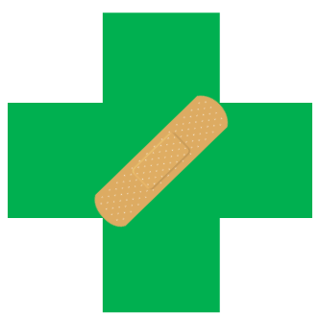
IN CASE OF INJURY AT WORK
Check – Call – Care
- Scene survey – Check the person if it is safe to do so.
  - Care must be taken when trying to eliminate any hazards. Emergency responder should help if the scene presents a danger.
- In case of EMERGENCY, call 9-1-1, and contact Security: 819-956-6777 (24 / 7).
- Obtain First Aid assistance immediately.
- Provide care according to your skills and comfort level.
- First Aid Kits are located <insert location of closest first aid kit>.
- Inform manager / supervisor as soon as possible.

