Appendix 1

Measurement Worksheet

Chair: # Casters: __________

Items | Image | Actual Measurements (in or cm) | Recommended Measurements (in or cm) | Adjustable to meet recommended measurements
 |  |  |  | Yes | No
1. Seat pan Height | 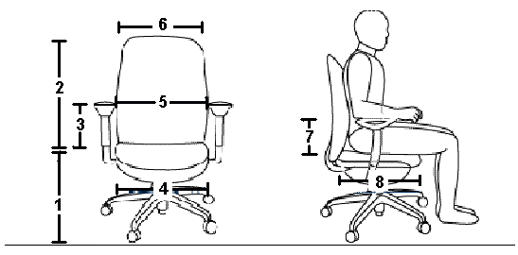
2. Backrest Height
3. Armrest Height
4.Seat pan Width
5.Armrest Width
6.Backrest Width
7.Lumbar support Height
8.Seat pan depth

Keyboard Tray, Keyboard, Pointing Device and Palm Rest

Items | Image | Actual Measurements (in or cm) | Recommended Measurements (in or cm) | Adjustable to meet recommended measurements
 |  |  |  | Yes | No
1.Keyboard Tray Depth | 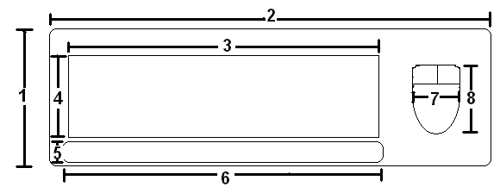
2.Keyboard Tray Width
3.Keyboard Width
4.Keyboard Depth
5.Palm Rest Depth
6.Palm Rest Width
7.Pointing Device Width
8.Pointing Device Depth

Desk, Monitor and Document Holder

Item | Image | Actual Measurement (in or cm) | Recommended Measurement (in or cm) | Adjustable to meet recommended measurements
 |  |  |  | Yes | No
1.Keyboard Tray Height | 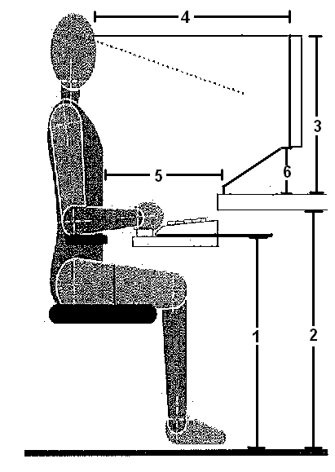
2. Desk Height
3.Monitor Height
4.Monitor Depth
5.Document Holder Depth
6.Document Holder Height

Lighting and Telephone: Is the Lighting adequate? Yes _____ No _____

Item | Image | Actual Measurement (in or cm) | Recommended Measurement (in or cm) | Adjustable to meet recommended measurements
 |  |  |  | Yes | No
Telephone (distance from edge of telephone to edge of desk) | 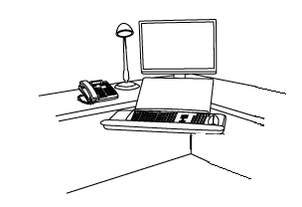

Footrest

Item | Image | Actual Measurement (in or cm) | Recommended Measurement (in or cm) | Adjustable to meet recommended measurements
 |  |  |  | Yes | No
1.Footrest Depth | 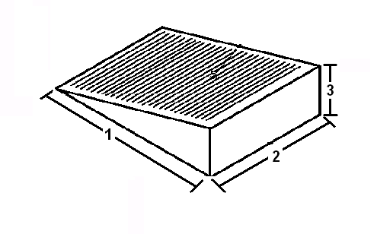
2.Footrest Width
3.Footrest Height

