**Using Your Branch / Region Report for Planning**

**A How-To Guide**

**ESDC Workplace Mental Health Survey 2019 (Updated)**

colouredbanner



**November 12th , 2019**

**USING YOUR BRANCH / REGION REPORT FOR PLANNING: A How-To Guide**

**The Purpose of this Guide is to support the organization to understand the results of ESDC’s Workplace Mental Health Survey; identify workplace areas of strength and concern; and use the results to guide its actions.**

1. **Locate Your Results**

* Refer to Branch / Region “Change Chart” to review your branch/region workplace mental health survey results. (You need to request this from the WMH Survey Team directly).

1. **Understand Your Results**

* Read through each item reported
  + Where is your branch / region strong?
  + What are areas in need of improvement?
  + Are there any factors of particular concern?
  + Use the legend as a guide:

|  |  |  |
| --- | --- | --- |
| * No concern | * + Moderate concern | * High concern |

1. **Identify Key Predictors and Compare to Results**

* Using your report, which of the 5 outcomes are of particular concern for you?
  + What factors influence each outcome? See “**The Model of Main Drivers” below**.

|  |  |  |
| --- | --- | --- |
| * No concern | * + Moderate concern | * High concern |

* + Are any of the predicting factors areas of concern for your branch or region? Check your results for

1. **Determine Where to Focus Your Efforts**

* See the “**Mapping Actions to Findings” charts below** 
  + There are two versions: Three are portfolio specific with 2019 results (to be used as examples), and one is blank (you can use for your own results).
* Look at your results. Depending on whether it is green, yellow or red (identified on your Change Chart, far right hand column), write the name of each factor in the appropriate row and column.
* One approach: tackle the factors in the yellow and red zones.
  + Based on the key predictors (from step 3), which factors are in the yellow or red zones? Start with those.
  + What other factors are in the yellow and red zones (step 4)? Move to these next.
  + **Some factors are important predictors for more than one outcome: consider working on those because you will get more ‘bang for your buck’.**
  + **Note: Don’t lose sight of factors in the green, healthier range. These can be important catalysts for sparking improvement in other workplace factors.**

1. **Plan**

* Now that your branch’s/ region’s results are organized,here are some questions to ask:
  + How do these results resonate with what else you know about your organization? What your team knows? Other survey results?
  + Which outcome(s) do you want to focus on?
  + Brainstorm actions and activities.
    - What is already being done? What’s missing?
    - Talk to your Workplace Mental Health Champion: What are other teams, branches/regions doing?
    - Are you focusing your actions/activities at the right level: Job demands? Factors relating to the individual? The team? The organization?

**Model of Main Predictors for Each Workplace Outcome, ESDC**

The top three predictors for each of the five outcomes are represented below. The outcome of interest is at the end of each ‘road’, and the three strongest predictors (either job demands or job resources) are “signs” along the way. Notice that Morale and Turnover both have the same key predictors (and for simplicity, they share a road).

For example:

* **Risk for Psychological Distress** is most strongly predicted by Autonomy, Relatedness, and Work-Family Conflict.
* **Burnout** is most strongly predicted by Meaning, Autonomy and Job Stress.
* **Engagement** is most strongly predicted by Meaning, Competence and Impact.
* **Morale and Turnover** **Intentions** are most strongly predicted by Meaning, Autonomy and Organizational Support.

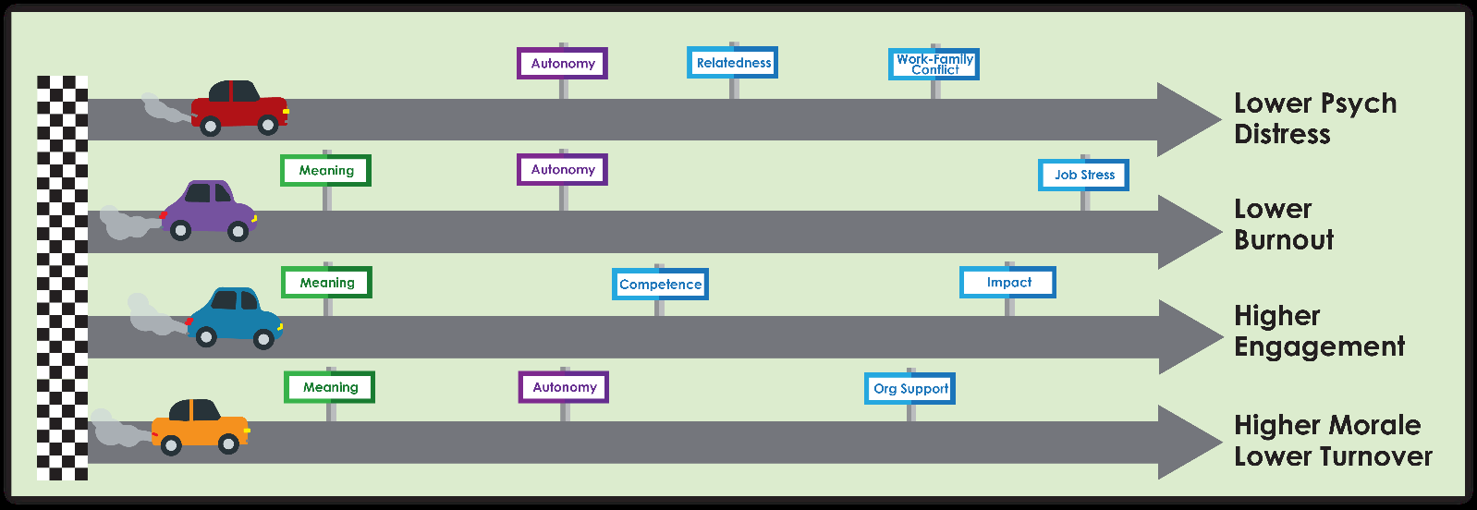

**Mapping Actions to Findings – Blank**

* Use this page if you are working with branch/region results.

|  |  |  |  |  |  |  |  |  |
| --- | --- | --- | --- | --- | --- | --- | --- | --- |
|  | **Workplace Factors** | **Job Demands** | **Job Resources** | | | |  | **Outcomes** |
|  | **Individual** | **Team** | **Leader** | **Organization** |  |
|  | Work-family Conflict  Workload  Job Stress | Competence  Meaning  Autonomy  Impact | Relatedness  Psychological Safety  Civility and respect | Role Clarity  Leadership  Recognition | Organizational Support  Group Culture |  | Engagement  Turnover Intentions  Morale  Burnout  Psychological Distress |
| **Concern level** | No |  |  |  |  |  |  |  |
| Moderate |  |  |  |  |  |  |  |
| High |  |  |  |  |  |  |  |

**Mapping Actions to Findings – Employment and Social Development**

* Use Portfolio results if your branch/region responses were too low to generate your own report. ESD’s results are mapped below.

|  |  |  |  |  |  |  |  |  |
| --- | --- | --- | --- | --- | --- | --- | --- | --- |
|  | **Workplace Factors** | **Job Demands** | **Job Resources** | | | |  | **Outcomes** |
|  | **Individual** | **Team** | **Leader** | **Organization** |  |
| **Concern level** | No | Work-Family Conflict | Competence  Meaning | Psychological Safety  Civility and respect | Leadership | Organizational Support  Group Culture |  | Engagement |
| Moderate | Workload | Autonomy | Relatedness | Role Clarity  Recognition |  |  | Turnover Intentions  Morale |
| High | Job Stress | Impact |  |  |  |  | Burnout  Psychological Distress |

**Mapping Actions to Findings – Service Canada**

* Use Portfolio results if your branch/region responses were too low to generate your own report. Service Canada’s results are mapped below.

|  |  |  |  |  |  |  |  |  |
| --- | --- | --- | --- | --- | --- | --- | --- | --- |
|  | **Workplace Factors** | **Job Demands** | **Job Resources** | | | |  | **Outcomes** |
|  | **Individual** | **Team** | **Leader** | **Organization** |  |
| **Concern level** | No |  | Competence  Meaning | Civility and respect | Role Clarity |  |  | Engagement |
| Moderate | Work-family Conflict  Workload |  | Psychological Safety  Relatedness | Leadership | Organizational Support  Group Culture |  | Turnover Intentions  Morale |
| High | Job Stress | Autonomy  Impact |  | Recognition |  |  | Burnout  Psychological Distress |

**Mapping Actions to Findings – Labour Program**

* Use Portfolio results if your branch/region responses were too low to generate your own report. Labour Program’s results are mapped below.

|  |  |  |  |  |  |  |  |  |
| --- | --- | --- | --- | --- | --- | --- | --- | --- |
|  | **Workplace Factors** | **Job Demands** | **Job Resources** | | | |  | **Outcomes** |
|  | **Individual** | **Team** | **Leader** | **Organization** |  |
| **Concern level** | No |  | Competence  Meaning | Psychological Safety  Civility and respect | Leadership | Organizational Support  Group Culture |  | Engagement |
| Moderate | Work-family Conflict  Workload | Autonomy | Relatedness | Role Clarity  Recognition |  |  | Turnover Intentions  Morale |
| High | Job Stress | Impact |  |  |  |  | Burnout  Psychological Distress |