|  |
| --- |
|  |
| Workplace Mental Health Survey 2017 |
| Detailed Departmental Results |
|  |
| **Human Resources Services Branch** |
| **November 2018** |

|  |
| --- |
|  |



Table of Contents

Acknowledgments i

Executive Summary ii

1 Background and Purpose 1

2 Findings 2

2.1 Job Demands at ESDC 5

2.2 Job Resources at ESDC 5

2.3 Workplace Well-being at ESDC 5

2.4 Descriptive Analysis 6

2.5 Progress of *Framework* Implementation 11

2.6 Summary of Qualitative Survey Responses 12

2.7 Main Predictors of Workplace Well-being Outcomes 14

2.8 Workplace Well-being Groups: Who is Most At-Risk? 16

3 Suggested Areas for Action 17

3.1 Workload & Job Stress 18

3.2 Psychological Needs at Work (Autonomy & Impact) 19

3.3 Leadership, Organizational Support and Group Culture 19

3.4 Recognition 20

4 Next Steps 21

Annex A: Description of UMP V2.0 Variables and Associated Scales 22

Annex B: ESDC Workplace Mental Health Survey Measures and *The Standard* 27

Annex C: Technical Details, Development and Implementation of Survey 28

Annex D: How Means are Classified into No, Moderate or High Concern 33

Annex E: Additional Reference Tables 34

Annex F: Workplace Domain Tables by Selected Demographics 41

Annex G: Key Predictors of Workplace Well-being Outcomes by Portfolio 61

# Acknowledgments

ESDC’s Workplace Mental Health Survey team would like to thank our colleagues at Director General Military Personnel Research and Analysis (DGMPRA) at the Department of National Defense, for their support, guidance, mentoring and contributions to the development of this report; and for conducting the segmentation analysis. It has been a privilege to work alongside a team which is so generous in sharing their extensive experience.

We are also grateful for our colleagues within ESDC who provided critical advice and guidance throughout the implementation, analysis and reporting stages, in particular colleagues from Tier 5 within Human Resources Services Branch; Public Affairs and Stakeholder Relations Branch; Strategic and Service Policy, Evaluation Directorate; and Innovation, Information, and Technology Branch.

Finally thank you to ESDC employees who participated in the pre-testing of the survey and generously provided comments and feedback to support the development of a tool that is relevant to our organization.

# Executive Summary

**Purpose.** This report summarizes departmental-level results of the ESDC Workplace Mental Health Survey administered to a random sample of employees between February 13th and March 28th 2017. The survey was conducted by the Human Resources Services Branch as part of ESDC’s Integrated Framework on Mental Health in the Workplace. Detailed results for each Portfolio are available separately.

**Survey Respondents.** A random sample of 6,957 employees was invited to participate in the Workplace Mental Health Survey (WMH). A total of 3,359 employees completed the questionnaire (48%). Survey data is weighted to adjust for the differences in under- and over-representation by portfolio among survey respondents, which increases our confidence in being able to draw departmental conclusions representative of each portfolio.

**Overall Findings.** Research shows that key factors shape how people experience the workplace, which in turn affect employees’ health and well-being and the quality of their work.

|  |  |
| --- | --- |
| *Some factors measure* ***job demands****, also known as* ***risk factors****. These are physical or emotional stressors like time pressure, heavy workload, and a stressful working environment.*  *The WMH Survey measures three job demands: Workload, Work-Family Conflict, and Job Stress.* | The majority of ESDC employees are able to **balance** work and family life (62%). However, a majority also experiences moderate to high challenges with respect to their **workload** (55%), and have moderate to high **job stress** (73%). |

|  |  |
| --- | --- |
| *Other factors measure* ***job resources****, also known as resilience factors. These are the physical, social and organizational factors that promote goal achievement, stress reduction, learning and development, and well-being. They can* ***protect*** *employees* ***from the negative effects of job demands****, and reduce potential negative outcomes.*  *The WMH Survey measures 14 job resources, grouped as follows: Individual Resources (Meaning, Autonomy, Impact, Competence), Leader Resources (Leadership, Role Clarity, Recognition & Reward), Team Resources (Relatedness, Psychological Safety, Civility & Respect), and Organizational Resources (Supervisor Safety Behaviours and Expectations, Organizational Support, Group Culture).* | The majority of ESDC employees feel **competent** in their job (85%), feel they work in an environment characterized by **civility and respect** (80%), have a clear understanding of their **role** (75%), find their work **meaningful** (66%), feel **safe** to take risks in their team, such as offering opinions and asking questions (64%), have a sense of community and connection (**relatedness**) in the workplace (62%), and feel their **leaders** are a positive source of support and inspiration (57%).  On the other hand, **many** ESDC employees experience low to moderate **group culture** (52%), experience low to moderate **organizational support** (52%), feel low to moderate sense of control over their work (**autonomy**) (64%), feel a low sense of **impact** in their job (47%), and feel their work is not **appreciated** or **recognized** (42%). |

|  |  |
| --- | --- |
| *ESDC’s survey also measures important* ***outcomes*** *associated with employees’ psychological health and safety in the workplace: Engagement, Turnover Intentions, Morale, Burnout, and Psychological Distress.* | Employees’ engagement is an area of strength, with a majority reporting they are **highly engaged** in their work (80%). However, just over half (56%) **intend to stay** in the organization. Further, employees’ morale, job burnout, and self-reported psychological distress are particularly concerning. The majority of ESDC employees have low to moderate **morale** (52%), experience moderate to high **burnout** (69%), and are at moderate to high risk to meet the minimum clinical threshold of an **anxiety and/or depressive disorder** (72%). |

**Descriptive Analysis.** Differences were examined according to several organizational and demographic variables of interest.

* Portfolio. Each portfolio has areas of strengths, and areas of challenge. Relative to their colleagues, Employment Social Development (ESD) employees report lower job demands and higher job resources. In some cases, this translates to healthier well-being outcomes (e.g. morale). By contrast, employees from Service Canada often have more in common with colleagues from Labour Program, and together report greater job demands and fewer job resources than those from ESD. While noted as areas of concern for the department as a whole, employees in Service Canada report the highest levels of psychological distress and burnout.

* Geographic Location. There are significant differences on all workplace measures depending on where people work. *In general*, the NCR and Quebec regions report lower job demands and higher job resources, and experience slightly better well-being outcomes. Ontario and West and Territories regions report the highest job demands and lowest job resources, and experience the most negative well-being outcomes. The Atlantic region experiences job demands and job resources that fall in between those of other regions, which may help explain some healthier well-being outcomes relative to colleagues in other areas.
* Supervisor/Manager vs. Other Employees. Relative to non-supervising employees, supervisor/managers report higher job demands and higher resources; supervisors/managers also have healthier workplace well-being outcomes.
* Citizen-facing vs. Non-Citizen-facing. All employees experience concerning levels of job stress, and citizen-facing employees report higher levels than their colleagues. A greater proportion of citizen-facing respondents feel their work is not appreciated or recognized, report a low to moderate sense of control over their work, and a low sense of impact in their job relative to their non-citizen-facing colleagues. Citizen-facing employees do not differ greatly from non-citizen-facing employees in terms of engagement and turnover intentions; however, citizen-facing respondents report lower levels of morale and significantly higher levels of burnout.

**Main Drivers of Workplace Well-being Outcomes.** While each outcome has a unique set of workplace demands and resources that act as the main drivers, two factors are most prevalent when we look at ESDC as a whole: Autonomy and Meaning. These findings are consistent with other research which points to the critical importance of autonomy, competence, meaning and relatedness to workplace well-being. In essence, strengthening these two workplace factors *alone* will improve well-being outcomes.

* **Engagement** is most strongly predicted by Competence, Meaning and Group Culture.
* **Morale** is most strongly predicted by Autonomy, Meaning, and Organizational Support.
* **Burnout** is most strongly predicted by Autonomy, Meaning, and Job Stress.
* **Psychological Distress** is most strongly predicted by Autonomy, Relatedness, and Job Stress.
* **Turnover** I**ntentions** are most strongly predicted by Autonomy, Meaning, and Organizational Support.

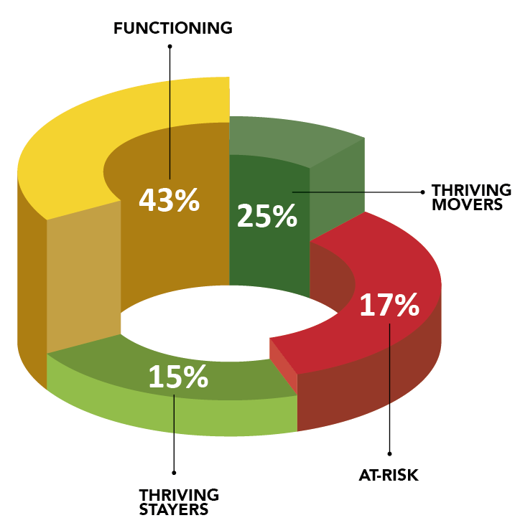**Workplace Well-being Groups**. An in-depth analysis identified four distinct respondent groups at ESDC based on their workplace well-being outcome scores: An **At-Risk** group (17%), a **Functioning** group (43%), **Thriving Movers** (25%) and **Thriving Stayers** (15%). Both groups of thriving employees have the healthiest scores on each of the five workplace well-being outcomes; where they differ is in their intentions to leave. Although their turnover intentions remain lower than average, the Thriving Movers may still be more likely to consider career opportunities outside of ESDC relative to the Thriving Stayers.

The **At-Risk** group shows the lowest levels of engagement and morale, the highest levels of burnout and psychological distress, and the greatest intentions to leave. On average, this group is at high risk for meeting the clinical threshold for an anxiety or depressive disorder. Additional analysis isolated key workplace factors correlated with membership in the At-Risk group. These employees are more likely to report: (1) lower levels of autonomy, (2) less meaningfulness at work, (3) elevated levels of job stress, (4) less organizational support, and (5) a reduced sense of belonging. The At-Risk group has higher proportions of employees: in mid-career; who are citizen-facing; in non-supervisory roles; or younger than 35.

**Suggested Areas for Action.** Understanding key drivers affecting workplace well-being outcomes can assist leaders to identify more precise responses. At the same time, there may be creative ways to improve workplace well-being outcomes by strengthening workplace factors of concern that may *not* be key predictors. This is because the workplace is a dynamic environment, and job demands, resources and workplace well-being outcomes are all interconnected. Finally, sometimes the way to address an area of challenge is to leverage an area of strength. Key areas of action identified at the Departmental level include:

* Job Stress and Workload
* Psychological Needs at Work (Autonomy and Impact)
* Leadership, Organizational Support, Group Culture
* Recognition

In identifying areas of action:

* **Align actions to the source of the challenge:** When we think about workplace areas of concern, either job demands or resources, we need to ask: are they a characteristic of individuals, teams, leaders, or the organization itself? When identifying responses to workplace challenges, match these to the source of the workplace challenge.
* **Use a combined “top down” (strategic) and “Bottom up” (proactive) approach:** *Strategic* interventions through Human Resource Management and transformational leadership initiatives can foster employee engagement. These can have an important, system-level impact on the organization and its employees by supporting a healthy work environment. *Proactive* approaches encourage employees to take the initiative to develop and/or mobilize existing resources, with the result that employees are healthier and more productive. Both types of interventions are important.
* **Remember we have a mutual responsibility to each do our part to foster a psychologically healthy and safe workplace:** Find creative ways to include a diversity of employees in developing responses to workplace mental health issues that affect them.

**Next Steps.** Every team within ESDC is unique, with its own strengths and challenges. The work environment is complex, and creating a psychologically healthy and safe workplace requires ongoing attention and management. Leaders at all levels are encouraged to consider these, and other survey findings, to create integrated action plans going forward. In addition to activities that target specific workplace factors, below are actions that leaders and employees at all levels of the organization can take to support a psychologically healthy and safe workplace.

|  |  |
| --- | --- |
|  | **Individual level**   * To demonstrate their commitment to action, build trust and support transparent and meaningful conversations throughout the Department at all levels, leaders are invited to share the results of the survey with all employees. Doing so acknowledges that employees have been heard, and will foster their engagement in finding solutions and being part of the change. * Employees at all levels are encouraged to access tools and resources to manage individual workplace mental health and build resiliency. |
|  | **Team level**   * Hold discussions with senior staff to understand the WMH survey results, and reflect on what is working and what needs improvement. Include employees in discussions about how to move forward to address areas of concern. * Integrate information from WMH survey with findings from other surveys and data sources to create integrated action plans. |
|  | **Organization level**   * Empower and equip Workplace Mental Health Champions, representatives from various employee networks, and other enabling services to use WMH and other survey results to inform dialogue, discussion and action at multiple levels. Use communications to spark conversations and encourage involvement by sharing actions and lessons learned. * Find concrete opportunities to support workplace mental health throughout the department. Get familiar with WMH and other survey results, and with the next Workplace Mental Health Three-Year Action Plan (2018-2021), to help identify what branches or regions can do to address identified challenges. Commit to trying something new, be it a large change or something smaller. |

# Background and Purpose

There are many reasons to build a mentally healthy workplace; research shows a healthy workplace contributes to employee morale, reduces absenteeism, and improves productivity and employee retention.[1] It is not only the **smart thing** to do (and a legal obligation for the employer) but the **right thing** to do. And while employees have a responsibility to manage their own mental health, it is important for the employer to create the right environment and put in place the right resources to support employee mental health.

In January 2013, the Mental Health Commission of Canada published the **National Standard** of Canada for Psychological Health and Safety in the Workplace (the **Standard)** in collaboration with the Bureau de normalisation du Québec.[2] The document identifies 13 psychosocial risk and resilience factors that leaders and managers should monitor and positively influence as part of their commitment to a psychologically healthy and safe workplace. Inspired by the **Standard** and the importance of fostering a healthy workplace, and informed by knowledge of existing challenges[3], ESDC launched an information gathering and planning exercise to develop the *Integrated Framework for Mental Health in the Workplace* (the *Framework)*. Following approval of the Framework by Senior Management in 2014, an Implementation Committee was established with a mandate to oversee the implementation of concrete actions to enhance the psychological health and safety of our employees.[4]

Under the guidance of the Implementation Committee, a Progress Evaluation Strategy was developed to help measure the progress of the *Framework* actions. Understanding why and how actions contribute to a healthier workplace – or don’t – helps in allocating resources where they are most needed, and in course correcting along the way. Three main sources of data are identified within the Progress Evaluation Strategy: Branch and Regional activities and outputs related to supporting workplace mental health; departmental data linked to key indicators; and a workplace mental health baselining survey.

The purpose of the Workplace Mental Health Survey is to hear directly from employees about their experiences in the workplace related to psychological health and safety. Following a period of research and a pre-test, ESDC implemented a modestly tailored version of the Unit Morale Profile (UMP) V2.0, a tool developed by Director General Military Personnel Research and Analysis (DGMPRA) of the Department of National Defense.[5] This evidence-based tool is a compilation of published academic and scientific scales measuring each of the 13 factors identified in the **Standard**, as well as key workplace well-being outcomes. By using a theoretical model to look at how job demands and job resources relate to workplace well-being outcomes, the Survey helps get at the root causes of workplace psychological health and safety in ways not supported by other surveys. With the support of DND, ESDC has pioneered the use of the UMP V2.0 as a departmental survey tool. To date, DND has used the UMP v2.0 as a strategic tool at the unit (or team) level at the invitation of leaders interested in understanding and improving the psychological well-being of their personnel. Finally, at the time of writing, ESDC is the only department outside of DND to implement the UMP v2.0.

In this first year of implementation, the main objective of the Survey is to establish a baseline – in other words, a sense of ‘where we are’ as a Department. In addition, information collected through the survey will be reviewed with other departmental data to identify and assess areas of strength and concern; ensure we take corrective action where needed; and know whether we are making a difference in workplace culture at the departmental, business line, and regional levels. A second implementation of the survey is planned for Winter 2019. For a complete description of the development of ESDC’s Workplace Mental Health Survey, please see Annex C.

This report summarizes departmental-level results of the ESDC Workplace Mental Health Survey administered to a random sample of employees between February 13th and March 28th 2017. The survey was conducted by the Human Resources Services Branch as part of ESDC’s Integrated Framework on Mental Health in the Workplace. Detailed results for each Portfolio are available separately.

# Findings

Research shows that key factors shape how people experience t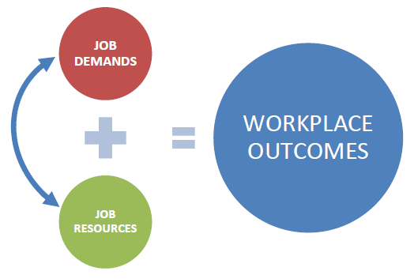he workplace, which in turn affect employees’ health and well-being and the quality of their work.[6] A description of each factor and its associated scale is provided in Annex A.[7] Briefly, some factors measure **job demands**, also known as risk factors. These are physical or emotional stressors like time pressure, heavy workload, and a stressful working environment. **Job demands can impair employees’ mental and physical energies** which can lead to lower engagement or morale, and also lead to more burnout, depression, heart disease or cold symptoms. The WMH Survey measures three job demands:

* Workload
* Work-Family Conflict
* Job Stress

Other factors measure **job resources**, also known as resilience factors. These are the physical, social and organizational factors that promote goal achievement, stress reduction, learning and development, and well-being. **Job resources** can **motivate and increase employee engagement** and commitment. They can also protect employees from the negative effects of job demands, and reduce potential negative outcomes.

The WMH Survey measures 14 job resources, grouped as follows:

|  |  |  |  |
| --- | --- | --- | --- |
|  | **Individual Resources**   * Meaning * Autonomy * Impact * Competence |  | **Leader Resources**   * Leadership * Role Clarity * Recognition and Reward * Protection of Physical Safety: Supervisor Safety Behaviours and Expectations[8] |
|  | **Team Resources**   * Relatedness * Psychological Safety * Civility and Respect |  | **Organizational Resources**   * Organizational Support * Organizational Culture |

What happens when job demands and job resources are out of balance, and create an unhealthy work environment? ESDC’s survey measures important **outcomes** associated with employees’ psychological health and safety in the workplace:

|  |  |  |
| --- | --- | --- |
| * Morale * Engagement | * Burnout * Psychological Distress[9] | * Turnover intentions |

To identify strengths and areas of concern among ESDC employees, we have categorized mean scores on each measure as no concern, moderate concern, or high concern. High mean scores on resources (e.g., competence) and positive outcomes (e.g., engagement) are categorized as no concern (green). High job resources contribute to greater resilience and healthier workplace well-being. High mean scores on demands (e.g., job stress) and negative outcomes (e.g., burnout) are categorized as high concern (red). High job demands contribute to greater risk for experiencing challenging workplace well-being outcomes. The process for creating these categories is described in Annex D.

Figure 1 displays the results using coloured bars. Bars that are mostly yellow (moderate concern), or with large proportions of yellow and red (high concern), are likely a higher priority for intervention. Factors that are mostly green (no concern) can be considered areas of relative strength.[10] **Table 10 (Annex E) displays the same information in table format.**

Figure 1: Percentage of ESDC Employees in the No Concern, Moderate, and High Concern Categories by Workplace Factor and Outcome

The strengths and areas for concern within ESDC are summarized below using the following key:

|  |  |  |
| --- | --- | --- |
| * No concern | * Moderate concern | * High concern |

## Job Demands at ESDC

* The **majority** of ESDC employees
* Are able to **balance work and family** life – 62%
  + Experience moderate to high challenges with respect to their **workload** – 55%
* Have moderate to high **job stress** – 73%

## Job Resources at ESDC

* The **majority** of ESDC employees

|  |  |
| --- | --- |
| * Feel **competent** in their job — 85% * Feel they work in an environment characterized by **civility and respect** — 80% * Have a clear understanding of their **role** — 75% * Find their work **meaningful** — 66% | * Feel **safe** to take risks in their team, such as offering opinions and asking questions — 64% * Have a sense of community and connection (**relatedness**) in the workplace — 62% |

* On the other hand, **many** ESDC employees
  + Feel their **leaders** are a positive source of support and inspiration – 57%
  + Experience low to moderate **group culture**, such as employee participation, cooperation, mutual trust, team spirit, learning, and cohesiveness – 52%
  + Experience low to moderate **organizational support** – 52%
* Feel low to moderate sense of control over their work (**autonomy**) – 64%
* Feel a low sense of **impact** in their job — 47%
* Feel their work is not **appreciated** or **recognized** — 42%

## Workplace Well-being at ESDC

* Employees’ engagement is an area of strength, and the majority of ESDC employees
* Are **highly engaged** in their work – 80%
* At the same time, reported levels of morale and turnover intentions are less healthy, and employees’ job burnout and self-reported psychological distress are especially concerning. The majority of ESDC employees
* **Intend to stay** in the organization – 56%
* Have low to moderate **morale** – 52%
* Experience moderate to high **burnout** – 69%
* Are at moderate to high risk to meet the minimum clinical threshold of an **anxiety and/or depressive disorder** – 72%

## Descriptive Analysis

Differences were examined according to several organizational and demographic variables of interest. Additional tables on these demographic differences are included in Annex F.

### Organizational Differences

To enhance departmental awareness and support action plans, information is presented by portfolio, geographic location, role, and type of job (i.e. directly serve Canadian public as part of daily work).

Highlights by Portfolio. Respondents were invited to indicate in which portfolio they work. Tests indicate there are statistically significant differences by portfolio on 17 of 22 measures. (See Table 11, Annex E for mean scale values and percentage of ESDC employees in the no concern, moderate and high concern categories for each portfolio.) The results can be summarized as follows:

**Employment Social Development** (ESD) employees *in general* experience **lower** **job demands** and **higher job resources** than their Service Canada and Labour Program colleagues on almost every measure. ESD employees report challenges with autonomy, impact and recognition, challenges which are also shared with colleagues in other portfolios.

**ESD employees** also experience **significantly higher morale**, and equally high engagement, relative to employees in the rest of the Department. Although psychological distress and burnout are of concern for all respondents, ESD employees face slightly lower risks for meeting the minimum clinical threshold of an anxiety and/or depressive disorder (68%),and for experiencing moderate to high burnout (62%). While they experience somewhat more positive workplace outcomes, a small majority of ESD employees intend to stay in the organization (53%).

In terms of their experiences in the workplace, **Service Canada** (SC) **employees** often have more in common with colleagues from Labour Program (LP) than from ESD. SC respondents report **greater demands** and **fewer** **job resources**, and specifically report the **lowest levels of autonomy** (67% moderate to high concern), **impact** (51% high concern) and **recognition** (46% high concern) in the department. By contrast, SC employees report the **highest levels of role clarity** (77% no concern).

Similar to LP, SC employees report low morale, and significantly higher moderate to high burnout (72%) and risk for meeting the minimum clinical threshold of an anxiety and/or depressive disorder (74%) relative to colleagues in the rest of the Department. At the same time, SC employees expressed the greatest intentions to stay within the organization (58%).

Relative to colleagues in the rest of the department, **Labour Program** (LP) **respondents** report the **highest job** **demands** on all three measures – **workload**, **work-family conflict** and **job stress** – and some of the lowest **job resources** related to psychological safety, civility and respect, and group culture. On the other hand, LP employees also report the highest meaning (75% no concern).

Relative to SC, LP respondents have similar levels of engagement, and somewhat **lower levels of morale**. Similar to ESD, LP employees face slightly lower risks for meeting the minimum clinical threshold of an anxiety and/or depressive disorder (68%),and for experiencing moderate to high burnout (62%). Respondents from LP also express the lowest intentions to stay in the organization (44%).

Highlights by Geographic Location. Respondents were asked “In which province or region do you work?” There are significant differences on all workplace measures depending on where people work. (See Tables 12 and 13 in Annex E for means and percentage of ESDC employees in the no concern, moderate, and high concern categories by geographic location.) The results can be summarized as follows:

* *In general*, **respondents** working in the **National Capital Region (NCR) and Quebec** (excluding NCR) regions report **lower** **job demands**, **higher job resources**, and some **healthier** **outcomes** relative to respondents located in other areas of the country. Employees in the NCR report the lowest job demands in terms of workload and job stress (50% and 63% moderate to high concern respectively), while those in Quebec (excluding NCR) have the best work-family balance (70% no concern). The NCR also reports the highest autonomy, impact, psychological safety, leadership, recognition, and organizational support. Respondents in Quebec (excluding NCR) region report highest meaning, relatedness at work, civility and respect, and group culture, and together employees in the NCR and Quebec feel most competent.

In terms of **outcomes**, **burnout** and **psychological distress levels** for **respondents in the NCR** (63% and 67% moderate to high concern respectively) **are lower than other regions but are still areas of moderate to high concern**. They also have the lowest intentions to stay in the organization (50% no concern). However, given the generally positive outlook for NCR respondents, these lower intentions to stay may be linked to greater opportunities for job mobility compared to other regions, rather than being an indicator of an unhealthy workplace. Employees in Quebec region have the highest morale and engagement (55% and 88% no concern respectively), but are at higher risk for meeting the minimum clinical threshold of an anxiety and/or depressive disorder (76% moderate to high concern, similar to respondents in the West and Territories).

* By contrast, in general, **employees** in **Ontario** (excluding NCR) and **West and Territories** report **higher job demands, lower job resources**, and **greatest challenges** in **several workplace well-being** **outcomes**. Specifically, employees in the West and Territories report the highest workloads (60% moderate to high concern) and lowest work-family balance (52% no concern), and together with respondents in Ontario region the highest job stress (78% moderate to high concern). In terms of job resources, people working in Ontario (excluding NCR) and the West and Territories report much lower autonomy (72% or greater moderate to high concern) and impact (60% or greater high concern), and report levels of psychological safety, relatedness, and leadership that fall from areas of strength at the departmental level to areas of moderate concern in these two geographic locations. Similarly, organizational support and group culture are of moderate concern departmentally, but are of high concern in Ontario (excluding NCR) and the West and Territories.

Given reported higher job demands and lower job resources, it is perhaps not surprising that respondents in Ontario (excluding NCR) and the West and Territories also have the lowest morale and engagement, although engagement remains a strength overall. Ontario (excluding the NCR) and West and Territories respondents have the highest burnout (73% or greater moderate to high concern) and highest risks for meeting the minimum clinical threshold of an anxiety and/or depressive disorder (72% and 76% moderate to high concern respectively). Respondents in the West and Territories also report the second lowest intent to stay in the organization after the NCR (52%).

* **Atlantic region respondents’** **job demands** and **job resources** **generally mirror departmental results**, and generally fall between those of employees working in the NCR and Quebec regions, and those of employees working in the Ontario and West and Territories regions. **Several job resources are areas of strength** for respondents working in the Atlantic region, including meaning, competence, relatedness, psychological safety, civility and respect, and role clarity. Respondents living in the Atlantic region have a low sense of autonomy (64% moderate to high concern) and low sense of impact (49%), although these levels are not the most concerning in the department. Similarly, Atlantic respondents’ feelings of recognition are similar to those reported for respondents in Quebec (excluding NCR) (39% high concern), and are slightly more positive than for the department as a whole.

In terms of **outcomes**, employees in **Atlantic region** report the **second highest engagement (83%) and the highest intent to stay in the organization** (65% no concern). In addition to being linked to some positive job resources, these high intentions to stay may also be related to the lower availability of alternative, comparable positions in the region. Respondent burnout (69% moderate to high concern) and risk for meeting the minimum clinical threshold of an anxiety and/or depressive disorder (72% moderate to high concern) are mid-way between those reported in other regions, all of which are cause for concern.

**KEY TAKEWAYS:**

* Results vary by geographic location.
* Respondents working west of and including Ontario report the greatest job demands and lowest job resources, and the least healthy workplace well-being outcomes.
* Respondents in the NCR and Quebec regions report the healthiest well-being outcomes, the lowest risks in terms of job demands, and greatest resilience or protective factors in terms of job resources.
* Respondents in Atlantic fall in between both in terms of their well-being outcomes, and in terms of their levels of risk and resilience factors.

Highlights by Role: Respondents were asked “Please select whether you are a supervisor/manager or employee. If you are in an acting position, choose your acting position.” There are significant differences on the majority of workplace measures depending on whether a respondent is a supervisor/manager. (See Table 14, Annex E for means and percentages of ESDC employees in the no concern, moderate and high concern categories by role.) The results can be summarized as follows:

* **Relative to supervisors/managers**, **other employees** have **lower job demands:** they have lower job stress (71% compared to 84% moderate to high concern), workload (50% compared to 79% moderate to high concern), and experience lower work-family conflict (65% no concern compared to 48% among supervisors/managers).
* At the same time, relative to supervisors/managers, **other employees** report **lower job resources** on almost every measure. Exceptions include competence, civility and respect, and role clarity, where other employees report similar levels to supervisors/managers. Of particular note, other employees report a much lower sense of the impact of their work (52% high concern), compared with just 25% of supervisors/managers reporting a low sense of impact.
* **Supervisors/managers** have **healthier** **outcomes** compared with other employees: they express higher morale (55% compared to 46% of other employees no concern) and engagement (86% compared to 78% other employees no concern), slightly lower burnout (67% versus 70% moderate to high concern among other employees), and slightly lower risk for meeting the minimum clinical threshold of an anxiety and/or depressive disorder (68% versus 73% moderate to high concern among other employees). Turnover intentions are not statistically different between roles.

**KEY TAKEWAYS:**

* Healthier workplace outcomes among supervisors/managers may be explained by higher levels of job resources (like autonomy, meaning, impact and connection to colleagues).
* These resilience factors may help to buffer or mitigate the risks posed by their higher job demands.

Highlights by Type of Job (Citizen-facing compared to non-Citizen-facing): Respondents were asked “Do you occupy a position in which you provide services directly to the public as a regular part of your job?”. There are significant differences on the majority of workplace measures depending on whether a respondent’s position is ‘citizen facing’ versus non-citizen facing. (See Table 15, Annex E, for means and percentages of ESDC employees in the no concern, moderate and high concern categories by type of job.) The results can be summarized as follows:

* In terms of **job demands**, **non-citizen-facing employees** report being **better able to balance their work and family lives** (64% no concern). Both citizen-facing and non-citizen-facing employees experience concerning levels of job stress, though citizen-facing employees reported higher levels than their colleagues (81% compared to 67% moderate to high concern). It is important to note that workload and job stress are issues affecting the department as a whole.
* Competence, relatedness, psychological safety, civility and respect, and role clarity are healthy **job resources** for all respondents regardless of type of job, with non-citizen-facing respondents typically reporting the highest levels. Levels of organizational support and group culture are of moderate concern for both groups, although these levels are of even greater concern among citizen-facing employees. Of note, a greater proportion of citizen-facing respondents feel their work is not appreciated or recognized (49% compared to 37% among non-citizen-facing respondents). A majority of citizen-facing employees also report a low to moderate sense of control over their work (72%) and a low sense of impact in their job (56%) relative to their non-citizen-facing colleagues (59% and 41% respectively).
* In terms of workplace well-being **outcomes**, citizen-facing employees do not differ greatly from non-citizen-facing employees in terms of engagement and turnover intentions. However, **citizen-facing respondents** report **lower levels of morale** and **significantly higher levels of burnout** (77% compared to 64% moderate to high concern relative to non-citizen-facing colleagues). A higher proportion of citizen-facing employees are also at moderate to high risk to meet the minimum clinical threshold of an anxiety and/or depressive disorder (77% compared to 69% moderate to high concern).

**KEY TAKEWAYS:**

* Poorer workplace well-being outcomes among citizen-facing respondents may be explained by higher levels of job stress, and lower job resources overall.
* Current levels of job resources like organizational support, sense of group culture, autonomy, impact, recognition and psychological safety may be too low to buffer the kinds of job stress experienced by citizen-facing employees on a daily basis.

## Progress of *Framework* Implementation

In addition to questions measuring various workplace factors, the survey also included two questions related to the implementation of ESDC’s *Integrated Framework*, and two questions related to individual initiatives within ESDC being implemented as part of creating a psychologically healthy and safe workplace. Results are included in Tables 1 and 2 below.

Respondents were asked:“*How important is addressing psychological health and safety within ESDC?”.* On a scale of 1-10, with 1 representing not at all important and 10 representing critically important, the mean response to is close to 7. In terms of judging how far along ESDC is in creating a psychologically healthy and safe work environment, the mean response was 5 – about mid-way from *just getting started* to *sustaining well-established policies/programs/supports*. These compare to 2017 PSEAS results which probed two related questions: “*My department or agency does a good job of raising awareness of mental health in the workplace”*, of which 68% reported Somewhat Agree or Strongly Agree; and *“I would describe my workplace as being psychologically healthy”*, of which 60% reported in the affirmative. Across portfolios, addressing psychological health and safety within ESDC is perceived as being more important at ESD (7.1), with Labour Program employees reporting the least mean importance (6.6).

Table 1: Mean Importance of, and Progress Towards, Creating a Psychologically Healthy and Safe Work Environment at ESDC

|  |  |  |  |
| --- | --- | --- | --- |
| ***Questions*** | | Mean (out of 10) | |
| **How important is addressing psychological health and safety within ESDC?** | ESD | | 7.1 |
| Service Canada | | 6.8 |
| Labour Program | | 6.6 |
| Total | | 6.9* |
| **How far along is ESDC in creating and sustaining a psychologically healthy and safe work environment?** | ESD | | 5.6 |
| Service Canada | | 5.0 |
| Labour Program | | 5.1 |
| Total | | 5.1** |

Note. Significant differences are indicated by *p<0.05 and **p<0.001.

The Workplace Mental Health Survey also asked respondents about two workplace initiatives: the *Not Myself Today* (NMT)campaign aimed specifically at encouraging positive discussions about mental health issues in the workplace; and the *Positive Space Initiative* (PSI), which aims to create a welcoming and inclusive environment for everyone including members of the LGBTQ* community by training volunteers to become champions of workplace inclusion (Table 6 below).

At the time of the Survey, both the NMT and PSI were in the early stages of implementation, and the levels of awareness and participation among respondents reflect this reality. Just over 10% of respondents (11.8%) reported participating in a NMT campaign in 2016-17, with an additional half of respondents indicating that they were “not sure”. A smaller percentage of respondents were aware of the PSI (8.4%), and another one in five respondents indicated some familiarity (20.9%). In both cases, respondents from Labour Program were the most aware.

Table 2: Number and Percentage Aware of Not Myself Today Campaign and Positive Space Initiative

|  |  |  |  |  |  |
| --- | --- | --- | --- | --- | --- |
| ***Questions*** |  | **Yes (%)** | **No (%)** | **Not sure (%)** | **Total N** |
| **Did your work team participate in the NMT campaign in 2016 or 2017?** | ESD | 9 | 35 | 56 | 782 |
| Service Canada | 13 | 37 | 50 | 2270 |
| Labour Program | 15 | 31 | 54 | 85 |
| All | 12 | 37 | 53 | 3,137 |
| **Are you aware of the PSI Initiative?** | ESD | 11 | 70 | 19 | 782 |
| Service Canada | 7 | 72 | 21 | 2269 |
| Labour Program | 23 | 42 | 35 | 86 |
| All | 8 | 71 | 21 | 3,137 |

*Weighted by Portfolio.*

## Summary of Qualitative Survey Responses

Respondents were invited to provide feedback in their own words to the question: “*If you could make one change to support psychological health and safety in the workplace, what would it be*?”. A total of 1197 respondents (36%) answered this question; comments were then coded against the workplace well-being factors (see Table 3 for distribution of responses by category).[11] This information is included to provide management with constructive suggestions for their consideration in future action planning.

Table 3: Qualitative Survey Responses, Categorized by Job Demands and Job Resources

|  |  |  |  |  |  |  |
| --- | --- | --- | --- | --- | --- | --- |
|  | **Job Demands** | **Job Resources** | | | | **Total Suggestions** |
| **Individual** | **Team** | **Leader** | **Organization** |
| Suggestions (#) | 470 | 44 | 159 | 285 | 399 | 1357 |
| Suggestions (%) | 35% | 3% | 12% | 21% | 29% | 100% |

### Job Demands

Over one third of suggestions (35%) relate to the three job demands factors: work-family conflict, workload and job stress. To manage the negative effects of high job demands, most suggested enhancing job resources as opposed to reducing the excessive job demands themselves. This reflects a commonly-held perception that job demands are ‘fixed’, and it is up to employees to devise strategies to mitigate their negative impact. Some suggestions to address **job demands** directly include:

* The option to telework / Adjusting rigid daily schedules
* Realistic expectations that match approval timeframes
* Less pressure on productivity rates (nb of files, On-line pourcentages, etc.)
* More time off of phones (call centers)
* Limiting BlackBerry use while at home

### Job Resources

Resource-related suggestions were sub-categorized into individual, team, leader or organizational resources.

*“Build a more connected, co-operative workforce.”*

***Organizational***

Almost three in ten comments were directed at organizational resources (29%), and specifically at addressing challenges with organizational support and group culture. Common suggestions to address ***organizational*** ***resources*** include:

* Improve implementation of Workplace 2.0

*“Get to know the interests and special talents within your team. [Give] employees the opportunity to use skills not needed in their current position.”*

*“Communicate clearly – even negative information.”*

*“Foster respect for roles and responsibilities.”*

* Mental Health Workshops/Training for everyone
* Address Phoenix
* Enhance on-site EAP support/accessibility
* On-site fitness opportunities (meditation, yoga)
* Paid mental health sick days
* Quiet spaces/dark rooms to meditate, reflect

*“[We need to create more] safe spaces to talk openly.”*

*“Have team leaders trained in how to listen to staff.”*

***Leadership***

Leadership is the job resource category with the second highest frequency of suggestions (21%). Comments pertaining to leadership include suggestions related to transformational leadership, role clarity and recognition. Common suggestions to address ***leadership*** ***resources*** include:

* Improve management’s Mental Health training
* Listen to staff at every level
* Enforce an open-door policy
* Management should be “walking the talk”
* Equip managers with the competencies to address issues of bullying

***Individual & Team***

The fewest suggestions for change were directed at individual and/or team resources (15%): autonomy, meaning, impact, competence, relatedness, psychological safety, and civility and respect. Common suggestions to address ***individual and/or team*** ***resources*** include:

* Eliminate micromanaging
* Address issues of bullying / Treat every employee with respect
* Hold weekly de-briefing meetings

## Main Predictors of Workplace Well-being Outcomes

The relationship between job demands, job resources, and well-being outcomes is complex. To make improvements in the workplace, where should we focus our efforts to have the greatest impact? One way is to look at which workplace factors are the strongest predictors of workplace well-being outcomes within ESDC. The top three departmental predictors for each outcome are presented in Table 4, and in Figure 2 in graphic form (below). See Annex G for key predictors by portfolio.

* Reading the table horizontally, the main predictors for each outcome are identified by a coloured circle: green for job resources, red for job demands.
* Blank cells indicate that the factor is not a top three predictor of that outcome, although it may be associated.

Table 4: Workplace Factors Predicting Five Workplace Well-Being Outcomes

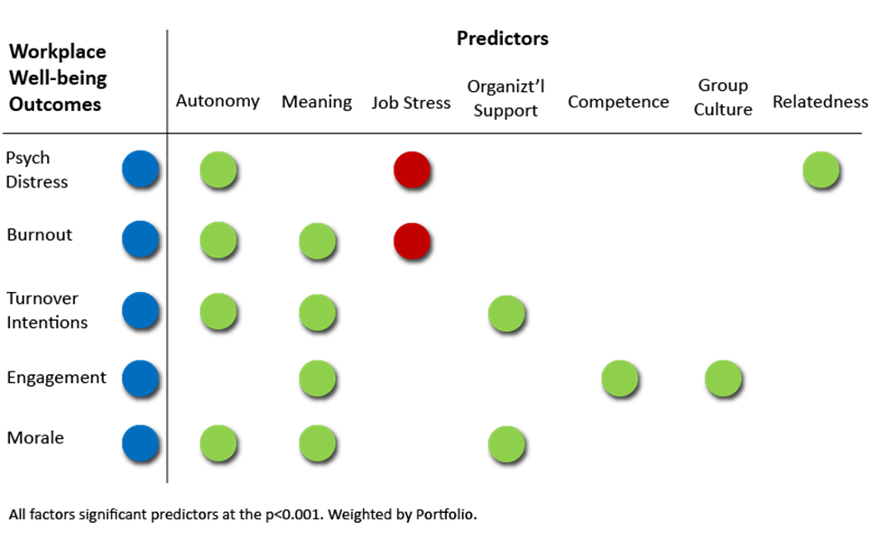

For example, to reduce levels of **Burnout** at ESDC, Figure 2 suggests **paying close attention** to **two job resources** – **Autonomy** and **Meaning** – and **one job demand** – **Job Stress**. It doesn’t mean we ignore the other factors, but this gives us a place to start.

Departmentally, two factors appear as strong predictors in almost every outcome: Autonomy and Meaning. These findings are consistent with other research which points to the critical importance of autonomy, competence and relatedness to workplace well-being.[12] In essence, by strengthening these two workplace factors *alone*, there is a strong likelihood that well-being outcomes will improve.

Figure 2: Model of Main Predictors for Each Workplace Outcome, ESDC

The top three predictors for each of the five outcomes are represented in the figures below. The outcome of interest is in blue in the middle of each figure, and the three strongest predictors (either job demands or job resources) are on the outside. In these figures, job resources are in green, and job demands are in red.

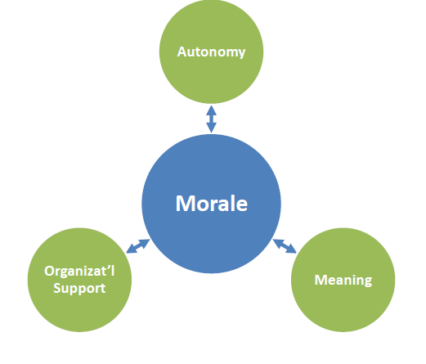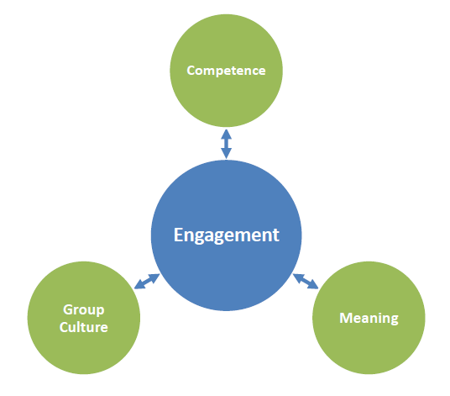

**Morale** is most strongly predicted by Autonomy, Meaning, and Organizational Support**.**

**Engagement** is most strongly predicted by Competence, Meaning, and Group Culture.

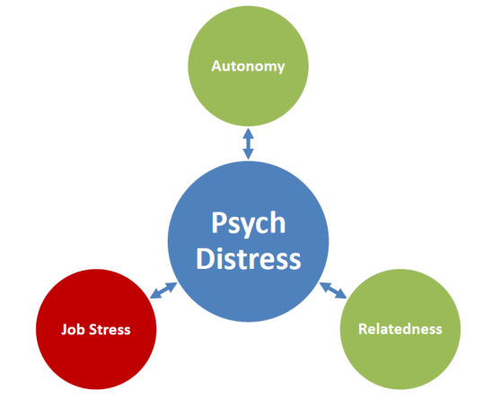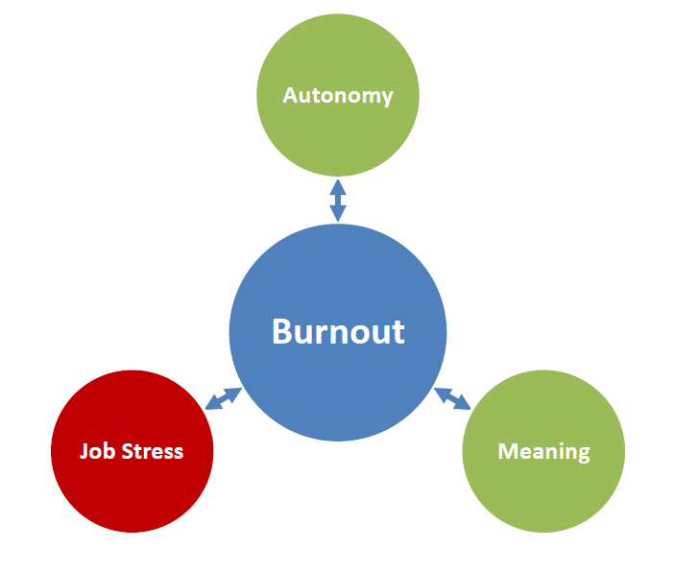

**Burnout** is most strongly predicted by Autonomy, Meaning, and Job Stress.

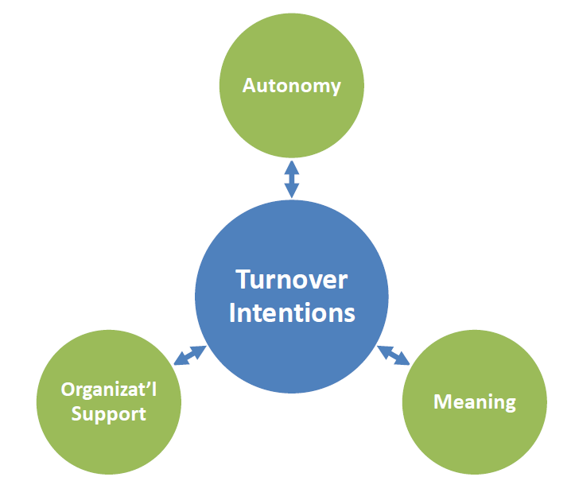

Riskfor **Psychological Distress** is most strongly predicted by Autonomy, Relatedness, and Job Stress.

**Turnover** **Intentions** are most strongly predicted by Autonomy, Meaning, and Organizational Support**.**

## Workplace Well-being Groups: Who is Most At-Risk?

An in-depth analysis identified four distinct respondent groups at ESDC based on their workplace well-being outcome scores: An At-Risk group (17%), a Functioning group (43%), Thriving Movers (25%) and Thriving Stayers (15%) (see Figure 3).

Both groups of **thriving** employees have the healthiest scores on each of the five workplace well-being outcomes; where they differ is in their intentions to leave. Although their turnover intentions remain lower than average, the **Thriving Movers** may still be more likely to consider job opportunities outside of ESDC relative to the **Thriving Stayers**. The **Thriving Movers** report considerably less meaning at work compared to the **Thriving Stayers**; NCR-based males have greater odds of thriving and moving (vs. thriving and staying with the organization (see Figure 3).

Figure 3: Segments of the ESDC Workforce

Employees in the **Functioning** group have **moderate scores** on all **workplace well-being outcomes**, and can be considered to occupy the zone of ‘moderate concern’. The **Functioning** group is comprised of employees representing a range of demographic characteristics, with the exception of employees located in Quebec (see Figure 3).

The **At-Risk** group shows the **lowest levels of engagement and morale**, the **highest levels of burnout and psychological distress**, and the **greatest intentions to leave**. Of note, this group is, on average, at high risk for meeting the clinical threshold for an anxiety or depressive disorder (see Figure 4).

### The “At-Risk” Group: Main Drivers and Demographic Information

Additional analysis was done to isolate the key workplace factors correlated with membership in the At-Risk group. The **following top five factors increase the odds of being at risk** (vs. functioning or thriving): (1) lower levels of autonomy, (2) less meaningfulness at work, (3) elevated levels of job stress, (4) less organizational support, and (5) a reduced sense of belonging. Belonging to *any one* of the following sub-populations increases an individual’s odds of being in the At-Risk group (odds in brackets):

* Non-supervising/managing employees: (1.5 times)
* Citizen-facing: (1.3 times)
* Mid-career (11-15 years of service): (2.0 times)

**Figure 4: Average Scores for each Workplace Outcome**

* Younger than 35: (between 1.5 and 2.3 times)

# Suggested Areas for Action

The following section provides examples of how to address the main areas of concern for ESDC as a whole by tackling individual or correlated workplace factors together. Actions discussed are examples for inspiration, and are not intended as required for all areas of the department. Every team within ESDC is unique, with its own work environment, strengths and challenges. Leaders at all levels are encouraged to consider these results, other survey findings, and their existing knowledge of the organization to create integrated actions plans going forward.

* **Take a targeted approach.** Understanding key drivers affecting workplace well-being outcomes can assist leaders to identify more precise responses. At the same time, there may be creative ways to improve workplace well-being outcomes by strengthening workplace factors of concern that may *not* be key predictors. This is because the workplace is a dynamic environment, and job demands, resources and workplace well-being outcomes are all interconnected. Finally, sometimes the way to address an area of challenge is to leverage an area of strength; and often, efforts in one area can have positive ripples into several others.
* *Start with key predictors.*
* *Tackle areas of challenge.*
* *Leverage areas of strength.*
* *Create integrated responses.*
* **Align actions to the source of the challenge within the organization.** As a ‘quick reference’, Figure 5 below maps the information from page 6 by **job demand**, **job resource**, or **workplace outcome**. Measures receiving a green check mark on page 6 are placed in the green ‘row’; measures receiving a yellow caution are placed in the yellow ‘row’; and measures receiving a red exclamation mark are placed in the red ‘row’. This figure also shows that job resources are measured at different ‘levels’. The WMH Survey includes measures of resources at the individual, team, leader, or organizational levels. When we think about workplace areas of concern, either job demands or resources, we need to ask: are they a characteristic of individuals, teams, leaders, or the organization itself? When identifying responses to workplace challenges, we need to match the response to the level of the workplace challenge.

*When identifying responses to* *workplace challenges, we need to match the response to the source of the workplace challenge.*

For example, if the root cause of unhealthy workloads is inefficient organizational processes or procedures, it is unlikely that sending individuals on training can resolve the challenge. Instead, the response might be to do an assessment that considers the needs of clients, business objectives, and employee psychological health and safety, and introduce process changes that support employee workplace well-being without compromising productivity objectives. (On the other hand, if a process or procedure is very well designed, but individual users do not know how to use it, sending employees on training could be an appropriate response.)

Figure 5: Mapping Actions Related to Job Demands, Resources and Outcomes by Level of Concern

|  |  |  |  |  |  |  |  |  |
| --- | --- | --- | --- | --- | --- | --- | --- | --- |
|  | **Workplace Factors** | **Job Demands** | **Job Resources** | | | |  | **Outcomes** |
| **Individual** | **Team** | **Leader** | **Organization** |  |
| **Concern Level** | No | Work-family Conflict | Meaning  Competence | Relatedness  Psychological Safety  Civility and respect | Role Clarity |  |  | Engagem’t |
| Moderate | Workload |  |  | Leadership | Group Culture  Organiz’l Support |  | Morale Turnover Intentions |
| High | Job Stress | Autonomy  Impact |  | Recognition |  |  | Burnout  Psych’l Distress |

* **Use combined “top down” and “bottom up” approach.** Current research categorizes workplace interventions as “top-down” (or strategic) and “bottom-up” (or proactive). Both approaches are found to increase employee engagement, well-being, and job performance.[13] **Strategic** interventions through Human Resource Management and transformational leadership initiatives can foster employee engagement. This can have an important system-level impact on the organization and its employees by supporting a healthy work environment. **Proactive** approaches encourage employees to take the initiative to develop and/or mobilize existing resources, with the result that employees are healthier and more productive.

## Workload & Job Stress

Workload management and feelings of job stress can vary from one employee to another. Individual employees and their managers have a joint responsibility to discuss priorities, and to make sure each is working as effectively as possible. At the same time, challenges with workload management and job stress can be related to the way that work is organized, processed, and distributed. To address these sources of excessive workload and job stress, changes need to be made at the organizational level.

* **Proactive**: Make training available for those individuals who have difficulty prioritizing or managing their work. Include training for both employees and managers so that together, they can do their part to manage workloads in a healthy way.
* **Strategic:** Examine *organizational* *sources* of workplace job demands, specifically workload and job stress.
* Where practical, consider reducing organizational obstacles to productivity (e.g. excessive approval stages), and ensure there is enough time to successfully complete assigned tasks. Lessening excessive workload in this way might also help improve job stress, as well as perceptions of leadership and organizational support, employees’ morale, and symptoms of burnout.
* To tackle job stress directly, look at processes and deadlines: are there changes that could be made – such as removing Friday deadlines – that could have a positive impact on employees’ stress levels? Are there adjustments to processes that could eliminate duplication of effort and tasks?

## Psychological Needs at Work (Autonomy & Impact)

Well-being in the workplace is primarily driven by the satisfaction of psychological needs at work (autonomy, competence, meaning and relatedness). Creating a work environment where employees can satisfy their psychological work needs could increase well-being, and help mitigate some of the negative effects of excessive job demands.

* **Proactive:** Provide employees with opportunities for greater involvement in key decisions that affect their work, control over how they organize their priorities, and, where possible, how they conduct their work. Engaging in regular discussions with employees about workload, and how processes could be streamlined to be more efficient, can also enhance employees’ sense of autonomy and impact. Ultimately, such actions could decrease workload and job stress and positively impact their sense of competence, perceptions of organizational support, as well as their morale, and overall well-being.
  + For example, **job crafting** is one way of working with an employee to enhance job resources and healthy job demands, and decrease negative demands. Managers can work with employees to proactively choose tasks and/or job content according to their strengths and interests (where possible). By supporting employees to take the initiative, job crafting can also increase employee engagement.
  + Every employee is different, both in terms of how much autonomy and impact they need, and the best ways of meeting these needs. By discussing existing challenges to employees’ autonomy and impact, and exploring potential responses with individuals or teams, managers can also strengthen their relationships with their direct reports.

## Leadership, Organizational Support and Group Culture

Research shows that leaders play a key role in cultivating a working environment where individuals can meet their needs for autonomy, competence, meaning and connection. Through their style of leadership and way of working with employees, leaders can influence employees’ perceptions of organizational support, psychological safety, and group culture, and as a result, enhance psychological health and safety outcomes.[14]

* **Strategic:** Consider offering training targeted to managers, supervisors and team leads specifically designed to help them build morale, and reduce burnout and psychological distress among their employees. Examples include Transformational Leadership and Psychological Needs Satisfaction training. Teams managed by participating leaders are expected to have increased morale, sense of autonomy and engagement in their work, as well as increased productivity and reduced negative behaviours (e.g., absence due to illness).

## Recognition

Recognition and rewards initiatives should include the full spectrum of official honours and awards and/or other forms of compensation for long hours worked, as well as informal ways of communicating appreciation for a job well done on a daily basis. Research shows that recognition needs to be sincere, specific, personal, positive, and timely.[15] Recognition and rewards must also be perceived to be distributed fairly.

*Recognition and rewards should be sincere, specific, personal, positive, timely, and fairly distributed.*



* **Proactive:** Consider discussing with employees what recognition means for them, and ensure that team-based recognition is reflective of their ideas. Doing so could increase perceptions of organizational support and confidence in leadership. These conversations could take the form of a mini-consultation within a team or a division; they could also take place one-on-one between managers and their direct reports during Performance Management conversations. Consider also offering employees the choice of how they would then like to be recognized: in addition to the benefits already described, doing so could enhance employees’ sense of autonomy
* **Strategic**: Become familiar with updates to the departmental Recognition Program.

# Next Steps

In addition to activities that target specific workplace factors, there are actions that leaders and employees at all levels of the organization can take to support a psychologically healthy and safe workplace. The following suggestions are offered as immediate next steps following the release of these detailed WMH survey results.

|  |  |
| --- | --- |
|  | **Individual level**   * To demonstrate their commitment to action, build trust and support transparent and meaningful conversations throughout the Department at all levels, leaders are invited to share the results of the survey with all employees. Doing so acknowledges that employees have been heard, and will foster their engagement in finding solutions and being part of the change. * Employees at all levels are encouraged to access tools and resources to manage individual workplace mental health and build resiliency. |
|  | **Team level**   * Hold discussions with senior staff to understand the WMH survey results, and reflect on what is working and what needs improvement. Include employees in discussions about how to move forward to address areas of concern. * Integrate information from WMH survey with findings from other surveys and data sources to create integrated action plans. |
|  | **Organization level**   * Empower and equip Workplace Mental Health Champions, representatives from various employee networks, and other enabling services to use WMH and other survey results to inform dialogue, discussion and action at multiple levels. Use communications to spark conversations and encourage involvement by sharing actions and lessons learned. * Find concrete opportunities to support workplace mental health throughout the department. Get familiar with WMH and other survey results, and with the next Workplace Mental Health Three-Year Action Plan (2018-2021), to help identify what branches or regions can do to address identified challenges. Commit to trying something new, be it a large change or something smaller. |

# Annex A: Description of UMP V2.0 Variables and Associated Scales[16]

## Demands

**Workload**. It is important for employees to feel that their assigned tasks can be accomplished successfully within the time available. Otherwise, evidence suggests that too much work can exhaust their energy and result in burnout.[17] Participants were instructed to rate statements pertaining to their workload management by using a 7-point scale ranging from 1 = *Never* to 7 = *Always*. A sample item reads, “*I cannot ever seem to catch up.*”

**Work-Family Conflict**. It is important for employees to have balance between their work and personal lives. Over time, work-to-life conflict can lead to turnover intentions as well as to mental health problems such as burnout and depression.[18] Participants were asked to respond to statements related to work-to-family conflict by using a 7-point scale ranging from 1 = *Strongly disagree* to 7 = *Strongly agree*. A sample item reads, “*The amount of time my job takes up makes it difficult to fulfill family responsibilities.*”

**Job Stress**. Employees face many demands in the workplace, some of which can be experienced as healthy (growth-related), while others can be experienced as stressful and negatively impact their psychological health.[19] These stressors may stem from their job, such as rest periods, time pressure, and hours of work. To assess the level of stress that participants experience at work, they were asked to indicate if given words and statements described their job by using a 3-point scale including 0 = *No*, 1 = *Not Sure*, and 2 = *Yes*. A sample item reads, “*More stressful than I’d like.*”

## Resources

### Job Resources

**Meaning.** Meaning in the workplace refers to the value attributed to one’s job derived from personal beliefs, attitudes and values[20]. Having meaningful work is believed to be a critical element in fostering work motivation and productivity, contributing to job satisfaction and lower absenteeism and turnover[21]. To assess participants’ perceptions of meaning in their work[22], they were asked to rate their level of agreement with three statements by using a 5-point agreement scale ranging from 1 = *Totally disagree* to 5 = *Totally agree*. A sample item reads, “*The work I do is very important to me*.”

**Autonomy**. Autonomy refers to an employee’s desire to be in control of their own work and act in harmony with their integrated self. When employees’ needs for autonomy are met, they experience greater job satisfaction and fewer symptoms of distress (e.g., fewer symptoms of burnout and anxiety).[23] Participants were asked to rate their level of agreement with statements relating to autonomy by using a 5-point scale ranging from 1 = *Totally disagree* to 5 = *Totally agree*. A sample item reads, “*I feel free to do my job the way I think it could best be done.*”

**Impact**. Impact reflects the degree to which employees feel they can make contributions to decision making. Participants were asked to rate their level of agreement with statements pertaining to impact by using a 5-point scale ranging from 1 = *Strongly disagree* to 5 = *Strongly agree*. A sample item includes, “*I have a great deal of control over what happens in my department.”*

**Competence**. In the workplace, competence is an individual’s passion toward controlling a task or a project’s outcome and their experience toward mastery of their work. Feeling competent at work is another key determinant of psychological health; competence is associated with greater job satisfaction and reduced strain.[24] Participants were asked to rate their level of agreement with statements relating to their competence at work by using a 5-point scale ranging from 1 = *Totally disagree* to 5 = *Totally agree*. A sample item reads, “*I am good at the things I do in my job.*”

### Team Resources

**Relatedness**. Relatedness in the workplace refers to the individual’s desire to interact, be connected to, and experience the relational benefits of being part of something larger than one’s self. Feeling supported by others in the workplace can improve resilience by mitigating the adverse effects of workplace stressors on mental health.[25] Participants were asked to assess the extent to which they feel connected to the people they work with by rating their level of agreement with statements pertaining to perceived social support using a 5-point scale ranging from 1 = *Totally disagree* to 5 = *Totally agree*. A sample item reads, “*At work, I can talk with people about things that really matter to me.*”

**Psychological Safety**.Psychological safety, or protection, refers to apsychologically safe work environment where employees feel that they can take risks (e.g. offering opinions and asking questions) without fear of retribution or ridicule. Research has shown that working in a psychologically safe work environment is associated with a number of positive outcomes, including psychological well-being.[26] Participants were asked to rate statements relating to team psychological safety by using a 7-point scale ranging from 1 = *Very inaccurate* to 7 = *Very accurate*. A sample item reads, “*Members of this team are able to bring up problems and tough issues.*”

**Civility and Respect**. For good psychological health and safety, co-workers should treat each other with civility and respect. Research suggests that workplace incivility may adversely affect well-being and increase turnover intentions.[27] Participants were instructed to rate statements pertaining to the extent with which they feel treated in a civil and respectful manner by individuals in their workplace by using a 5-point scale ranging from 1 = *To a very small extent* to 5 = *To a very large extent*. A sample item reads, “*Individuals (coworkers, supervisors, etc.) treat you in a polite manner.*”

### Leader Resources

**Leadership**. Effective leadership, namely transformational leadership, is associated with enhanced performance, well-being, and mental health among subordinates. Transformational leaders tend to have a positive influence on the way their followers think about work and interpret events. Through coaching and advising, transformational leaders serve as yet another source of support that their employees can rely on for assistance in coping with work demands.[28] Participants were instructed to indicate how often their supervisor engages in transformational leadership behaviours, such as treating staff as individuals, supporting, and encouraging their development, on a 5-point scale ranging from 1 = *Rarely or never* to 5 = *Very frequently, if not always*. A sample item reads, “*My supervisor communicates a clear and positive vision of the future.”*

**Role Clarity**. Having a clear understanding of leaders’ expectations can influence subordinates’ performance and well-being. Participants responded to statements asking if they feel that their roles and expectations are clearly defined. In particular, they were asked to rate their level of agreement with statements pertaining to role clarity by using a 7-point scale ranging from 1 = *Strongly disagree* to 7 = *Strongly agree*. A sample item reads, *“I know exactly what is expected of me.*”

**Recognition and Reward**. To ensure that employees feel valued and appreciated by the organization, it is important to regularly recognize and reward their efforts. A sustained imbalance between efforts and rewards can trigger strong negative emotions that can, in turn, lead to impaired health and well-being (e.g., cardiovascular disease, burnout symptoms).[29] Participants were asked to rate their level of agreement with statements pertaining to recognition and rewards by using a 6-point scale ranging from 1 = *Disagree very much* to 6 = *Agree very much*. A sample item reads, “*When I do a good job, I receive the recognition for it that I should receive.*”

**Protection of Physical Safety[30]**. Feeling safe in one’s environment is a basic need that can impact well-being.[31] One significant determinant of how employees feel about their physical work environment is the importance their supervisor places on physical safety, as reflected through supervisors’ attitudes and behaviours pertaining to unsafe conditions. To assess protection of physical safety, two areas are assessed: *Supervisor Safety Actions* and *Supervisor Safety Expectations*. Participants were asked to rate their level of agreement with statements relating to their supervisors’ actions when confronted with safe behaviours by using a 5-point scale ranging from 1 = *Strongly disagree* to 5 = *Strongly agree*. A sample item reads, “*My supervisor says a good word whenever he sees a job done according to the safety rules.*” Participants were also asked to rate their level of agreement with statements relating to perceived supervisor attitudes toward work safety by using a 5-point scale ranging from 1 = *Strongly disagree* to 5 = *Strongly agree*. A sample item reads, “*Whenever pressure builds up, my supervisor wants us to work faster, rather than by the rules.*”

### Organization Resources

**Organizational Support**. As with social support, feeling supported by the organization can improve resilience by buffering the effects of workplace stressors on mental health.[32] Participants were asked to rate their level of agreement with statements pertaining to organizational support by using a 7-point scale ranging from 1 = *Strongly disagree* to 7 = *Strongly agree*. A sample item reads, “*The organization really cares about my well-being.”*

**Group Organizational Culture.** The term organizational culture commonly refers to the norms, values, and beliefs that an organization’s members embrace and use as behavioural and problem-solving cues. When an organizational culture is group-oriented, employees report fewer symptoms of psychological distress and experience greater well-being (e.g., feeling calm and relaxed). In this survey, an organization is assessed as having a group-oriented organizational culture when it emphasizes employee participation, cooperation, mutual trust, team spirit, learning, fulfilling work through human resource development, trust in human potential, and cohesiveness. Participants were asked to indicate to what extent several characteristics describe the culture of their organization (i.e. Branch or Service Canada region they report to) by using a 5-point scale ranging from 1 = *Not at all* to 5 = *To a great extent*. A sample item reads, “*Please indicate to what extent your organization is Being socially responsible.*”

## Outcomes

### Positive outcomes

**Morale**. Morale has been described as both an individual and group psychological phenomenon, defined as “an employee’s motivation and enthusiasm for accomplishing work objectives.”[33] Participants were asked to rate their level of agreement with statements pertaining to their morale by using a 5-point scale ranging from 1 = *Very low* to 5 = *Very high*. A sample item reads, “*Please rate your level of motivation.*”

**Engagement**. Engaged employees are energetic and passionate about their work and motivated to do their job well. As a result, many studies have found that feeling engaged at work is positively related to working safely.[34] Participants were asked read statements about how they invest their energies at work, rating their agreement with each statement using a 5-point scale ranging from 1 = *Strongly disagree* to 5 = *Strongly agree*. A sample item reads, “*I try my hardest to perform well on my job.*”

### Negative outcomes

**Job Burnout**.Burnout is characterized by exhaustion and disengagement resulting from excessive job demands and lack of resources. Burnout can result in negative psychological and behavioural outcomes such as the increased likelihood of engaging in negative safety behaviours.[35] To assess burnout, participants were asked to rate their level of agreement with statements pertaining to exhaustion and disengagement by using a 4-point scale ranging from 1 = *Strongly disagree* to 4 = *Strongly agree*. A sample item reads, “*During my work, I often feel emotionally drained.*”

**Psychological Distress**. Chronic or high intensity exposure to physical and psychological stressors in the workplace may lead employees to experience psychological distress. Participants were instructed to rate the frequency with which they experienced various symptoms of anxiety and depressive disorders (e.g., “*Feeling tired out for no good reason”*) in the four weeks preceding survey administration by using a 5-point scale ranging from 1 = *None of the time* to 5 = *All of the time*. The ten items are combined to form a total score out of 50. Scores are categorized into ranges of *High* (30-50), *Moderate* (16-29), and *Low or no* (10-15) psychological distress. Individuals with low levels of psychological distress are unlikely to require medical assistance, whereas those with high levels should consider seeking medical assistance.[36]

**Turnover Intentions**. Turnover intentions measure one’s intent to leave an organization. Turnover can be costly to organizations in terms of replacing employees (recruiting and training), and by lost productivity.[37] Participants were asked to rate their level of agreement with statements related to turnover intentions[38] by using a 5-point scale ranging from 1 = *Strongly disagree* to 5 = *Strongly agree*. A sample item reads, “*I frequently think of quitting my job.*”

# Annex B: ESDC Workplace Mental Health Survey Measures and *The Standard*

|  |  |  |
| --- | --- | --- |
| **ESDC Workplace Mental Health Survey\*** | **Source(s)** | ***Standard* Workplace Factor** |
| **Demands** |  |  |
| Reilly Role Overload* | Reilly (1982) | Workload Management |
| Stress in General Scale* | Stanton et al. (2001) | Workload Management |
| Work-Family conflict subscale of the WFCS* | Netemeyer et al. (1996) | Balance |
| **Resources** |  |  |
| ***Job*** |  |  |
| Meaning at Work Scale* | Spreitzer (1995) | Growth and Development |
| Autonomy subscale of the WRBNS* | van den Broeck et al. (2010) | Involvement and Influence |
| Impact subscale of the PES* | Spreitzer (1995) |  |
| Competence subscale of the WRBNS* | van den Broeck et al. (2010) | Psychological Competencies and Requirements |
| ***Team*** |  |  |
| Relatedness subscale of the WRBNS* | van den Broeck et al. (2010) | Psychological and Social Support |
| Team Psychological Safety scale* | Edmondson (1999) | Psychological Protection |
| Interpersonal Justice subscale of the OJS* | Colquitt (2001) | Civility and Respect |
| ***Leader*** |  |  |
| Global Transformational Leadership Scale* | Carless et al. (2000) | Clear Leadership and Expectations |
| Role Ambiguity subscale of the Role Questionnaire* | Rizzo et al. (1970) |  |
| Contingent Reward subscale of the JSS* | Spector (1985) | Recognition and Reward |
| Group Safety Climate Scale*  Supervisor’s actions toward safety Supervisor’s expectation toward safety | Zohar (2000) | Protection of Physical Safety |
| ***Organization*** |  |  |
| Survey of Perceived Organizational Support* | Eisenberger et al. (1986) | Psychological and Social Support |
| Group subscale of the Organizational Culture Profile | O’Reilly et al. (1991)  Marchand et al. (2013) | Organizational Culture |
| **Outcomes** |  |  |
| ***Positive*** |  |  |
| Job Engagement Scale* | Rich et al. (2010) | Engagement |
| Military Morale Scale* | Britt and Dickinson (2006) | N/A |
| ***Negative*** |  |  |
| Oldenberg Burnout Inventory* | Demerouti et al. (2003) | N/A |
| Kessler Psychological Distress Scale (K10) | Kessler et al. (2002) | N/A |
| Turnover Intentions* | Colarelli (1984) | N/A |

*Unit Morale Profile (UMP) v2.0 Measure, Director General Military Employees Research and Analysis (DGMPRA), the Department of National Defense.

# Annex C: Technical Details, Development and Implementation of Survey

## Development of the Survey Tool

As part of developing the Progress Evaluation Strategy, ESDC investigated survey tool options that could assist the department in establishing a workplace psychological health and safety baseline. Two tools were identified for in-depth examination: Guarding Minds@Work and the Unit Morale Profile V2.0 developed by the Department of National Defense. In collaboration with DND, a slightly modified version of the UMP V2.0 was pre-tested with a small sample of employees in December 2016. The purpose of the pre-test was to gauge whether the questions in the survey resonated with ESDC employees, to identify gaps or challenges with the survey questions and the online tool itself, and to ultimately determine whether the UMP V2.0 would meet ESDC’s baselining needs. A description of each factor and its associated scale is provided in Annex A.

## Sample Development

The sample was designed with the objective of being able to draw reliable, robust findings that could be generalizable to the organization as a whole, and secondarily, by portfolio. A target of approximately 2500 responses was set, or 10% of the Department. Several other employee surveys were deployed in and around the same time as the Workplace Mental Health Survey, including the PSEAS, Innovation Survey, employee Engagement Survey, and Pulse Survey. In order to minimize survey fatigue among employees, we chose to invite a random sample of employees to participate.

A list of employees was drawn from PeopleSoft in December, 2016, which included 25,940 names. Assuming an estimated response rate of 30%, a random sample of 8,000 names was drawn. Random numbers were generated using random.org, a random-number generator website. The sampled names were then verified and inactive names removed from the sample, with 6,957 remaining in the sample. Statistical analyses of the random sample indicate it was representative of the Department by portfolio and region.

## Survey Communications

**Broad communications**. During the pre-testing period, Department-wide communications were used to inform employees of the development of the survey, and the possibility that they might be invited to participate. Following the pre-test, a similar broad communication was used to thank respondents for their participation, and to inform all employees of the upcoming launch of the survey to a sample of employees across the Department. These communications were designed to inform employees about the specifics of the survey, and to also maintain the overall level of interest and ‘buzz’ in the *Integrated Strategy*. A similar approach was used during the dissemination of the full baseline survey, including broad communications to all employees leading up to and then following the survey, with targeted communications to survey participants during the survey period itself.

**Survey invitations.** In February 2017, a random sample of 6,957 employees representing a cross-section of classifications, business lines and regions was invited to participate in the Workplace Mental Health Survey (WMH). Although not pre-stratified, analyses show that the random sample was representative by portfolio and geographic location. Invitations to participate were distributed in two batches or ‘waves’[39]. Those invited were sent weekly reminders to complete the survey, and both waves were accorded one supplementary week. Some tailoring of invitations was done to support the participation of sectors of the Department that were found to be lagging based on their distribution within the Department.

**Factors affecting participation**. A number of contextual factors have been identified that may have impacted the participation rate. Some negative factors include:

* Large number of surveys in the field at the same time;
* March Break;
* Generalized disruption due to Phoenix;
* Unfamiliarity with the Survey, and concerns related to safeguarding of privacy, evidenced by questions / concerns submitted through the Generic Inbox;
* Lack of confidence in Senior Leaders’ commitment to action to improve workplace culture, and associated cynicism, as expressed in a small number of emails to the Generic Inbox.

By contrast, other factors may have supported participation:

* Belief in the importance of the topic of psychological health and safety in the workplace, indicated by close to 50 requests to participate by employees who were not selected into the random sample;
* Strong communications within portions of the organization encouraging all invited employees to take the opportunity and have their voice heard.

## Response Rate and Description of Survey Respondents

The questionnaire was divided into two sections: the “Main” questionnaire, which included the 13 factors and outcomes questions; and the “demographic” questionnaire, 26 demographic questions, of which seven were optional. Of the 3,359 people who completed the Main questionnaire, 219 (6.5%) exited the survey and didn’t complete *any* demographic questions. This response rate is comparative to those obtained by surveys conducted around the same time: the 2017 Public Service Employee Annual Survey (52%), and the 2017 Association of Professional Executives survey (48%).

|  |  |
| --- | --- |
| Table 5: Overall Response Rate of 48% |  |
|  | **Number** |
| Total number of employees in Department | 25,940* |
| Number of employees invited to complete the Workplace Mental Health Survey | 6,957 |
| Number of employees who completed the Workplace Mental Health Survey | 3,359 |
| Response Rate | 48% |

Survey data is weighted to adjust for the differences in under- and over-representation by Portfolio among Survey Respondents. Weighting the data by Portfolio increases our confidence in being able to draw departmental conclusions that are representative of each of these three business lines. The Table below displays the distribution by Portfolio for Survey Respondents compared and the Department as a whole. At the departmental level, survey results are considered accurate to plus or minus 1.6 percent, based on a 95% confidence level.

Statistical tests show that survey respondents are not statistically representative of the Department as a whole, but are nonetheless very similar according to several demographic characteristics. For example, consistent with all ESDC employees, a majority of respondents are female (71.6%), English-speaking (64.1%), of Indeterminate status (76.3%) and between 35 and 54 years of age (17.2%). On the other hand, survey respondents differ from all ESDC employees in other ways. There are fewer Supervisors or Managers, fewer respondents located in the National Capital Region (NCR), and a greater proportion providing service directly to the public. To support generalizability of departmental findings, survey data is weighted by Portfolio. Please see Annex C for a detailed description of the sampling approach and characteristics of survey respondents.

## Limitations

As with all applied research, there are limitations to the validity of the findings.

* The results of the survey reflect a snapshot in time, and reflect respondents’ attitudes and beliefs at the time of survey completion. These may have been influenced by contextual factors that can change over time, both within the organization as well as within the world around them (e.g., policies, procedures, leadership, and traumatic events). Key considerations for the survey deployment in 2017 include the impact of implementing large-scale systems changes (e.g. Phoenix pay system, PeopleSoft, Saba) as well as organizational restructuring (e.g. Passport Canada, PPSB transformation); the simultaneous distribution of several other surveys (e.g. Public Service Annual Employee Survey, Innovation Survey, Employee to Manager Feedback Questionnaire); an ambitious government agenda; as well as events in the wider world.
* Finally, this is the first time the Workplace Mental Health Survey has been administered at ESDC, and analysis is ongoing to continue to examine the robustness and applicability of the tool to the needs and realities of the Department. Nonetheless, results indicate the need for monitoring or improvement in several areas, as well as the need to continue to engage in open and curious conversations at all levels of the organization in order to sustain areas of strength.

## A Note on Interpreting the Findings

Confidence in the generalizability of findings from survey respondents to the departmental and portfolio populations is high, and the terms respondents and employees are often used interchangeably for ease of reporting. Nevertheless, caution should be used when interpreting data within some demographic characteristics in particular. Readers are reminded that behind the report’s numbers are real ESDC employees who took the time to share their experiences of the workplace – experiences which help shine the light on individual and collective strengths, as well as critical areas for improvement.

Table 6: Distribution of Survey Respondents by Portfolio and Department Overall

|  |  |  |
| --- | --- | --- |
| **Portfolio** | **Department Overall** | **Survey Respondents** |
| Employment Social Development | 25.0% | 23.1% |
| Service Canada | 72.3% | 74.1% |
| Labour Program | 2.7% | 2.9% |

Table 7: Distribution of Survey Respondents by Branch, Region (unweighted)

|  |  |  |
| --- | --- | --- |
| **Branch/Region** | **N** | **%** |
| **TOTAL** | **3,140** | **100** |
| **Employment Social Development** |  |  |
| Chief Financial Officer | 91 | 2.9 |
| Corporate Secretariat | 24 | 0.8 |
| Human Resources Services | 129 | 4.1 |
| Income Security and Social Development | 76 | 2.4 |
| Innovation, Information, and Technology | 198 | 6.3 |
| Learning | 52 | 1.7 |
| Public Affairs and Stakeholder Relations | 18 | 0.6 |
| Skills and Employment | 76 | 2.4 |
| Strategic and Service Policy | 46 | 1.5 |
| Other (Internal Audit, Legal, Policy Horizons) | 13 | 0.4 |
|  |  |  |
| **Service Canada** |  |  |
| Benefits Delivery Services | 565 | 18.0 |
| Citizen Service - National Headquarters | 55 | 1.8 |
| Integrity Services - National Headquarters | 64 | 2.0 |
| Program Operations - National Headquarters | 53 | 1.7 |
| Service Canada Atlantic Region | 192 | 6.1 |
| Service Canada Quebec Region | 500 | 15.9 |
| Service Canada Ontario Region | 345 | 11.0 |
| Service Canada Western and Territories Region | 461 | 14.7 |
| Transformation and Integrated Service Management | 90 | 2.9 |
|  |  |  |
| **Labour Program** |  |  |
| Compliance, Operations, and Program Development | 76 | 2.4 |
| Policy, Dispute Resolution, and International Affairs | 15 | 0.5 |

Note: Some Branches/Regions omitted due to low counts.

| Table 8: ESDC Employee Demographic Information (unweighted) | | | |
| --- | --- | --- | --- |
| **Variable** |  | **Count (N)** | **Valid %** |
| **Gender** | Male | 791 | 28.4 |
|  | Female | 1990 | 71.6 |
| **Age Category** | 24 years and under | 77 | 2.8 |
|  | 25-29 | 203 | 7.4 |
|  | 30-34 | 297 | 10.9 |
|  | 35-39 | 406 | 14.9 |
|  | 40-44 | 401 | 14.7 |
|  | 45-49 | 447 | 16.4 |
|  | 50-54 | 469 | 17.2 |
|  | 55-59 | 290 | 10.6 |
|  | 60 years and older | 141 | 5.2 |
| **First Official Language** | English | 2014 | 64.1 |
|  | French | 1126 | 35.9 |
| **Geographical Location** | National Capital Region (NCR) | 813 | 25.9 |
|  | Ontario (excluding NCR) | 631 | 20.1 |
|  | Quebec (excluding NCR) | 583 | 18.6 |
|  | Western and Territories Region | 796 | 25.4 |
|  | Atlantic Region | 317 | 10.1 |
| **Employee Status** | Indeterminate | 2393 | 76.3 |
|  | Term | 647 | 20.6 |
|  | Casual | 67 | 2.1 |
|  | Other | 29 | 0.9 |
| **Employee Type** | Supervisor, Manager | 501 | 16.0 |
|  | Other Employee | 2639 | 84.0 |
| **Years of Public Service** | Under a year | 205 | 7.0 |
|  | 1-2 years | 285 | 9.8 |
|  | 3-5 years | 240 | 8.2 |
|  | 6-10 years | 702 | 24.1 |
|  | 11-15 years | 436 | 15.0 |
|  | 16-20 years | 427 | 14.6 |
|  | More than 20 years | 621 | 21.3 |
| **Citizen-Facing** | Yes | 1389 | 44.2 |
|  | No | 1751 | 55.8 |
| **Visible Minority Status** | Yes | 408 | 14.8 |
|  | No | 2355 | 85.2 |
| **Persons with Disability Status** | Yes | 239 | 8.6 |
|  | No | 2543 | 91.4 |
| **Aboriginal Status** | Yes | 106 | 3.8 |
|  | No | 2671 | 96.2 |
| **LGBTQ* Status** | Yes | 122 | 4.4 |
|  | No | 2642 | 95.6 |
|  |  |  |  |

# Annex D: How Means are Classified into No, Moderate or High Concern

Means are classified into No, Moderate or high Concern by applying rational cut-offs based on scale anchors in the Table below.

Table 9: Mean Cut-offs for Classification into Concern Categories

|  |  |  |  |  |
| --- | --- | --- | --- | --- |
|  |  | * No concern | * Moderate concern | * High concern |
| **Resources and positive outcomes** | |  |  |  |
| 7-point scales | * Psychological Safety * Role Clarity * Organizational Support | 4.50 – 7.00 | 3.51 – 4.499 | 1.00 – 3.509 |
| 6-point scale | * Recognition & Reward | 4.00 – 6.00 | 3.01 – 3.999 | 1.00 – 3.009 |
| 5-point scales | * Meaning * Autonomy * Impact * Competence * Relatedness * Civility and respect * Leadership * Supervisor Safety Behaviours * Supervisor Safety Expectations * Group Culture * Engagement * Morale | 3.50 – 5.00 | 2.51 – 3.499 | 1.00 – 2.509 |
| **Demands and negative outcomes** | |  |  |  |
| 7-point scales | * Workload * Work-Family Conflict | 1.00 – 3.509 | 3.51 – 4.499 | 4.50 – 7.00 |
| 5-point scale | * Turnover Intentions | 1.00 – 2.509 | 2.51 – 3.499 | 3.50 – 5.00 |
| 4-point scale | * Burnout | 1.00 – 2.249 | 2.25 – 2.759 | 2.76 - 4.00 |
| 3-point scale (0-2) | * Job Stress | 0.00 – 0.509 | 0.51 – 1.499 | 1.50 – 2.00 |
| Psych distress | * Psychological Distress | 10 - 15 | 16 - 29 | 1. - 50 |

*Note*: High means on resources (e.g., relatedness) and positive outcomes (e.g., engagement) result in *no concern*, whereas high means on demands (e.g., workload) and negative outcomes (e.g., burnout) result in *high concern*.

# Annex E: Additional Reference Tables

The following table was used to create Figure 1 on page 4 above.

Table 10: Workplace Factor Scale Means and Percentage of ESDC Employees in the No Concern, Moderate, and High Concern Categories by Workplace Measure

|  |  |  |  |  |
| --- | --- | --- | --- | --- |
| ***Workplace Well-Being Factors*** |  | **Concern Level (%)** | | |
| **Means** | * **No** | * **Moderate** | * **High** |
| **Demands** |  |  |  |  |
| Workload | 3.74 | 45 | 26 | 28 |
| Work-Family Conflict* | 2.96 | 62 | 15 | 23 |
| Job Stress | 1.07 | 27 | 38 | 35 |
| **Resources** |  |  |  |  |
| Meaning* | 3.76 | 66 | 23 | 11 |
| Autonomy | 3.08 | 36 | 40 | 24 |
| Impact | 2.59 | 18 | 34 | 47 |
| Competence | 4.01 | 85 | 12 | 4 |
| Relatedness | 3.56 | 62 | 25 | 14 |
| Psychological Safety | 4.89 | 64 | 23 | 13 |
| Civility/Respect | 4.04 | 80 | 14 | 6 |
| Leadership | 3.48 | 57 | 20 | 23 |
| Role Clarity | 5.14 | 75 | 12 | 13 |
| Recognition | 3.38 | 35 | 23 | 42 |
| Supervisor Safety Behaviours | 3.13 | 26 | 62 | 12 |
| Supervisor Safety Expectations | 3.55 | 51 | 42 | 8 |
| Organizational Support | 4.33 | 48 | 22 | 30 |
| Group Culture | 3.37 | 48 | 35 | 17 |
| **Outcomes** |  |  |  |  |
| Morale | 3.32 | 48 | 35 | 18 |
| Engagement* | 3.92 | 80 | 18 | 3 |
| Burnout | 2.52 | 31 | 37 | 32 |
| Psychological Distress | 21.28 | 28 | 56 | 17 |
| Turnover Intentions | 2.45 | 56 | 24 | 20 |
| Notes: Differences are statistically significant at p<0.05 or better, **except** for work-family conflict, meaning and engagement as indicated by *. Weighted by Portfolio. **Concern percentages are subject to rounding. | | | | |

The following table is summarized on page 6 above.

Table 11: Workplace Factor Scale Means and Percentage of ESDC Employees in the No Concern, Moderate, and High Concern** Categories by Portfolio

|  |  |  |  |  |  |  |  |  |  |  |  |  |
| --- | --- | --- | --- | --- | --- | --- | --- | --- | --- | --- | --- | --- |
|  | **ESD** | | | | **SC** | | | | **LP** | | | |
| ***Workplace Well-Being Factors*** |  | **% Concern** | | |  | **% Concern** | | |  | **% Concern** | | |
| **Mean** | **No** | **Mod.** | **High** | **Mean** | **No** | **Mod.** | **High** | **Mean** | **No** | **Mod.** | **High** |
| **Demands** |  |  |  |  |  |  |  |  |  |  |  |  |
| Workload | 3.64 | 49 | 27 | 24 | 3.76 | 44 | 27 | 29 | 4.03 | 41 | 18 | 41 |
| Work-Family Conflict | 2.83 | 65 | 14 | 20 | 3.00 | 61 | 15 | 24 | 3.17 | 60 | 12 | 29 |
| Job Stress | 0.89 | 37 | 40 | 24 | 1.13 | 24 | 37 | 39 | 1.15 | 24 | 38 | 39 |
| **Resources** |  |  |  |  |  |  |  |  |  |  |  |  |
| Meaning* | 3.77 | 67 | 22 | 11 | 3.75 | 65 | 24 | 11 | 3.96 | 75 | 14 | 11 |
| Autonomy | 3.23 | 44 | 38 | 18 | 3.04 | 33 | 41 | 26 | 3.03 | 40 | 33 | 27 |
| Impact | 2.83 | 27 | 35 | 39 | 2.50 | 15 | 34 | 51 | 2.80 | 23 | 42 | 35 |
| Competence | 4.12 | 90 | 8 | 2 | 3.98 | 83 | 13 | 4 | 4.00 | 82 | 15 | 2 |
| Relatedness | 3.67 | 67 | 22 | 11 | 3.53 | 60 | 26 | 15 | 3.48 | 61 | 20 | 19 |
| Psychological Safety | 5.16 | 73 | 17 | 10 | 4.81 | 62 | 25 | 14 | 4.66 | 58 | 19 | 24 |
| Civility/Respect | 4.16 | 82 | 13 | 5 | 4.01 | 80 | 14 | 7 | 3.83 | 67 | 24 | 9 |
| Leadership | 3.66 | 65 | 17 | 18 | 3.42 | 55 | 21 | 24 | 3.38 | 57 | 16 | 27 |
| Role Clarity* | 5.08 | 72 | 13 | 15 | 5.17 | 77 | 12 | 12 | 4.96 | 68 | 17 | 15 |
| Recognition | 3.74 | 46 | 23 | 32 | 3.25 | 31 | 23 | 46 | 3.49 | 45 | 14 | 41 |
| Supervisor Safety Behaviours* | 3.18 | 25 | 66 | 10 | 3.12 | 26 | 62 | 13 | 3.17 | 33 | 50 | 17 |
| Supervisor Safety Expectations* | 3.56 | 50 | 44 | 6 | 3.55 | 51 | 41 | 8 | 3.56 | 50 | 40 | 10 |
| Organizational Support | 4.66 | 57 | 19 | 25 | 4.22 | 45 | 23 | 33 | 4.42 | 55 | 17 | 28 |
| Group Culture | 3.55 | 55 | 34 | 12 | 3.32 | 46 | 36 | 18 | 3.17 | 42 | 29 | 30 |
| **Outcomes** |  |  |  |  |  |  |  |  |  |  |  |  |
| Morale | 3.41 | 51 | 34 | 15 | 3.30 | 46 | 35 | 19 | 3.28 | 48 | 31 | 21 |
| Engagement* | 3.95 | 80 | 18 | 2 | 3.91 | 79 | 18 | 3 | 3.96 | 82 | 13 | 5 |
| Burnout | 2.41 | 37 | 38 | 24 | 2.56 | 28 | 37 | 35 | 2.42 | 38 | 33 | 29 |
| Psychological Distress | 20.33 | 32 | 52 | 16 | 21.63 | 26 | 57 | 17 | 20.66 | 32 | 54 | 14 |
| Turnover Intentions | 2.52 | 53 | 25 | 22 | 2.41 | 58 | 23 | 19 | 2.69 | 44 | 32 | 25 |

Notes: Differences are statistically significant at p<0.05 or better on all measures **except** meaning, role clarity, safety behaviours and expectations, and engagement as indicated by*. **Concern percentages are subject to rounding.

The following tables are summarized on pages 7-8 above.

Table 12: Workplace Factor Scale Means by Geographic Location

|  |  |  |  |  |  |  |
| --- | --- | --- | --- | --- | --- | --- |
|  | | **Geographic Location** | | | | |
| ***Workplace Well-Being Factors*** | | **NCR** | **ON (excl NCR)** | **QC (excl NCR)** | **WT** | **AT** |
| **Demands** | |  |  |  |  |  |
|  | Workload | 3.60 | 3.80 | 3.60 | 3.93 | 3.73 |
|  | Work-Family Conflict* | 2.77 | 3.05 | 2.75 | 3.35 | 2.76 |
|  | Job Stress | 0.89 | 1.17 | 1.07 | 1.19 | 1.11 |
| **Resources** | |  |  |  |  |  |
|  | Meaning | 3.75 | 3.67 | 3.96 | 3.64 | 3.90 |
|  | Autonomy | 3.24 | 2.92 | 3.19 | 2.94 | 3.15 |
|  | Impact | 2.87 | 2.27 | 2.99 | 2.26 | 2.55 |
|  | Competence | 4.12 | 3.98 | 4.09 | 3.90 | 3.93 |
|  | Relatedness | 3.68 | 3.43 | 3.75 | 3.40 | 3.55 |
|  | Psychological Safety | 5.18 | 4.60 | 5.05 | 4.68 | 4.91 |
|  | Civility/Respect | 4.14 | 3.84 | 4.26 | 3.94 | 4.04 |
|  | Leadership | 3.64 | 3.35 | 3.56 | 3.35 | 3.48 |
|  | Role Clarity* | 5.05 | 5.14 | 5.15 | 5.21 | 5.23 |
|  | Recognition | 3.77 | 3.06 | 3.41 | 3.16 | 3.46 |
|  | Supervisor Safety Behaviours | 3.18 | 3.00 | 3.35 | 3.02 | 3.14 |
|  | Supervisor Safety Expectations | 3.51 | 3.48 | 3.70 | 3.48 | 3.64 |
|  | Organizational Support | 4.73 | 3.92 | 4.44 | 4.10 | 4.46 |
|  | Group Culture | 3.50 | 3.18 | 3.53 | 3.25 | 3.45 |
| **Outcomes** | |  |  |  |  |  |
|  | Morale | 3.40 | 3.22 | 3.45 | 3.22 | 3.36 |
|  | Engagement | 3.93 | 3.85 | 4.10 | 3.83 | 3.97 |
|  | Burnout | 2.40 | 2.62 | 2.48 | 2.62 | 2.50 |
|  | Psychological Distress | 20.09 | 21.80 | 21.77 | 21.93 | 20.93 |
|  | Turnover Intentions | 2.62 | 2.42 | 2.23 | 2.55 | 2.20 |

Note. All differences are statistically significant at the p<0.001,**except** for work-family conflict and role clarity as indicated by *. Post-Hoc tests for specific differences were also done using Bonferroni and Games-Howell and are available upon request. Weighted by portfolio.

Table 13: Workplace Well-Being Factors by Geographic Location

| ***Workplace Well-Being Factors*** | **Concern %** | **NCR** | | **ON (excl NCR)** | **QC (excl NCR)** | **WT** | **AT** |
| --- | --- | --- | --- | --- | --- | --- | --- |
|  | * No | 50 | | 44 | 48 | 40 | 42 |
| Workload | * Moderate | 26 | | 25 | 26 | 27 | 30 |
|  | * High | 24 | | 31 | 26 | 33 | 28 |
|  | * No | 67 | | 60 | 70 | 52 | 65 |
| Work-Family Conflict | * Moderate | 14 | | 15 | 11 | 19 | 12 |
|  | * High | 19 | | 25 | 18 | 30 | 23 |
|  | * No | 37 | | 22 | 26 | 22 | 26 |
| Job Stress | * Moderate | 41 | | 37 | 40 | 35 | 35 |
|  | * High | 22 | | 41 | 35 | 43 | 38 |
|  | * No | 66 | | 63 | 75 | 58 | 72 |
| Meaning | * Moderate | 22 | | 24 | 19 | 29 | 19 |
|  | * High | 12 | | 13 | 6 | 13 | 9 |
|  | * No | 46 | | 28 | 41 | 27 | 35 |
| Autonomy | * Moderate | 37 | | 41 | 39 | 42 | 44 |
|  | * High | 17 | | 31 | 19 | 31 | 20 |
|  | * No | 27 | | 10 | 25 | 11 | 15 |
| Impact | * Moderate | 36 | | 29 | 48 | 26 | 36 |
|  | * High | 37 | | 61 | 27 | 63 | 49 |
|  | * No | 90 | | 84 | 88 | 80 | 79 |
| Competence | * Moderate | 8 | | 11 | 9 | 17 | 17 |
|  | * High | 2 | | 5 | 3 | 3 | 4 |
|  | * No | 68 | | 55 | 69 | 55 | 63 |
| Relatedness | * Moderate | 22 | | 30 | 22 | 26 | 20 |
|  | * High | 10 | | 16 | 9 | 19 | 16 |
| Psychological Safety | * No | 73 | | 57 | 70 | 58 | 61 |
| * Moderate | 18 | | 24 | 22 | 26 | 27 |
| * High | 9 | | 19 | 8 | 16 | 11 |
|  | * No | 83 | | 71 | 89 | 77 | 81 |
| Civility/Respect | * Moderate | 12 | | 19 | 8 | 16 | 14 |
|  | * High | 5 | | 10 | 3 | 7 | 5 |
|  | * No | 63 | | 53 | 61 | 51 | 56 |
| Leadership | * Moderate | 19 | | 20 | 19 | 22 | 21 |
|  | * High | 18 | | 27 | 20 | 27 | 23 |
|  | * No | 72 | | 75 | 77 | 77 | 77 |
| Role Clarity* | * Moderate | 13 | | 12 | 13 | 11 | 12 |
|  | * High | 15 | | 14 | 10 | 12 | 11 |
|  | * No | 47 | | 28 | 35 | 28 | 36 |
| Recognition | * Moderate | 22 | | 18 | 27 | 24 | 25 |
|  | * High | 31 | | 54 | 39 | 48 | 39 |
| Supervisor Safety Behaviours | * No | 26 | | 18 | 41 | 20 | 23 |
| * Moderate | 65 | | 64 | 51 | 66 | 66 |
| * High | 9 | | 18 | 9 | 15 | 11 |
| Supervisor Safety Expectations | * No | 49 | | 46 | 62 | 46 | 55 |
| * Moderate | 44 | | 45 | 31 | 45 | 41 |
| * High | 7 | | 9 | 7 | 9 | 5 |
| Organizational Support | * No | 59 | | 37 | 51 | 41 | 51 |
| * Moderate | 19 | | 22 | 24 | 23 | 23 |
| * High | 23 | | 41 | 26 | 36 | 26 |
|  | * No | 53 | | 40 | 56 | 41 | 53 |
| Group Culture | * Moderate | 34 | | 36 | 32 | 40 | 32 |
|  | * High | 13 | | 24 | 12 | 19 | 16 |
|  | * No | | 52 | 43 | 55 | 40 | 48 |
| Morale | * Moderate | | 33 | 33 | 32 | 39 | 35 |
|  | * High | | 15 | 23 | 13 | 21 | 17 |
|  | * No | | 79 | 77 | 88 | 74 | 83 |
| Engagement | * Moderate | | 18 | 19 | 11 | 22 | 15 |
|  | * High | | 3 | 3 | 1 | 3 | 2 |
|  | * No | | 37 | 26 | 33 | 25 | 31 |
| Burnout | * Moderate | | 38 | 34 | 39 | 38 | 36 |
|  | * High | | 25 | 39 | 28 | 38 | 33 |
| Psychological Distress | * No | | 34 | 28 | 23 | 24 | 29 |
| * Moderate | | 53 | 53 | 59 | 57 | 56 |
| * High | | 14 | 19 | 17 | 19 | 16 |
| Turnover Intentions | * No | | 50 | 58 | 64 | 52 | 65 |
| * Moderate | | 26 | 23 | 20 | 26 | 22 |
| * High | | 24 | 19 | 15 | 22 | 13 |

Notes. All differences are statistically significant at p<0.05 or better, **except** for role clarity as indicated by *. Post-Hoc tests for specific differences were also done using Bonferroni and Games-Howell and are available upon request. Weighted by portfolio. **Concern percentages are subject to rounding.

The following table is summarized on page 9 above.

Table 14: Workplace Factor Scale Means and Percentage of ESDC Employees in the No Concern, Moderate, and High Concern** Categories by Role

|  |  |  |  |  |  |  |  |  |  |  |  |  |
| --- | --- | --- | --- | --- | --- | --- | --- | --- | --- | --- | --- | --- |
|  | |  |  | **Supervisor/Manager** | | |  |  | | **Other Employee** | | |
| ***Workplace Well-Being Factors*** | | | **% Concern** | | | | |  | **% Concern** | | | |
|  |  | **Mean** | **No** | | **Moderate** | **High** | | **Mean** | **No** | | **Moderate** | **High** |
| **Demands** | |  |  | |  |  | |  |  | |  |  |
|  | Workload | 4.45 | 21 | | 31 | 48 | | 3.60 | 50 | | 26 | 24 |
| Work-Family Conflict | 3.58 | 48 | | 17 | 35 | | 2.85 | 65 | | 14 | 21 |
| Job Stress | 1.22 | 16 | | 42 | 42 | | 1.05 | 29 | | 37 | 34 |
| **Resources** | |  |  | |  |  | |  |  | |  |  |
|  | Meaning | 3.95 | 74 | | 18 | 8 | | 3.72 | 64 | | 24 | 12 |
|  | Autonomy | 3.20 | 41 | | 39 | 20 | | 3.06 | 35 | | 41 | 25 |
| Impact | 3.16 | 40 | | 35 | 25 | | 2.48 | 14 | | 34 | 52 |
| Competence* | 4.05 | 88 | | 11 | 2 | | 4.00 | 84 | | 12 | 4 |
| Relatedness | 3.74 | 70 | | 21 | 9 | | 3.53 | 60 | | 25 | 15 |
| Psychological Safety | 5.03 | 69 | | 20 | 11 | | 4.86 | 63 | | 24 | 13 |
| Civility/Respect* | 4.09 | 83 | | 12 | 5 | | 4.03 | 80 | | 14 | 7 |
| Leadership | 3.71 | 65 | | 19 | 17 | | 3.44 | 56 | | 20 | 24 |
| Role Clarity* | 5.06 | 73 | | 13 | 14 | | 5.16 | 76 | | 12 | 12 |
| Recognition | 3.58 | 39 | | 25 | 36 | | 3.34 | 34 | | 22 | 43 |
| Supervisor Safety Behaviours | 3.23 | 32 | | 61 | 8 | | 3.12 | 25 | | 62 | 13 |
| Supervisor Safety Expectations | 3.68 | 58 | | 36 | 6 | | 3.52 | 50 | | 43 | 8 |
| Organizational Support | 4.62 | 56 | | 20 | 24 | | 4.28 | 46 | | 22 | 32 |
| Group Culture | 3.55 | 57 | | 31 | 12 | | 3.34 | 46 | | 36 | 18 |
| **Outcomes** | |  |  | |  |  | |  |  | |  |  |
|  | Morale | 3.48 | 55 | | 32 | 13 | | 3.29 | 46 | | 35 | 19 |
| Engagement | 4.08 | 86 | | 13 | 1 | | 3.89 | 78 | | 19 | 3 |
| Burnout | 2.46 | 33 | | 42 | 25 | | 2.53 | 30 | | 36 | 34 |
| Psychological Distress | 20.14 | 32 | | 56 | 12 | | 21.50 | 27 | | 55 | 18 |
| Turnover Intentions* | 2.51 | 53 | | 27 | 21 | | 2.44 | 57 | | 23 | 20 |
| Notes: All differences are statistically significant at p<.05 or better, **except** for competence, civility and respect, role clarity, and turnover intentions as indicated by*. Weighted by Portfolio. **Concern percentages are subject to rounding. | | | | | | | | | | | | |

The following table is summarized on page 10 above.

Table 15: Workplace Factor Scale Means and Percentage of ESDC Employees in the No Concern, Moderate, and High Concern** Categories by Type of Job

|  |  |  |  |  |  |  |  |  |  |
| --- | --- | --- | --- | --- | --- | --- | --- | --- | --- |
|  | |  | **Citizen-Facing** | | |  | **Non-Citizen-Facing** | | |
| ***Workplace Well-Being Factors*** | | | **% Concern** | | |  | **% Concern** | | |
|  |  | **Mean** | **No** | **Moderate** | **High** | **Mean** | **No** | **Moderate** | **High** |
| **Demands** | |  |  |  |  |  |  |  |  |
|  | Workload* | 3.70 | 46 | 26 | 28 | 3.77 | 45 | 27 | 28 |
| Work-Family Conflict | 3.05 | 61 | 14 | 22 | 2.90 | 64 | 14 | 22 |
| Job Stress | 1.23 | 20 | 36 | 45 | 0.95 | 33 | 40 | 27 |
| **Resources** | |  |  |  |  |  |  |  |  |
|  | Meaning* | 3.74 | 65 | 23 | 12 | 3.78 | 66 | 23 | 11 |
|  | Autonomy | 2.95 | 28 | 42 | 30 | 3.19 | 42 | 40 | 19 |
| Impact | 2.37 | 11 | 33 | 56 | 2.76 | 24 | 35 | 41 |
| Competence | 3.97 | 83 | 12 | 4 | 4.04 | 86 | 11 | 3 |
| Relatedness | 3.48 | 59 | 24 | 17 | 3.62 | 64 | 25 | 12 |
| Psychological Safety | 4.68 | 58 | 27 | 16 | 5.05 | 69 | 20 | 11 |
| Civility/Respect | 3.99 | 78 | 15 | 7 | 4.08 | 81 | 13 | 6 |
| Leadership | 3.33 | 52 | 21 | 27 | 3.60 | 61 | 19 | 20 |
| Role Clarity | 5.24 | 79 | 11 | 11 | 5.06 | 73 | 13 | 14 |
| Recognition | 3.11 | 27 | 23 | 49 | 3.59 | 41 | 23 | 37 |
| Supervisor Safety Behaviours | 3.08 | 23 | 61 | 16 | 3.18 | 28 | 63 | 9 |
| Supervisor Safety Expectations | 3.50 | 50 | 42 | 9 | 3.59 | 52 | 41 | 6 |
| Organizational Support | 4.08 | 42 | 23 | 35 | 4.53 | 53 | 21 | 27 |
| Group Culture | 3.28 | 45 | 36 | 20 | 3.44 | 51 | 35 | 15 |
| **Outcomes** | |  |  |  |  |  |  |  |  |
|  | Morale | 3.26 | 44 | 36 | 20 | 3.37 | 50 | 34 | 16 |
| Engagement* | 3.91 | 79 | 19 | 3 | 3.94 | 80 | 17 | 3 |
| Burnout | 2.63 | 24 | 36 | 41 | 2.44 | 36 | 38 | 26 |
| Psychological Distress | 22.32 | 23 | 57 | 20 | 20.49 | 32 | 55 | 14 |
| Turnover Intentions | 2.46 | 57 | 22 | 22 | 2.44 | 56 | 25 | 19 |
|  | Notes: All differences are statistically significant at p<.05 or better, **except** for workload, meaning, and engagement as indicated by *. Weighted by Portfolio. **Concern percentages are subject to rounding. | | | | | | | | |

# Annex F: Workplace Domain Tables by Selected Demographics

For the purposes of this report, information is presented by gender, employees’ first official language, length of employment in the federal public service, disability status, Indigenous status, visible minority status, and LGBTQ* status.

General Statements: The Workplace Mental Health Survey collected information on 13 demographic characteristics. Analysis indicates that respondents with any one of the following demographic characteristics can be considered more at risk for challenging workplace well-being outcomes due to a combination of higher job demands and/or lower job resources.[40]

|  |  |
| --- | --- |
| * Women * Anglophones * Employees in the pubic service 11-15 years * Employees younger than 35[41] | * Employees with a disability * Employees identifying as belonging to a visible minority |

**Employees** with **intersecting characteristics** (e.g. who have a disability and identify as belonging to a visible minority) likely experience **amplified risks**. Due to small sample sizes it is important to recognize that these findings may not be representative of the target populations. Findings should be validated with other data sources and in collaboration with employee networks to identify areas for action.

Highlights by Gender: Respondents were asked “What is your gender?”. There are significant differences on a majority of workplace measures depending on whether an employee is male or female. Table 16 (below) presents means and percentages of ESDC employees in the no concern, moderate and high concern categories by gender.

* Female respondents report higher **job demands** than their male colleagues except for work-family conflict. A higher percentage of female respondents reports levels of moderate to high concern for both job stress (75% compared to 66% among male respondents) and workload (55% compared to 52% among male respondents).
* **Both male** and **female** employees report **healthy levels** of **job resources** on several job resources, with females experiencing significantly higher levels of meaning, relatedness, and role clarity, and males reporting significantly higher levels of competence and psychological safety. **Autonomy, impact** and **recognition** are **areas of concern** for **both males and females**, with females reporting significantly lower levels of impact relative to their male counterparts (48% high concern compared with 44% among male respondents). Female respondents also reported significantly lower levels of group culture (e.g. employee cooperation, mutual trust, team spirit, learning, and cohesiveness) (52% moderate to high concern, compared to 47% among males).
* There are **significant differences** in **four of the five** workplace well-being **outcomes** by gender, the exception being morale. **Female** respondents are **more engaged** (82% no concern compared with 76% among males) and intend to stay in the organization (60% compared with 53% among males). While a concern for all respondents, **females** are at **higher risk** for experiencing **burnout** (70% moderate to high concern compared to 65% among males). Similarly, the risk for meeting the minimum clinical threshold of an anxiety and/or depressive disorder is also higher among females (73% moderate to high concern compared to 67%).

Table 16: Workplace Factor Scale Means and Percentage of ESDC Employees in the No Concern, Moderate, and High Concern** Categories by Gender

|  |  |  |  |  |  |  |  |  |  |
| --- | --- | --- | --- | --- | --- | --- | --- | --- | --- |
|  | |  |  | **Female** |  |  |  | **Male** |  |
| ***Workplace Well-Being Factors*** | | | **% Concern** | | |  | **% Concern** | | |
|  |  | **Mean** | **No** | **Moderate** | **High** | **Mean** | **No** | **Moderate** | **High** |
| **Demands** | |  |  |  |  |  |  |  |  |
|  | Workload* | 3.73 | 46 | 26 | 29 | 3.64 | 48 | 28 | 24 |
| Work-Family Conflict | 2.96 | 63 | 14 | 23 | 2.83 | 65 | 16 | 19 |
| Job Stress* | 1.09 | 26 | 38 | 37 | 0.98 | 34 | 37 | 29 |
| **Resources** | |  |  |  |  |  |  |  |  |
|  | Meaning* | 3.81 | 68 | 23 | 9 | 3.68 | 64 | 22 | 15 |
|  | Autonomy | 3.11 | 37 | 40 | 23 | 3.10 | 37 | 40 | 23 |
| Impact* | 2.58 | 17 | 35 | 48 | 2.70 | 23 | 34 | 44 |
| Competence* | 4.00 | 84 | 13 | 4 | 4.06 | 88 | 9 | 3 |
| Relatedness | 3.60 | 63 | 24 | 13 | 3.53 | 61 | 25 | 15 |
| Psychological Safety | 4.89 | 64 | 24 | 13 | 5.00 | 68 | 20 | 12 |
| Civility/Respect | 4.05 | 80 | 14 | 6 | 4.12 | 83 | 11 | 6 |
| Leadership | 3.50 | 58 | 20 | 22 | 3.55 | 60 | 20 | 21 |
| Role Clarity* | 5.22 | 78 | 11 | 11 | 5.05 | 73 | 13 | 15 |
| Recognition | 3.39 | 35 | 23 | 42 | 3.47 | 39 | 22 | 39 |
| Supervisor Safety Behaviours | 3.12 | 25 | 61 | 14 | 3.19 | 29 | 62 | 10 |
| Supervisor Safety Expectations | 3.58 | 52 | 41 | 7 | 3.53 | 52 | 41 | 8 |
| Organizational Support | 4.37 | 48 | 22 | 30 | 4.43 | 53 | 20 | 28 |
| Group Culture* | 3.38 | 48 | 35 | 17 | 3.47 | 53 | 33 | 14 |
| **Outcomes** | |  |  |  |  |  |  |  |  |
|  | Morale* | 3.35 | 48 | 36 | 17 | 3.36 | 52 | 29 | 19 |
| Engagement* | 3.97 | 82 | 16 | 2 | 3.84 | 76 | 20 | 5 |
| Burnout* | 2.53 | 30 | 38 | 32 | 2.46 | 35 | 36 | 29 |
| Psychological Distress* | 21.42 | 26 | 56 | 17 | 20.70 | 33 | 52 | 15 |
| Turnover Intentions* | 2.36 | 60 | 23 | 18 | 2.54 | 53 | 25 | 22 |

*Notes: Differences are statistically significant p<0.05 or better. Weighted by Portfolio. **Concern percentages are subject to rounding.

Highlights by Age: Respondents were asked “What is your age group?” There are significant differences on a majority of workplace well-being measures by age category.[42] Please see Table 17 for means and Table 18 for percentages of ESDC employees in the no concern, moderate, and high concern categories by age category (below).

* Employees between the ages of <24-29 years and 60+ years report lower **job demands** than their colleagues between the ages of 30-59 years. Employees within the **45-54 year** age groups report the **highest workloads** (58% moderate to high concern) and **job stress** (76% moderate to high concern).
* There is considerable variability in **job resources** by age group:on several measures (see Table 17), resources decline with age, such as perceptions of leaders as a positive source of inspiration and change, civility and respect, group culture and organizational support. Role clarity is highest among the youngest and oldest age groups.
* In terms of **outcomes**, ESDC employees aged 60+ years reported the healthiest outcomes of any other age group. **Respondents aged <24** report the **highest levels** of **morale** (64%), second highest levels of engagement (86%) and second lowest risk for burnout (63% moderate to high concern), but also experience the **greatest psychological distress** (80% moderate to high concern). Finally, **respondents aged 30-34** experience the **highest levels of burnout** (74% moderate to high concern) and risk for psychological distress (75% moderate to high concern), as well as moderately concerning levels of morale (51%) and intent to stay in the organization (54%). These challenging outcomes can be linked to **lower levels of key resources** such as autonomy, impact, recognition and organizational support.

Table 17: Workplace Factor Scale Means by Age Category

|  |  |  |  |  |  |  |  |  |  |  |
| --- | --- | --- | --- | --- | --- | --- | --- | --- | --- | --- |
| ***Workplace Well-Being Factors*** | | **Age Category** | | | | | | | | |
|  | | **<24** | **25-29** | **30-34** | **35-39** | **40-44** | **45-49** | **50-54** | **55-59** | **60+** |
| **Demands** | |  |  |  |  |  |  |  |  |  |
|  | Workload | 2.89 | 3.35 | 3.62 | 3.72 | 3.84 | 3.78 | 3.85 | 3.75 | 3.58 |
|  | Work-Family Conflict | 2.13 | 2.51 | 2.91 | 2.97 | 3.08 | 3.02 | 3.09 | 2.88 | 2.55 |
|  | Job Stress | 0.72 | 1.00 | 1.02 | 1.05 | 1.07 | 1.08 | 1.11 | 1.10 | 1.06 |
| **Resources** | |  |  |  |  |  |  |  |  |  |
|  | Meaning | 3.71 | 3.43 | 3.64 | 3.73 | 3.67 | 3.78 | 3.91 | 3.99 | 4.08 |
|  | Autonomy | 3.36 | 3.14 | 3.06 | 3.18 | 3.09 | 3.07 | 3.06 | 3.08 | 3.17 |
|  | Impact* | 2.68 | 2.44 | 2.59 | 2.68 | 2.58 | 2.60 | 2.67 | 2.64 | 2.61 |
|  | Competence* | 4.14 | 3.91 | 4.06 | 4.00 | 3.96 | 4.03 | 4.04 | 4.07 | 4.09 |
|  | Relatedness* | 3.62 | 3.58 | 3.65 | 3.62 | 3.56 | 3.59 | 3.52 | 3.52 | 3.62 |
|  | Psychological Safety* | 5.26 | 4.99 | 4.91 | 5.02 | 4.89 | 4.89 | 4.86 | 4.85 | 4.98 |
|  | Civility/Respect | 4.39 | 4.18 | 4.16 | 4.18 | 4.11 | 4.02 | 3.99 | 3.89 | 3.90 |
|  | Leadership | 3.75 | 3.67 | 3.49 | 3.68 | 3.54 | 3.46 | 3.44 | 3.33 | 3.45 |
|  | Role Clarity | 5.38 | 5.23 | 5.06 | 5.06 | 5.05 | 5.06 | 5.31 | 5.25 | 5.55 |
|  | Recognition | 3.94 | 3.56 | 3.35 | 3.41 | 3.40 | 3.38 | 3.33 | 3.40 | 3.44 |
|  | Supervisor Safety Behaviours | 3.06 | 3.06 | 3.17 | 3.26 | 3.20 | 3.12 | 3.13 | 3.08 | 3.07 |
|  | Supervisor Safety Expectations | 3.71 | 3.63 | 3.51 | 3.60 | 3.62 | 3.51 | 3.50 | 3.57 | 3.67 |
|  | Organizational Support | 5.00 | 4.62 | 4.40 | 4.55 | 4.32 | 4.27 | 4.28 | 4.26 | 4.38 |
|  | Group Culture | 3.90 | 3.57 | 3.42 | 3.48 | 3.38 | 3.33 | 3.33 | 3.29 | 3.42 |
| **Outcomes** | |  |  |  |  |  |  |  |  |  |
|  | Morale | 3.58 | 3.42 | 3.36 | 3.37 | 3.31 | 3.26 | 3.32 | 3.32 | 3.55 |
|  | Engagement | 3.96 | 3.78 | 3.87 | 3.93 | 3.88 | 3.91 | 4.00 | 4.02 | 4.10 |
|  | Burnout | 2.43 | 2.60 | 2.57 | 2.49 | 2.52 | 2.53 | 2.53 | 2.48 | 2.35 |
|  | Psychological Distress | 22.76 | 22.54 | 21.76 | 21.32 | 21.35 | 21.59 | 21.30 | 19.83 | 18.76 |
|  | Turnover Intentions | 2.51 | 2.67 | 2.58 | 2.39 | 2.42 | 2.50 | 2.22 | 2.33 | 2.23 |

Notes: All differences are statistically significant at p<.05 or better, **except for** impact, competence, relatedness and psychological safety as indicated by *. Post-Hoc tests for specific differences were also done using Bonferroni and Games-Howell and are available upon request. Weighted by Portfolio.

Table 18: Workplace Well-Being Factors by Age Category

| ***Workplace Well-Being Factors*** | **Concern %** | **<24** | | **25-29** | | **30-34** | **35-39** | **40-44** | **45-49** | **50-54** | **55-59** | **60+** |
| --- | --- | --- | --- | --- | --- | --- | --- | --- | --- | --- | --- | --- |
|  | * No | 70 | | 57 | | 51 | 47 | 44 | 42 | 42 | 44 | 53 |
| Workload | * Moderate | 16 | | 22 | | 23 | 27 | 26 | 28 | 28 | 28 | 23 |
|  | * High | 14 | | 21 | | 27 | 26 | 30 | 30 | 30 | 28 | 24 |
|  | * No | 81 | | 75 | | 66 | 62 | 61 | 63 | 58 | 62 | 71 |
| Work-Family Conflict | * Moderate | 9 | | 8 | | 12 | 17 | 15 | 13 | 16 | 17 | 14 |
|  | * High | 10 | | 17 | | 23 | 21 | 24 | 24 | 25 | 21 | 16 |
|  | * No | 53 | | 34 | | 35 | 28 | 25 | 24 | 25 | 26 | 27 |
| Job Stress | * Moderate | 26 | | 32 | | 31 | 39 | 43 | 41 | 39 | 37 | 38 |
|  | * High | 21 | | 34 | | 34 | 33 | 32 | 35 | 37 | 38 | 35 |
|  | * No | 63 | | | 52 | 62 | 67 | 63 | 66 | 70 | 75 | 79 |
| Meaning | * Moderate | 24 | | | 31 | 24 | 22 | 23 | 24 | 22 | 19 | 16 |
|  | * High | 13 | | | 16 | 14 | 11 | 14 | 10 | 8 | 6 | 5 |
|  | * No | 49 | | | 36 | 33 | 43 | 37 | 38 | 33 | 37 | 37 |
| Autonomy | * Moderate | 34 | | | 47 | 41 | 38 | 41 | 35 | 44 | 40 | 44 |
|  | * High | 17 | | | 17 | 27 | 19 | 23 | 28 | 23 | 23 | 19 |
|  | * No | 14 | | | 15 | 17 | 25 | 19 | 20 | 19 | 18 | 16 |
| Impact | * Moderate | 44 | | | 29 | 33 | 31 | 33 | 32 | 39 | 39 | 40 |
|  | * High | 42 | | | 55 | 49 | 45 | 49 | 48 | 42 | 44 | 44 |
|  | * No | 93 | | | 79 | 87 | 86 | 81 | 86 | 85 | 87 | 89 |
| Competence | * Moderate | 4 | | | 13 | 11 | 10 | 16 | 11 | 11 | 10 | 9 |
|  | * High | 3 | | | 8 | 2 | 3 | 3 | 3 | 4 | 2 | 2 |
|  | * No | 65 | | | 68 | 65 | 67 | 60 | 60 | 59 | 58 | 66 |
| Relatedness* | * Moderate | 22 | | | 18 | 23 | 22 | 26 | 28 | 25 | 28 | 21 |
|  | * High | 13 | | | 14 | 13 | 12 | 14 | 12 | 15 | 13 | 13 |
| Psychological Safety* | * No | 78 | | | 67 | 68 | 69 | 64 | 64 | 63 | 60 | 66 |
| * Moderate | 12 | | | 19 | 21 | 22 | 23 | 25 | 23 | 26 | 22 |
| * High | 10 | | | 13 | 11 | 9 | 13 | 12 | 13 | 14 | 11 |
|  | * No | 90 | | | 86 | 87 | 85 | 83 | 76 | 78 | 73 | 76 |
| Civility/Respect | * Moderate | 9 | | | 10 | 7 | 12 | 13 | 18 | 14 | 18 | 13 |
|  | * High | 1 | | | 4 | 6 | 3 | 4 | 6 | 8 | 9 | 11 |
|  | * No | 65 | | | 64 | 58 | 66 | 59 | 57 | 55 | 51 | 58 |
| Leadership | * Moderate | 18 | | | 20 | 21 | 18 | 21 | 19 | 21 | 20 | 14 |
|  | * High | 17 | | | 16 | 20 | 16 | 20 | 24 | 24 | 29 | 28 |
|  | * No | 82 | | | 79 | 75 | 73 | 73 | 75 | 79 | 75 | 86 |
| Role Clarity* | * Moderate | 6 | | | 10 | 11 | 14 | 12 | 12 | 11 | 14 | 6 |
|  | * High | 12 | | | 11 | 13 | 13 | 15 | 13 | 10 | 11 | 8 |
|  | * No | 53 | | | 40 | 31 | 36 | 38 | 36 | 34 | 34 | 34 |
| Recognition | * Moderate | 21 | | | 22 | 25 | 24 | 22 | 19 | 22 | 28 | 21 |
|  | * High | 26 | | | 38 | 43 | 40 | 39 | 45 | 44 | 38 | 44 |
| Supervisor Safety Behaviours | * No | 28 | | | 24 | 29 | 37 | 29 | 22 | 25 | 21 | 22 |
| * Moderate | 56 | | | 62 | 60 | 53 | 61 | 65 | 64 | 64 | 61 |
| * High | 15 | | | 15 | 11 | 10 | 11 | 13 | 10 | 15 | 17 |
|  |  |  | | |  |  |  |  |  |  |  |  |
|  |  |  | | |  |  |  |  |  |  |  |  |
| Supervisor Safety Expectations | * No | 68 | | | 49 | 53 | 54 | 56 | 47 | 50 | 51 | 64 |
| * Moderate | 25 | | | 46 | 35 | 40 | 38 | 47 | 40 | 43 | 31 |
| * High | 8 | | | 4 | 12 | 6 | 6 | 7 | 10 | 6 | 5 |
| Organizational Support | * No | 69 | | | 59 | 51 | 54 | 49 | 45 | 44 | 46 | 46 |
| * Moderate | 16 | | | 16 | 20 | 23 | 22 | 24 | 22 | 21 | 27 |
| * High | 16 | | | 25 | 29 | 23 | 30 | 32 | 34 | 33 | 26 |
|  | * No | 71 | | | 61 | 50 | 54 | 48 | 46 | 46 | 43 | 49 |
| Group Culture | * Moderate | 23 | | | 27 | 36 | 32 | 38 | 35 | 33 | 41 | 37 |
|  | * High | 5 | | | 12 | 14 | 15 | 14 | 20 | 20 | 16 | 14 |
|  | * No | | 64 | | 55 | 51 | 50 | 48 | 45 | 46 | 46 | 55 |
| Morale | * Moderate | | 23 | | 30 | 31 | 35 | 35 | 34 | 36 | 37 | 36 |
|  | * High | | 13 | | 15 | 18 | 15 | 18 | 22 | 18 | 17 | 9 |
|  | * No | | 86 | | 70 | 76 | 80 | 77 | 78 | 84 | 83 | 91 |
| Engagement | * Moderate | | 13 | | 24 | 21 | 17 | 19 | 19 | 14 | 14 | 9 |
|  | * High | | 1 | | 5 | 4 | 2 | 4 | 3 | 1 | 2 | 0 |
|  | * No | | 37 | | 31 | 26 | 30 | 30 | 32 | 28 | 33 | 37 |
| Burnout* | * Moderate | | 38 | | 32 | 39 | 42 | 39 | 34 | 40 | 34 | 41 |
|  | * High | | 24 | | 37 | 35 | 28 | 31 | 34 | 31 | 32 | 22 |
| Psychological Distress | * No | | 19 | | 23 | 26 | 26 | 27 | 28 | 27 | 37 | 39 |
| * Moderate | | 62 | | 52 | 58 | 58 | 57 | 52 | 55 | 52 | 53 |
| * High | | 18 | | 25 | 17 | 16 | 16 | 20 | 18 | 11 | 9 |
| Turnover Intentions | * No | | 55 | | 50 | 54 | 57 | 58 | 55 | 63 | 60 | 67 |
| * Moderate | | 23 | | 26 | 23 | 27 | 21 | 23 | 23 | 23 | 21 |
| * High | | 22 | | 25 | 23 | 17 | 20 | 22 | 14 | 17 | 12 |

Notes. All differences are statistically significant at p<0.05 or better, **except for** relatedness, psychological safety, role clarity and burnout as indicated by *. Post-Hoc tests for specific differences were also done using Bonferroni and Games-Howell and are available upon request. Weighted by portfolio. **Concern percentages are subject to rounding.

Highlights by First Official Language: Respondents were asked “What is your first official language?” There are significant differences on every workplace measure depending on the employee’s first official language. See Table 19 for means and percentages of ESDC employees in the no concern, moderate, and high concern categories by first official language (below).

* **Respondents** who identify **French** as their **first official language** report **lower job demands** on all three factors relative to their Anglophone colleagues. Francophones report lower workload (50% moderate to high concern compared to 57% among Anglophones), slightly lower job stress (71% moderate to high concern compared to 74% among Anglophones), and are also **better able to balance work-family conflict** (71% no concern compared with 57% among Anglophones).
* Meaning, competence, relatedness, psychological safety, civility and respect and role clarity are healthy **job resources** for a majority of Francophones and Anglophones, but on every measure a higher percentage of Anglophones fall in the moderate to high concern areas. Similarly, on those measures that are of concern for the whole department, Anglophones face greater challenges than Francophones. For example, **Anglophone** respondents report **lower autonomy** (69% moderate to high concern compared with 56% among Francophones) and **lower impact** (59% high concern compared to 28% among Francophones), as well as **lower recognition** (45% high concern compared to 36% among Francophones). Francophone respondents’ report greater organizational support (54% no concern) and higher group culture (57% no concern) compared with just 45% and 43% of Anglophones (respectively).
* A similar pattern is observed in terms of **outcomes:** both **Anglophone and Francophone** respondents are **highly engaged in their work**, with Francophones having the highest levels (86% compared to 76% among Anglophones). Francophones also report higher morale (46% moderate to high concern compared with 56% among Anglophones), as well as a greater intent to stay in the organization (59% compared with 55% among Anglophones). **Burnout levels** are **concerning for both groups** (71% of Anglophones and 67% of Francophones moderate to high concern), and risk for psychological distress is of high concern regardless of first official language.

Table 19: Workplace Factor Scale Means and Percentage of ESDC Employees in the No Concern, Moderate, and High Concern** Categories by First Official Language

|  |  |  |  |  |  |  |  |  |  |
| --- | --- | --- | --- | --- | --- | --- | --- | --- | --- |
|  | |  |  | **English** |  |  |  | **French** |  |
| ***Workplace Well-Being Factors*** | | | **% Concern** | | |  | **% Concern** | | |
|  |  | **Mean** | **No** | **Moderate** | **High** | **Mean** | **No** | **Moderate** | **High** |
| **Demands** | |  |  |  |  |  |  |  |  |
|  | Workload | 3.84 | 43 | 26 | 31 | 3.55 | 50 | 26 | 24 |
| Work-Family Conflict | 3.15 | 57 | 16 | 27 | 2.63 | 71 | 13 | 15 |
| Job Stress | 1.11 | 26 | 36 | 38 | 1.00 | 30 | 41 | 30 |
| **Resources** | |  |  |  |  |  |  |  |  |
|  | Meaning | 3.66 | 62 | 25 | 13 | 3.93 | 73 | 20 | 7 |
|  | Autonomy | 2.99 | 31 | 41 | 28 | 3.24 | 44 | 40 | 16 |
| Impact | 2.35 | 12 | 30 | 59 | 3.02 | 30 | 43 | 28 |
| Competence | 3.94 | 83 | 13 | 4 | 4.13 | 89 | 8 | 3 |
| Relatedness | 3.47 | 58 | 26 | 17 | 3.73 | 69 | 22 | 9 |
| Psychological Safety | 4.79 | 61 | 24 | 16 | 5.08 | 70 | 22 | 8 |
| Civility/Respect | 3.95 | 76 | 16 | 8 | 4.20 | 87 | 9 | 4 |
| Leadership | 3.42 | 55 | 20 | 25 | 3.58 | 61 | 20 | 19 |
| Role Clarity | 5.13 | 75 | 12 | 14 | 5.17 | 77 | 13 | 11 |
| Recognition | 3.28 | 33 | 22 | 45 | 3.56 | 40 | 24 | 36 |
| Supervisor Safety Behaviours | 3.04 | 21 | 65 | 15 | 3.28 | 33 | 58 | 9 |
| Supervisor Safety Expectations | 3.49 | 47 | 45 | 8 | 3.63 | 57 | 36 | 7 |
| Organizational Support | 4.21 | 45 | 22 | 34 | 4.54 | 54 | 21 | 25 |
| Group Culture | 3.27 | 43 | 37 | 20 | 3.55 | 57 | 32 | 11 |
| **Outcomes** | |  |  |  |  |  |  |  |  |
|  | Morale | 3.25 | 44 | 35 | 21 | 3.45 | 54 | 33 | 13 |
| Engagement | 3.84 | 76 | 21 | 4 | 4.07 | 86 | 13 | 1 |
| Burnout | 2.56 | 29 | 36 | 35 | 2.46 | 34 | 39 | 28 |
| Psychological Distress* | 21.38 | 28 | 54 | 18 | 21.11 | 27 | 58 | 15 |
| Turnover Intentions | 2.51 | 55 | 24 | 22 | 2.33 | 59 | 24 | 17 |

Notes: All differences are statistically significant at p<.05 or better, **except** for psychological distress as indicated by *. Weighted by Portfolio. **Concern percentages are subject to rounding.

Highlights by Years of Service: Respondents were asked “How many years have you worked in the federal public service?” There are significant differences on the majority of workplace measures depending on the how long an employee has served in the federal public service. See Table 20 for means and Table 21 for percentages of ESDC employees in the no concern, moderate, and high concern categories by years of service (below).

* For **job demands**, employees who have worked in the federal public service 2 years or less report the most manageable workloads, while **employees** who have been with the organization for **11+ years of experience** **moderate to high workload challenges**. Most employees are able to balance work and family life, with the exception of two groups whose levels of work-family conflict are of moderate concern (those who have worked 11-15 years and twenty years or more). **All respondents** (except those working in the federal public service for less than a year) report **concerning levels of job stress**, with those working **20+ years** **experiencing the most** (80% moderate to high concern).
* All employees report healthy levels of the following **job resources:** meaning, competence, relatedness, psychological safety, civility and respect and role clarity. Leadership, organizational support and group culture were identified as areas of moderate concern for all employees except those who have worked in the federal public service 2 years or less. Autonomy and recognition follow similar patterns, with employees in the public service two years or less reporting the healthiest levels, while those in the federal public service for 6-10 years reporting the lowest levels (68% and 69% moderate to high concern). Although impact is an area of concern among all respondents, those in the organization 1-2 years report the lowest levels of impact, while employees who have worked between 20+ years report the highest.
* Not surprisingly, those employed by the federal government less than one year report the healthiest **outcomes** relative to their colleagues. Morale, engagement and intentions to stay in the organization are healthiest among respondents who have worked 5 years or less, although **engagement is high for all respondents** regardless of time in the federal public service. In contrast, **burnout** and **psychological distress** are of **concern** for **all respondents**, with those who have worked **6-10 years** experiencing the **highest levels of burnout** (75% moderate to high concern), and those working between 11-15 years the highest risk for meeting the clinical threshold to experience psychological distress (76% moderate to high concern).

Table 20: Workplace Factor Scale Means by Years of Service

|  |  |  |  |  |  |  |  |  |
| --- | --- | --- | --- | --- | --- | --- | --- | --- |
| ***Workplace Well-Being Factors*** | | **Years of Service** | | | | | | |
|  | | **< 1** | **1-2** | **3-5** | **6-10** | **11-15** | **16-20** | **20 +** |
| **Demands** | |  |  |  |  |  |  |  |
|  | Workload | 2.90 | 3.24 | 3.49 | 3.78 | 3.97 | 3.93 | 3.92 |
|  | Work-Family Conflict | 2.29 | 2.42 | 2.71 | 3.03 | 3.28 | 3.03 | 3.14 |
|  | Job Stress | 0.8 | 0.92 | 1.05 | 1.11 | 1.11 | 1.06 | 1.17 |
| **Resources** | |  |  |  |  |  |  |  |
|  | Meaning | 3.84 | 3.73 | 3.71 | 3.70 | 3.71 | 3.76 | 3.89 |
|  | Autonomy | 3.37 | 3.20 | 3.08 | 3.01 | 3.09 | 3.06 | 3.07 |
|  | Impact | 2.60 | 2.49 | 2.53 | 2.52 | 2.62 | 2.61 | 2.72 |
|  | Competence | 3.83 | 3.96 | 4.05 | 4.02 | 4.04 | 4.05 | 4.06 |
|  | Relatedness* | 3.55 | 3.61 | 3.59 | 3.52 | 3.58 | 3.61 | 3.59 |
|  | Psychological Safety | 5.26 | 5.07 | 4.89 | 4.73 | 4.87 | 4.88 | 4.95 |
|  | Civility/Respect | 4.37 | 4.30 | 4.10 | 4.00 | 4.04 | 3.97 | 3.96 |
|  | Leadership | 3.87 | 3.75 | 3.55 | 3.39 | 3.42 | 3.43 | 3.46 |
|  | Role Clarity | 5.57 | 5.34 | 5.17 | 5.04 | 4.97 | 5.01 | 5.28 |
|  | Recognition | 4.03 | 3.60 | 3.36 | 3.23 | 3.32 | 3.31 | 3.37 |
|  | Supervisor Safety Behaviours | 3.24 | 3.20 | 3.11 | 3.10 | 3.09 | 3.17 | 3.11 |
|  | Supervisor Safety Expectations | 3.85 | 3.75 | 3.56 | 3.47 | 3.46 | 3.48 | 3.55 |
|  | Organizational Support | 5.23 | 4.73 | 4.44 | 4.19 | 4.24 | 4.12 | 4.26 |
|  | Group Culture | 3.97 | 3.74 | 3.45 | 3.27 | 3.26 | 3.24 | 3.30 |
| **Outcomes** | |  |  |  |  |  |  |  |
|  | Morale | 3.70 | 3.54 | 3.45 | 3.28 | 3.20 | 3.29 | 3.25 |
|  | Engagement | 4.07 | 3.94 | 3.98 | 3.88 | 3.90 | 3.91 | 3.95 |
|  | Burnout | 2.23 | 2.45 | 2.52 | 2.58 | 2.59 | 2.50 | 2.55 |
|  | Psychological Distress* | 20.34 | 21.55 | 21.36 | 21.85 | 21.81 | 20.70 | 20.88 |
|  | Turnover Intentions | 2.08 | 2.37 | 2.39 | 2.55 | 2.61 | 2.50 | 2.32 |

Notes: All differences are statistically significant at p<.05 or better, **except for** relatedness and psychological distress as indicated by *. Post-Hoc tests for specific differences were also done using Bonferroni and Games-Howell and are available upon request. Weighted by Portfolio.

Table 21: Workplace Factor Scale Means and Percentage of ESDC Employees in the No Concern, Moderate, and High Concern** Categories by Years of Service

| ***Workplace Well-Being Factors*** | **Concern %** | **<1 year** | **1-2 years** | **3-5 years** | **6-10 years** | **11-15 years** | **16-20 years** | **20+ years** |
| --- | --- | --- | --- | --- | --- | --- | --- | --- |
| **Demands** |  |  |  |  |  |  |  |  |
|  | * No | 72 | 61 | 54 | 46 | 37 | 37 | 39 |
| Workload | * Moderate | 16 | 23 | 26 | 23 | 29 | 31 | 29 |
|  | * High | 12 | 16 | 21 | 30 | 34 | 32 | 32 |
|  | * No | 80 | 75 | 70 | 61 | 55 | 63 | 57 |
| Work-Family Conflict | * Moderate | 8 | 14 | 12 | 15 | 14 | 14 | 16 |
|  | * High | 12 | 11 | 18 | 24 | 31 | 23 | 27 |
|  | * No | 46 | 38 | 30 | 25 | 24 | 27 | 20 |
| Job Stress | * Moderate | 32 | 36 | 36 | 39 | 39 | 39 | 40 |
|  | * High | 22 | 26 | 34 | 36 | 37 | 35 | 40 |
| **Resources** |  |  |  |  |  |  |  |  |
|  | * No | 68 | 64 | 64 | 65 | 63 | 66 | 70 |
| Meaning* | * Moderate | 22 | 25 | 24 | 22 | 25 | 22 | 23 |
|  | * High | 10 | 11 | 12 | 13 | 12 | 12 | 7 |
|  | * No | 50 | 41 | 34 | 33 | 34 | 36 | 37 |
| Autonomy | * Moderate | 39 | 40 | 41 | 40 | 42 | 39 | 39 |
|  | * High | 11 | 19 | 25 | 28 | 24 | 25 | 24 |
|  | * No | 14 | 12 | 13 | 18 | 21 | 23 | 20 |
| Impact | * Moderate | 41 | 37 | 36 | 29 | 32 | 31 | 39 |
|  | * High | 45 | 51 | 51 | 52 | 47 | 46 | 41 |
|  | * No | 79 | 82 | 86 | 85 | 87 | 87 | 87 |
| Competence* | * Moderate | 15 | 13 | 12 | 12 | 10 | 12 | 9 |
|  | * High | 6 | 5 | 3 | 4 | 3 | 2 | 4 |
|  | * No | 62 | 67 | 57 | 60 | 62 | 62 | 63 |
| Relatedness* | * Moderate | 23 | 19 | 30 | 25 | 24 | 26 | 23 |
|  | * High | 14 | 14 | 13 | 15 | 14 | 12 | 14 |
| Psychological Safety | * No | 79 | 74 | 64 | 59 | 65 | 62 | 64 |
| * Moderate | 16 | 17 | 21 | 27 | 22 | 23 | 24 |
| * High | 4 | 9 | 15 | 14 | 13 | 15 | 12 |
|  | * No | 92 | 89 | 82 | 80 | 80 | 76 | 77 |
| Civility/Respect | * Moderate | 7 | 9 | 12 | 14 | 13 | 17 | 14 |
|  | * High | 1 | 2 | 7 | 6 | 7 | 7 | 9 |
|  | * No | 76 | 67 | 58 | 53 | 57 | 56 | 55 |
| Leadership | * Moderate | 12 | 17 | 21 | 23 | 19 | 19 | 20 |
|  | * High | 12 | 16 | 21 | 24 | 24 | 25 | 24 |
|  | * No | 88 | 84 | 74 | 72 | 71 | 72 | 78 |
| Role Clarity | * Moderate | 6 | 7 | 15 | 14 | 13 | 13 | 11 |
|  | * High | 6 | 9 | 12 | 14 | 16 | 15 | 11 |
|  | * No | 56 | 43 | 32 | 31 | 34 | 32 | 34 |
| Recognition | * Moderate | 20 | 24 | 26 | 22 | 23 | 23 | 23 |
|  | * High | 23 | 33 | 42 | 47 | 43 | 45 | 44 |
|  |  |  |  |  |  |  |  |  |
|  |  |  |  |  |  |  |  |  |
| Supervisor Safety Behaviours | * No | 32 | 30 | 28 | 23 | 26 | 27 | 23 |
| * Moderate | 59 | 58 | 56 | 66 | 58 | 62 | 64 |
| * High | 9 | 12 | 16 | 12 | 16 | 10 | 12 |
| Supervisor Safety Expectations | * No | 67 | 63 | 54 | 47 | 47 | 47 | 50 |
| * Moderate | 30 | 34 | 35 | 44 | 43 | 44 | 43 |
| * High | 2 | 4 | 11 | 8 | 9 | 10 | 7 |
| Organizational Support | * No | 74 | 62 | 51 | 43 | 44 | 42 | 46 |
| * Moderate | 16 | 21 | 23 | 22 | 24 | 21 | 22 |
| * High | 10 | 17 | 26 | 35 | 32 | 38 | 32 |
|  | * No | 76 | 67 | 52 | 43 | 44 | 41 | 44 |
| Group Culture | * Moderate | 21 | 27 | 33 | 39 | 36 | 40 | 36 |
|  | * High | 3 | 6 | 15 | 18 | 21 | 19 | 20 |
| **Outcomes** | * No |  |  |  |  |  |  |  |
|  | * Moderate | 67 | 61 | 57 | 45 | 42 | 45 | 41 |
| Morale | * High | 26 | 28 | 26 | 36 | 36 | 36 | 39 |
|  | * No | 7 | 10 | 17 | 19 | 21 | 19 | 20 |
|  | * Moderate | 85 | 81 | 85 | 77 | 78 | 80 | 80 |
| Engagement | * High | 14 | 15 | 12 | 20 | 19 | 17 | 19 |
|  | * No | 1 | 4 | 3 | 4 | 3 | 3 | 1 |
|  | * Moderate | 49 | 36 | 33 | 25 | 28 | 33 | 28 |
| Burnout | * High | 33 | 35 | 33 | 41 | 36 | 36 | 38 |
|  | * No | 18 | 28 | 34 | 34 | 36 | 31 | 34 |
| Psychological Distress* | * Moderate | 32 | 26 | 31 | 25 | 24 | 32 | 30 |
| * High | 53 | 56 | 50 | 57 | 59 | 53 | 54 |
| * No | 14 | 17 | 18 | 18 | 17 | 15 | 17 |
| Turnover Intentions | * Moderate | 72 | 61 | 58 | 52 | 50 | 52 | 62 |
| * High | 15 | 20 | 25 | 26 | 25 | 26 | 22 |
| * No | 13 | 19 | 17 | 22 | 24 | 22 | 16 |

Notes. All differences are statistically significant at p<0.05 or better, **except for** meaning, competence, relatedness and psychological distress as indicated by *. Post-Hoc tests for specific differences were also done using Bonferroni and Games-Howell and are available upon request. Weighted by portfolio. **Concern percentages are subject to rounding.

Highlights by Disability: Respondents were asked “Are you a person with a disability?” There are significant differences on a majority of workplace measures depending on an employee’s disability status. See Table 22 for means and percentages of ESDC employees in the no concern, moderate, and high concern categories by disability status (below).

* **Employees** who identified themselves as **having** a **disability** reported **higher job demands** on two of three factors relative to their non-disabled colleagues (workload differences were not statistically significant). Unlike the majority of respondents who are able to balance work and family life, **one third *of* respondents** with a **disability** have **high workload challenges** (33% high concern). However, it is important to note that although employees without a disability reported lower levels of job stress than their colleagues with a disability (72% compared to 76% of moderate to high concern), job stress is an area of concern for everyone.
* All respondents experience healthy **job resources** related to meaning, competence, civility and respect, and role clarity, although these levels are less positive among respondents with a disability. Similarly, although reported as areas of strength among non-disabled employees, relatedness (47%), psychological safety (49%) and leadership (49%) are all of moderate concern among employees with a disability. **These employees** also report **lower organizational support** (63% moderate to high concern), **lower group culture** (65% moderate to high concern), and feel a **lower sense of impact** (59% high concern) relative to their non-disabled colleagues (50%, 49% and 45% respectively). A higher proportion of respondents with a disability also feel their work is not recognized (53%) relative to their non-disabled colleagues (41%).
* Not surprisingly, respondents with a disability have **more challenging** **outcomes** relative to those without a disability in three areas. Six in ten (61%) of employees with a disability have low to moderate morale compared with 50% of non-disabled employees. While **burnout levels** are concerning for both groups, a greater proportion of **respondents** with a **disability** experience **moderate to high burnout** (74% compared to 68% of employees without a disability). Similarly, **psychological distress** is highly concerning for both groups, though respondents with a disability are **at even higher risk** (80% moderate to high concern compared with 71% among non-disabled respondents). There are no differences in engagement or intentions to stay in the organization by disability status.

Table 22: Workplace Factor Scale Means and Percentage of ESDC Employees in the No Concern, Moderate, and High Concern** Categories by Disability Status

|  |  |  |  |  |  |  |  |  |  |
| --- | --- | --- | --- | --- | --- | --- | --- | --- | --- |
|  | |  | **With Disability** | | |  | **Without Disability** | | |
| ***Workplace Well-Being Factors*** | | | **% Concern** | | |  | **% Concern** | | |
|  |  | **Mean** | **No** | **Moderate** | **High** | **Mean** | **No** | **Moderate** | **High** |
| **Demands** | |  |  |  |  |  |  |  |  |
|  | Workload* | 3.85 | 44 | 24 | 32 | 3.69 | 47 | 26 | 27 |
| Work-Family Conflict | 3.33 | 50 | 17 | 33 | 2.88 | 65 | 14 | 21 |
| Job Stress | 1.16 | 24 | 34 | 42 | 1.05 | 28 | 38 | 34 |
| **Resources** | |  |  |  |  |  |  |  |  |
|  | Meaning* | 3.74 | 64 | 21 | 15 | 3.79 | 67 | 22 | 10 |
|  | Autonomy | 2.85 | 27 | 36 | 37 | 3.13 | 38 | 40 | 22 |
| Impact | 2.33 | 14 | 27 | 59 | 2.64 | 20 | 35 | 45 |
| Competence* | 4.04 | 83 | 11 | 6 | 4.02 | 85 | 11 | 3 |
| Relatedness | 3.24 | 47 | 25 | 28 | 3.62 | 64 | 24 | 12 |
| Psychological Safety | 4.38 | 49 | 24 | 27 | 4.97 | 67 | 23 | 11 |
| Civility/Respect | 3.74 | 66 | 20 | 15 | 4.10 | 82 | 13 | 5 |
| Leadership | 3.28 | 49 | 22 | 29 | 3.53 | 59 | 20 | 21 |
| Role Clarity* | 5.01 | 70 | 14 | 16 | 5.19 | 77 | 11 | 12 |
| Recognition | 3.02 | 26 | 21 | 53 | 3.43 | 37 | 23 | 41 |
| Supervisor Safety Behaviours | 2.98 | 20 | 59 | 21 | 3.16 | 27 | 62 | 12 |
| Supervisor Safety Expectations | 3.35 | 45 | 39 | 17 | 3.58 | 53 | 41 | 6 |
| Organizational Support | 3.93 | 37 | 18 | 45 | 4.41 | 50 | 22 | 28 |
| Group Culture | 3.07 | 35 | 36 | 29 | 3.43 | 51 | 34 | 15 |
| **Outcomes** | |  |  |  |  |  |  |  |  |
|  | Morale | 3.20 | 39 | 36 | 25 | 3.36 | 50 | 34 | 16 |
| Engagement* | 3.91 | 78 | 18 | 5 | 3.94 | 81 | 17 | 3 |
| Burnout | 2.63 | 26 | 33 | 41 | 2.50 | 32 | 38 | 30 |
| Psychological Distress | 24.17 | 20 | 50 | 30 | 20.90 | 29 | 56 | 15 |
| Turnover Intentions* | 2.60 | 50 | 23 | 27 | 2.41 | 58 | 24 | 19 |
|  | Notes: All differences are statistically significant at p<.05 or better, **except** for workload, meaning, competence, role clarity, engagement and turnover intentions as indicated by *. Post-Hoc tests for specific differences were also done using Bonferroni and Games-Howell and are available upon request. Weighted by Portfolio. **Concern percentages are subject to rounding. | | | | | | | | |

Highlights by Indigenous Status: Respondents were asked “Are you an Aboriginal[43] person?” There are significant[44] differences on six workplace measures by employee’s Indigenous status. See Table 23 for means and percentages of ESDC employees in the no concern, moderate, and high concern categories by Indigenous status (below).

* In terms of **job demands**, respondents who identified themselves as **Indigenous** experience **higher challenges** with **workload** (63% moderate to high concern compared to 53% among non-Indigenous respondents), but **lower job stress** (69% moderate to high concern compared to 72% among non-Indigenous respondents). (Differences in work-family conflict are not significant).
* Indigenous employees report **lower job resources** on four measures including civility and respect, recognition, organizational support and group culture (other differences not statistically significant). Indigenous respondents report healthy levels on six job resources compared to seven among non-Indigenous, and report even higher levels of meaning than non-Indigenous (79% no concern compared to 67%).
* In terms of **outcomes,** there are **no significant differences** between whether or not a respondent identifies as Indigenous.

Table 23: Workplace Factor Scale Means and Percentage of ESDC Employees in the No Concern, Moderate, and High Concern** Categories by Indigenous Status

|  |  |  |  |  |  |  |  |  |  |  |  |
| --- | --- | --- | --- | --- | --- | --- | --- | --- | --- | --- | --- |
|  | | |  | **Indigenous** | | |  | **Non-Indigenous** | | | |
| ***Workplace Well-Being Factors*** | | | | **% Concern** | | |  | **% Concern** | | | |
|  | |  | **Mean** | **No** | **Moderate** | **High** | **Mean** | **No** | **Moderate** | **High** | |
| **Demands** | | |  |  |  |  |  |  |  |  | |
|  | | Workload | 3.87 | 37 | 31 | 32 | 3.70 | 47 | 26 | 27 | |
| Work-Family Conflict* | 3.26 | 51 | 22 | 28 | 2.91 | 64 | 12 | 22 | |
| Job Stress | 1.10 | 31 | 28 | 41 | 1.06 | 28 | 38 | 34 | |
| **Resources** | | |  |  |  |  |  |  |  |  | |
|  | | Meaning* | 4.06 | 79 | 17 | 4 | 3.77 | 67 | 23 | 11 | |
|  | | Autonomy | 3.04 | 29 | 46 | 26 | 3.11 | 38 | 40 | 23 | |
| Impact | 2.59 | 15 | 38 | 47 | 2.62 | 19 | 35 | 46 | |
| Competence | 4.12 | 88 | 9 | 4 | 4.02 | 85 | 12 | 3 | |
| Relatedness | 3.59 | 63 | 22 | 15 | 3.59 | 63 | 24 | 13 | |
| Psychological Safety | 4.83 | 62 | 26 | 12 | 4.93 | 65 | 22 | 12 | |
| Civility/Respect | 3.87 | 76 | 13 | 11 | 4.08 | 81 | 13 | 6 | |
| Leadership | 3.33 | 53 | 21 | 26 | 3.52 | 59 | 20 | 22 | |
| Role Clarity | 5.10 | 75 | 11 | 14 | 5.18 | 76 | 12 | 12 | |
| Recognition | 3.16 | 27 | 30 | 44 | 3.42 | 36 | 23 | 41 | |
| Supervisor Safety Behaviours | 3.10 | 27 | 58 | 15 | 3.15 | 26 | 62 | 12 | |
| Supervisor Safety Expectations | 3.53 | 50 | 42 | 9 | 3.56 | 52 | 41 | 7 | |
| Organizational Support | 4.07 | 42 | 23 | 35 | 4.39 | 49 | 22 | 29 | |
| Group Culture* | 3.20 | 44 | 30 | 26 | 3.42 | 50 | 35 | 16 | |
| **Outcomes** | | |  |  |  |  |  |  |  |  | |
|  | | Morale | 3.32 | 49 | 38 | 14 | 3.35 | 49 | 34 | 17 | |
| Engagement | 4.02 | 83 | 16 | 1 | 3.94 | 80 | 17 | 3 | |
| Burnout | 2.56 | 27 | 38 | 35 | 2.51 | 31 | 38 | 31 | |
| Psychological Distress | 22.55 | 27 | 52 | 21 | 21.11 | 28 | 56 | 16 | |
| Turnover Intentions | 2.50 | 51 | 27 | 22 | 2.42 | 58 | 23 | 19 | |
| *Notes: Differences are statistically significant at p<0.05 or better. Weighted by Portfolio. **Concern percentages are subject to rounding. | | | | | | | | | |

Highlights by Visible Minority Status: Respondents were asked “Are you a member of a visible minority group?” There are significant differences on ten workplace measures depending on whether an employee identified as being a visible minority. In general, respondents identifying as a visible minority have more in common with their non-visible minority colleagues than differences. See Table 24, for means and percentages of ESDC employees in the no concern, moderate and high concern categories by visible minority status (below).

* **Job demands** are **not significantly different** by visible minority status **except** for **work-family conflict**, where a smaller percentage of those who identify as belonging to a visible minority are able to balance work and family life (58% no concern compared with 64% among non-visible minority respondents).
* Respondents identifying as a visible minority report healthy **job resources** in five areas, compared with seven among non-visible minority respondents. Even in these healthy areas, respondents identifying as a visible minority report slightly lower levels than their non-visible minority colleagues. Respondents identifying as a visible minority have significantly lower autonomy, relatedness, psychological safety, civility and respect, and group culture relative to their non-visible minority colleagues.
* Workplace well-being **outcomes** are similar regardless of visible minority status with the exception of **higher levels of burnout** among **visible minority** respondents (37% high concern compared with 31% high concern among non-visible minority respondents), and higher turnover intentions (53% moderate to high concern compared with 41% moderate to high concern among non-visible minority respondents).

Table 24: Workplace Factor Scale Means and Percentage of ESDC Employees in the No Concern, Moderate, and High Concern** Categories by Visible Minority Status

|  |  |  |  |  |  |  |  |  |  |  |
| --- | --- | --- | --- | --- | --- | --- | --- | --- | --- | --- |
|  | |  | | **Visible Minority** | | |  | **Non Visible Minority** | | |
| ***Workplace Well-Being Factors*** | | | | **% Concern** | | |  | **% Concern** | | |
|  |  | | **Mean** | **No** | **Moderate** | **High** | **Mean** | **No** | **Moderate** | **High** |
| **Demands** | | |  |  |  |  |  |  |  |  |
|  | Workload | | 3.80 | 45 | 25 | 30 | 3.69 | 47 | 26 | 27 |
| Work-Family Conflict* | | 3.14 | 58 | 17 | 25 | 2.88 | 64 | 14 | 22 |
| Job Stress | | 1.08 | 30 | 34 | 37 | 1.06 | 28 | 39 | 34 |
| **Resources** | | |  |  |  |  |  |  |  |  |
|  | Meaning | | 3.77 | 65 | 23 | 12 | 3.79 | 68 | 22 | 10 |
|  | Autonomy* | | 3.02 | 35 | 38 | 27 | 3.12 | 38 | 40 | 22 |
| Impact* | | 2.50 | 16 | 33 | 52 | 2.64 | 20 | 35 | 46 |
| Competence | | 3.98 | 82 | 13 | 5 | 4.03 | 85 | 11 | 3 |
| Relatedness | | 3.51 | 59 | 26 | 16 | 3.60 | 63 | 24 | 13 |
| Psychological Safety* | | 4.70 | 57 | 27 | 16 | 4.96 | 66 | 22 | 12 |
| Civility/Respect* | | 3.90 | 73 | 19 | 8 | 4.10 | 82 | 12 | 6 |
| Leadership | | 3.43 | 56 | 20 | 24 | 3.53 | 59 | 20 | 22 |
| Role Clarity | | 5.09 | 72 | 14 | 13 | 5.19 | 77 | 11 | 12 |
| Recognition | | 3.31 | 32 | 26 | 42 | 3.42 | 37 | 22 | 41 |
| Supervisor Safety Behaviours | | 3.12 | 27 | 59 | 15 | 3.15 | 26 | 62 | 12 |
| Supervisor Safety Expectations* | | 3.37 | 42 | 47 | 12 | 3.59 | 54 | 40 | 6 |
| Organizational Support | | 4.29 | 46 | 26 | 29 | 4.39 | 50 | 21 | 29 |
| Group Culture* | | 3.28 | 43 | 36 | 21 | 3.43 | 51 | 34 | 15 |
| **Outcomes** | | |  |  |  |  |  |  |  |  |
|  | Morale* | | 3.34 | 51 | 28 | 22 | 3.35 | 48 | 35 | 16 |
| Engagement | | 3.90 | 77 | 20 | 4 | 3.94 | 81 | 16 | 3 |
| Burnout* | | 2.57 | 31 | 33 | 37 | 2.50 | 30 | 39 | 31 |
| Psychological Distress | | 21.77 | 29 | 52 | 19 | 21.11 | 28 | 56 | 16 |
| Turnover Intentions* | | 2.70 | 47 | 28 | 25 | 2.37 | 59 | 23 | 18 |
| *Notes: Differences are statistically significant at p<0.05 or better. Weighted by Portfolio. **Concern percentages are subject to rounding. | | | | | | | | | | |

Highlights by LGBTQ+ Status: Respondents were asked “Do you identify as LGBTQ*?” There are significant differences on seven workplace measures depending on whether an employee identified as LGBTQ*[45]. See Table 25 for means and percentages of ESDC employees in the no concern, moderate, and high concern categories by identification with LGBTQ* (below).

* There are **no statistically significant differences** in **job demands** experienced by LGBTQ* respondents relative to their non-LGBTQ* colleagues.
* **Respondents** who identify as **LGBTQ\*** have significantly **lower impact**, **relatedness**, **psychological safety**, and **role clarity resources** relative to their colleagues who do not identify as LGBTQ*. Of specific note, relatedness is of moderate concern among respondents identifying as LGBTQ*, with 49% feeling a sense of community and connection in the workplace compared to 63% of respondents who do not identify.
* In terms of **outcomes**, **LGBTQ* employees** have **higher turnover intentions** (50% moderate to high compared to 42% among their non-LGBTQ* colleagues). LGBTQ* respondents have a significantly higher risk for experiencing burnout (73% moderate to high concern compared to 69% for respondents who do not identify LGBTQ*), and for meeting the clinical threshold for psychological distress (82% moderate to high concern compared with 71% when compared to their non-LGBTQ* colleagues).

Table 25: Workplace Factor Scale Means and Percentage of ESDC Employees in the No Concern, Moderate, and High Concern Categories by LGBTQ* Status

|  |  |  |  |  |  |  |  |  |  |
| --- | --- | --- | --- | --- | --- | --- | --- | --- | --- |
|  | |  | **LGBTQ\*** | | |  | **Non-LGBTQ\*** | | |
| ***Workplace Well-Being Factors*** | | | **% Concern** | | |  | **% Concern** | | |
|  |  | **Mean** | **No** | **Moderate** | **High** | **Mean** | **No** | **Moderate** | **High** |
| **Demands** | |  |  |  |  |  |  |  |  |
|  | Workload | 3.81 | 43 | 23 | 34 | 3.70 | 47 | 26 | 34 |
| Work-Family Conflict | 2.98 | 63 | 12 | 25 | 2.92 | 63 | 14 | 22 |
| Job Stress | 1.11 | 31 | 28 | 41 | 1.06 | 28 | 38 | 34 |
| **Resources** | |  |  |  |  |  |  |  |  |
|  | Meaning | 3.72 | 68 | 18 | 14 | 3.79 | 67 | 23 | 10 |
|  | Autonomy | 3.02 | 33 | 42 | 25 | 3.11 | 38 | 40 | 23 |
| Impact | 2.41 | 15 | 33 | 53 | 2.62 | 19 | 35 | 46 |
| Competence* | 3.97 | 84 | 9 | 7 | 4.02 | 85 | 12 | 3 |
| Relatedness* | 3.35 | 49 | 30 | 22 | 3.60 | 63 | 24 | 13 |
| Psychological Safety | 4.68 | 58 | 24 | 18 | 4.93 | 65 | 23 | 12 |
| Civility/Respect | 3.95 | 79 | 12 | 9 | 4.08 | 81 | 14 | 6 |
| Leadership | 3.47 | 55 | 26 | 19 | 3.52 | 59 | 20 | 22 |
| Role Clarity | 4.91 | 72 | 13 | 15 | 5.19 | 76 | 12 | 12 |
| Recognition | 3.31 | 36 | 24 | 40 | 3.41 | 36 | 23 | 41 |
| Supervisor Safety Behaviours | 3.07 | 23 | 62 | 16 | 3.15 | 26 | 62 | 12 |
| Supervisor Safety Expectations | 3.36 | 46 | 41 | 14 | 3.57 | 52 | 41 | 7 |
| Organizational Support | 4.28 | 50 | 19 | 31 | 4.39 | 49 | 22 | 29 |
| Group Culture | 3.25 | 48 | 31 | 22 | 3.41 | 50 | 35 | 16 |
| **Outcomes** | |  |  |  |  |  |  |  |  |
|  | Morale | 3.24 | 45 | 39 | 16 | 3.36 | 49 | 34 | 17 |
| Engagement | 3.89 | 76 | 22 | 3 | 3.94 | 81 | 17 | 3 |
| Burnout | 2.64 | 26 | 36 | 37 | 2.50 | 31 | 38 | 31 |
| Psychological Distress* | 24.79 | 18 | 49 | 33 | 20.99 | 29 | 55 | 16 |
| Turnover Intentions | 2.57 | 50 | 24 | 26 | 2.41 | 58 | 23 | 19 |
|  | *Notes: Differences are statistically significant at p<0.05 or better. Weighted by Portfolio. **Concern percentages are subject to rounding. | | | | | | | | |

# Annex G: Key Predictors of Workplace Well-being Outcomes by Portfolio

Figure : Model of Main Predictors for Each Workplace Outcome, Employment Social Development Portfolio

The top three predictors for each of the five outcomes are represented in the figures below. The outcome of interest is in blue in the middle of each figure, and the three strongest predictors (either job demands or job resources) are on the outside. In these figures, job resources are in green, and job demands are in red.

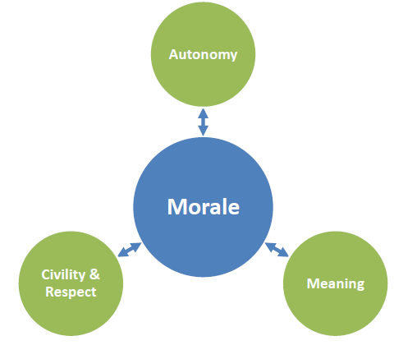 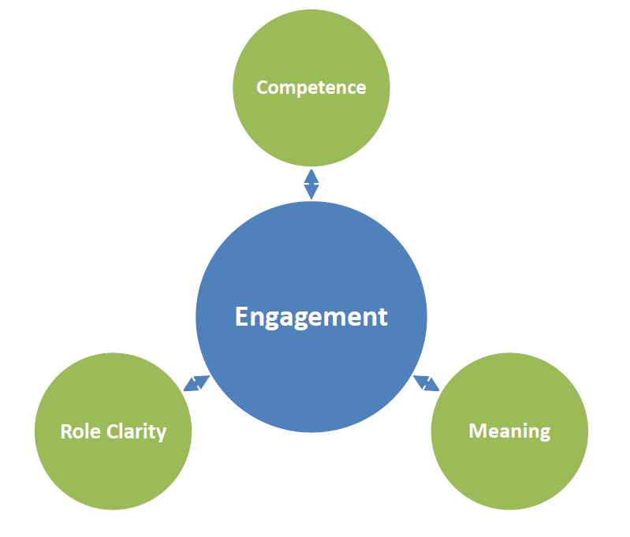

**Engagement** is most strongly predicted by Competence, Meaning, and Role Clarity.

**Morale** is most strongly predicted by Autonomy, Meaning, and Civility & Respect**.**

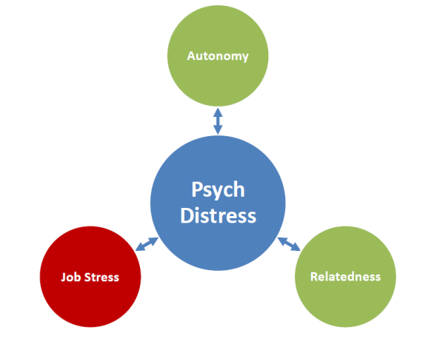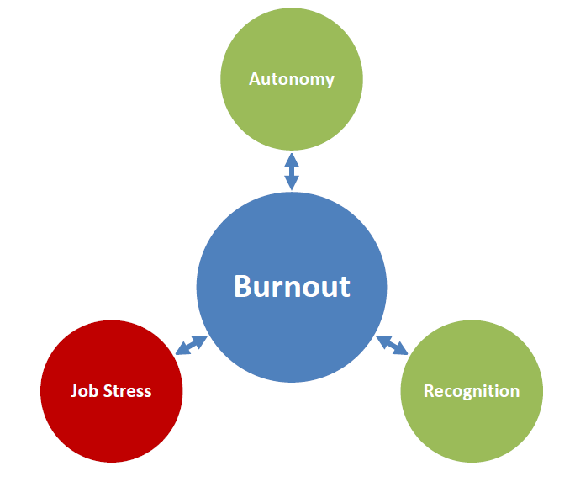

**Burnout** is most strongly predicted by Autonomy, Recognition, and Job Stress.

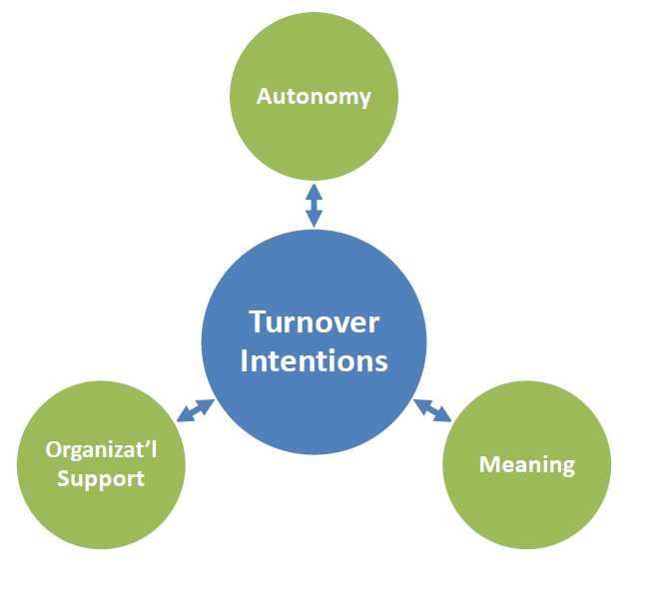

Riskfor **Psychological Distress** is most strongly predicted by Autonomy, Relatedness and Job Stress.

**Turnover** **Intentions** are most strongly predicted by Autonomy, Meaning, and Organizational Support**.**

Figure : Model of Main Predictors for Each Workplace Outcome, Service Canada Portfolio

The top three predictors for each of the five outcomes are represented in Figure 2 below. The outcome of interest is in blue in the middle of each figure, and the three strongest predictors (either job demands or job resources) are on the outside. In these figures, job resources are in green, and job demands are in red.



**Engagement** is most strongly predicted by Competence, Meaning, and Group Culture.

**Morale** is most strongly predicted by Autonomy, Meaning, and Organizational Support**.**



**Burnout** is most strongly predicted by Autonomy, Meaning, and Job Stress.



Riskfor **Psychological Distress** is most strongly predicted by Autonomy, Relatedness and Job Stress.

**Turnover** **Intentions** are most strongly predicted by Autonomy, Meaning, and Organizational Support**.**

**Figure 8: Model of Main Predictors for Each Workplace Outcome, Labour Program Portfolio**

The top three predictors for each of the five outcomes are represented in Figure 2 below. The outcome of interest is in blue in the middle of each figure, and the three strongest predictors (either job demands or job resources) are on the outside. In these figures, job resources are in green, and job demands are in red.

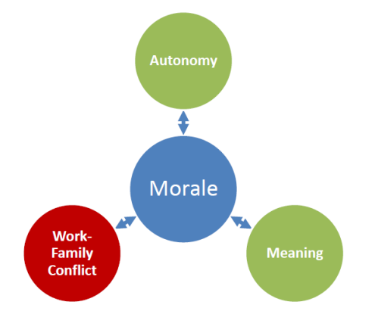 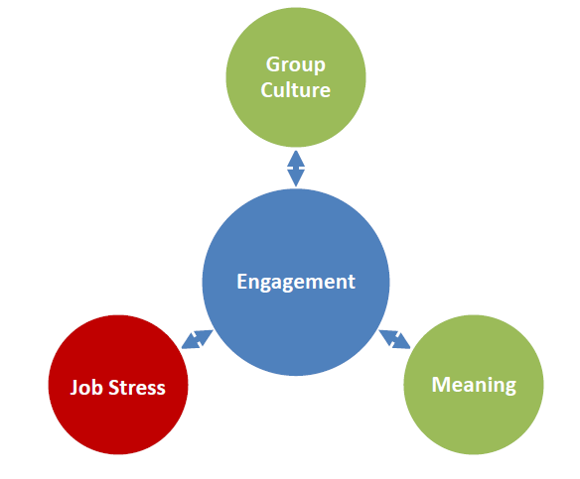

**Engagement** is most strongly predicted by Group Culture, Meaning and Job Stress.

**Morale** is most strongly predicted by Autonomy, Meaning, and Work-family Conflict**.**

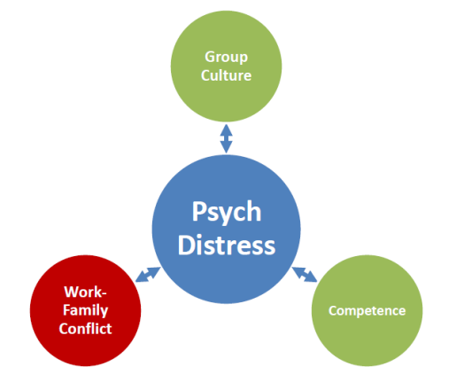 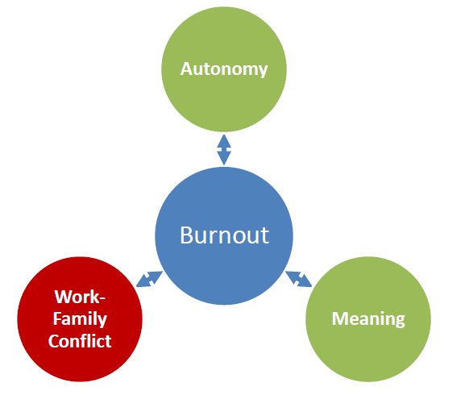

**Burnout** is most strongly predicted by Autonomy, Meaning and Work-family Conflict.

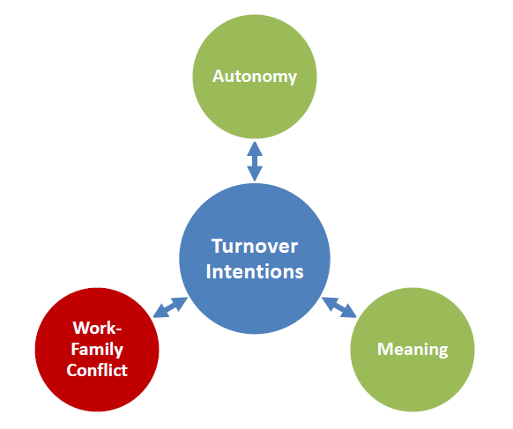

Riskfor **Psychological Distress** is most strongly predicted by Group Culture, Competence and Work-family Conflict.

**Turnover** **Intentions** are most strongly predicted by Autonomy, Meaning, and Work-family Conflict**.**

1. For example, World Health Organization, 2010. Healthy Workplaces: A Model for Action for Employers, Workers, Policy-makers and Practitioners; Crompton, Susan (2011). "What’s stressing the stressed? Main sources of stress among workers." *Canadian Social Trends* 92: 44-51; Great West Life Centre for Mental Health, 2016. Mental Health Issues - Facts and Figures; <https://www.workplacestrategiesformentalhealth.com/mental-health-issues-facts-and-figures>. Viewed May 3rd 2016; Shain, Martin (2013). Weathering the Perfect Legal Storm: A Bird’s Eye View. Great West Life Centre for Mental Health.
2. CSA Group and Bureau de normalisation du Québec. (2013). Psychological Health and Safety in the Workplace – Prevention, promotion, and guidance to staged implementation. CAN/CSA-Z1003-13/BNQ 9700-803/2013. Mississauga, Ontario.
3. Government of Canada (2015). [Public Service Employee Survey - Summary Report](https://www.canada.ca/content/dam/canada/tbs-sct/migration/psm-fpfm/modernizing-modernisation/pses-saff/dr-rd-eng.pdf). Ottawa: Her Majesty the Queen in Right of Canada. Catalogue No. BT1-34/2014E-PDF. Retrieved September 5 2017.
4. The Implementation Committee is co-chaired by an ADM and a Union representative, and is comprised of employees from various occupational groups and levels, business lines, and National Headquarters and the Regions.
5. The workplace well-being version of the Unit Morale Profile (UMP v2.0) survey was developed by DGMPRA’s Operational Effectiveness and Leadership (OEL) Team to facilitate the assessment of the 13 psychosocial risk factors of the National Standard and to provide Canadian Armed Forces (CAF)/Department of National Defence (DND) leaders and managers with a snapshot of the psychological well-being and turnover intentions of their staff.
6. CSA Group and Bureau de normalisation du Québec. (2013). Psychological Health and Safety in the Workplace – Prevention, promotion, and guidance to staged implementation. CAN/CSA-Z1003-13/BNQ 9700-803/2013. Mississauga, Ontario. 
7. Constructs and definitions used with permission from: Ivey, G.W. et al (2018). A Measure and Model of Psychological Health and Safety in the Workplace that Reflects Canada’s National Standard. Canadian Journal of Administrative Sciences.
8. Results collected from Supervisor Safety Behaviours and Expectations scales was of insufficient quality to include in the report. Please see Annex A for more information.
9. The term psychological distress is used for brevity, although the more precise description is “risk to meet the minimum clinical threshold of an anxiety and/or depressive disorder”.
10. The method used to calculate levels of concern should be considered a starting point for discussions. Some teams may feel that a threshold of 60% no concern (green) is ‘not good enough’, and may choose to take action and make improvements.
11. In some cases, respondents made more than one suggestion in their comment, in which case these are coded to more than one category.
12. Ryan, R. M., & Deci, E. L. (2000). Self-determination theory and the facilitation of intrinsic motivation, social development, and well-being. *American Psychologist, 55*(1), 68-78.
13. Bakker (2017). Strategic and proactive approaches to work engagement. *Organizational Dynamics.* 46, pp 67-75.
14. E. Kevin Kelloway, Julian Barling, (2000) "What we have learned about developing transformational leaders", Leadership & Organization Development Journal, Vol. 21 Issue: 7, pp.355-362, https://doi.org/10.1108/01437730010377908.
15. http://hrcouncil.ca/hr-toolkit/keeping-people-employee-recognition.cfm.
16. Annex A is reproduced in its entirety with the permission of DGMPRA, and are based on the following publication: Ivey, G.W., Blanc, J-R., S. Michaud, K., & Dobreva-Martinova, T. (in press). A Measure and Model of Psychological Health and Safety in the Workplace that Reflects Canada’s National Standard. Canadian Journal of Administrative Sciences.
17. Cordes, C. L., & Dougherty, T. W. (1993). A review and integration of research on job burnout. *Academy of Management Review, 18*(4), 621-656.
18. Allen, T. D., Herst, D. E. L., Bruck, C. S., & Sutton, M. (2000). Consequences associated with work-to-family conflict: A review and agenda for future research. *Journal of Occupational Health Psychology, 5*(2), 278-308.
19. McCuaig Edge, H. J., & Ivey, G. W. (2012). Mediation of cognitive appraisal on combat exposure and psychological distress. *Military Psychology, 24*(1), 75-85.
20. Gagné, M., Senécal, C. B., & Koestner, R. (1997). Proximal job characteristics, feelings of empowerment, and intrinsic motivation: A multidimensional model. *Journal of Applied Social Psychology, 27*, 1222-1240.
21. Hackman, J. R., & Oldham, G. R. (1975). Development of the Job Diagnostic Survey. *Journal of Applied Psychology, 60*, 159-170.
22. Spreitzer, G. M. (1995). Psychological empowerment in the workplace: Dimensions, measurement, and validation. *The Academy of Management Journal, 38*(5), 1442-1465.
23. Vander Elst, T., Van den Broeck, A., De Witte, H., & De Cuyper, N. (2012). The mediating role of frustration of psychological needs in the relationship between job insecurity and work-related well-being. *Work & Stress, 26*(3), 252-271.
24. Deci, E. L., Ryan, R. M., Gagné, M., Leone, D. R., Usunov, J., & Kornazheva, B. P. (2001). Need satisfaction, motivation, and well-being in the work organizations of a former Eastern bloc country: A cross-cultural study of self-determination. *Personality and Social Psychology Bulletin, 27*, 930-942.
25. Rhoades, L., & Eisenberger, R. (2002). Perceived organizational support: A review of the literature. *Journal of Applied Psychology, 87*(4), 698-714.
26. Parker, C. P., Baltes, B. B., Young, S. A., Huff, J. W., Altmann, R. A., Lacost, H. A., & Roberts, J. E. (2003). Relationships between psychological climate perceptions and work outcomes: A meta-analytic review. *Journal of Organizational Behavior, 24*(4), 389-416.
27. Lim, S., Cortina, L. M. & Magley, V. J. (2008). Personal and workgroup incivility: Impact on work and health outcomes. *Journal of Applied Psychology, 93*(1), 95-107.
28. Bradley, P., & Charbonneau, D. (2004). Transformational leadership: something new, something old. *Canadian Military Journal, 5*(1), 7-14.
29. Van Vegehel, N., de Jonge, J., Bosma, H., & Schaufeli, W. (2005). Reviewing the effort-reward imbalance: Drawing up the balance of 45 empirical studies*. Social Science & Medicine, 60*(5), 1117-1131.
30. Psychometric tests performed on these scales raised questions concerning their validity and reliability. In consultation with the DND team, the decision was taken to not discuss the results in the report.
31. Tay, L., & Diener, E. (2011). Needs and subjective well-being around the world. *Journal of Personality and Social Psychology, 101*(2), 354-365.
32. Rhoades, L., & Eisenberger, R. (2002). Perceived organizational support: A review of the literature. *Journal of Applied Psychology, 87*(4), 698-714.
33. Britt, T. W., & Dickinson, J. M. (2006). Morale during military operations: A positive psychology approach. In T. W. Britt, C. A. Castro & A. B. Adler (Vol. Eds.), *Military life: The psychology of serving in peace and combat: Vol. 1. Military performance* (pp. 157-184). Westport, CT: Praeger Security International.
34. Nahrgang, J. D., Morgeson, F. P., & Hofmann, D. A. (2011). Safety at work: A meta-analytic investigation of the link between job demands, job resources, burnout, engagement, and safety outcomes. *Journal of Applied Psychology, 96*(1), 71-94.
35. Nahrgang, J. D., Morgeson, F. P., & Hofmann, D. A. (2011). Safety at work: A meta-analytic investigation of the link between job demands, job resources, burnout, engagement, and safety outcomes. *Journal of Applied Psychology, 96*(1), 71-94.
36. Australian Bureau of Statistics (2001). Information paper: Use of the Kessler Psychological Distress Scale in ABS health surveys. Retrieved from http://www.abs.gov.au/.
37. Tracey, J. B., & Hinkin, T. R. (2008). Contextual factors and cost profiles associated with employee turnover. *Cornell Hospitality Quarterly, 49*(1), 12-27.
38. Colarelli, S. M. (1984). Methods of Communication and Mediating Processes in Realistic Job Previews. *Journal of Applied Psychology,* *69*(4), 633-642.
39. The original plan was to distribute invitations in three waves, gauging whether the final wave was necessary depending on whether the target of 2,500 responses had been met. Each of the three waves was representative of the Department by portfolio, gender and region. Two weeks into the survey period, we determined that all invitations should be distributed, and so the second wave of invitations was larger than the first.
40. In some cases the differences are statistically significant, but in many cases they are not, likely due to small sample sizes.
41. The relationship between years of service and age category and job demands, resources and outcomes tends to follow a U-shape: levels are more positive earlier in their career/among younger categories, increasing in level of concern with time, and then gradually becoming more healthy later in the career/in later age groups. This pattern mirrors typical career progression, during which an individual gradually acquires more competence and sense of power in the workplace, while at the same time experiencing greater demands in terms of what is expected from them. With experience, priorities and perceptions further shift, resulting in greater access to job resources, which may play an important role in producing healthier outcomes. Life course changes unrelated to the workplace (e.g. child-rearing, caring for an aging parent) may also affect respondents’ experience of the workplace, and are not accounted for within this survey. Detailed Tables for Years of Service and Age Category are included in Annex E.
42. It is important to note the interplay between age, stages of life and life experience when interpreting these results. Although the information provides an overview of ESDC employees’ workplace mental health, it does not indicate the presence of other life factors that may also be influencing these results.
43. Current practice is the use the term Indigenous to refer to collectively refer to people identifying as First Nations, Métis or Inuit.
44. With a larger sample size, it is possible that more differences would appear.
45. Note: This question was developed in collaboration with the co-chairs of ESDC’s Pride Network. LGBTQ* is an acronym often used to describe the lesbian, gay, bisexual, transgender and queer community. It is not fully inclusive of the full spectrum of gender and sexual orientation diversity, hence the “*”.To our knowledge, this is the first time a question like this has been asked within ESDC.