These are places where EX employees and managers often get stuck. Please consult this tip sheet for solutions.

Problem #1: Commitments and Performance Measures show as incomplete

The EX has entered all their commitments and performance measures and the system is still marking them as incomplete. Help!

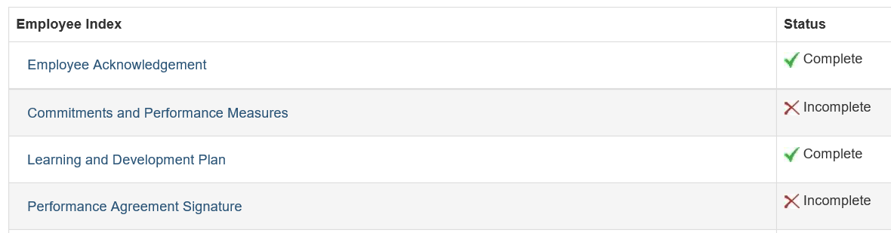

**Solution:**

The default corporate commitment entered by TBS have not been edited; please add the additional ESDC text from [the Executive Commitments for Performance and Related Performance Measures for 2020-2021 guide](http://iservice.prv/eng/hr/executives/topics/perf_mgmt/executive-commitments-related-performance-measures.shtml).

In the example below, the corporate commitment #2 needs to have the additional ESDC text added to “Fostering Diversity and Inclusion” instead of the “insert text here”:

**Before**

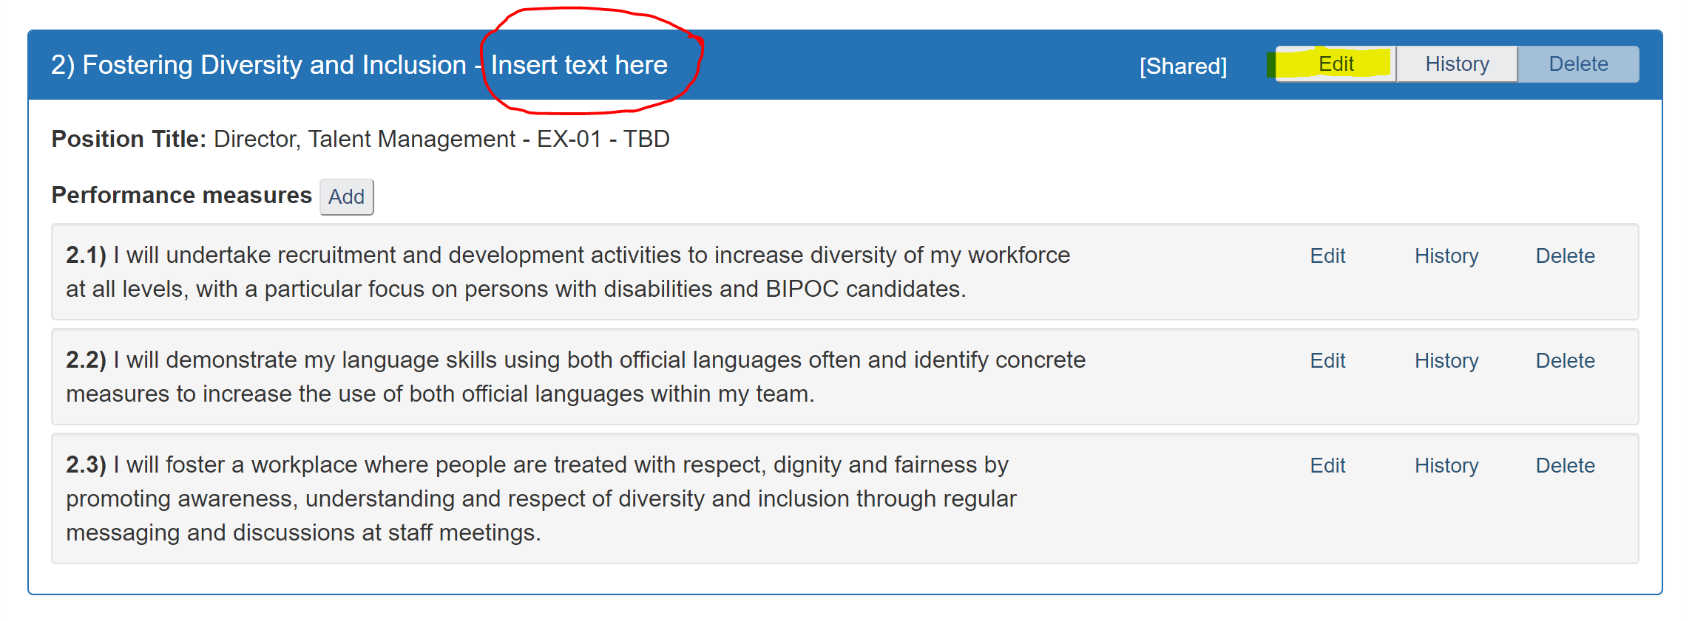

**After**

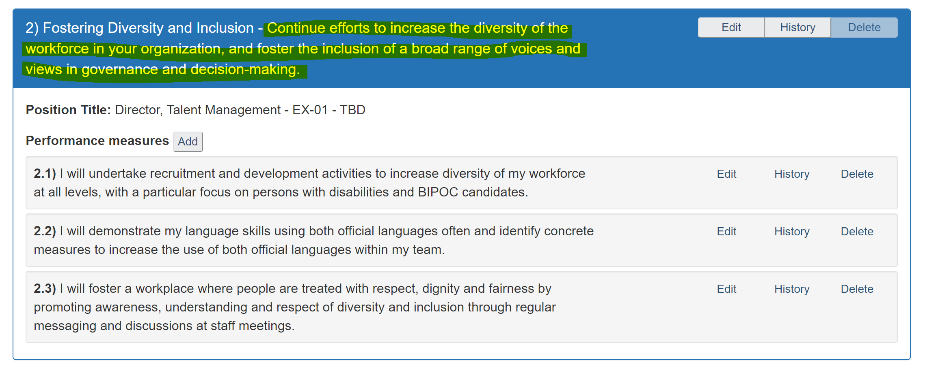

Problem #2: The EX employee cannot edit their commitments and performance measures; all the add/edit buttons are greyed out.

**Solution:**

Either the EX employee or the manager has signed the initial agreement which blocks the employee from editing. To have access to edit the commitments and performance measures again, please apply the missing signature (either the EX employee or the manager) and once they reopen the agreement and click on the commitments and performance measures link on the index, the commitments and performance measures will be editable again.