**Instructions for Executives to Submit Management Leave in PeopleSoft**

Please note, management leave (Exceptional Leave With Pay) “may be carried over into the next fiscal year, and is to be used within six months of being granted,” as defined in section A. II. 9.3 of the [Directive on Terms and Conditions of Employment for Executives](https://www.gcpedia.gc.ca/gcwiki/images/e/e3/Directive_on_Terms_and_Conditions_of_Employment_for_Executives_FINAL2.pdf).

1. Go to [PeopleSoft](https://masge-myems-peoplesoft.service.gc.ca/psp/rhprod/?cmd=login&languageCd=ENG&) and login to your account
2. On Main Page select Employee Self Serve
3. Click Time

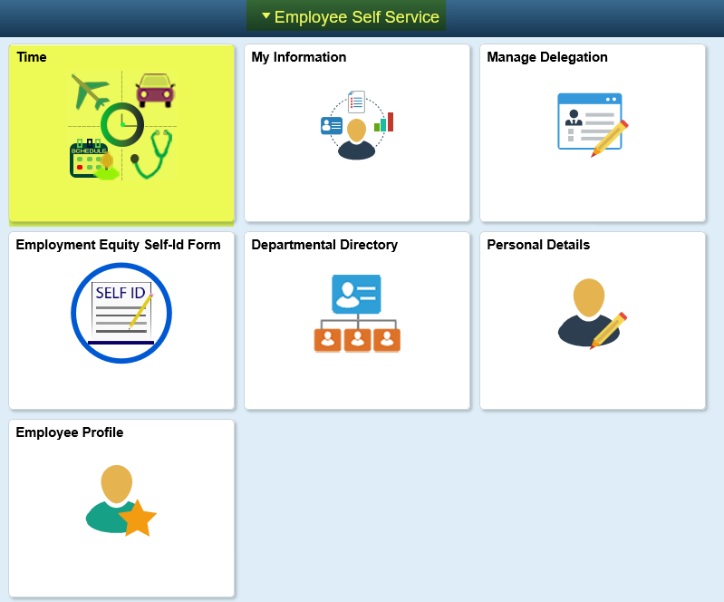

1. Click Request Absence

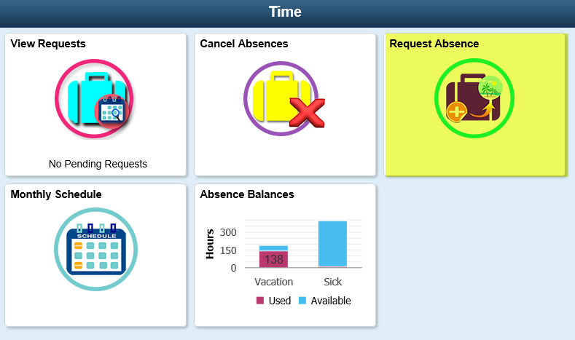

1. Fill out the requested information:
   1. *Absence Name: Oth Pd - Exceptional
   2. *Start Date
   3. End Date

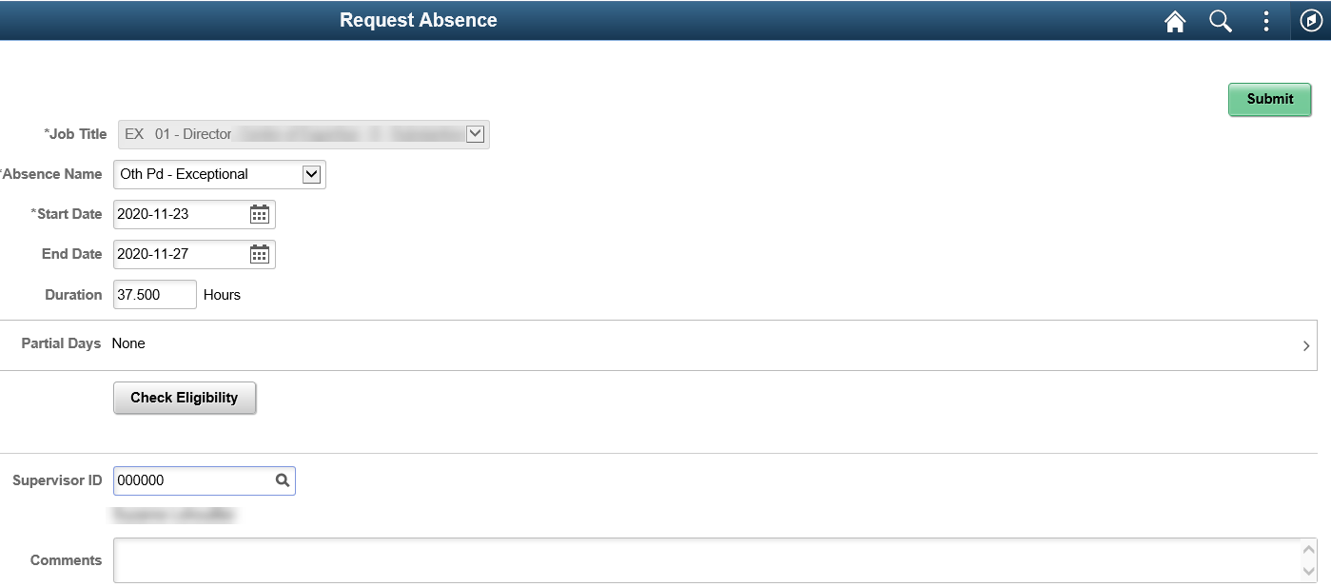

1. For Supervisor ID
   1. For management leave requests of five (5) days or less, the approver should be your Assistant Deputy Minister (ADM)
   2. For management leave requests exceeding five (5) days, the approver should be your ADM, on behalf of the Deputy Minister, once you’ve received notification that it has been approved by the Deputy Minister

If you are an ADM:

* 1. For all management leave requests, the approver should be your Deputy Minister.

1. Click Check Eligibility
2. Pop-up displays, click OK

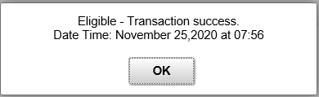

1. Click Submit
2. Pop-up displays, click Yes

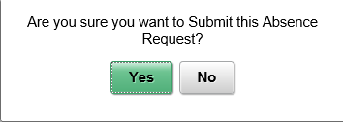

Updated: November 25, 2020