**Executive Talent Management System (ETMS)**

**Quick Reference Guide for Assistant Deputy Ministers**

**Editing your 2020-21 Performance Agreement to address the recent changes to the Assistant Deputy Minister measures for the diversity and inclusion corporate commitment.**

Following the email sent by Darlène de Gravina on the update to the Assistant Deputy Minister measures for the diversity and inclusion corporate commitment, please find instructions on how to include these in your performance agreement (PA) at whatever stage you are at in the Executive and Talent Management System (ETMS).

To get started, you will need to know what stage your PA status is at in ETMS.

How do I view my PA status?

1. Log in to the ETMS at [https://talent.tbs-sct.gc.ca/etms-sgtcs/login-eng.aspx.](https://talent.tbs-sct.gc.ca/etms-sgtcs/login-eng.aspx)
2. Select the Employee role at the top left side of the screen and click go
3. Click on the Performance Agreement tab in the Employee Workspace
4. Verify the PA status on the “Current Year” line

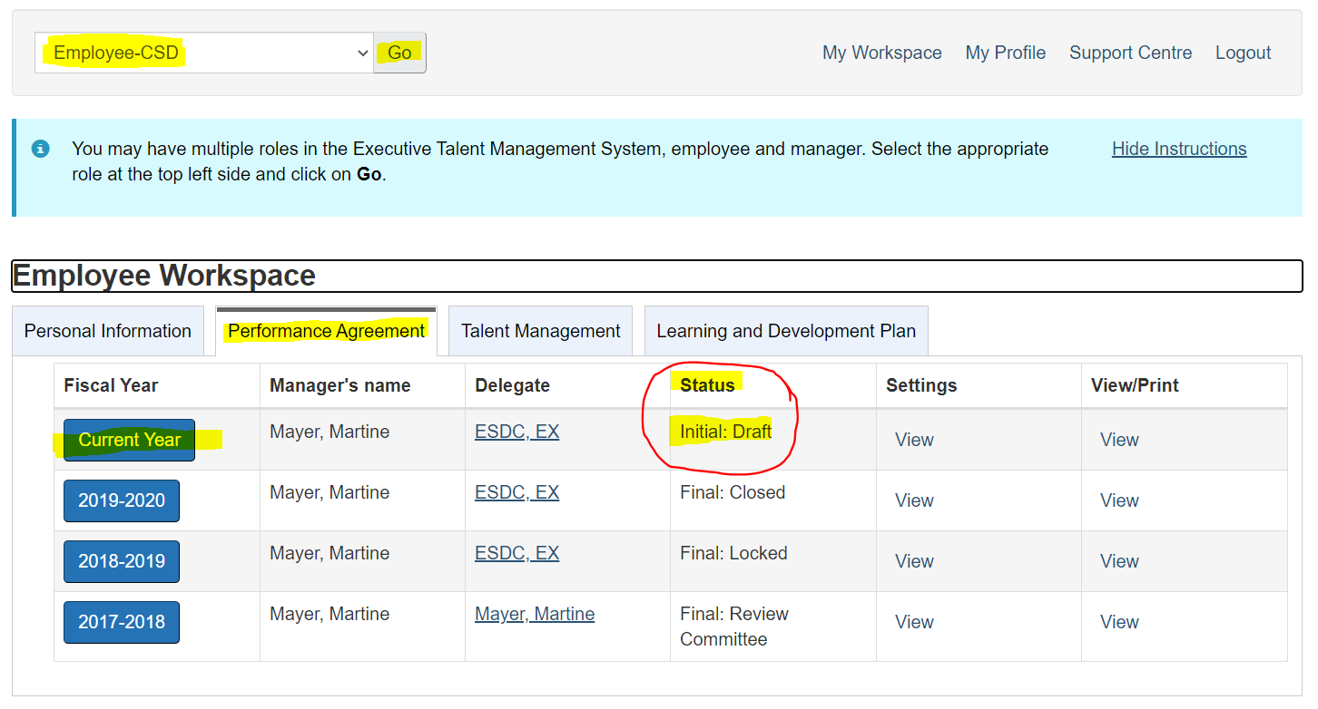

What stage are you at?

|  |  |  |
| --- | --- | --- |
| **#1 My manager and I have not done anything with my PA yet** | **#2 My manager and I have completed my PA with both beginning and mid-year signatures** | **#3 My manager and I are in the middle of completing my PA and have not finished.** |
| Your PA status will be:   * Initial: Open   Click here for instructions | Your PA status will be any of the following:   * Mid-year: Closed * Final: Draft   Click here for instructions | Your PA status will be any of the following:   * Initial: Draft * Initial: Closed * Mid-year: Draft   Click here for instructions |

**Stage #1: My manager and I have not done anything with my PA yet**

Please refer to the [ETMS Quick Reference for 2020-21 Beginning of Year Performance Agreement and Mid-Year Review](http://iservice.prv/eng/hr/executives/topics/perf_mgmt/etms-guide-beginning-mid-year-review.shtml) on Iservice.

**Stage #2: My manager and I have completed my PA with both beginning and mid-year signatures**

1. Select the Employee role at the top left side of the screen.
2. Open the Performance Agreement (PA) tab and click on Current Year.
3. Click on Commitments and Performance Measures under the Employee Index.
4. Add the update to the diversity and inclusion commitment.

**Stage #3: My manager and I are in the middle of completing my PA and have not finished**

**If your PA status is Initial: Draft OR Mid-year: Draft**

Are you able to edit your commitments and performance measures?

Follow these steps to check:

1. Select the Employee role at the top left side of the screen.
2. Open the Performance Agreement (PA) tab and click on Current Year.
3. Click on Commitments and Performance Measures under the Employee Index.

Is the edit button beside the commitments clickable?

This button is clickable:



This button is not clickable



**Yes, the button is clickable:**

1. Add the update to the diversity and inclusion commitment and any other changes required to ensure your commitments and performance measures are up to date.
2. Proceed per the [ETMS Quick Reference for 2020-21 Beginning of Year Performance Agreement and Mid-Year Review](http://iservice.prv/eng/hr/executives/topics/perf_mgmt/etms-guide-beginning-mid-year-review.shtml) on Iservice

**No, the button is not clickable**

1. Click on Performance Agreement Signature (if you are in Initial: Draft) or Mid-Year Review (if you are in Mid-year: Draft) line in the Employee Index, and apply your signature.
2. Click on Commitments and Performance Measures under the Employee Index and edit your PA to add the update to the Diversity and inclusion commitment.
3. Proceed per the [ETMS Quick Reference for 2020-21 Beginning of Year Performance Agreement and Mid-Year Review](http://iservice.prv/eng/hr/executives/topics/perf_mgmt/etms-guide-beginning-mid-year-review.shtml) on Iservice

If the edit button is not clickable and you are not able to sign, please contact us at [our generic mailbox](mailto:NC-HR-RH-PGR_PMP-EX-GD@hrsdc-rhdcc.gc.ca) for additional support.

**If your PA status is Initial: Closed**

1. Select the Employee role at the top left side of the screen.
2. Open the Performance Agreement (PA) tab and click on Current Year.
3. Click on Commitments and Performance Measures under the Employee Index.
4. Add the update to the diversity and inclusion commitment and any other changes required to ensure your commitments and performance measures are up to date.
5. Proceed per the [ETMS Quick Reference for 2020-21 Beginning of Year Performance Agreement and Mid-Year Review](http://iservice.prv/eng/hr/executives/topics/perf_mgmt/etms-guide-beginning-mid-year-review.shtml) on Iservice