**Information Package for Employee on Sick Leave**

**Onset of Leave   
(Non Occupational illness or injury)**

**Manager Instructions**

**NOTE: Please take out this page before sending to the employee**

**Purpose:**

* Acknowledge the potential long term sick leave situation
* Establish need to stay connected during the absence
* Provide essential information on:
  + Leave management (including required medical information)
  + Income maintenance (ex: Disability Insurance)
  + The Return-to-Work Process

**When to use:**

* Within first 2 weeks of health related absence that could last over 1 month (paid or unpaid sick leave)
* Ideally before all paid sick leave credits are exhausted

**Why:**

* Prevent communication breakdown during the leave
* Abide by relevant governance for leave management (Collective Agreements, Treasury Board Secretariat Directive on Leave and Special Working Arrangements, etc.)
* Ensure employees understand their responsibility for substantiating and requesting leave
* Prevent financial hardship through continued income maintenance
* Prepare for a Return-to-Work
* Manage health related leave in a proactive and consistent fashion across ESDC

**How to use:**

1. A best practice is to discuss the information in the template with the employee, in person or by phone, advising you will be providing all the information in writing afterwards. Information provided in writing to employees should be discussed first.

1. Complete information required (red font) as relevant to the case.
2. Personalize the text to fit the situation.
3. Follow up on paper through registered mail.

**REMINDER: Each step must be documented in your case file, including notes on conversations with the employee, copies of sent e-mails, copies of signed letters and proof of reception from the postal company.**

|  |
| --- |
| **Useful links:**  [**Application process for Disability Insurance (SunLife)**](https://www.sunlife.ca/slf/FDI?vgnLocale=en_CA&/di)  [**Application process for Long Term Disability Insurance (Industrial Alliance)**](http://www.tbs-sct.gc.ca/tbsf-fsct/5945-5946-eng.asp) |

**protected b**

DATE

EMPLOYEE NAME

EMPLYEE ADDRESS

CITY, PROVINCE POSTAL CODE

Dear (employee name):

Following our discussion of (date), I am enclosing information regarding your absence for health reasons. It is important you review the information to ensure you understand it and keep it for future reference.

During your absence, one of the responsibilities you and I have is to remain in contact. I will want to know how you are doing and see if there is anything I can help you with. Annex A outlines the schedule that we have agreed to in terms of staying connected. It details when and how we will connect. I would like to reiterate that when we connect I will not ask for personal information on your situation.

You are currently on paid sick leave and will exhaust the credits you have on (date of last day on paid sick leave). Should you find yourself in a position where you are unable to return to work before this date, you will have to request Sick Leave Without Pay (SLWOP).

Income maintenance options are available while on SLWOP.

Given that the approval process takes several weeks, I strongly encourage you to apply for Disability Insurance-SunLife /Long Term Disability- Industrial Alliance benefits right away. These benefits cover 70% of your salary and begin after 13 weeks of absence (or when you run out of paid sick leave credits should you have more than 13 weeks/65 days in your bank). You should apply even if you are currently hoping to be back to work before benefits begin. Delaying your application could leave you without an income for a period of time should you require more than 13 weeks to recover. Your application could also be denied if it is not provided early enough.

To apply for disability benefits, simply let me know and I will explain the process to you and provide the appropriate forms for you and your physician to complete.

Should you have to begin accessing SLWOP before 13 weeks of absence, you may apply for [Employment Insurance Sickness Benefits](http://www.servicecanada.gc.ca/eng/sc/ei/benefits/sickness.shtml) to bridge the income gap until you either return to work or transition to long term benefits, should you be approved by SunLife/Industrial Alliance.

…/2

- 2 -

Within the first few weeks of SLWOP you will receive a letter from the Public Service Pay Centre, providing you with pay and benefits information related to SLWOP (pension, health and dental insurance coverage during your leave, etc.)

Annexes B and C provide you with information on responsibilities that you and I both have to fulfill while you are on SLWOP. You will also find enclosed forms that you will need during the entire period of your leave to substantiate and request leave.

Although you are away from work, the Employee Assistance Program (EAP) remains available to you. It offers free confidential counselling to you and your family. You will find more information about EAP services in Annex E.

You may not be in a position to currently consider a return to work date. However, it is important that you **let me know as soon as you are planning to talk to your treating physician about returning to work**. This will allow me time to provide you with a form (the Fitness to Work and Functional Abilities Assessment Form) for your physician to fill out, in order to provide all required information for your Return-to-Work (RTW). Annex D provides more details on the RTW process in order to ensure we are fully prepared when the time comes to plan for your reintegration.

As suggested in Annex A, we will connect on (date and time). Until then, if you have questions please do not hesitate to contact me.

Yours truly,

Manager name

Telephone: (888) 888-8888, Ext. 321

Fax: (888) 888-8888

E-mail: your.name@canada.ca

Enclosures:

Annex A: Protocol for Staying Connected During an Absence

Annex B: Information on Sick Leave Without Pay

Annex C: Excerpt of the Directive on Leave and Special Working Arrangements

Annex D: Return to Work Information

Annex E: Employee Assistance Program Pamphlet

Sick Leave Substantiation Form

Leave Application and Absence Report Form

**protected b**

**ANNEX A – PROTOCOL FOR STAYING CONNECTED DURING AN ABSENCE**

Staying connected during your absence is a joint responsibility. Our respective expectations should be clear as to when and how we will connect. With this in mind, we have agreed upon an initial schedule of dates and times in the table attached to this note. Depending on how your situation unfolds, we can always make adjustments to the schedule. The important point is that we commit to a timetable of regular contacts.

I will want to know how you are doing, provide you with relevant information to your situation and answer any questions you may have. You will have the opportunity to provide me with information in relation to your leave extending or your return to duty. I would like to reiterate that I will not be asking for personal information.

For in-person or phone meetings, you may be accompanied by a friend, family member or union representative.

In order to make communication simpler, I will take care of contacting you at the agreed upon dates and time should we connect by phone or e-mail.

**Please confirm your current contact information**

|  |  |
| --- | --- |
| Home phone: __________________________ | Cell phone: __________________________ |
| E-mail: __________________________________________________________ | |
| Complete home address: ________________________________________________________ | |

If your contact information changes please let me know immediately and I will do the same.

**Here is confirmation of my contact information**

|  |  |
| --- | --- |
| Manager name: ____________________________________________________________ | |
| Work address: _____________________________________________________________ | |
| Phone: _____________________________ | Fax: _________________________ |
| E-mail: __________________________________________________________ | |

Please let me know in advance if you are unable to participate in one of our agreed upon conversations and propose an alternative date/time. I will do the same.

**Emergency Contact Information**

Also please provide an emergency contact. This person would inform me in the event you are hospitalised or otherwise indisposed and also be the person I contact anytime I’m unable to reach you. Please ensure this person is aware that they are your emergency contact and give them my name.

|  |  |
| --- | --- |
| First Name: _____________________________ | Last Name: ____________________________ |
| Home phone: ____________________________ | Cell phone: ____________________________ |
| E-mail: _________________________________ | Relationship to you:______________________ |

|  |  |
| --- | --- |
| **Date and time where I will contact you** | **Means (in person, by phone or by e-mail)** |
| *Ex: Monday February 5th, 2013, 14:00* | *Ex: in person, we’ll meet at the building front desk* |
|  |  |
|  |  |
|  |  |
|  |  |
|  |  |
|  |  |

**STAYING CONNECTED DURING AN ABSENCE**

**Schedule**

Should you require my assistance between scheduled times,

please do not hesitate to contact me.

**ANNEX B – INFORMATION ON SICK LEAVE WITHOUT PAY**

Sick Leave Without Pay (SLWOP) situations must be managed in accordance with the Treasury Board Secretariat Directive on Leave and Special Working Arrangements. More precisely, Appendix B, section 2 of this directive speaks to SLWOP situations (see following Annex).

A period of SLWOP is utilized when an employee has exhausted all their paid sick leave credits and an additional period of leave is required before being medically able to return to work. Regular pay is stopped but employment status is maintained and the employee can access third party income maintenance, such as: Employment Insurance Sickness Benefits, Disability Insurance benefits, etc.

**SLWOP pay will only be granted:**

* **for a period of time that is substantiated by a treating physician as being illness or injury related.** Therefore, employees need to substantiate their leave on an ongoing basis by providing regular Sick Leave Substantiation Forms, regardless if they are in receipt of disability insurance benefits. Employees who do not provide the necessary documentation to substantiate their leave may face disciplinary actions.
* **as long as there is a possibility that the employee will be able to return to work.** At any point, should your physician confirm that your medical situation will not allow you to return to work, the protocol for resolving leave has to be followed (see reverse).
* **for a maximum of 24 months.** In order to ensure the leave will not extend over that period, the department ensures employees are informed ahead of time that they need to proceed with resolving their leave situation (see Protocol for resolving SLWOP on reverse).

Accordingly, management’s responsibility is to regularly confirm that a medical situation precludes the employee from working and that there is an indication they will be medically able to return to work.

**Protocol for substantiating leave and evaluating the prognosis for RTW**

The following two forms must be completed, signed and returned to management (by mail, fax or scanned and e-mailed) each time the leave period needs to be prolonged:

* Sick Leave Substantiation Form – completed by the treating physician[1]
* Application for Leave – completed by the employee

**Protocol for resolving SLWOP situations[2]**

At any time during the leave, should it be confirmed by a physician that the employee’s medical situation will not allow him/her to return to work,

**OR**

should the SLWOP period reach 18 months,

**THEN**

the employee will officially be asked by the department (through an official letter) to select one of the following options that will allow for the SLWOP situation to be resolved:

* Return to work before the 24 month mark - if medically possible
* Retire – if eligible
* Proceed with a Medical Retirement application
* Resign

Although most situations are resolved through the voluntary options noted above as a last resort, if an employee does not collaborate in resolving their SLWOP situation, management could proceed with termination due to incapacity.

**ANNEX C – EXCERPT: DIRECTIVE ON LEAVE AND SPECIAL WORKING ARRANGEMENTS, Appendix B, Section 2**

Available online at: <http://www.tbs-sct.gc.ca/pol/doc-fra.aspx?id=15774&section=text#appB>

**TREASURY BOARD SECRETARIAT**

**1. Effective date**

1.1 This directive takes effect on April 1, 2009.

**2. Management of Specific Leave without Pay Situations**

2.1 This Appendix establishes criteria that are to be followed by departments in the following leave without pay situations:

* illness;
* injury in the workplace;
* to accept employment in the office of a minister, a minister of State, a secretary of State; or a member of Parliament;
* to seek nomination as or be a candidate in a federal, provincial, territorial or municipal election as stipulated under Part 7 of the Public Service Employment Act;
* to serve in the Canadian Forces Reserves.

**2.2 Illness or injury in the workplace**

When a person appointed to the core public administration is unable to work due to illness or injury in the workplace and has exhausted his or her sick leave credits or injury-on-duty leave, the person with the delegated authority is to consider granting leave without pay.

For administrative and benefits purposes only, this type of leave without pay is referred to as sick leave without pay and is recorded as such.

If it is clear that a person will not be able to return to duty within the foreseeable future, the person with the delegated authority is to consider granting such leave without pay for a period sufficient to enable the person to make the necessary personal adjustments and preparations for separation from the core public administration on medical grounds.

When a person with the delegated authority is satisfied that there is a good chance a person will be able to return to duty within a reasonable period of time (the length of which will vary according to the circumstances of the case), leave without pay provides an option to bridge the employment gap. The period of leave without pay is to be flexible enough to allow person with the delegated authority to accommodate the needs of a person with special recovery problems, including retraining.

Persons with the delegated authority are to regularly re-examine all cases of leave without pay due to illness or injury in the workplace to ensure that continuation of leave without pay is warranted by current medical evidence. Such leave without pay situations are to be resolved within two years of the leave commencement date, although each case must be evaluated on the basis of its particular circumstances.

All leave without pay due to illness or injury in the workplace will be terminated by the person's:

* return to duty;
* resignation or retirement on medical grounds;
* cessation of employment pursuant to section 42 of the Public Service Employment Act; or
* termination for reasons other than breaches of discipline pursuant to the Financial Administration Act.

**ANNEX D – RETURN TO WORK INFORMATION**

In order to ensure a successful re-integration to the workplace, a number of steps must be taken.

**Step 1: The employee must inform management as soon as there is consideration for a Return to Work (RTW)**

Ideally, preparing for a RTW starts 2 months before the actual reintegration. **As soon as the employee plans to talk to their physician about returning to work, they should mention it to their manager.** This will allow time for management to provide the employee with a form (Fitness to Work and Functional Abilities Assessment Form) for the physician to fill out in order to provide all required information for the RTW. Management will attach relevant information to the form in order to assist the physician in evaluating if the employee is fit to return to work and perform the duties of the substantive position; for example, a copy of the work description or a summary of daily tasks performed.

Preparing for a return to work takes time to ensure all necessary arrangements are in place. If there is insufficient time to prepare, management may ask the employee to reintegrate the workplace at a later date to provide time to gather the required medical information; or to collaborate on the RTW plan and determine accommodation requirements.

**Step 2: Medically deemed fit to return**

The employee is responsible to provide management with medical information clearing them to return to work and with information regarding any functional limitations which may require accommodation in the workplace. As noted in Step 1, to facilitate obtaining the information required, the employee is provided with a Fitness to Work and Functional Abilities Assessment Form to take to their physician for completion.

Should there be unclear or missing information in the Form, management could request further information from the physician. If deemed necessary, management would provide the employee with specific written questions for the physician to answer.

In certain cases, a referral to Health Canada or an Independent Medical Examiner for a Fitness to Work Evaluation may be necessary. Management will discuss the process with the employee in more detail should such an assessment be required.

Once the employee is deemed fit to return to work, including clear functional limitations, management and the employee will move forward with the next steps.

**Step 3: Return to Work Plan**

Once the employee provides a completed Fitness to Work and Functional Abilities Assessment Form, management and the employee must collaborate on a RTW Plan. A case manager with the insurance provider may also be involved. If they are not, it is important that the employee advise them of the plans to return to work to ensure benefits continue and/or to prevent an overpayment.

The RTW Plan is an ESDC standard tool that states:

* What accommodations will be put into place.
* On what day and time the employee will be working.
* On what date the employee will be back full time and at full work capacity.
* What tasks will be delegated to the employee while they are at work.
* On what days and times management and the employee will meet to ensure ongoing evaluation of the reintegration.

|  |
| --- |
| NOTE : The completed Fitness to Work and Functional Abilities Assessment Form and agreed upon RTW Plan are prerequisites to reintegrating the workplace. The reintegration date could be postponed by management until these two documents are completed. |

**Step 4: Follow-up**

Once back at work, regularly scheduled feedback meetings between management and the employee will take place. The employee is responsible for communicating any issues to management. Management will provide the employee with honest feedback. The RTW Plan is an agreement between management and the employee to support a successful reintegration and therefore it is important that both management and the employee follow it. Management and the employee can agree to amend the plan as the reintegration progresses in order to respond to any rising needs. Follow-up medical evaluations may be needed to validate certain information or to orient any required modifications to the RTW Plan.

**ANNEX E – EMPLOYEE ASSISTANCE PROGRAM PAMPHLET**

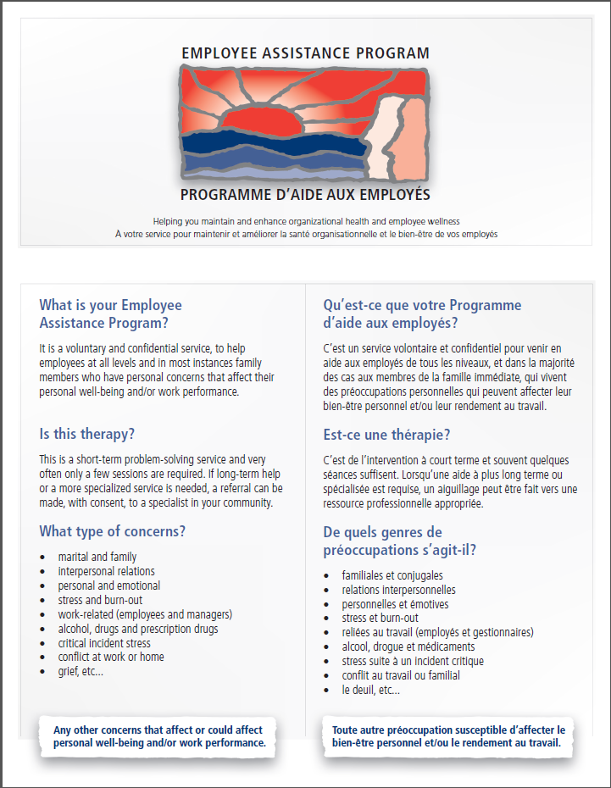

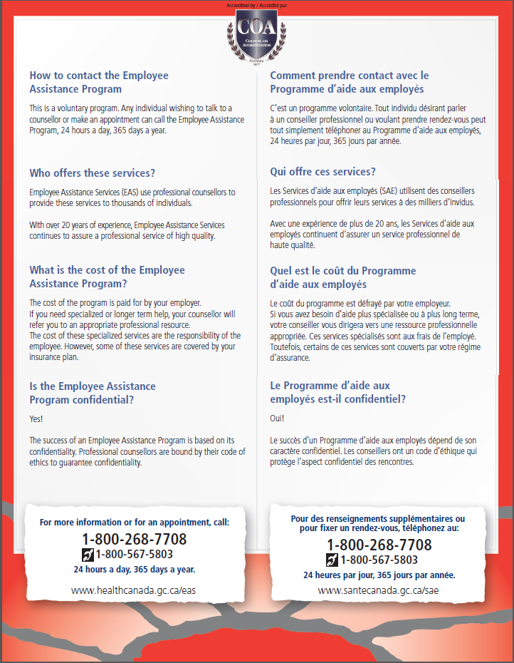

Employee Code:

**protected b** when completed

**SICK LEAVE SUBSTANTIATION FORM**

**Note:** Do not include information about the employee’s diagnosis or treatment (including medication).

To whom it may concern,

I saw ­_________________________________________­­ on ­­__________________________.

(Please print patient’s name) (dd-mm-yyyy)

Given the health information before me (check and fill all that applies):

**PAST ABSENCE**

The above named patient was incapable of working due to medical reasons from:

________________________ to ________________________ inclusiveliy.

(dd-mm-yyyy) (dd-mm-yyyy)

**FUTURE ABSENCE & RETURN-TO-WORK**

The patient will not be able to work for medical reasons effective ________________________

**AND** (dd-mm-yyyy)

Will be medically able to return to work as of: __________________________.

(dd-mm-yyyy)

**OR**

A return to work date cannot be established at this time. The patient will be re-evaluated on ______________________. (Please indicate Return to Work prognosis at the next section

(dd-mm-yyyy)

**OR**

In my opinion, the above named patient is **permanently unable to work.**

**RETURN TO WORK PROGNOSIS**

I anticipate the patient will be able to return to work in the next:

|  |  |  |  |  |
| --- | --- | --- | --- | --- |
| 0 to 2 months | 2 to 4 months | 4 to 6 months | 6 to 8 months | 8 to 10 months |
| 10 to 12 months | 12 to 15 months | 15 to 18 months | 18 to 24 months | More than 24 months |

**COMMENTS**

**PHYSICIAN’S SIGNATURE**

Name Physician Stamp

________________________________________

Signature Date

_____________________________ __________________

(dd-mm-yyyy)



1. A specialist physician or Practitioner Nurse may also fill out the Sick Leave Substantiation Form.
2. Please note that these are the usual circumstances which may require this protocol to be implemented. Other circumstances may require it as well and depending on what they are, not all options may apply.