**Information Package for Employees on Sick Leave Without Pay**

**Resolution of Leave – Inability to Return to Work  
(Non Occupational Illness or Injury)**

**Manager Instructions  
NOTE : Please take out before sending the following pages to the employee**

|  |
| --- |
| This tool should be used in consultation with your Disability Management Advisor or please open a ticket at the [Human Resources Service Centre](http://hrsc-csrh.prv/). |

**Purpose:**

Provide information to employees about resolving their Sick Leave Without Pay (SLWOP) situation.

**When to use?**

**At any time** during the SLWOP when it is confirmed by the treating physician (in the Sick Leave Substantiation Form) that there is no prognosis for RTW,

**Why?**

To abide by Annex B of the Treasury Board Secretariat Directive on Leave and Special Working Arrangements.

To manage SLWOP in a proactive and consistent fashion across ESDC.

To ensure the department’s due diligence in supporting and informing its employees.

**How to use?**

1. A best practice is to discuss the information in the template with the employee, in person or by phone, advising you will be providing all the information in writing afterwards. Information provided in writing to employees should be discussed first.
2. Personalize the text to fit the situation.
3. Type your office mailing address in Annex C.
4. Follow up on paper through registered mail.

**REMINDER: Each step must be documented in your case file, including notes on conversations with the employee, copies of sent e-mails, copies of signed letters and proof of reception from the postal company.**

**protected b**

DATE

EMPLOYEE’S NAME

EMPLOYEE’S ADDRESS

CITY, PROVINCE POSTAL CODE

Dear (employee name):

This letter is a follow-up to our conversation of (date). As discussed, the latest submitted Sick Leave Substantiation Form indicates that you will not be able to return to work.

*.*

Treasury Board Secretariat sets out standards for extended illness or injury situations. The information on this type of leave as well as the relevant section of the Directive on Leave and Special Working Arrangements was provided to you in a letter at the outset of your absence. A copy is attached in Annex A (Information on Sick Leave Without Pay - SLWOP) and Annex B (Excerpt of the Directive on Leave and Special Working Arrangements).

Return to work not being possible, the protocol for resolving your current SLWOP situation stipulates that you be asked to select one of the following options:

* Retire – if you are eligible.
* Proceed with an application for Retirement on Medical Ground (see Annex C for information).
* Resign.

Please provide your response by completing the enclosed Resolution of SLWOP Form and returning to my attention by (date and time).

I recognize this is not an easy decision and want to ensure you have all the support you need.

I recommend you contact the Pension Service Centre who will provide pension estimates (contact information in Annex D). Requesting pension estimates will not bind you in any way but will provide information on your benefits that will be useful in your decision process. Obtaining information from the Pension Service Centre can take several weeks and it is therefore important to contact them right away.

Once you receive your pension information, it is recommended that you discuss your finances with a personal financial advisor.

…/2

- 2 -

Most SLWOP situations are resolved through the voluntary options noted above. However, as a last resort, if you do not participate in resolving your SLWOP situation through electing one of the above mentioned options, I may unfortunately have to consider a recommendation to terminate your employment due to incapacity. This is not something I would want to do, particularly when there are other options available to you.

Please know that you can seek support from your union representative. The Employee Assistance Program (EAP) is also available to you. It offers free confidential counselling for you and your family. I have attached the EAP pamphlet in Annex E.

Should you have any questions please do not hesitate to contact me. Otherwise, I will be expecting your response through the Resolution of SLWOP Form by (date and time).

Yours truly,

Manager name

Telephone: (888) 888-8888, Ext. 321

Fax: (888) 888-8888

E-mail: your.name@canada.ca

Enclosures:

Annex A: Information on Sick leave Without Pay

Annex B: Excerpt of the Directive on Leave and Special Working Arrangements

Annex C: Information on Retirement on Medical Grounds

Annex D: Pension Service Centre contact information

Annex E: Employee Assistance Program pamphlet

Resolution of SLWOP Form

Self-addressed envelope

**ANNEX A – INFORMATION ON SICK LEAVE WITHOUT PAY**

Sick Leave Without Pay (SLWOP) situations must be managed in accordance with the Treasury Board Secretariat Directive on Leave and Special Working Arrangements. More precisely, Appendix B, section 2 of this directive speaks to SLWOP situations (see following Annex).

A period of SLWOP is utilized when an employee has exhausted all their paid sick leave credits and an additional period of leave is required before being medically able to return to work. Regular pay is stopped but employment status is maintained and the employee can access third party income maintenance, such as: Employment Insurance Sickness Benefits, Disability Insurance benefits, etc.

**SLWOP pay will only be granted:**

* **for a period of time that is substantiated by a treating physician as being illness or injury related.** Therefore, employees need to substantiate their leave on an ongoing basis by providing regular Sick Leave Substantiation Forms, regardless if they are in receipt of disability insurance benefits. Employees who do not provide the necessary documentation to substantiate their leave may face disciplinary actions.
* **as long as there is a possibility that the employee will be able to return to work.** At any point, should your physician confirm that your medical situation will not allow you to return to work, the protocol for resolving leave has to be followed (see reverse).
* **for a maximum of 24 months.** In order to ensure the leave will not extend over that period, the department ensures employees are informed ahead of time that they need to proceed with resolving their leave situation (see Protocol for resolving SLWOP on reverse).

Accordingly, management’s responsibility is to regularly confirm that a medical situation precludes the employee from working and that there is an indication they will be medically able to return to work.

**Protocol for substantiating leave and evaluating the prognosis for RTW**

The following two forms must be completed, signed and returned to management (by mail, fax or scanned and e-mailed) each time the leave period needs to be prolonged:

* Sick Leave Substantiation Form – completed by the treating physician[1]
* Application for Leave – completed by the employee

**Protocol for resolving SLWOP situations[2]**

At any time during the leave, should it be confirmed by a physician that the employee’s medical situation will not allow him/her to return to work,

**OR**

should the SLWOP period reach 18 months,

**THEN**

the employee will officially be asked by the department (through an official letter) to select one of the following options that will allow for the SLWOP situation to be resolved:

* Return to work before the 24 month mark - if medically possible
* Retire – if eligible
* Proceed with a Medical Retirement application
* Resign

Although most situations are resolved through the voluntary options noted above as a last resort, if an employee does not collaborate in resolving their SLWOP situation, management could proceed with termination due to incapacity.

**ANNEX B – EXCERPT: DIRECTIVE ON LEAVE AND SPECIAL WORKING ARRANGEMENTS, Appendix B, Section 2**

Available online at: <http://www.tbs-sct.gc.ca/pol/doc-eng.aspx?id=15774&section=text#appB>

**TREASURY BOARD SECRETARIAT**

**1. Effective date**

1.1 This directive takes effect on April 1, 2009.

**2. Management of Specific Leave without Pay Situations**

2.1 This Appendix establishes criteria that are to be followed by departments in the following leave without pay situations:

* illness;
* injury in the workplace;
* to accept employment in the office of a minister, a minister of State, a secretary of State; or a member of Parliament;
* to seek nomination as or be a candidate in a federal, provincial, territorial or municipal election as stipulated under Part 7 of the Public Service Employment Act;
* to serve in the Canadian Forces Reserves.

**2.2 Illness or injury in the workplace**

When a person appointed to the core public administration is unable to work due to illness or injury in the workplace and has exhausted his or her sick leave credits or injury-on-duty leave, the person with the delegated authority is to consider granting leave without pay.

For administrative and benefits purposes only, this type of leave without pay is referred to as sick leave without pay and is recorded as such.

If it is clear that a person will not be able to return to duty within the foreseeable future, the person with the delegated authority is to consider granting such leave without pay for a period sufficient to enable the person to make the necessary personal adjustments and preparations for separation from the core public administration on medical grounds.

When a person with the delegated authority is satisfied that there is a good chance a person will be able to return to duty within a reasonable period of time (the length of which will vary according to the circumstances of the case), leave without pay provides an option to bridge the employment gap. The period of leave without pay is to be flexible enough to allow person with the delegated authority to accommodate the needs of a person with special recovery problems, including retraining.

Persons with the delegated authority are to regularly re-examine all cases of leave without pay due to illness or injury in the workplace to ensure that continuation of leave without pay is warranted by current medical evidence. Such leave without pay situations are to be resolved within two years of the leave commencement date, although each case must be evaluated on the basis of its particular circumstances.

All leave without pay due to illness or injury in the workplace will be terminated by the person's:

* return to duty;
* resignation or retirement on medical grounds;
* cessation of employment pursuant to section 42 of the Public Service Employment Act; or
* termination for reasons other than breaches of discipline pursuant to the Financial Administration Act.

**ANNEX C – RETIREMENT ON MEDICAL GROUNDS**

In cases where federal public servants are unable to return to work due to illness or injury, the Government of Canada has established special pension and benefits related support that you may be eligible for: Retirement on Medical Ground (ROMG).

If you are deemed eligible, ROMG would allow you to receive pension payments right away, even if you may not be of retirement age or if you may not have cumulated enough years of service (you do require more than two years of service to access pension payments). Therefore, your benefits would be calculated according to your number of years of pensionable service. The Government of Canada waves the age penalty for employees eligible for ROMG since it is involuntary illness or injury that precludes them from returning to work. This way, the employer honors the entire pensionable service period and provides financial support that a regular retirement may not provide.

Employees eligible for ROMG are also allowed to maintain their health and dental insurance coverage which can be of significant financial support when in an illness or injury situation.

If you are currently receiving Disability Insurance (SunLife) or Long Term Disability (Industrial Alliance) benefits, after a ROMG your monthly pension income could be topped at 70% of your gross salary, and this, until age 65. In other words, this provides medically retired employees with the equivalent of a full pension until the age of 65, even though they might not be 55 years of age or completing 35 years of service when retiring.

If you are in receipt of Canada Pension Plan (CPP) or Régime des Rentes du Québec (RRQ) disability benefits, these benefits will be added to your pension. In the case where your employer pension and CPP/RRQ benefits represent less than 70% of your gross salary, SunLife/Industrial Alliance benefits will top up to 70%. In other words, three different payees (pension, CPP or RRQ and SunLife or Industrial Alliance) could together pay you up to 70% of your gross salary.

Also, employees who have retired from the Public Service due to health related reason may be eligible to a priority entitlement for a position within the federal Public Service (not specifically to ESDC) should their treating physician certify they are healthy enough to return to work (medical certification mandatory) within the five years of being approved for disability benefits. Therefore, in the event that you decide to retire from the Public Service, should your health improve enough to return to work within five year of receiving disability benefits, you may be provided with support to reintegrate the Public Service.

**Retirement on Medical Ground Process**

1. **Application:**
   1. Communicate with the Pension Service Centre to request ROMG forms (see Annex D for contact information)
   2. IMPORTANT: in Section A of the HC-SC 3312 Form, put the following address:

Manager’s Name

Office Mailing Address

Office Mailing Address

Office Mailing Address

* 1. Have the ROMG forms completed and signed by a physician
  2. Should you have them, it is recommended to include the following documents with your request in order to substantiate eligibility to ROMG:
     1. Proof of approval for benefits from Canada Pension Plan Disability (CPPD) or Régime des rentes du Québec – invalidité (RRQ – invalidité)
     2. Information from a physician sent to SunLife/Industrial Alliance or CPPD/RRQ invalidité
     3. Letter from SunLife/Industrial Alliance stating that you meet the 24 month definition of “disability”

Keep a copy of your application for your record and mail the originals to Health Canada (the relevant address will be provided by the Pension Centre). Health Canada is mandated to evaluate and render decisions on ROMG applications.

1. **Decision from Health Canada**
   1. As soon as you receive Health Canada’s response, share it with your manager. Should you be deemed eligible for medical retirement, step 3 will have to be completed immediately. Should you be denied, you will need to discuss possible next steps with your manager.
2. **Notice of Retirement on Medical Grounds** 
   1. You must submit a Notice of retirement to your manager in a timely manner, either through a letter or via e-mail. Your manager will provide you with a template. Your retirement date should be within 3 months of the time you received the Health Canada decision.
   2. Your manager will then respond to approve your retirement and will inform Compensation and Benefits,who will communicate with the Pension Centre in order to make sure that all necessary actions be taken so that you receive your pension benefits.

**ANNEX D – PUBLIC SERVICE PENSION CENTRE INFORMATION**

Any questions pertaining to retirement benefits (for conventional retirement and/or for retirement on medical grounds) are to be directed to the Public Service Pension Centre at Public Works and Government Services Canada.

Only you as an employee can request pension estimates. Your manager cannot make this request for you.

|  |  |
| --- | --- |
| **Telephone** | **Facsimile** |
| **Toll free:**  1-800-561-7930  Monday to Friday  8:00 a.m. to 4:00 p.m. (Your Local Time)  **Outside Canada and**  **the United States:**  (506) 533-5800 (collect calls accepted)  Monday to Friday  8:00 a.m. to 5:00 p.m. (Atlantic Time)  **Telephone Teletype (TTY):**  (506) 533-5990 (collect calls accepted)  Monday to Friday  8:00 a.m. to 5:00 p.m. (Atlantic Time) | (418) 566-6298 |
| **On-line** |
| <http://pensionetavantages-pensionandbenefits.gc.ca/accueil-home-eng.html> |
| **In writing** |
| **Public Works and Government Services Canada Public Service Pension Centre**  **Mail Facility PO Box 8000 Matane QC G4W 4T6** |

**NOTE:** Keep your superannuation number handy when communicating with the Pension Service Centre and include it when providing information by facsimile or in writing.

**ANNEX E – EMPLOYEE ASSISTANCE PROGRAM PAMPHLET**

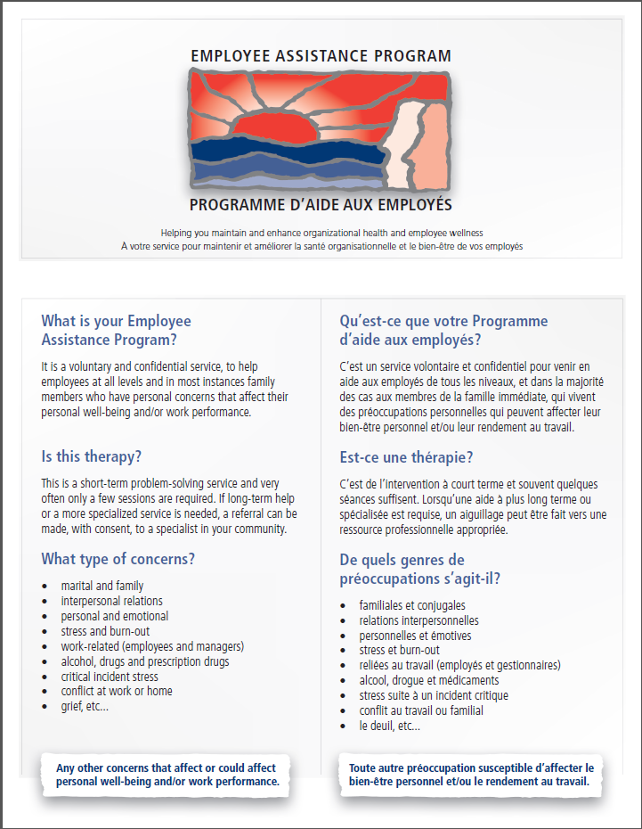

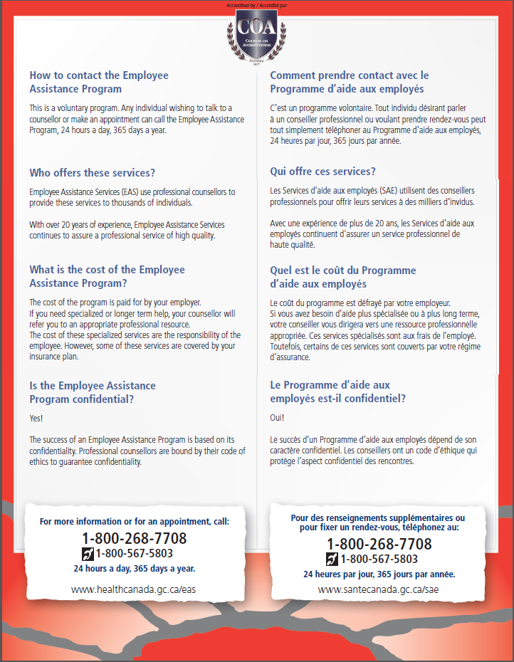

**protected b** when completed

**RESOLUTION OF SICK LEAVE WITHOUT PAY FORM**

|  |  |
| --- | --- |
| **SECTION A – EMPLOYEE INTENTION** | |
| In reference to the Treasury Board Secretariat’s [Directive on Leave and Special Working Arrangements](https://www.tbs-sct.gc.ca/pol/doc-eng.aspx?id=15774&section=html), this is to confirm the way in which I plan to resolve my current Sick Leave Without Pay situation.  I choose the following option:  N/A Return to work as of the following date: __________________________.  (dd-mm-yyyy)  Please find attached a Fitness to Work and Functional Abilities Assessment Form filled and signed by a health professionnal.  Regular Retirement  Retirement on Medical Grounds  Resignation | |
| **SECTION B – COMMENTS** | |
|  | |
| **SECTION C – EMPLOYEE SIGNATURE** | |
| _______________________________________  Name (Please print)  _______________________________________  Signature | __________________________  Date (dd-mm-yyyy)  __________________________  Telephone No |

1. A specialist physician or Practitioner Nurse may also fill out the Sick Leave Substantiation Form.
2. Please note that these are the usual circumstances which may require this protocol to be implemented. Other circumstances may require it as well and depending on what they are, not all options may apply.