**Information Package for Employee on Sick Leave Without Pay: Resolution of Leave**

**(Non Occupational Illness or Injury)**

**Manager Instructions**

**NOTE : Please take out this page before sending to the employee**

|  |
| --- |
| This tool should be used in consultation with your Disability Management Advisor or please open a ticket at the [Human Resources Service Centre](http://hrsc-csrh.prv/). |

**Purpose:**

* Provide information to employees about resolving their Sick Leave Without Pay (SLWOP) situation.

**When to use:**

* Should the SLWOP reach 18 months in duration.

**Why:**

* To abide by Appendix B of the Treasury Board Secretariat Directive on Leave and Special Working Arrangements.
* To manage SLWOP in a proactive and consistent fashion across ESDC.
* To ensure the department’s due diligence in supporting and informing its employees.

**How to use:**

1. A best practice is to discuss the information in the template with the employee, in person or by phone, advising you will be providing all the information in writing afterwards. Information provided in writing to employees should be discussed first.

1. Personalize the text to fit the situation.
2. Type your office address on the second page of Annex C.
3. Follow up on paper through registered mail.

**REMINDER: Each step must be documented in your case file, including notes on conversations with the employee, copies of sent e-mails, copies of signed letters and proof of reception from the postal company.**

**protected b**

DATE

EMPLOYEE NAME

EMPLOYEE ADRESS

CITY, PROVINCE POSTAL CODE

Dear (employee name):

This letter is a follow-up to our conversation of (date). As discussed, you have now been accessing Sick Leave Without Pay (SLWOP) for 18 months.

Treasury Board Secretariat sets out standards for extended illness or injury situations. The information on this type of leave as well as the relevant section of the Directive on Leave and Special Working Arrangements was provided to you in a letter at the outset of your absence (see Annex A and B).

The protocol for resolving your current SLWOP situation stipulates that you be asked to select one of the following options:

* Return to Work – should you be deemed medically fit to return in the foreseeable future (see Annex C)
* Retire – if you are eligible
* Proceed with an application for Retirement on Medical Ground (see Annex D)
* Resign

Please provide your response by completing the enclosed Resolution of SLWOP Form and returning to my attention by (date and time).

Since you have now been on SLWOP for 18 months, it is important to understand that the Return to Work option may be chosen only if it provides a resolution of your SLWOP situation within a timeframe that reasonably respects the Directive on Leave and Special Working Arrangements. The Directive states that:

“Such leave without pay situations are to be resolved within two years of the leave commencement date, although each case must be evaluated on the basis of its particular circumstances.”

For example, a situation where an employee elects to return to work while the treating physician is unable to determine when the employee will be fit to return may not be considered a valid resolution choice. Should you be unsure if your plans respect the Directive, I will gladly help you determine how the Directive applies in your situation.

…/2

- 2 -

I recognize this is not an easy decision and want to ensure you have all the support you need.

I recommend you contact the Pension Service Centre who will provide pension estimates (contact information in Annex E). Requesting pension estimates will not bind you in any way but will provide information on your benefits that will be useful in your decision process. Obtaining information from the Pension Service Centre can take several weeks and it is therefore important to contact them right away.

Once you receive your pension information, it is recommended that you discuss your finances with a personal financial advisor.

Most SLWOP situations are resolved through the voluntary options noted above. However, as a last resort, if you do not participate in resolving your SLWOP situation through electing one of the above mentioned options, I may unfortunately have to consider a recommendation to terminate your employment due to incapacity. This is not something I would want to do, particularly when there are other options available to you.

Please know that you can seek support from your union representative. The Employee Assistance Program (EAP) is also available to you. It offers free confidential counselling for you and your family. I have attached the EAP pamphlet in Annex F.

Should you have any questions please do not hesitate to contact me. Otherwise, I will be expecting your response through the Resolution of SLWOP Form by (date and time).

Yours truly,

Manager name

Telephone: (888) 888-8888, Ext. 321

Fax: (888) 888-8888

E-mail: your.name@canada.ca

Enclosures:

Annex A: Information on Sick leave Without Pay

Annex B: Excerpt of the Directive on Leave and Special Working Arrangements

Annex C: Return to Work Process

Fitness to Work and Functional Abilities Assessment Form

Annex D: Information on Retirement on Medical Grounds

Annex E: Pension Service Centre contact information

Annex F: Employee Assistance Program pamphlet

Resolution of SLWOP Form

Self-addressed envelope

**ANNEX A – INFORMATION ON SICK LEAVE WITHOUT PAY**

Sick Leave Without Pay (SLWOP) situations must be managed in accordance with the Treasury Board Secretariat Directive on Leave and Special Working Arrangements. More precisely, Appendix B, section 2 of this directive speaks to SLWOP situations (see following Annex).

A period of SLWOP is utilized when an employee has exhausted all their paid sick leave credits and an additional period of leave is required before being medically able to return to work. Regular pay is stopped but employment status is maintained and the employee can access third party income maintenance, such as: Employment Insurance Sickness Benefits, Disability Insurance benefits, etc.

**SLWOP pay will only be granted:**

* **for a period of time that is substantiated by a treating physician as being illness or injury related.** Therefore, employees need to substantiate their leave on an ongoing basis by providing regular Sick Leave Substantiation Forms, regardless if they are in receipt of disability insurance benefits. Employees who do not provide the necessary documentation to substantiate their leave may face disciplinary actions.
* **as long as there is a possibility that the employee will be able to return to work.** At any point, should your physician confirm that your medical situation will not allow you to return to work, the protocol for resolving leave has to be followed (see reverse).
* **for a maximum of 24 months.** In order to ensure the leave will not extend over that period, the department ensures employees are informed ahead of time that they need to proceed with resolving their leave situation (see Protocol for resolving SLWOP on reverse).

Accordingly, management’s responsibility is to regularly confirm that a medical situation precludes the employee from working and that there is an indication they will be medically able to return to work.

**Protocol for substantiating leave and evaluating the prognosis for RTW**

The following two forms must be completed, signed and returned to management (by mail, fax or scanned and e-mailed) each time the leave period needs to be prolonged:

* Sick Leave Substantiation Form – completed by the treating physician[1]
* Application for Leave – completed by the employee

**Protocol for resolving SLWOP situations[2]**

At any time during the leave, should it be confirmed by a physician that the employee’s medical situation will not allow him/her to return to work,

**OR**

should the SLWOP period reach 18 months,

**THEN**

the employee will officially be asked by the department (through an official letter) to select one of the following options that will allow for the SLWOP situation to be resolved:

* Return to work before the 24 month mark - if medically possible
* Retire – if eligible
* Proceed with a Medical Retirement application
* Resign

Although most situations are resolved through the voluntary options noted above as a last resort, if an employee does not collaborate in resolving their SLWOP situation, management could proceed with termination due to incapacity.

**ANNEX B – EXCERPT: DIRECTIVE ON LEAVE AND SPECIAL WORKING ARRANGEMENTS, Appendix B, Section 2**

Available online at: <http://www.tbs-sct.gc.ca/pol/doc-eng.aspx?id=15774#appB>

**TREASURY BOARD SECRETARIAT**

**1. Effective date**

1.1 This directive takes effect on April 1, 2009.

**2. Management of Specific Leave without Pay Situations**

2.1 This Appendix establishes criteria that are to be followed by departments in the following leave without pay situations:

* illness;
* injury in the workplace;
* to accept employment in the office of a minister, a minister of State, a secretary of State; or a member of Parliament;
* to seek nomination as or be a candidate in a federal, provincial, territorial or municipal election as stipulated under Part 7 of the Public Service Employment Act;
* to serve in the Canadian Forces Reserves.

**2.2 Illness or injury in the workplace**

When a person appointed to the core public administration is unable to work due to illness or injury in the workplace and has exhausted his or her sick leave credits or injury-on-duty leave, the person with the delegated authority is to consider granting leave without pay.

For administrative and benefits purposes only, this type of leave without pay is referred to as sick leave without pay and is recorded as such.

If it is clear that a person will not be able to return to duty within the foreseeable future, the person with the delegated authority is to consider granting such leave without pay for a period sufficient to enable the person to make the necessary personal adjustments and preparations for separation from the core public administration on medical grounds.

When a person with the delegated authority is satisfied that there is a good chance a person will be able to return to duty within a reasonable period of time (the length of which will vary according to the circumstances of the case), leave without pay provides an option to bridge the employment gap. The period of leave without pay is to be flexible enough to allow person with the delegated authority to accommodate the needs of a person with special recovery problems, including retraining.

Persons with the delegated authority are to regularly re-examine all cases of leave without pay due to illness or injury in the workplace to ensure that continuation of leave without pay is warranted by current medical evidence. Such leave without pay situations are to be resolved within two years of the leave commencement date, although each case must be evaluated on the basis of its particular circumstances.

All leave without pay due to illness or injury in the workplace will be terminated by the person's:

* return to duty;
* resignation or retirement on medical grounds;
* cessation of employment pursuant to section 42 of the Public Service Employment Act; or
* termination for reasons other than breaches of discipline pursuant to the Financial Administration Act.

**ANNEX C – RETURN TO WORK (RTW) PROCESS**

**Step 1: Medically deemed fit to return**

Should an employee elect to attempt a RTW, they first have to discuss it with their physician. They are responsible to provide management with medical information clearing them to return to work and with information regarding any functional limitations which may require accommodation in the workplace. To facilitate obtaining the information required, the employee is provided with the Fitness to Work and Functional Abilities Assessment Form to take to the physician for completion.

Should there be unclear or missing information in the Form, management could request further information from the physician. If deemed necessary, management would provide the employee with specific written questions for him/her to answer.

In certain cases, a referral to Health Canada or an Independent Medical Examiner for a Fitness to Work Evaluation may be necessary. Management will discuss the process with the employee in more detail should this procedure be necessary.

Once the employee is deemed fit to return to work, including clear functional limitations, management and the employee may move forward with collaborating on a RTW Plan.

**Step 2: Return to Work Plan**

Once a completed Fitness to Work and Functional Abilities Assessment Form is provided to management, the employee and manager will meet and collaborate on a Return to Work Plan. The Case Manager with the insurance provider may also be involved. If they are not, it is important that they be advised of the RTW intention to ensure benefits continue and/or to prevent an overpayment.

The RTW Plan is an ESDC standard tool that states:

* What accommodations will be put into place.
* On what day and time the employee will be working.
* On what date the employee will be back full time and at full work capacity.
* What tasks will be delegated to the employee while at work.
* On what days and times will the employee and manager meet to ensure ongoing evaluation of the reintegration.

|  |
| --- |
| NOTE: The completed Fitness to Work and Functional Abilities Assessment Form and agreed upon RTW Plan are prerequisites to reintegrating the workplace. The reintegration date could be postponed by management until these two documents are completed. |

**Step 3: Reintegrating the workplace and follow-ups**

Once back at work, regularly scheduled feedback meetings between management and the employee will take place. The employee is responsible for communicating any issues to management, while management will provide honest feedback to the employee. The RTW Plan is an agreement between management and the employee to support successful reintegration. It is therefore important that both management and the employee follow it. Management and the employee can agree to amend the plan as the reintegration progresses in order to respond to any rising needs. Follow-up medical evaluations may be needed to validate certain information or to orient any required modifications to the RTW Plan. The goal is to ensure the employee is successfully reintegrated into the workplace.

**protected b** when completed

**Fitness to Work and Functional Abilities Assessment Form**

|  |  |  |  |
| --- | --- | --- | --- |
| **SECTION A – Employee information** | | (To be completed by the manager) | |
| **Name of employee** | **Branch/Division** | | **Office/Location** |
|
| **Job title** | **Regular work schedule**  ______ hours/day  ______ days/week | | **Absence commenced date**  Summary of absences attached |
| **Name of supervisor** | **Date**  (dd-mm-yyyy) | | **Employment status** |

|  |  |
| --- | --- |
| **SECTION B – Fitness to work** | (To be completed by health care practitioner) |
| **Does the employee have a health condition (disability*) that must be accommodated in the workplace?** | |
| Yes  No | |
| * According to the Canadian Human Rights Act, “disability” means “any previous or existing mental or physical disability and includes disfigurement and previous or existing dependence on alcohol or a drug. | |
| **Which of these statements applies to the employee’s situation?**  Fit to work (able to work his or her regular work schedule without limitation or restriction) – **Complete Sections C and F**    Fit to work **subject** to certain functional limitations or restrictions – **Complete Sections C, D, E and F**  Date of next appointment: ____________________  (dd-mm-yyyy)    Unfit to work – **Complete Section F**    Date of next appointment: ____________________  (dd-mm-yyyy)  **Note: Do not provide medical diagnosis, treatment or medication information.** | |

|  |  |  |  |  |  |  |  |  |  |  |  |
| --- | --- | --- | --- | --- | --- | --- | --- | --- | --- | --- | --- |
| **SECTION C – Work schedule** | | | | | | (To be completed by health care practitioner) | | | | | |
| **Is the employee fit to work his or her regular work schedule as specified in Section A?** | | | | | | | | | | | |
| Yes  No | | | | | | | | | | | |
| **If the employee is unable to work the regular schedule**, please indicate in the table below the amount of hours per day and the numbers of days per week that the employee is able to work. Please specify the information for a 12 week period. | | | | | | | | | | | |
| **Week**  **1** | **Week**  **2** | **Week**  **3** | **Week**  **4** | **Week**  **5** | **Week**  **6** | **Week**  **7** | **Week**  **8** | **Week**  **9** | **Week**  **10** | **Week**  **11** | **Week**  **12** |
| **Hrs./Day** | **Hrs./Day** | **Hrs./Day** | **Hrs./Day** | **Hrs./Day** | **Hrs./Day** | **Hrs./Day** | **Hrs./Day** | **Hrs./Day** | **Hrs./Day** | **Hrs./Day** | **Hrs./Day** |
| **Days/Wk.** | **Days/Wk.** | **Days/Wk.** | **Days/Wk.** | **Days/Wk.** | **Days/Wk.** | **Days/Wk.** | **Days/Wk.** | **Days/Wk.** | **Days/Wk.** | **Days/Wk.** | **Days/Wk.** |

Page 1 of 4

**protected b** when completed

|  |  |  |  |  |
| --- | --- | --- | --- | --- |
| **SECTION D – Abilities required to perform principal work duties** | | | | |
| **To be completed by the manager**  (If required, use Section E to provide more details) | | | **To be completed by health care practitioner**  (If required, use Section E to provide more details) | |
| The employee’s principal work duties require the following physical and/or non-physical capacities: | | | Please provide details on each of the limitations and restrictions requiring accommodation measures. | |
| **Movement of the spinal column** | | | **Limitations and restrictions**  None  Permanent  Temporary  Anticipated duration:_________ |  |
| Back: | Bending forward  Bending backward  Side bending  Twisting | |
| Neck: | Bending forward  Looking up  Side bending  Rotation | |
| **Sitting activities**  Computer work: ____% of day  Meetings: ____% of day  Desk work (reading, writing): ____ % of day  Driving: ____% of day  Telephone use ( with headset): ____ % of day | | | **Limitations and restrictions**  None  Permanent  Temporary  Anticipated duration:_________ |  |
| **Standing activities**  Standing: ____% of day  On what type of surface: ___________________  Walking: _____ km, or _____ hours per day  On what type of surface: ___________________  Stooping  Crouching/Squatting  Kneeling  Operating general office equipment (e.g., printer)  Activities requiring balancing: ______________________  Climbing (e.g., stairs, stepladder): ___________________ | | | **Limitations and restrictions**  None  Permanent  Temporary  Anticipated duration:_________ |  |
| **Lifting, carrying, pushing or pulling** | | | **Limitations and restrictions**  None  Permanent  Temporary  Anticipated duration:_________ |  |
| Lifting from floor to waist  Lifting from waist to shoulder  Lifting above shoulder  Carrying  Pushing/pulling | | Max. weight:____ (kg)  Max. weight:____ (kg)  Max. weight:____ (kg)  Max. weight:____ (kg)  Max. weight:____ (kg) |
| **Working with shoulders, elbows, wrists,**  **hands or fingers**  Reaching:  Above shoulder level  Below shoulder level  At shoulder level  Using a keyboard: _____% of day  Writing: ____% of day  Using computer mouse  Filing  Handling objects  Handling vibrating tools/objects  Handling tools requiring strong hand grip | | | **Limitations and restrictions**  None  Permanent  Temporary  Anticipated duration:_________ |  |

Page 2 of 4**protected b** when completed

|  |  |  |
| --- | --- | --- |
| **SECTION D – Abilities required to perform principal work duties** | | |
| **To be completed by the manager**  (If required, use Section E to provide more details) | **To be completed by health care practitioner**  (If required, use Section E to provide more details) | |
| The employee’s principal work duties require the following physical and/or non-physical capacities: | Please provide details on each of the limitations and restrictions requiring accommodation measures. | |
| **Activities requiring senses**  Speaking  Hearing  Near vision  Far vision  Depth perception  Viewing computer screen -____% of day  Driving | **Limitations and restrictions**  None  Permanent  Temporary  Anticipated duration:_________ |  |
| **Cognitive/mental demands:**  Attention to detail  Continuous alertness, sustained concentration/focus  Multitasking  Communicate effectively  Autonomy / Minimal supervision  Working under specific instructions  Achieving specific performance standards  Retention of information  Initiative  Adaptability  Problem solving, decision making  Analytical thinking  Sound judgement | **Limitations and restrictions**  None  Permanent  Temporary  Anticipated duration:_________ |  |
| **Social/emotional demands:**  Working in isolation  Teamwork  Supervising others  Relationship/network building  Influencing others  Conflict resolution  Seeking/responding to feedback  Exposure to emotional or confrontational situations  Working closely with the public, clients or others  Working in crisis or emergency situations | **Limitations and restrictions**  None  Permanent  Temporary  Anticipated duration:_________ |  |
| **Schedule demands:**  Following a schedule, maintaining attendance/punctuality  Overtime work  Shift work  On call  Repetitive work  Variety of tasks  Travel:  Frequency per day: ________________________  Mode of transportation: _____________________  Time of day:______________________________ | **Limitations and restrictions**  None  Permanent  Temporary  Anticipated duration:_________ |  |

Page 3 of 4**protected b** when completed

|  |
| --- |
| **SECTION E – Specific questions, issues/comments** |
|  | |

|  |  |  |
| --- | --- | --- |
| **SECTION F – Signature of health care practitioner** | | |
| ________________________________________________  Name (please print) | | ______________________________________  Title |
| _________________________________________________  Signature | |  | | --- | | Stamp of health care practitioner | | |
| _____________________  Date (dd-mm-yyyy) |

Page 4 of 4

**ANNEX D – RETIREMENT ON MEDICAL GROUNDS**

In cases where federal public servants are unable to return to work due to illness or injury, the Government of Canada has established special pension and benefits related support that you may be eligible for: Retirement on Medical Ground (ROMG).

If you are deemed eligible, ROMG would allow you to receive pension payments right away, even if you may not be of retirement age or if you may not have cumulated enough years of service (you do require more than two years of service to access pension payments). Therefore, your benefits would be calculated according to your number of years of pensionable service. The Government of Canada waives the age penalty for employees eligible for ROMG since it is involuntary illness or injury that precludes them from returning to work. This way, the employer honors the entire pensionable service period and provides financial support that a regular retirement may not provide.

Employees eligible for ROMG are also allowed to maintain their health and dental insurance coverage which can be of significant financial support when in an illness or injury situation.

If you are currently receiving Disability Insurance (SunLife) or Long Term Disability (Industrial Alliance) benefits, after a ROMG your monthly pension income could be topped at 70% of your gross salary, and this, until age 65. In other words, this provides medically retired employees with the equivalent of a full pension until the age of 65, even though they might not be 55 years of age or completing 35 years of service when retiring.

If you are in receipt of Canada Pension Plan (CPP) or Régime des Rentes du Québec (RRQ) disability benefits, these benefits will be added to your pension. In the case where your employer pension and CPP/RRQ benefits represent less than 70% of your gross salary, SunLife/Industrial Alliance benefits will top up to 70%. In other words, three different payees (pension, CPP or RRQ and SunLife or Industrial Alliance) could together pay you up to 70% of your gross salary.

Also, employees who have retired from the Public Service due to health related reason may be eligible to a priority entitlement for a position within the federal Public Service (not specifically to ESDC) should their treating physician certify they are healthy enough to return to work (medical certification mandatory) within the five years of being approved for disability benefits. Therefore, in the event that you decide to retire from the Public Service, should your health improve enough to return to work within five year of receiving disability benefits, you may be provided with support to reintegrate the Public Service.

**Retirement on Medical Ground Process**

1. **Application**
   1. Communicate with the Pension Service Centre to request ROMG forms (see Annex E for contact information)
   2. IMPORTANT: in Section A of the HC-SC 3312 Form, put the following address:

Manager’s name

Office address

Office address

Office address

* 1. Have the ROMG forms completed and signed by a physician
  2. Should you have them, it is recommended to include the following documents with your request in order to substantiate eligibility to ROMG:
     1. Proof of approval for benefits from Canada Pension Plan Disability (CPPD) or Régime des rentes du Québec – invalidité (RRQ – invalidité)
     2. Information from a physician sent to SunLife/Industrial Alliance or CPPD/RRQ invalidité
     3. Letter from SunLife/Industrial Alliance stating that you meet the 24 month definition of “disability”

Keep a copy of your application for your record and mail the originals to Health Canada (the relevant address will be provided by the Pension Centre). Health Canada is mandated to evaluate and render decisions on ROMG applications.

1. **Decision from Health Canada**
   1. As soon as you receive Health Canada’s response, share it with your manager. Should you be deemed eligible for medical retirement, step 3 will have to be completed immediately. Should you be denied, you will need to discuss possible next steps with your manager.
2. **Notice of Retirement on Medical Grounds** 
   1. You must submit a retirement letter or email to your manager. Your retirement date should be within 3 month in the future and cannot be a Sunday, a Monday or a statutory holiday.
   2. Your manager will then respond to approve your retirement and will inform Compensation and Benefits, who will communicate with the Pension Centre in order to make sure that all necessary actions be taken so that you receive your pension benefits.

**ANNEX E – PUBLIC SERVICE PENSION CENTRE INFORMATION**

Any questions pertaining to retirement benefits (for conventional retirement and/or for retirement on medical grounds) are to be directed to the Public Service Pension Centre at Public Works and Government Services Canada.

Only you as an employee can request pension estimates. Your manager cannot make this request for you.

|  |  |
| --- | --- |
| **Telephone** | **Facsimile** |
| **Toll free:**  1-800-561-7930  Monday to Friday  8:00 a.m. to 4:00 p.m. (Your Local Time)  **Outside Canada and**  **the United States:**  (506) 533-5800 (collect calls accepted)  Monday to Friday  8:00 a.m. to 5:00 p.m. (Atlantic Time)  **Telephone Teletype (TTY):**  (506) 533-5990 (collect calls accepted)  Monday to Friday  8:00 a.m. to 5:00 p.m. (Atlantic Time) | (418) 566-6298 |
| **On-line** |
| <http://pensionetavantages-pensionandbenefits.gc.ca/accueil-home-eng.html> |
| **In writing** |
| **Public Works and Government Services Canada Public Service Pension Centre**  **Mail Facility PO Box 8000 Matane QC G4W 4T6** |

NOTE: Keep your superannuation number handy when communicating with the Pension Service Centre and include it when providing information by facsimile or in writing.

**ANNEX F – EMPLOYEE ASSISTANCE PROGRAM PAMPHLET**

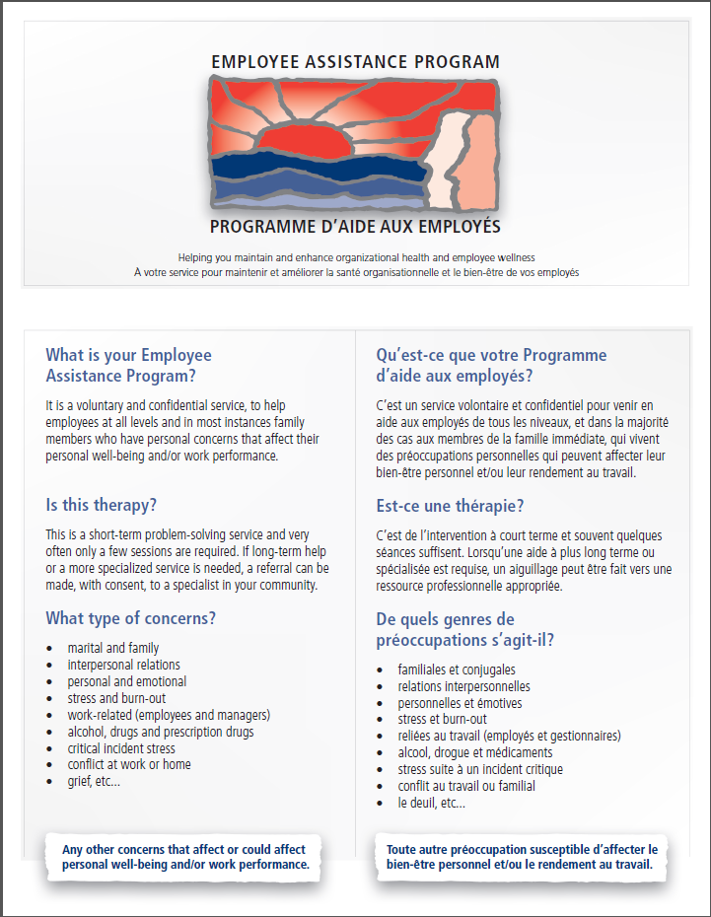

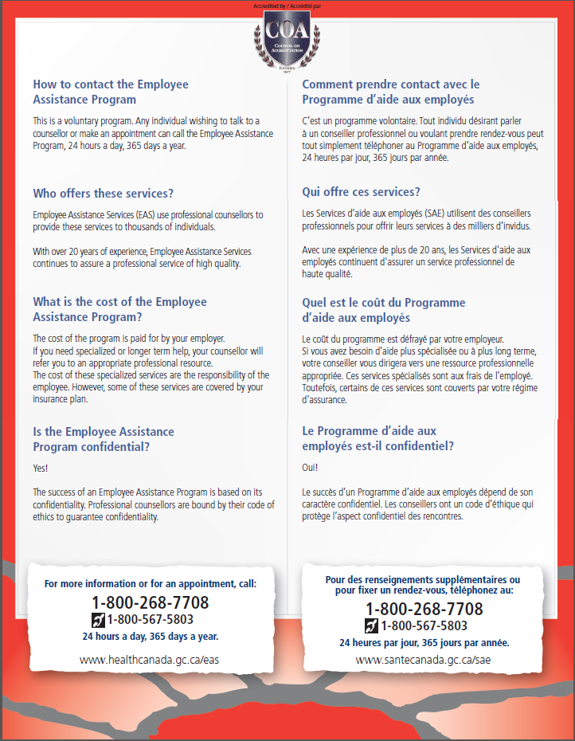

**protected b** when completed

**RESOLUTION OF SICK LEAVE WITHOUT PAY FORM**

|  |  |
| --- | --- |
| **SECTION A – EMPLOYEE INTENTION** | |
| In reference to the Treasury Board Secretariat’s [Directive on Leave and Special Working Arrangements](https://www.tbs-sct.gc.ca/pol/doc-eng.aspx?id=15774&section=html), this is to confirm the way in which I plan to resolve my current Sick Leave Without Pay situation.  I choose the following option:  Return to work as of the following date: __________________________.  (dd-mm-yyyy)  Please find attached a Fitness to Work and Functional Abilities Assessment Form filled and signed by a health professionnal.  Regular Retirement  Application for Retirement on Medical Grounds  Resignation | |
| **SECTION B – COMMENTS** | |
|  | |
| **SECTION C – EMPLOYEE SIGNATURE** | |
| _______________________________________  Name (Please print)  _______________________________________  Signature | __________________________  Date (dd-mm-yyyy)  __________________________  Telephone No |

1. A specialist physician or Practitioner Nurse may also fill out the Sick Leave Substantiation Form.
2. Please note that these are the usual circumstances which may require this protocol to be implemented. Other circumstances may require it as well and depending on what they are, not all options may apply.