**Information Package for Employees on Sick Leave**

**Without Pay: 12 Months Mark**

**(Non Occupational Illness or Injury)**

**Manager Instructions**

**NOTE: Please take out before sending the following**

**pages to the employee**

|  |
| --- |
| This tool should be used in consultation with your Disability Management Advisor or please open a ticket at the [Human Resources Service Centre](http://hrsc-csrh.prv/). |

**Purpose:**

* Proactively provide information to employees on the departmental process for resolution of Sick Leave Without Pay (SLWOP) situations.

**When to use:**

* When the employee’s SLWOP duration reached 12 months (paid sick leave duration does not count towards the 12 month period).

**Why:**

* To abide by Appendix B of the Treasury Board Secretariat Directive on Leave and Special Working Arrangements.
* To manage SLWOP in a proactive and consistent fashion across ESDC.
* To ensure the department’s due diligence in supporting and informing its employees.

**How to use:**

1. A best practice is to discuss the information in the template with the employee, in person or by phone, advising you will be providing all the information in writing afterwards. Information provided in writing to employees should be discussed first.

1. Complete information required (red font) as relevant to the case.
2. Personalize the text to fit the situation.
3. Follow up on paper through registered mail.

**REMINDER: Each step must be documented in your case file, including notes on conversations with the employee, copies of sent e-mails, copies of signed letters and proof of reception from the postal company.**

**protected b**

DATE

EMPLOYEE NAME

EMPLOYEE ADDRESS

CITY (PROVINCE) POSTAL CODE

Dear (employee name):

This letter is a follow-up from our conversation on (date). As discussed, since you have now been on Sick Leave Without Pay (SLWOP) for 12 months, it is time to validate next steps to ensure your absence situation is managed according to the established departmental process. In your Sick Leave Substantiation Form, your physician stated on (date) that he anticipated you would be able to return to work within the next (number) months.

At the onset of your leave, you received a letter containing information on the Return to Work (RTW) process. A copy is included in this letter as Annex A. Please review it carefully.

Although my priority is to see you return to the workplace, it is important at this time to inform you of all possible outcomes from your SLWOP situation.

Therefore, please note that should you be unable to return to work within the next 6 months, we will have to make a final assessment of your circumstances by following the protocol for resolving your SLWOP situation (see Annex B and C). At that time, you will be officially asked by the department to select one of the following options:

* Return to Work before the 24 month mark of SLWOP - should you be deemed medically fit to return
* Retire – if you are eligible
* Proceed with a Medical Retirement application
* Resign

I would like to take this opportunity to remind you about the availability of the Employee Assistance Program to you and your family. More information on this program is available in the Annex D included in this letter.

…/2

- 2 -

Should you have any questions please don’t hesitate to contact me at any time. Otherwise, as agreed in the Staying Connected Schedule, we will connect on (date).

Yours truly,

Manager name

Telephone: (888) 888-8888, Ext. 321

Fax: (888) 888-8888

E-mail: your.name@canada.ca

Enclosures:

Annex A: Return to Work Information

Annex B: Information on Sick leave Without Pay

Annex C: Excerpt of the Directive on Leave and Special Working Arrangements

Annex D: Employee Assistance Program Information

**ANNEX A – RETURN TO WORK INFORMATION**

In order to ensure a successful re-integration to the workplace, a number of steps must be taken.

**Step 1: The employee must inform management as soon as there is consideration   
 for a Return to Work (RTW)**

Ideally, preparing for a RTW starts 2 months before the actual reintegration. **As soon as the employee plans to talk to their physician about returning to work, they should mention it to their manager.** This will allow time for management to provide the employee with a form (Fitness to Work and Functional Abilities Assessment Form) for the physician to fill out in order to provide all required information for the RTW. Management will attach relevant information to the form in order to assist the physician in evaluating if the employee is fit to return to work and perform the duties of the substantive position; for example, a copy of the work description or a summary of daily tasks performed.

Preparing for a return to work takes time to ensure all necessary arrangements are in place. If there is insufficient time to prepare, management may ask the employee to reintegrate the workplace at a later date to provide time to gather the required medical information; or to collaborate on the RTW plan and determine accommodation requirements.

**Step 2: Medically deemed fit to return**

The employee is responsible to provide management with medical information clearing them to return to work and with information regarding any functional limitations which may require accommodation in the workplace. As noted in Step 1, to facilitate obtaining the information required, the employee is provided with a Fitness to Work and Functional Abilities Assessment Form to take to their physician for completion.

Should there be unclear or missing information in the Form, management could request further information from the physician. If deemed necessary, management would provide the employee with specific written questions for the physician to answer.

In certain cases, a referral to Health Canada or an Independent Medical Examiner for a Fitness to Work Evaluation may be necessary. Management will discuss the process with the employee in more detail should such an assessment be necessary.

Once the employee is deemed fit to return to work, including clear functional limitations, management and the employee will move forward with the next steps.

**Step 3: Return to Work Plan**

Once the employee provides a completed Fitness to Work and Functional Abilities Assessment Form, management and the employee must collaborate on a RTW Plan. A case manager with the insurance provider may also be involved. If they are not, it is important that the employee advise them of the plans to return to work to ensure benefits continue and/or to prevent an overpayment.

The RTW Plan is an ESDC standard tool that states:

* What accommodations will be put into place.
* On what day and time the employee will be working.
* On what date the employee will be back full time and at full work capacity.
* What tasks will be delegated to the employee while they are at work.
* On what days and times management and the employee will meet to ensure ongoing evaluation of the reintegration.

|  |
| --- |
| NOTE : The completed Fitness to Work and Functional Abilities Assessment Form and agreed upon RTW Plan are prerequisites to reintegrating the workplace. The reintegration date could be postponed by management until these two documents are completed. |

**Step 4: Follow-up**

Once back at work, regularly scheduled feedback meetings between management and the employee will take place. The employee is responsible for communicating any issues to management. Management will provide the employee with honest feedback. The RTW Plan is an agreement between management and the employee to support a successful reintegration and therefore it is important that both management and the employee follow it. Management and the employee can agree to amend the plan as the reintegration progresses in order to respond to any rising needs. Follow-up medical evaluations may be needed to validate certain information or to orient any required modifications to the RTW Plan.

**ANNEX B – INFORMATION ON SICK LEAVE WITHOUT PAY**

Sick Leave Without Pay (SLWOP) situations must be managed in accordance with the Treasury Board Secretariat Directive on Leave and Special Working Arrangements. More precisely, Appendix B, section 2 of this directive speaks to SLWOP situations (see following Annex).

A period of SLWOP is utilized when an employee has exhausted all their paid sick leave credits and an additional period of leave is required before being medically able to return to work. Regular pay is stopped but employment status is maintained and the employee can access third party income maintenance, such as: Employment Insurance Sickness Benefits, Disability Insurance benefits, etc.

**SLWOP pay will only be granted:**

* **for a period of time that is substantiated by a treating physician as being illness or injury related.** Therefore, employees need to substantiate their leave on an ongoing basis by providing regular Sick Leave Substantiation Forms, regardless if they are in receipt of disability insurance benefits. Employees who do not provide the necessary documentation to substantiate their leave may face disciplinary actions.
* **as long as there is a possibility that the employee will be able to return to work.** At any point, should your physician confirm that your medical situation will not allow you to return to work, the protocol for resolving leave has to be followed (see reverse).
* **for a maximum of 24 months.** In order to ensure the leave will not extend over that period, the department ensures employees are informed ahead of time that they need to proceed with resolving their leave situation (see Protocol for resolving SLWOP on reverse).

Accordingly, management’s responsibility is to regularly confirm that a medical situation precludes the employee from working and that there is an indication they will be medically able to return to work.

**Protocol for substantiating leave and evaluating the prognosis for RTW**

The following two forms must be completed, signed and returned to management (by mail, fax or scanned and e-mailed) each time the leave period needs to be prolonged:

* Sick Leave Substantiation Form – completed by the treating physician[1]
* Application for Leave – completed by the employee

**Protocol for resolving SLWOP situations[2]**

At any time during the leave, should it be confirmed by a physician that the employee’s medical situation will not allow him/her to return to work,

**OR**

should the SLWOP period reach 18 months,

**THEN**

the employee will officially be asked by the department (through an official letter) to select one of the following options that will allow for the SLWOP situation to be resolved:

* Return to work before the 24 month mark - if medically possible
* Retire – if eligible
* Proceed with a Medical Retirement application
* Resign

Although most situations are resolved through the voluntary options noted above as a last resort, if an employee does not collaborate in resolving their SLWOP situation, management could proceed with termination due to incapacity.

**ANNEX C – EXCERPT: DIRECTIVE ON LEAVE AND SPECIAL WORKING ARRANGEMENTS, Appendix B, Section 2**

Available online at: <http://www.tbs-sct.gc.ca/pol/doc-eng.aspx?id=15774&section=text>

**TREASURY BOARD SECRETARIAT**

**1. Effective date**

1.1 This directive takes effect on April 1, 2009.

**2. Management of Specific Leave without Pay Situations**

2.1 This Appendix establishes criteria that are to be followed by departments in the following leave without pay situations:

* illness;
* injury in the workplace;
* to accept employment in the office of a minister, a minister of State, a secretary of State; or a member of Parliament;
* to seek nomination as or be a candidate in a federal, provincial, territorial or municipal election as stipulated under Part 7 of the Public Service Employment Act;
* to serve in the Canadian Forces Reserves.

**2.2 Illness or injury in the workplace**

When a person appointed to the core public administration is unable to work due to illness or injury in the workplace and has exhausted his or her sick leave credits or injury-on-duty leave, the person with the delegated authority is to consider granting leave without pay.

For administrative and benefits purposes only, this type of leave without pay is referred to as sick leave without pay and is recorded as such.

If it is clear that a person will not be able to return to duty within the foreseeable future, the person with the delegated authority is to consider granting such leave without pay for a period sufficient to enable the person to make the necessary personal adjustments and preparations for separation from the core public administration on medical grounds.

When a person with the delegated authority is satisfied that there is a good chance a person will be able to return to duty within a reasonable period of time (the length of which will vary according to the circumstances of the case), leave without pay provides an option to bridge the employment gap. The period of leave without pay is to be flexible enough to allow person with the delegated authority to accommodate the needs of a person with special recovery problems, including retraining.

Persons with the delegated authority are to regularly re-examine all cases of leave without pay due to illness or injury in the workplace to ensure that continuation of leave without pay is warranted by current medical evidence. Such leave without pay situations are to be resolved within two years of the leave commencement date, although each case must be evaluated on the basis of its particular circumstances.

All leave without pay due to illness or injury in the workplace will be terminated by the person's:

* return to duty;
* resignation or retirement on medical grounds;
* cessation of employment pursuant to section 42 of the Public Service Employment Act; or
* termination for reasons other than breaches of discipline pursuant to the Financial Administration Act.

**ANNEX D – EMPLOYEE ASSISTANCE PROGRAM PAMPHLET**

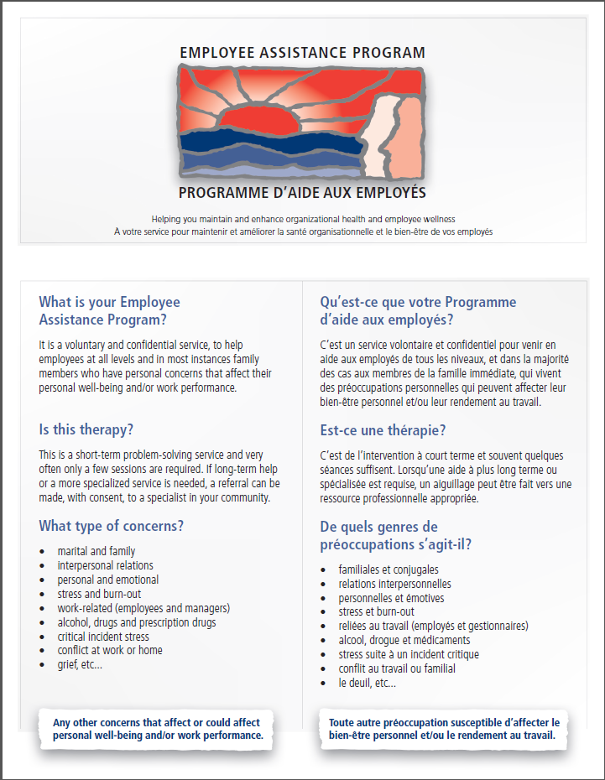

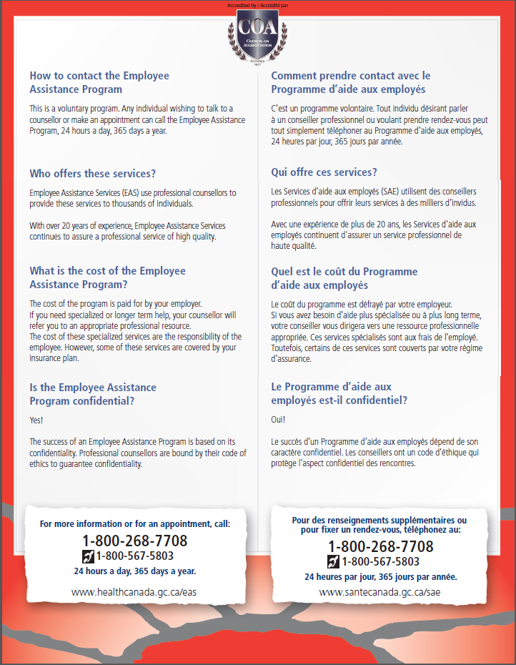

1. A specialist physician or Practitioner Nurse may also fill out the Sick Leave Substantiation Form.
2. Please note that these are the usual circumstances which may require this protocol to be implemented. Other circumstances may require it as well and depending on what they are, not all options may apply.