­

*Unclassified*

**Capacity on Demand – Innovation, Information and Technology branch (IITB) Wave 4 Process**

|  |  |
| --- | --- |
|  |  |
| **Author:** | Investment, Procurement and Project Management (IPPM), CFOB |
| **Revision Date:** | 2021-03-19 |
| **Document Status:** | Final |

# Document Review/ Revision History

|  |  |  |  |
| --- | --- | --- | --- |
| Version | Description of Change(s) | Date | Name |
| 0.1 | Draft | 2020-11-30 | Mimi Rabouin |
| 0.2 | Add Per diem rates | 2021-02-01 | Mimi Rabouin |
| 0.3 | Modify procedure | 2021-03-19 | Mimi Rabouin |

# Document Approvers

|  |  |  |  |
| --- | --- | --- | --- |
| Version | Description | Date | Name |
| 1.0 | Final | 2021-03-19 | Andrea Quinn |
|  |  |  |  |
|  |  |  |  |

Table of Contents

Document Review/ Revision History 2

Document Approvers 2

Purpose 3

*What is IITB Capacity on Demand W4 (COD W4)?* 4

*Who can use IITB COD W4?* 6

*Contact IITB FPS Team* 6

*NA-FPS-SFA-GD@hrsdc-rhdcc.gc.ca* 6

*Client* 6

*Procurement Planning and Advisory Services* 7

*CFOB COD Triage Team* 7

*ESDC Procurement Officer* 7

*Contractor* 7

*Public Services and Procurement Canada (PSPC)* 8

***Step-by-Step Process*** 9

***Documents*** 12

Draft Task Authorization 12

Certifications at the TA Stage (Appendix D to Annex A) 12

***Evaluation Grids and Tasks-Deliverables*** 13

*Cyber Protection Services* 13

*Project Management Services* 14

*Application Services* 15

*IM/IT Services* 16

# Purpose

This document describes the process to leverage the Innovation, Information and Technology Branch (IITB) Capacity on Demand Wave 4 contracts for **Cyber Protection Services**, **Project Management Services, Application Services and IM/IT Services streams** to address specific Information Technology needs and is associated with a specific set of activities and deliverables.

The IITB COD Wave 4 process is to be used by clients who require Information Technology professional services to support the delivery of projects for the department.

***Summary***

*What is IITB Capacity on Demand W4 (COD W4)?*

In an effort to satisfy an ongoing departmental need for Informatics Technology professional services to support various initiatives the Innovation, Information and Technology Branch (IITB) has awarded various task-based contracts (via PSPC as the Contracting Authority) for the following streams:

* + - Cyber Protection Services
    - Project Management Services
    - Application Services
    - IM/IT Services

The contracts are structured as **task-based** where a Task Authorization (TA) is issued to various contractors.

The TA will identify the category of resource required, level of effort, per diem rates and the work to be completed.

*Vendor list and per diem rate**s*

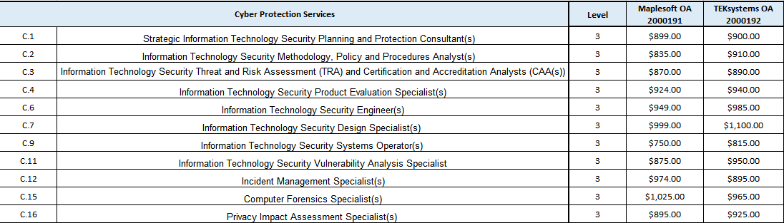



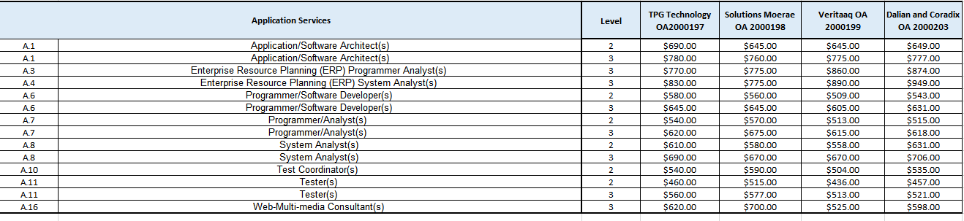

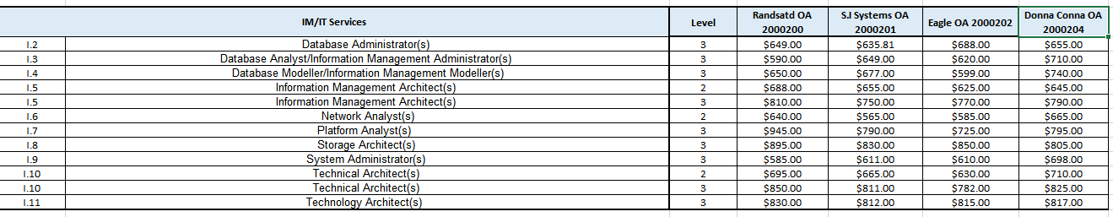

*Who can use IITB COD W4?*

This contract is to be used primarily by IITB only, however with the proper approval of IITB, it could be made available to other ESDC branch clients who require these services to support the delivery of projects for the Department.

The IITB COD W4 contracts were awarded using [Task-Based Informatics Professional Services (TBIPS)](http://www.tpsgc-pwgsc.gc.ca/app-acq/sptb-tbps/index-eng.html). The TA leveraged against theses COD contracts **should be related to a particular activity required to address a specific IT need or linked to an IT enabled project.**

If you are uncertain about whether your work is suited for the IITB COD W4 contracts please contact IITB Forecasting and Procurement Support Team (FPS).

*Contact IITB FPS Team*

[*NA-FPS-SFA-GD@hrsdc-rhdcc.gc.ca*](mailto:NA-FPS-SFA-GD@hrsdc-rhdcc.gc.ca)

***Roles and Responsibilities:***

*Client*

* + Defines requirement;
  + Works with the *Procurement Planning and Advisory Services* team on a Project Procurement Plan (where applicable);
  + Completes Draft Task Authorization form (DTA);
  + For Innovation, Information and Technology Branch (IITB) clients: Complete Procurement Initiation Form (PIF)
  + Project Authority Signs DTA form;
  + Sends DTA form, Project Procurement Plan (where applicable) and PIF (where applicable ) to IITB – Forecasting and Procurement Support Team (FPS) Inbox *(*[*NA-FPS-SFA-GD@hrsdc-rhdcc.gc.ca*](mailto:NA-FPS-SFA-GD@hrsdc-rhdcc.gc.ca)*)* for approval;
  + Client evaluates proposed resource submitted by the FPS Team (IITB) or COD Triage (non-IITB);
  + Client notifies FPS Team (IITB) or COD Triage (non-IITB)that resource was accepted;
  + Upon CFOB Triage Team approval, Client submits Purchase Requisition with completed evaluation grids, CV, DTA Form and Procurement Plan (where applicable) to Procurement via myEMS (SAP) or IITB’s FPS inbox for IITB clients;
  + Manages TA;
  + Closes-out TA;
  + Identifies needs for amendments in a timely fashion (where applicable), including changes of resources;
  + Completes service entry sheet (SES) and pays invoices in myEMS (SAP).

*Forecasting and Procurement Support Team (IITB FPS Team)*

* + Reviews Draft Task Authorization form and verifies that the information provided by the client is appropriate and that the IITB COD W4 is the appropriate method of supply;
  + Provides Draft Tasks Authorization form to CFOB COD triage.
  + Upon approval from *CFOB COD Triage Team*, submits Purchase Requisition with completed evaluation grids, CV, DTA Form Procurement Plan (where applicable) and PIF to Procurement via myEMS (SAP) for IITB clients.

*Procurement Planning and Advisory Services*

* + Procurement Planning and Advisory Services team works with client to create or amend the Project Procurement Plan;
  + Approves Project Procurement Plans;
  + Provides copy of CFOB approved Project Procurement Plan to client.

*CFOB COD Triage Team*

* + Reviews Draft Task Authorization form and verifies that the information provided by FPS Team is appropriate.
  + Advises FPS Team(IITB) or client (non-IITB), by email, that the desired vendor has been approved – or denied;
  + Contacts vendor for CVs and Security Information;
  + Routes CVs from Contractor to FPS Team or client and liaises between FPS Team or client and Contractor as needed;
  + Tracks usage against parent-contract(s);
  + Ensures distribution of work satisfies the obligations in the contracts.

*ESDC Procurement Officer*

* + Reviews Task Authorization to ensure appropriate legal contract language and security;
  + Actions TA in myEMS (SAP) via a Purchase Requisition from the FPS Team or client;
  + Issues TAs to Contractor for signature;
  + Actions amendments upon request from FPS Team or client via a Purchase Requisition;
  + Provides copies of the TA issued by ESDC to client, CFOB COD Triage Team, PSPC and IITB’s FPS inbox (for IITB only).

*Contractor*

* + Provides CVs and Signed Certifications upon request, within the timelines given by *CFOB COD Triage Team;*
  + Reviews TA and returns signed copy to Procurement (within 2 business days);
  + Performs work in accordance with the TA;
  + Provides replacement resources as required;
  + Complies with rules and regulations of the contract.

*Public Services and Procurement Canada (PSPC)*

* + Monitors burn rates of each contract;
  + Actions amendments to the contracts;
  + Issues TA’s over 400k (excluding taxes) to the contractors;
  + Monitors “no response” trends.

***Step-by-Step Process***

|  |  |  |  |
| --- | --- | --- | --- |
| **Step**  **#** | **ACTIVITY** | **Responsibility** | **Tool** |
| 1  2 | Client defines requirement and determines if a new or amended Project Procurement Plan is required.  If a Project Procurement Plan is required then client works with *Procurement Planning and Advisory Services* at the following  General Email Box: [NC-PPAS-PASC-GD](mailto:NC-PPAS-PASC-GD@hrdc-drhc.net). | Client  Procurement Planning and Advisory Services | Statement of Work  Project Procurement Plan |
| 3 | Client submits Draft TA form, PIF (if needed)and Project Procurement Plan (if need be) to the *IITB's FPS Inbox (*[*NA-FPS-SFA-GD@hrsdc-rhdcc.gc.ca*](mailto:NA-FPS-SFA-GD@hrsdc-rhdcc.gc.ca)*) for approval* | Client | Email  Draft TA Form  PIF |
| 4 | *Forecasting and Procurement Support (FPS)Team* reviews the Draft TA form submitted by the client and determines if the IITB COD W4 is the appropriate method of supply and sends the documents to CFOB COD Triage team | Forecasting and Procurement Support Team | Draft TA form  PIF |
| 5 | *CFOB COD Triage Team* will contact contractor requesting:   1. CV(s); 2. Signed certification(s) (Appendix D to Annex A); 3. Security File # and expiry date; 4. Date of Birth. | CFOB COD Triage Team | Email |
| 6 | Contractor provides requested documents to *CFOB COD Triage Team* within the specified time frame | Contractor | Email |
| 7 | *COD Triage Team* sends the signed Draft TA form and resource information to the FPS Team (IITB) or client (non-IITB) | CFOB COD Triage Team | Email |
| 8 | FPS Team sends the signed Draft TA form and resource information to IITB client. | FPS Team | Email |
| 9 | Client evaluates CV(s) using evaluation grids provided. | Client | Evaluation Grid |
| 10 | Client notifies FPS Team (IITB) that resource was accepted, FPS Team notifies CFOB COD Triage Team.  OR  Client (non-IITB) notifies COD Triage that the resource was accepted. | Client | Email |
| 11 | IITB Clients submits documents to *IITB's Inbox (*[*NA-FPS-SFA-GD@hrsdc-rhdcc.gc.ca*](mailto:NA-FPS-SFA-GD@hrsdc-rhdcc.gc.ca) *for submission of Purchase Requisition*  Non-IITB Clients submits a Purchase Requisition (PREQ) to Procurement via myEMS (SAP)  FPS team and Non-IITB client must ensure that the following information is included in the PREQ:   * Header Text reference  “IITB COD W4 Contract” and name of the contractor to be used * GL   533701 – Information Technologies Consultants   * Approved draft TA form * Signed certification:  Appendix D to Annex A  (for the successful resource only) * CV * Completed and signed evaluation grid (for the successful resource only) * Security Information (i.e. Date of birth, PSPC file #) * CFOB approved or amended Procurement Plan, if applicable. * PIF, if applicable | Client  Forecasting, Procurement Support Team | myEMS (SAP) |
| 12 | ESDC Procurement Officer will review the approved Draft TA and supporting documentation.  Once documentation provided by the client is complete and in order, a TA will be issued.  A TA will be issued to the contractor with a copy (cc) to the client, CFOB COD Triage Team, IITB FPS Team (for IITB only) and PSPC. | Procurement | TA |
| 13 | Contractor signs the TA and sends back to ESDC Procurement Officer by replying all. | Contractor | TA |
| 14 | *CFOB COD Triage Team* tracks usage against contracts to ensure that the work is being evenly distributed, as per the terms of the contract. | CFOB COD Triage Team | Excel |
| 15 | Client manages TA:   * Tracks completion of deliverables and manages burn rate. * Requests amendments in a timely manner as required. | Client | TA and myEMS(SAP) |

***Documents***

## Draft Task Authorization



## Certifications at the TA Stage (Appendix D to Annex A)



* **IITB Procurement Initiation Form (PIF)**

[Procurement Initiation Form](https://dialogue/grp/SFI-IFS/RM%20TEST/Formulaire%20d'initiation%20d'approvisionnement%20(FIA-DGIIT)%20-%20Procurement%20Initiation%20Form%20(IITB-PIF).xlsm)

***Evaluation Grids and Tasks-Deliverables***

*Cyber Protection Services*

|  |  |  |
| --- | --- | --- |
| **Cyber Protection Services** | **Evaluation Grids** | **Tasks and Deliverables** |
| C.1 Strategic Information Technology Security Planning and Protection Consultant(s) Level 3 |  |  |
| C.2 Information Technology Security Methodology, Policy and Procedures Analyst(s) Level 3 |  |  |
| C.3 Information Technology Security Threat and Risk Assessment (TRA) and Certification and Accreditation Analysts (CAA(s))  Level 3 |  |  |
| C.4 Information Technology Security Product Evaluation Specialist(s)  Level 3 |  |  |
| C.6 Information Technology Security Engineer(s)  Level 3 |  |  |
| C.7 Information Technology Security Design Specialist(s) Level 3 |  |  |
| C.9 Information Technology Security Systems Operator(s)  Level 3 |  |  |
| C.11 Information Technology Security Vulnerability Analysis Specialist  Level 3 |  |  |
| C.12 Incident Management Specialist(s)  Level 3 |  |  |
| C.15 Computer Forensics Specialist(s)  Level 3 |  |  |
| C.16 Privacy Impact Assessment Specialist(s) Level 3 |  |  |

*Project Management Services*

|  |  |  |
| --- | --- | --- |
| **Project Management Services** | **Evaluation Grids** | **Tasks and Deliverables** |
| P.2 Enterprise Architect(s) Level 3 |  |  |

## *Application Services*

|  |  |  |
| --- | --- | --- |
| **Application Services** | **Evaluation Grids** | **Tasks and Deliverables** |
| A.1 Application/Software Architect(s)  Level 2 |  |  |
| A.1 Application/Software Architect(s)  Levels 3 |  |  |
| A.3 Enterprise Resource Planning (ERP) Programmer Analyst(s)  Level 3 |  |  |
| A.4 Enterprise Resource Planning (ERP) System Analyst(s)  Level 3 |  |  |
| A.6 Programmer/Software Developer(s)  Level 2 |  |  |
| A.6 Programmer/Software Developer(s)  Level 3 |  |  |
| A.7 Programmer/Analyst(s) Level 2 |  |  |
| A.7 Programmer/Analyst(s) Level 3 |  |  |
| A.8 System Analyst(s)  Level 2 |  |  |
| A.8 System Analyst(s)  Level 3 |  |  |
| A.10 Test Coordinator(s)  Level 2 |  |  |
| A.11 Tester(s)  Level 2 |  |  |
| A.11 Tester(s)  Level 3 |  |  |
| A.16 Web-Multi-media Consultant(s)  Level 3 |  |  |

## *IM/IT Services*

|  |  |  |
| --- | --- | --- |
| **IM/IT Services** | **Evaluation Grids** | **Tasks and Deliverables** |
| I.2 Database Administrator(s) Level 3 |  |  |
| I.3 Database Analyst/Information Management Administrator(s) Level 3 |  |  |
| I.4 Database Modeller/Information Management Modeller(s)  Level 3 |  |  |
| I.5 Information Management Architect(s)  Level 2 |  |  |
| I.5 Information Management Architect(s)  Level 3 |  |  |
| I.6 Network Analyst(s)  Level 2 |  |  |
| I.7 Platform Analyst (s)  Level 3 |  |  |
| I.8 Storage Architect(s)  Level 3 |  |  |
| I.9 System Administrator(s) Level 3 |  |  |
| I.10 Technical Architect(s) Level 2 |  |  |
| I.10 Technical Architect(s) Level 3 |  |  |
| I.11 Technology Architect(s) Level 3 |  |  |