­

*Unclassified*

**Capacity on Demand – Non-IT Business Consulting / Change Management and Project Management Services Process**

|  |  |
| --- | --- |
|  |  |
| **Author:** | Investment, Procurement and Project Management (IPPM), CFOB |
| **Revision Date:** | 2021-04-15 |
| **Document Status:** | Final |

# Document Review/ Revision History

|  |  |  |  |
| --- | --- | --- | --- |
| Version | Description of Change(s) | Date | Name |
| 0.1 | Draft | 2021-04-15 | Mimi Rabouin |
|  |  |  |  |

# Document Approvers

|  |  |  |  |
| --- | --- | --- | --- |
| Version | Description | Date | Name |
| 1.0 | Approval | 2021-04-15 | Andrea Quinn |

Table of Contents

Document Review/ Revision History 2

Document Approvers 2

Purpose 3

***Summary*** 4

*What is Capacity on Demand COD?* 4

*Who can use COD Non-IT* 4

*Contact COD Triage Team* 4

***Roles and Responsibilities:*** 5

*Client* 5

*Procurement Planning and Advisory Services (PPAS)* 5

*COD Triage Team* 5

*ESDC Procurement Officer* 5

*Contractor* 6

***Step-by-Step Process*** 7

***Documents*** 9

Draft Task Authorization (DTA) 9

Certifications at the TA Stage (Appendix to Annex D) 9

***Basis of Payment*** 10

***Flexible Grids*** 11

# Purpose

This document describes the process to leverage the Capacity on Demand contracts for Business Consulting / Change Management and Project Management Services to address specific Non- Informatics (Non-IT) Technology needs and is associated with a specific set of activities and deliverables.

***Summary***

*What is Capacity on Demand (COD) Business Consulting / Change Management and Project Management Services?*

In an effort to satisfy an ongoing departmental need for Non- IT professional services to support various initiatives the Chief Financial Officer Branch (CFOB) has awarded two (2) task-based contracts for the following streams:

* + - Business Consulting / Change Management Services
    - Project Management Services

The contracts are structured as **task-based** where a Task Authorization (TA) is issued to the contractors.

The TA will identify the category of resource required, level of effort, per Diem rates and the work to be completed.

*Who can use COD Non-IT?*

All branches of ESDC

If you are uncertain about whether your requirement is suited for this COD contracts please contact the *COD Triage team*.

If it is determined your requirements are not suitable for the COD Non-IT contracts, an alternate method of supply to meet your needs, may be [Task and Solutions Professional Services (TSPS)](http://www.tpsgc-pwgsc.gc.ca/app-acq/spc-cps/spcts-tsps-eng.html). TSPS are used for the provision of **Non-IT Professional Services**, both task and solution based.

*Contact COD Triage Team*

[NC-COD-CALD-GD@hrsdc-rhdcc.gc.ca](mailto:NC-COD-CALD-GD@hrsdc-rhdcc.gc.ca)

***Roles and Responsibilities:***

*Client*

* + Defines requirement;
  + Works with the *Procurement Planning and Advisory Services (PPAS)* team on a Project Procurement Plan (where applicable);
  + Completes Draft Task Authorization form (DTA);
  + Project Authority Signs DTA form;
  + Sends DTA form and Project Procurement Plan (where applicable) to   
    *COD Triage Team (Triage Team);*
  + Client evaluates proposed resource submitted by the *Triage Team* using the flexible grid*;*
  + Upon *Triage Team* approval, Client submits Purchase Requisition with completed flexible grid, CV, Approved DTA Form and Procurement Plan (where applicable) to Procurement via myEMS (SAP);
  + Manages TA;
  + Closes out TA;
  + Identifies needs for amendments in a timely fashion (where applicable), including changes of resources;
  + Completes Service Entry Sheet (SES) and pays invoices in myEMS (SAP).

*Procurement Planning and Advisory Services (PPAS)*

* + PPAS team works with client to create or amend the Project Procurement Plan;
  + Approves Project Procurement Plans;
  + Provides copy of CFOB approved Project Procurement Plan to client.

*COD Triage Team*

* + Reviews DTA form and verifies that the information provided by the client is appropriate and can be supported by COD Non-IT Contracts;
  + Obtains approval from the Enterprise Project Management Office within the Investment, Procurement and Project Management directorate for requirements under the Project Management Services stream;
  + Obtains approval from the Transformation and Integrated Service Management Branch for requirements under the Business Services stream;
  + If it is determined that the COD Non-IT is the appropriate method of supply,   
    *Triage Team* signs the DTA;
  + Advises client, by email, that the request has been approved – or denied;
  + Contacts vendor for CVs and Security Information;
  + Routes CVs from Contractor to Client and liaise between Client and Contractor as needed;
  + Tracks usage against parent-contract;

*ESDC Procurement Officer*

* + Reviews TA to ensure appropriate legal contract language and security;
  + Reviews TA to ensure that it matches what was approved in the Project Procurement Plan (if applicable);
  + Issues TAs to Contractor for signature;
  + Actions TA in myEMS (SAP) via a Purchase Requisition from the client;
  + Provides copy of signed TA to client;
  + Actions amendments upon request from client via a Purchase Requisition;
  + Provides copies of the TA issued by ESDC to *Triage Team*.

*Contractor*

* + Provides CVs , Signed Certifications and PWGSC Security Clearance File Number and date of birth , within the timelines given by *Triage Team;*
  + Reviews TA and returns signed copy to Procurement (within 2 business days);
  + Performs work in accordance with the TA;
  + Provides replacement resources as required;
  + Complies with rules and regulations of the contract.

***Step-by-Step Process***

| **Step #** | **ACTIVITY** | **Responsibility** | **Tool** |
| --- | --- | --- | --- |
| 1 | Client defines requirement and determines if a new or amended Project Procurement Plan is required. | Client | Statement of Work |
| 2 | If a Project Procurement Plan is required then client works with *Procurement Planning and Advisory Services (PPAS)* at the following General Email Box: | PPAS | Project Procurement Plan |
| [NC-PPAS-PASC-GD.](mailto:NC-PPAS-PASC-DG@hrsdc-rhdcc.gc.ca) |
| 3 | Client submits Draft TA form and Project Procurement Plan (if needed) to the COD Triage Team at the following General Email Box for review: | Client | Email |
| [NC-COD-CALD-GD](mailto:NC-COD-CALD-GD@hrsdc-rhdcc.gc.ca) |
| 4 | *COD Triage Team* reviews the Draft TA form submitted by the client and determines if the COD Non-IT is the appropriate method of supply. | COD  Triage Team | Draft TA form |
| 5 | To ensure that capacity for particular resources does not already exist in the department, COD Triage Team will send the Draft TA form to:   1. The Enterprise Project Management Office, within the Investment, Procurement and Project Management directorate, for requirements under the Project Management Services Stream.      1. The Transformation group in the Transformation and Integrated Service Management Branch, for requirements under the Business Service Stream. | COD  Triage Team | Draft TA form |
| 6 | If COD Non-IT is the appropriate method of supply, *COD Triage Team* will advise the client by email. | COD  Triage Team | Email |
| 7 | *COD Triage Team* will contact contractor and request: | COD Triage Team | Email |
| 1)     CV(s);  2)     Signed certification(s) (Appendix to Annex D);  3)     Security File;  4)     Date of Birth. |
|  |
| 8 | Contractor provides requested documents to *COD Triage Team* within the specified time frame. | Contractor | Email |
| 9 | *COD Triage Team* sends the signed Draft TA form and resource information to the client, including the appropriate Flexible Grid. | COD Triage Team | Email |
| 10 | Client evaluates CV(s) using Flexible Grid provided. | Client | Flexible Grid |
| 11 | Client submits a Purchase Requisition (PREQ) to Procurement via myEMS (SAP)  Client to ensure that the following information is included in the PREQ:   1. Header Text   “COD Non-IT Project Management Services Contract 2000212 -Maplesoft Consulting Inc” or  “COD Non-IT Business Services Contract 2000213 – BDO Canada LLP.”   1. GL   533801 – Management Consulting   1. Approved Draft TA form 2. Signed certification: Appendix to Annex D 3. CV 4. Completed and signed flexible grid (for the successful resource only) 5. Security Information (i.e. Date of birth, PSPC file #) 6. CFOB approved or amended Procurement Plan, if applicable. | Client | myEMS (SAP) |
| 12 | ESDC Procurement Officer will review the Draft TA and supporting documentation. | Procurement | TA |
| Once documentation provided by the client is complete and in order, a TA will be issued. |
| A TA will be issued to the contractor with a copy (cc) to the client **and** *COD Triage Team.* |
| 13 | Contractor signs the TA and sends back to ESDC Procurement Officer by replying all. | Contractor | TA |
| 14 | ESDC Procurement Officer ensures that a copy of the signed TA went to the client and to the *COD Triage Team* for tracking purposes. | Procurement | TA |
| 15 | *COD Triage Team* tracks usage against contract. | COD Triage Team | Excel |
| 16 | Client manages TA:   1. Tracks completion of deliverables and manages burn rate. 2. Requests amendments in a timely manner as required. | Client | TA and myEMS(SAP) |

***Documents***

## Project Management

**Contract #: 2000212**

**Name: Maplesoft Consulting Inc.**

## Draft Task Authorization (DTA)



## Certifications at the TA Stage (Appendix D to Annex A)



## Business Consulting / Change Management

**Contract #: 2000213**

**Name: BDO Canada LLP**

## Draft Task Authorization (DTA)



## Certifications at the TA Stage (Appendix D to Annex A)



***Basis of Payment, Tasks and Deliverables and flexible grid***

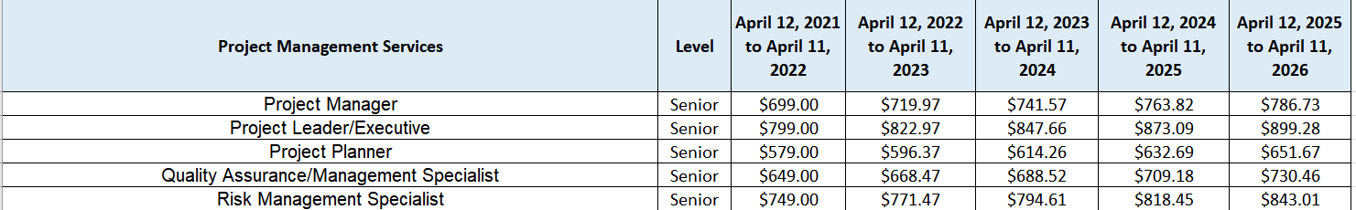

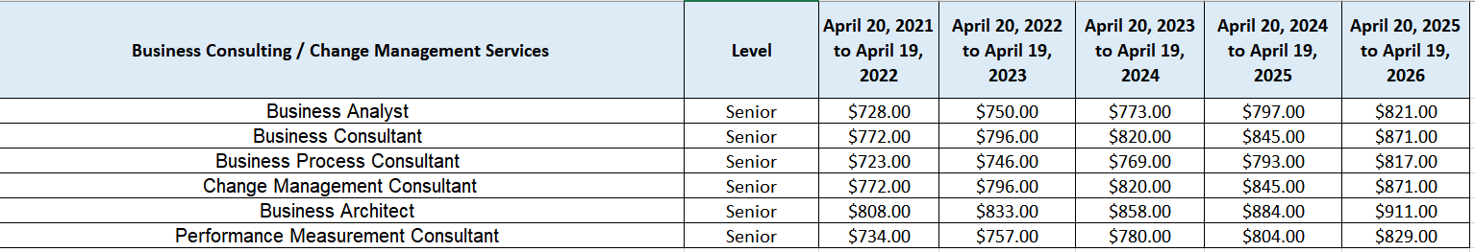

|  |  |  |
| --- | --- | --- |
| Project Management Services | **Tasks and Deliverables** | **Evaluation Grid** |
| Project Manager |  |  |
| Project Leader/Executive |  |  |
| Project Planner |  |  |
| Quality Assurance/Management Specialist |  |  |
| Risk Management Specialist |  |  |

|  |  |  |
| --- | --- | --- |
| Business Consulting / Change Management | **Tasks and Deliverables** | **Evaluation**  **Grid** |
| Business Analyst |  |  |
| Business Consultant |  |  |
| Business Process Consultant |  |  |
| Change Management Consultant |  |  |
| Business Architect |  |  |
| Performance Measurement Consultant |  |  |