# Searching and Displaying Purchase Requisitions (PReqs) in myEMS

This procedure provides information on:

* How to get a list of PReqs for your cost center
* How to find the name of the Procurement Specialist assigned to your PReq
* How to find the status of your PReq

1. From the portal, choose the *Materials Management* tab, click on *Requisitioner*

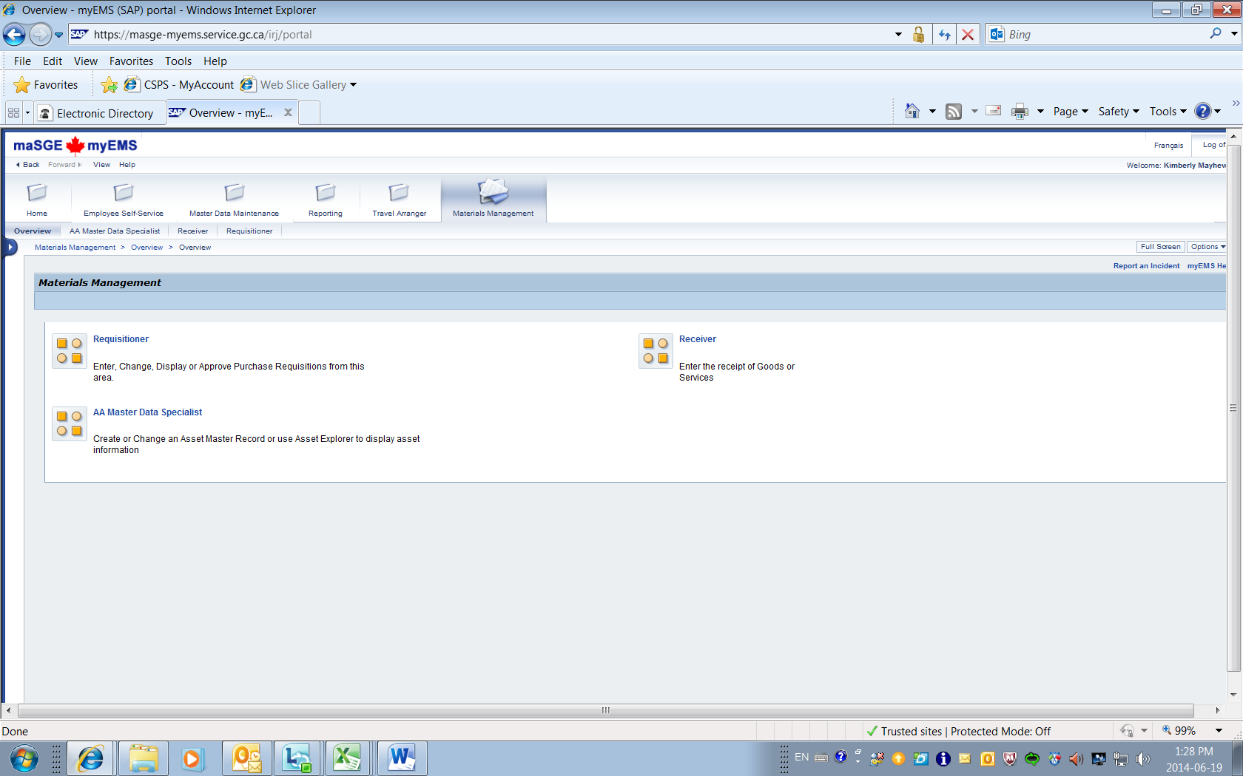

1. Click *Purchasing Documents*, then *Document Tracing*

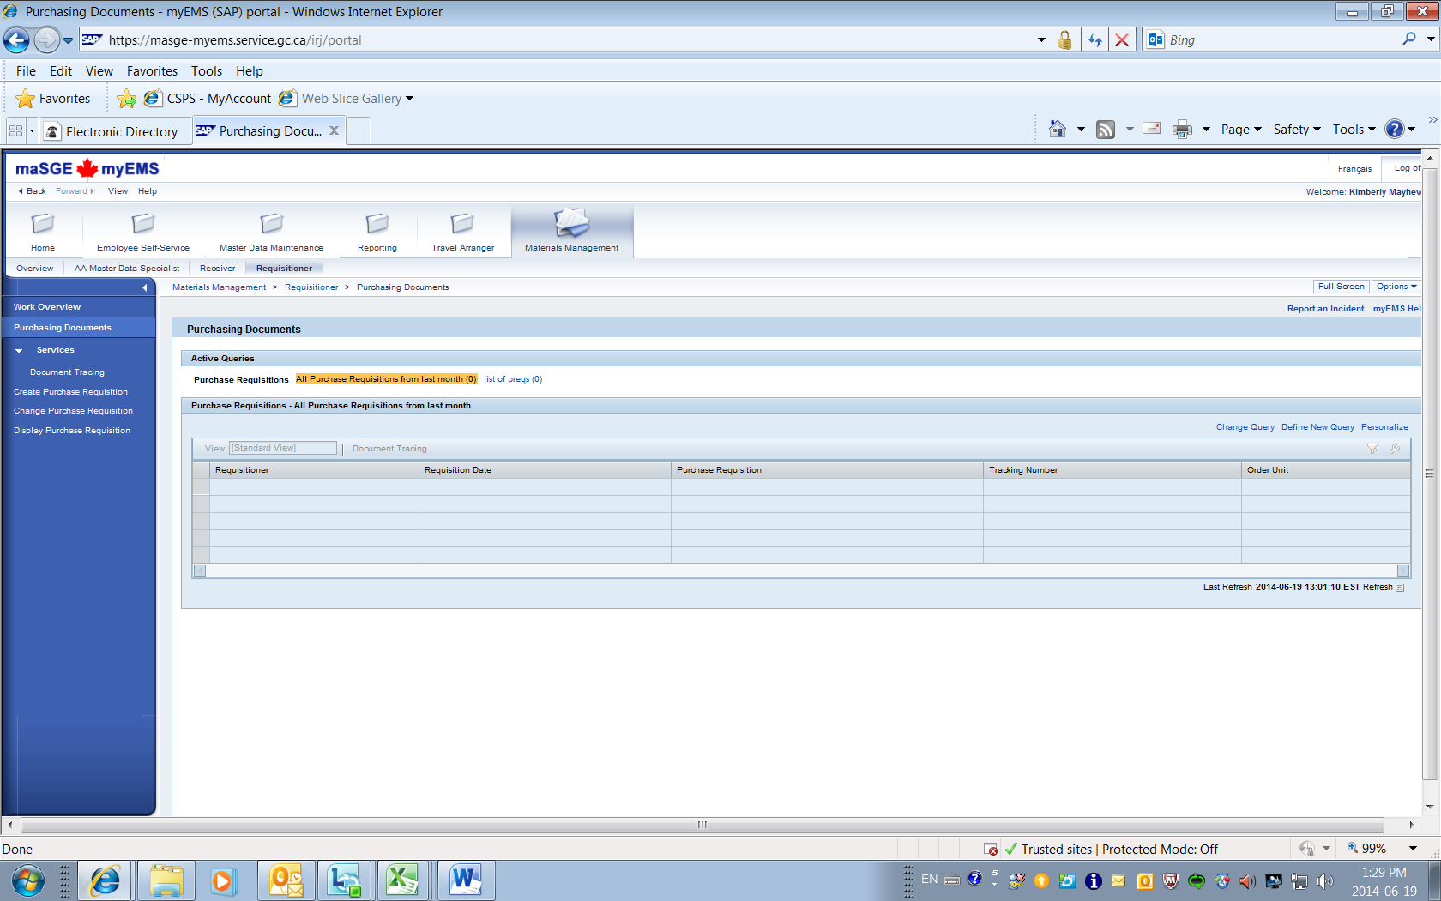

1. In the *Search* box, click *Purchase Requisition*
2. In the *Document Number* box, click the window drop down menu

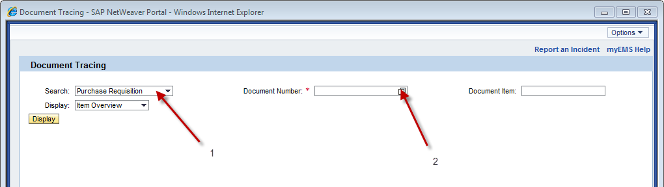

1. In the window *More Search Help*, choose *Purchase Requisition per Cost Center* (other options are available if you wish)
2. In the *Cost Center* window, enter the cost center you want to search for
3. Click the button *Start Search*

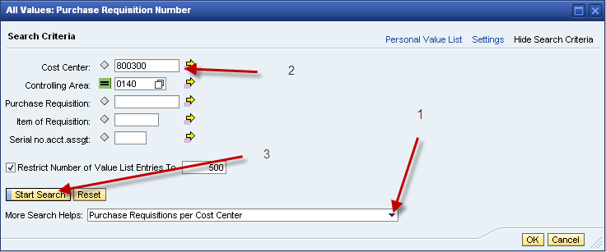

1. A list of PReqs will appear, showing **each line** of the PReqs. **Stop here if what you want is a list of PReqs.**
2. To find the status of your PReq or to find the name of the Procurement Specialist assigned to your file, click on the PReq number on the list

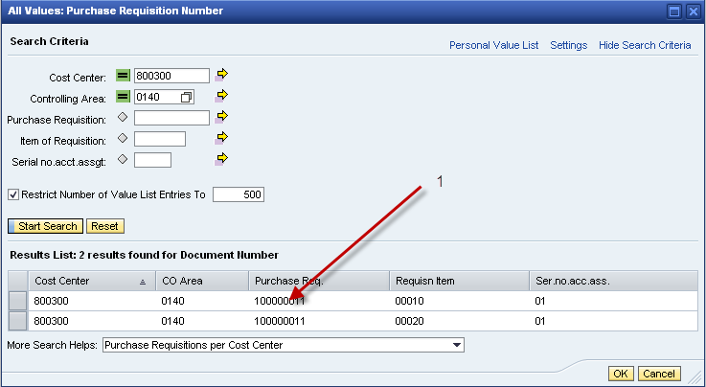

1. Click the *Display* button in the window that pops up – you will see the PReq number in the *Document Number* window

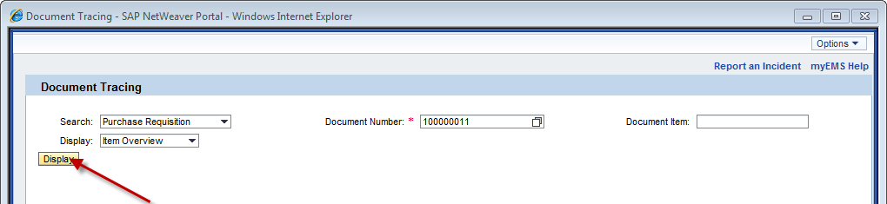

1. Click one of the lines of the PReq

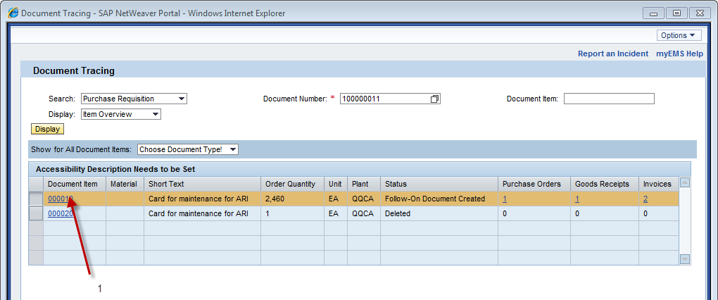

1. To find out the status of your PReq, click the *Status* tab
2. To find out the name of the Procurement Specialist on the file, click the drop down icon in the column PGr beside the number identified (note the number)

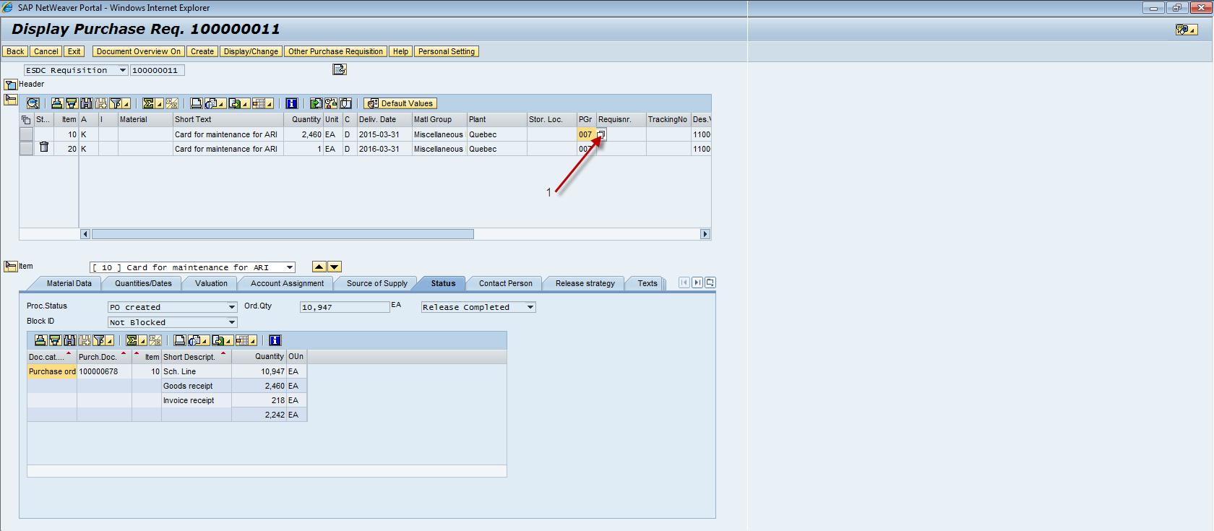

1. A window will pop up showing a list of names of Procurement Specialists by number; locate your number to find the name and phone number of the Procurement Specialist assigned to the PReq.

