Human Resources and Skills Development Canada

Receipt and Deposit National Directive

HRSDC / Service Canada

Table of Contents

1 Effective Date 5
2 Policy Objective 5
3 Policy Statement 5
4 Application 5
5 Process mapping 6
6 Roles and Responsibilities of the Service Canada Centers 8
6.1 Training and Statement of Responsibilities: 8
6.2 Lock Boxes: 8
6.3 Safes: 8
6.4 Change Floats: 9
6.5 Secure Pouches and Numbered Seals/Tags: 9
6.6 Point of Sale Terminals: 9
7 Procedures of the Service Canada Centers 10
7.1 Local Web Receipt (LWR) 10
7.2 Accepted Methods of Payment 10
7.2.1 Canadian money cheque drawn from a non Canadian bank 11
7.3 Cash Payment Procedures 12
7.3.1 Counterfeit bill: 12
7.4 Cheque, Certified Cheque, Money Order or Draft 12
7.4.1 Returned warrant (EI) 12
7.4.2 Returned CPP/OAS cheque 13
7.5 Post-Dated Cheques 14
7.6 Credit/Debit Cards 14
7.7 Other Government Department payments 17
7.8 Cash Float Shortages 17
7.9 Passport applications 17
8 Service Canada Centers (SCC) - End of day procedures 18
9 Roles and Responsibilities - Processing Offices 22
10 Processing office procedures 23
10.1 Mail handling 23
10.1.1 Mail Delivered by Canada Post or Courier Services: 23
10.1.2 Receipt of Revenue via Courier from Local Offices: 23
10.2 Bank Deposits 23
10.3 Cashier Shortages 25
10.4 CMS - ARADS Preparation 27
10.4.1 Bank Authorization Numbers – Bank of Nova Scotia POS Terminals: 27
10.4.2 Separate Bundles: 27
10.4.3 CMS-ARADS Screen EA201 Input: 28
10.5 CMS - ARADS Input 28
10.5.1 Mandatory Information to be entered on the EA201 screen: 29
10.5.2 Mask Card Number Option: 30
10.5.3 Credit/Debit Card Transactions: 30
10.5.4 Completion of CMS Revenue Screens – Multiple Payments: 31
10.5.5 Directed/Undirected Payments in DARS: 31
10.5.6 Examples - Multiple Payments – Different Payer 32
10.5.7 Locked bundle: 37
10.5.8 Returned EI warrant 39
10.5.9 Returned CPP/OAS cheque 40
10.6 Approval of deposit 40
10.7 Foreign Currency 43
10.8 Locked Authorisation Number - Deposit processing 46
10.9 Transfer of money received to an OGD - Other than Passport 47
10.10 Monitoring 48
10.11 Chargeback’s 48
10.11.1 Processing Canadian NSF in ARADS: 49
10.11.2 Processing Foreign NSF in ARADS: 49
10.11.3 Systems Bugs on Foreign NSF: 49
10.12 Reminder to cashier 51
10.13 8323 ARADS Suspense 52
10.13.1 To clear a current fiscal year transaction 52
10.13.2 To clear a previous fiscal year transaction 53
10.13.3 Refunds of Miscellaneous Revenue 53
10.14 Archive - Retention Periods 54
10.15 Procedures - Bank Reconciliation / RHQ 54
11 Roles and Responsibilities of NHQ 61
12 Procedures of NHQ 62
12.1 Clearing Matane’s suspense account 62
12.2 Passport Applications 64
13 References 65
14 Contact person 65
15 Appendix A - STATEMENT OF RESPONSIBILITIES 66
16 Appendix B - (LWR) – Questions and Answers 67
17 Appendix C - PPTC184 80
18 Appendix D - Old Receipt and Deposit envelope instructions 81
19 Appendix E - Barcode Tracking Sheet 86
20 Appendix F – All purpose letter 87
21 Appendix G –Payment Money transfer record 88

Sept 2009 | L. Potvin | Accepted Methods of Payment Sect 7.2
Dec 2009 | L. Potvin | Local Web Receipt Sec 7.1
July 2009 | L.Guérin | Appendix D - Old Receipt and Deposit envelope instructions Page 82
July 2009 | L.Guérin | Canadian money cheque drawn from a non Canadian bank Sect 7.2.1
Novembre 2010 | G. Loiselle / M. Lauriault | Replaced ''Parent/satellite'' offices with ''Local'' offices or ''SCC''  Removed procedures related to decentralized offices  Section 5 Process mapping: updated - Added under client's column - Web payment  Section 7.3.1 Added the link for Bank of Canada  Section 7.4 added Amounts and signature on the cheque  Section 7.4.1 added a section for EI Warrants (7.4.1) and on CPP/OAS cheques (7.4.2)  7.6 New chip POS machine process and the client will have to sign the receipt to authorize the transaction.”  Section 8 : removed Lyne Gérin's name  Section 8.9 : Last sentence modified  Section 10.1.2 12 : complete section modified.  Section 10.5.5 Directed Payments : changed LWR for CMS  Section 10.5.6 Addition of a section for EI Warrants Section 10.5.7 Addition of a section for CPP/OAS cheques  Section 10.7 added OAS  Section 10.10 screen AA001 addition of: older than 10 days  Section 10.14 The QA006 Screen print of each bundle requirement is removed. Regions will be responsible to print the QA006 upon request.  Section 10.15 Removed Kim Garamvolgyi's name  Removed CEE11 from the definition source 0060  Added Cash and cheque to Deposit not yet approved  Section 2nd research Remove CMS DH002 replace by DARS DH002  Section 14 Remove Lyne's name  Appendix F : Change the suspense letter for the all purpose letter  Policies ' link updated
December 2010 | M. Lauriault | Sections 7.2, 7.6, 10.5.2 and 10.5.3 Acceptable credit card, replaced American Express by AMEX.
May 16, 2011 | M. Lauriault | Section 7.4 - Removal of : Bank authorization number
May 24, 2011 | M. Lauriault | Replaces : Citizen Service Agents (CSA) by Citizen Service Officers (CSO).

Receipt and Deposit National Directive

Effective Date

This directive on receipt and deposit takes effect immediately.

Policy Objective

To clarify roles and responsibilities and ensure consistency and uniformity with respect to the national receipt and deposit process.

Policy Statement

It is the government's policy to ensure that public money it receives is promptly deposited to prevent and reduce, to the extent possible, instances of error, fraud, or omission and to decrease the need to borrow.

The mission of the National Accounts Receivable is to effectively carry out the accounting of the deposits and the money due to the department. The team pledges to offer a high quality service, on a timely basis and with professionalism to its customers. Moreover, we have a role as leader by advising the regions and our partners.

Application

These directives apply to Citizen Service Officers (CSO), Finance Clerks, Processing Clerks and others with receipt and deposit responsibilities who are employed in Service Canada Centres (SCC), Processing Offices across Canada and any Chief Financial Officer Branch employee involved in the receipt and deposit of public money.

Process mapping -

Roles and Responsibilities of the Service Canada Centers

The screens mentioned in this document refer to the Corporate Management System (CMS) and the Local Web Receipt (LWR) system.

Training and Statement of Responsibilities:

Service Canada Centres are responsible for ensuring that prior to assuming receipt and deposit responsibilities the Citizen Service Officers (CSO’s) will:

Receive the appropriate training,
and
Sign the “Statement of Responsibilities for Cashiers” (Appendix A).

Lock Boxes:

Each Service Canada Service Centre (SCC) is required to have a lock box for use by the (CSO)’s. The lock box is to be secured in a central location, away from public access and used to store “all” envelopes with payments/cancelled payments during the day.

The person(s) responsible for the lock box will:

- Be responsible for the key to open the lock box;
- Know where the spare key is kept in (a safe or secured cabinet);
- Ensure nothing is left in the lock box overnight.

Safes:

Each SCC is required to have an RCMP approved safe for use by the CSO’s for overnight storage. The safe is to be used to store “all” reconciled envelopes with payments/cancelled payments at the end of the day. The combination should only be known by a restricted number of people and must be changed as soon as there is a change in the personnel having the combination or at a minimum once a year.

Change Floats:

The Change float Custodian is responsible for:

- Reading the appropriate materials and signing a Statement of Responsibilities for Petty Cash Fund or Change Float Custodian, Alternates and Designated Employees, acknowledging responsibility for the change float;

- Ensuring the cash float is being used for the appropriate purpose;
- Maintaining the key to the change float;
- Securing the change fund in a locking cash box;
- Storing the change float in a safe or secure storage area when not in use;
- Accessing and making change from the change float;
- Carefully reconciling the money in the change fund;
- Reporting any shortages or overages in the change fund to the Team Leader/Manager/Director; and when required, completing an “incident” report;
- Completing a “Transfer of Change Fund” (E-form FIN 2116) to temporarily transfer the change fund between the custodian and the temporary custodian.

In the event of an extended absence:

- A second change float key will be secured in the safe, known and accessible to the Team Leader/Manager/Director only; and
- If both the custodian and back-up are absent, the Team Leader/Manager/Director and the individual who is designated as alternate during the absence will open the cash box, count the contents and complete a Transfer of Change Fund form to be retained on file.

Secure Pouches and Numbered Seals/Tags:

Are to be used at all times, when securing cash and negotiable assets for shipment to their processing office.

Point of Sale Terminals:

All SCC’s are equipped with Point of Sale (POS) Terminal and may accept both Credit and Debit Cards.

CSO’s may only accept credit card payments for fees for services, including:

- SIN applications, and
- Passport applications;
- POS are set for “automatic settlement” at 02h00am eastern time for offices who forget to settle at the end of the day. This may cause a difference in the bank reconciliation and should happen only in exceptional circumstance.

To protect the client’s information, if the machine prints the complete credit card number, you should phone Chase Paymentech directly for instructions on how to mask the card Number on the POS machine.

Procedures of the Service Canada Centers

Local Web Receipt (LWR)

CSO in SCC’s across Canada process various applications and receive and process payments from multiple sources. The payments are entered in the LWR application and inserted into deposit envelopes. The deposit envelopes are then forwarded to the Processing Offices located, usually at Regional Headquarters for reconciliation and approval in the Corporate Management System (CMS).

You will find the “LWR Questions and Answers” document in Appendix B of this directive.

CSO’s must complete the Computer base training for the LWR application. Instructions can be found at the following site:

http://intracom.hq-ac.prv/sc-college/eng/finance/LWR/lwr.shtmlAccepted Methods of Payment
IMPORTANT:

- Cash and negotiable items are to be safeguarded and recorded promptly;
- Under no circumstances will money be left on a desk or counter.

Only the following methods of payment are acceptable:
 | SIN | Passport | DARS | CPP | OAS | Other
Cash | Allowed | Allowed | Allowed | Allowed | Allowed | Allowed
Money order | Allowed | Allowed | Allowed | Allowed | Allowed | Allowed
Bank draft | Allowed | Allowed | Allowed | Allowed | Allowed | Allowed
Personal Cheque | Allowed | X | Allowed | Allowed | Allowed | Allowed
Post dated cheque | X | X | Allowed | Allowed | Allowed | Allowed
Certified cheque | Allowed | Allowed | Allowed | Allowed | Allowed | Allowed
Government cheque | Allowed | Allowed | Allowed | Allowed | Allowed | Allowed
Traveller's cheque | Allowed | Allowed | Allowed | Allowed | Allowed | Allowed
Cheque drawn from a Credit Card | Allowed | Allowed | X | X | X | Allowed
Credit card 1 | Allowed | Allowed | X | X | X | Allowed
Debit card 2 | Preferred | Preferred | Preferred | Preferred | Preferred | Preferred

- 1Visa / MasterCard / American Express;
- 2 Visa Debit card not accepted as per Receiver General’s memo dated December 7, 2010

Foreign currency is only accepted for repayment of an overpayment (DARS/CPP/OAS).
Clients should be strongly encouraged to pay in Canadian currency. However, the following foreign funds may be accepted:

- Australian Dollar
- British Pound
- Danish Krone
- Euro Dollar
- Japanese Yen
- New Zealand Dollar
- Swiss Franc
- US Dollar

Clients wishing to pay in a foreign currency must understand that:

- No exchange or change will be given at this point;
- The client may have to pay the cost of conversion;
- The payment applied will be in Canadian currency;
- If a credit card is used, the transaction must be recorded in Canadian dollars on the sales draft/slip. The credit card company will calculate the conversion and report the charge on the client’s statement in the appropriate currency.

CSO's accept payments on behalf of various programs and departments; however, wherever possible, CSO's should avoid accepting payments intended for Canada Revenue Agency (CRA). Advise the client of the advantages of using other payment methods (e.g. Internet payment, directly to CRA office, automatic teller machine, bank cashiers, etc.) because the account of the client will be adjusted faster if the payment is done directly to CRA, resulting in lower interest charged. If the client still wants to make the payment, you should accept it. We must never send a payment to another government department in the mail.

Canadian money cheque drawn from a non Canadian bank

All agents should be made aware that when dealing with an overseas client, they should always request a cheque in Canadian currency drawn from a Canadian bank or and International cheque or money order to recover the overpayment and or Debt to the Crown, otherwise there may be cost involved that will have to be absorbed by the depositing RC Manager.

7.3 Cash Payment Procedures

Regions having an “Exact Change Only” policy must post a sign to inform clients of the policy and identifying various payment options available to them see example:

The authorized CSO who receives a cash payment will:

- Count the cash twice in presence of the client to confirm that the correct amount has been received, and
- Once counted , input the payment in LWR;
- Give the LWR receipt to the client;
- Seal the envelope in front of the client and place the envelope in a lock box.

7.3.1 Counterfeit bill:
It is illegal to knowingly use a counterfeit bill or to keep one without a lawful reason.
If you work with customers:
You must ensure that you not accepting counterfeit money. The bank of Canada site explains how to verify if the bill is genuine.

http://www.bankofcanada.ca/en/banknotes/counterfeit/security_features.html

If you suspect being handed a counterfeit bill, please follow the procedures of Bank of Canada:
- Explain that you think the bill may be a fake. Ask for another bill – one with a metallic stripe.
- Advise the customer that the bill should be given to local police for verification.
- Notify the local police of an attempt to pass a suspected fake bill.
- Avoid putting yourself at risk.
- Remember that the customer may not know that the bill is suspicious and may be an innocent victim.

http://www.bankofcanada.ca/en/banknotes/fraud/tip_sheet09.pdf

7.4 Cheque, Certified Cheque, Money Order or Draft

Upon receipt of a cheque, certified cheque, money order or draft, an authorized (CSO) will stamp the cheque “For deposit to the Credit of the Receiver General for Canada” and also ensure that:

- The date on the Cheque/Money Order is correct (i.e. current date or before, but not stale dated – date older than six months);
- The payee is the Receiver General for Canada;
- Amounts on the cheque
- Signature

7.4.1 Returned warrant (EI)
Upon receipt of an Employment Insurance (EI) warrant, CSO have to follow these procedures:
- Input the warrant for other services
- Description field must have reason for the return claimant is deceased or not allowed to have this warrant, not the good address etc.) and phone number
- Register the warrant as certified cheque
- Issue a receipt to the claimant or third party
- Write on the receipt : RETURN WARRANT
- Complete the return payment check list (Word format)
- Print the checklist and attach it to the payment document submit
- Send an AppliMessage (AM) Action Item (AI) to the processing centre, copy and paste the Returned Payment checklist containing all pertinent information;
- Print all documents submitted by the client and send them to the processing centre
- Attach all other original documents submitted by the client to the returned payment
- Put the warrant and the documents in an envelope
- Put the envelope in the lockbox
- Follow the end of day procedures in LWR
- Dispose of the documents as per local procedures in place so they may be forwarded to the appropriate location.
Reference:
In Person reference tool:
http://intracom.hq-ac.prv/en/ei/iprt-orp/payment_returned.shtml

7.4.2 Returned CPP/OAS cheques

Upon receipt of Canadian Pension Plan (CPP) or Old Age security (OAS) cheques, CSO have to follow these procedures:

- Input the cheques for other services
- Description field must have reason for the return (claimant is deceased or not allowed to have this warrant, not the good address etc.) and phone number.
- Register the cheque as certified cheque
- Issue a receipt to the claimant or third party
- Write on the receipt : RETURN CPP cheque
- Attach all other original documents submitted by the client to the returned payment
- Put the warrant and the documents in an envelope
- Put the envelope in the lockbox
- Follow the end of day procedures in LWR
- Dispose of the documents as per local procedures in place so they may be forwarded to the appropriate location.

7.5 Post-Dated Cheques

Following verification, the series of post dated cheques will be inserted into one deposit envelope which has been completed as follows:

- Agent’s initials;
- Client’s name;
- Reason for payment (e.g. Canada Student Loan or DARS overpayment);
- Client id, if not already on the cheque;
- Number of post-dated cheque(s) contained in the envelope.

In the case of only post-dated cheque(s) being presented, the (CSO) will:

- Not record the cheques in LWR and will not provide the client with a receipt; and
- Immediately place the deposit envelope containing the cheque(s) in the lock box.
- At the end of the day, the designated (CSO) who performs the reconciliation will manually record the information regarding the post-dated cheque(s) deposit envelope on the Public Money Transfer Record generated by LWR.

In cases where a client presents both a negotiable cheque (with a current date) and post-dated cheque(s), the (CSO) will:

- Use two deposit envelopes (one deposit envelope for the cashable cheque that has been recorded in LWR, and one deposit envelope for the post-dated cheque(s));
- Provide the client with the receipt from LWR (for the negotiable cheque);
- Place the remaining post dated cheque(s) in the second envelope, as per the instructions above;

7.6 Credit / Debit Cards

All SCC’s are equipped with Point of Sale (POS) Terminals and accept both Credit and Debit Cards.

(CSO) ’s may only accept credit card payments for fees for services, including:

- SIN applications, and
- Passport applications

Exclusions:

Credit Card payments are not accepted for debts owed to the Crown (DARS Payments).

Acceptable credit cards are:

- Amex;
- Visa;
- Master Card.

When processing credit payments, the (CSO) will confirm that:

- Credit card is in the name of the bearer;
- Expiry date of the credit card is valid (not expired);
- The signature on the credit card and the POS terminal receipt match.

Credit/Debit Card Authorization:

Using a Scotia Bank POS terminal, in the presence of the client, an authorized (CSO) will obtain authorization for the debit/credit card transaction using the following procedures:

- Ensure bank card is signed;
- Swipe card in the POS terminal, following the instructions on the screen;
- Enter the total amount and wait for the transaction slip.

Debit or Chip Enable Credit Card Transactions:

- Standby while the cardholder verifies the transaction with PIN Pad;
- For Chip Enable Credit Cards, the card must stay in the terminal for the full duration of the transaction;
- Confirm the authorization number;
- Confirm that the accurate amount appears and if yes, circle the amount on the transaction slip (i.e. (001) APPROVED – THANK YOU AUTH #0886F8), this number will be entered in LWR.

In instances where the transaction slip indicates that authorization is denied:

- Restart the process;
- If authorization is denied on the second try, ask for another method of payment.

Credit Card Transactions (magnetic stripe cards):

- Have the client/payer sign the merchant copy;
- Confirm that the credit card signature and the merchant copy signature match before returning the card to the client, and
- Confirm that the accurate amount appears and if yes, circle the amount on the transaction slip i.e. (001) APPROVED – THANK YOU AUTH #0886F8, this number will be entered in LWR.

For both debit and credit card transactions, the (CSO) will:

- Input the payment in LWR;
- Provide the client with:

  - The customer copy of the transactions slip, and
  - The LWR receipt.

- Insert the merchant copy of the transaction slip in the deposit envelope;
- Place the envelope in lock box.

What is the procedure to follow if you need to “Void” a transaction :

If you made a mistake and want to cancel the transaction with the terminal, this can only be done if the client is still in the office, and only on the same day as the original transaction, you must “Void” the transaction by following the prompts on the terminal. Under no circumstances will the CSO issue refunds as they do not have the financial authority to do this.

What is the procedure to follow when a manual credit card imprinter is used?

When the Point-Of-Sale (POS) terminal is not operable, you should adhere to the following procedure.

- Take a manual imprint of the credit card. The imprint must include all of the following:
  - The imprint of the credit card
  - The imprint of the merchant imprinter plate
  - 3 digit card security code located at the back of client’s card
  - Transaction date
  - Details of the transaction (ex. SIN, PPT, or DARS)
  - Dollar amount
  - Verification of expiry date
  - CSO’s initials
  - Authorization number obtained by calling Paymentech @ 1-800-265-5158
  - Customer signature
- Make sure that the information on all three copies (customer, merchant and processing copy) of credit card slip is legible.
- The authorization number to be entered in LWR will become the one obtained by telephone.
- The credit card slips will be handled as follows:
  - Hand the “Customer Copy” to the client.
  - The “Merchant Copy” will be kept in an unsealed envelope until you can enter it in the terminal.
  - The “Processing Copy” and the LWR receipt will immediately be placed in a sealed deposit envelope in the lockbox.
- When the POS terminal becomes available, using the “Merchant Copy”, manually enter the card data into the POS device to obtain an authorization number electronically and to deposit the funds.
- In order to cross-reference the documents:
  - Print “Original signature on manual slip” on the signature line of the POS terminal receipt.
  - Record the pre-printed reference number (as it appears on the manual sales draft) on the POS terminal receipt.
- Staple together the “Merchant Copy” of the manual sales draft and the POS transaction receipt and place them in a deposit envelope with the mention “2nd copy”. These copies are needed to fulfill any retrieval requests that are generated.
- The deposit envelopes are sent to the regional office as usual.

Because the receipt of the money will only appear on the bank reconciliation once the transaction is processed through the POS terminal, it is imperative that the transaction be entered in the POS terminal as soon as it becomes available. Failure to follow this procedure will result in financial loss to the department.

The imprinter and all documents relating to the use of credit cards must be kept in secure storage equipment when not in use.

7.7 Other Government Department payments

- Input the payment in LWR in the “OTHER” product/service screen indicating clearly who the payment is for, for example “Immigration”;
- Print the LWR receipt and give it to the Client;
- Immediately place the Deposit envelope in the lock box;
- Transfer of Envelopes to the Processing Office.

7.8 Cash Float Shortages

All cash float shortages will be reported immediately to the team Leader, Manager or Director, along with an incident report which provides the details and circumstances that caused the shortage. The report should include a description of the incident, the date and time of occurrence, problem resolutions, comments, steps to avoid future occurrences and signature block. A national form is being developed.

7.9 Passport applications

In offices that are mandated to accept Passport Applications, authorized (CSO) ’s are responsible for accepting payments and issuing receipts to passport applicants via LWR.

Multiple Passport Applications:

A payment may cover multiple passport applications; consequently, the same LWR receipt number may appear on more than one line of the Receiving Agent Transaction Log.

Cancelled or Voided Bar Code Numbers:

- Must be marked as “cancelled”;
- Recorded in numerical sequence as “cancelled” on the Receiving Agent Transaction Log, and notated with the reason for cancellation.

IMPORTANT:

Names are not to be recorded on the Passport Transaction Log.

Each passport requires its own entry in LWR or CMS.

Service Canada Centers (SCC) - End of day procedures

Transfer the Deposit Envelopes to the Processing Office

For Public Money Transfer Record (PMTR) – Finance Log (Appendix D):

At the close of business, the designated CSO or the backup (with access to LWR) will:

Print the Public Money Transfer Record PMTR from LWR for the whole local office (only one copy needs to be printed, and it can be on letter-size paper). ‘Start Date’ and ‘End Date’ are required (must be completed the same day and cannot include the next day). To print the PMTR at the end of each day, the designated CSO is asked to complete the following steps:

- Select "Generate Report" from LWR
- Select "Acrobat (PDF)" from the drop-down menu
- Click on "EXPORT" and then click on "Open" when the report appears
- Select "File" from the top menu and "Print"
- If required, change the printer properties to print in landscape
- Do not use “Print Screen” button on the keyboard as it does not print the full PMTR.

All offices have to print their PMTR from LWR and do the reconciliation on a daily basis, even though they do not send their payments (security pouch) on a daily basis (smaller SCCs).

- Process to the POS settlement manually at the end of the day. Note: the automatic settlement remains in case you forgot to do the manual one. Should this happen there may be a difference to the bank reconciliation, which should be avoided. If the automatic settlement reprints a blank copy, contact Paymentech to setup the terminal.

Please refer to the following procedures in instances where you experience problem with the POS:

- Refer to the Merchant’s Manual, or if still unable to resolve the issue;
- Contact the Bank of Nova Scotia Help Desk, Toll-free number: 1-800-265-5158.

Specific instructions to settle the POS machine can be obtained by contacting Payment Tech directly

The designated staff member* and a witness* will:

- Get all the envelopes from the lock box.

- Confirm that the envelopes are in the same order as listed on the PMTR Record. The agent will have to match the receipt numbers on the envelopes against the PMTR. If an envelope is missing, check the PMTR to determine which Agent took the payment and follow-up with that individual. When a follow-up can not be done immediately with the individual or the envelope can not be located, the two employees opening the lock box indicate on the PMTR that the envelope is missing beside the receipt number, the date and time it was discovered and the signature of both individuals..

- Sign and date the PMTR Record as “Verified by” and “Witnessed by”* (see * note below).

- Notate on the PMTR the Lock/Clip# and the Blue Bag # being used; and make a photocopy of the completed report to be retained in the local office. The copy of the PMTR should be kept in the local office for a period of 3 months and then shredded. The original PMTR should be filed in the RHQ and kept for a period of 7 years.

- When ready for sending, the “Security Pouch” must include:
- Payment Envelopes
- Signed PMTR ** (see ** note below)
- POS terminal readings for each machine
- If applicable, and in Passport Offices only, the Carbonized copy of the PPTC 184

- Close the Security pouch with the numbered Lock/Clip. The security pouch must be stored in an RCMP-approved safe if being held overnight.

When ready to be sent to the Processing site:

- Place the Security pouch in a plain departmental brown envelope marked: Revenue Accounting and the address.

- Place the departmental envelope in an Xpress Post (or other bonded courier service) envelope and send to the Processing Office. Ensure you write the bill of lading number from Express Post on your photocopy of the PMTR or make a photocopy of the bill of lading to ensure you have on record which Express Post envelope contained the funds.

- Some regions may want to send an e-mail or a Fax to RHQ Revenue Accounting, indicating that a shipment is in transit. Unless your fax is secured, you should not be sending “Protected B” information by fax, for example the PMTR. The information that should be provided is the Lock/Clip# and the Blue Bag # as well as your RC. NHQ’s recommendation: local offices that do not send their pouches on a daily basis should inform RHQ via email/fax.

Note: In the event that the LWR System is down during the day - (CSO) s are instructed to use the old carbonized pre-numbered deposit envelopes and record the transactions manually (following the old receipt and deposit envelope instructions). See appendix D

These will need to be verified separately and will require two separate end of day reconciliations:

- One manual PMTR for the old carbonized pre-numbered deposit envelopes, and
- One PMTR generated by LWR for the new deposit envelopes.

Please refer to the Appendix B – (LWR) Q & A’s document for more information.

* Note: In some offices, the staff members are currently from CFOB, Programs, or Integrity staff. The ONLY exception to not having a witness would be in very small offices where no other employee is on-site. Note, not having a witness does not respect the TBS policy. Having two employees protects both the employee and the public funds.

** LWR will not be used for post-dated cheques. You will need to record them manually on the PMTR.

Processing Offices mandated to process payments for Passport Applications must ensure that:

For Receiving Agent Passport Transaction Log (PPTC 184):
- Some regions may want to ensure that the Passport barcode stickers remain in sequential order. For these offices the SCCs will maintain a daily Barcode Sheet (Appendix E) to record and track the use of each block of stickers. This sheet includes a space for the (CSO) s to affix one of the passport barcode stickers and their initials.

This sheet will be for internal local office use only and will not be sent to Passport Canada. Only the PPTC 184 generated from the LWR system will be sent to Passport Canada, and when necessary, the carbonized copy of the manual PPTC 184 (see #3 below for those cases).

At your cut-off time with Passport Canada and at the end of the day, the designated (CSO) will:

Print one copy of the Receiving Agent (RA) Transaction Log (PPTC 184) for the whole local office. The transactions can be printed ‘by Agent, then file #’ within the local office or by file # only. We recommend printing the report sorted by file # only. These reports must be printed on legal-size paper to facilitate the placement of the stickers onto the Log. Two reports must be printed - one for New Passports and one for Renewals.

Caution must be used when selecting the correct Starting Time and Ending Time for this report. The very first time the Report is accessed, the designated (CSO) must change both the Starting Time and the Ending Time (both based on a 24-hour clock). The Starting Time for this first Report should reflect the start time of the first working day (8:00am or 8:30am). The Ending Time is to reflect the actual time that the Report is printed.

Following the first time that the PPTC 184 is printed, the designated (CSO) must continue to ensure that the correct Starting Date and Starting Time are selected. The Starting Time will be pre-filled with the last time the report was printed for your office and the Ending time will be the actual time the report is printed.
For example, if an office used 14:00:00 pm as the Ending Time, the Starting Time for the next printed Report should be 14:00:01 pm.

- The PPTC 184 will now be printed electronically, therefore, the designated (CSO) will apply the correct bar code stickers over the corresponding file numbers on the PPTC 184.

- The old carbonized version of the PPTC 184 will be used when:
  - There are exceptions which could include errors, cancellations, duplicate use of same barcode sticker number for more than one passport payment, selecting the wrong Passport product, etc (the barcode sticker will be placed on the PPTC 184 with these exceptions);
  - There is additional information regarding passport applications (i.e. supporting documents, photos, etc) submitted and no payment is required/received as LWR is not used when no payment is received. A barcode sticker is not applicable to these types of transactions as the original barcode assigned to the application still applies;
  - The LWR System is not available.

Note: In the event that the LWR System is down during the day - (CSO) s are instructed to use the old carbonized pre-numbered deposit envelopes and record the transactions manually (following the old receipt and deposit envelope instructions).

Note: In the event that the LWR is down when it is time to print and send the PPTC 184, we recommend that you wait until LWR is up to print the report. The recommendation can delay your shipment to passport, but it is better to delay it than send wrong information to Passport Canada.

- Unused barcode sticker should be put on the outside of the corresponding Passport Canada plastic pouch (do not staple or paper clip to the pouch).

- Record the Batch control # and the Bill of Lading Number from the Priority Post waybill on the top of the PPTC 184, and keep this copy for future references. Note, for the local offices that use the manual Barcode Tracking sheet, the photocopy is not required since the Bill of Lading Number and the batch number are available on the Barcode Tracking sheet.

- Retain the photocopies of the PPTC184 or the Barcode Tracking Sheet for 7 years in the event that Passport Canada calls with enquiries.

- Prior to shipping the bundle to Passport Canada, the designated (CSO) will need to re-sort the passport applications to match the sequence listed on the PPTC 184.

- Send the daily PPTC 184 report(s) generated by LWR to Passport Canada (i.e. the one with the barcode stickers). There is no need to include a copy of the LWR-generated PPTC 184 for Revenue Accounting in RHQ or NHQ, as they can obtain the report from the LWR application.

- If there were any exceptions recorded on the old carbonized version of the PPTC 184 (per #3 above), the copies are dispersed as follows:
- Top copy with stickers to Passport Canada;
- Second copy to RHQ Revenue Accounting; and
- Third copy retained in local office.

The anomalies must be identified and sent by email to the following address: NC-FAS-SFA-DEPOSIT-9263-DEPOT-GD
.

Roles and Responsibilities - Processing Offices

Financial Services of Processing Offices are responsible for:

- Receiving logs and envelopes with money from SCC’s;
- Ensuring that all envelopes are opened and contents are verified in the presence of a witness and have witness sign-off the Public Money Transfer Record.

Procedures for processing office

Mail handling

Mail Delivered by Canada Post or Courier Services:

- All mail from Canada Post or a courier service is to be sent directly to the mailroom;
Where the mail may contain public money, a minimum of two employees must be present when mail is opened and sorted in order to protect both the employees and the public funds. All cheques received should be stamped “For deposit to the Credit of the Receiver General for Canada” – Bank Authorization # 014XXXXX.”

- All public money received by the mailroom must be recorded on a Cash Blotter which is signed by both employees and kept in a secure location until the responsibility for those payments have been signed over to CFOB employees.
- As an alternative, an agreement may be reached with the Regional Revenue Accounting Chief, to have the incoming mail containing public money sorted and delivered, unopened, to the Revenue Accounting office.

Receipt of Revenue via Courier from Local Offices:

Upon receipt of the shipment, the mailroom will:

- Contact the Finance Clerk to come and retrieve the envelope, or
- Hand-deliver the unopened envelope to the Finance Clerk.

The Finance Clerk will:
- Place the unopened envelope under lock and key until ready to verify the contents.

Note: In instances where the expected shipment does not arrive, the Processing Office must contact the local office to request that a trace be made through the courier service.

Bank Deposits

Deposit Envelope Verification Process

Upon receipt of the shipment from the local offices, and in the presence of a witness, the Finance Clerk will:

- Open the departmental envelope;

- Verify the seal/tag number used on the Security Pouch matches the number listed on the email/fax received from the local office;

- Open the pouch;

- Remove the deposit envelopes, and PMTR;

- Open all envelopes (always in the presence of a witness);

- Verify the content of each envelope corresponds to the amount recorded on the PMTR;

- Ensure all negotiable assets are stamped “For deposit to the Credit of the Receiver General for Canada” – Bank Authorization # 014XXXXX.

EXCEPTIONS:

- Government Cheques that are payable to employees (e.g. Travel Advances), and
- Returned EI benefit warrants.
- Returned CPP/OAS cheque

- Prepare the deposit by assembling all the POS transactions by RC and by assembling all negotiable instruments by RCs. A tape must be prepared to facilitate the approval and attached to each bundle;

- Ensure the PMTR total balances with the terminal settlement total and all negotiable assets;

- If does not balance: a verification of each transaction will have to be performed through QA006. With supporting document, change the information in CMS, for example POS transaction entered in LWR as $87.00 but POS print out shows $78.

- From LWR print the Suspense Report for that RC for that day. If you have enough information to correct the transaction in CMS, do the correction. For example. Client id entered as 123-456-789 should be 123456789; you should correct the client id and change the coding to DARS. Efforts should be made to avoid depositing the money to suspense. The suspense report will serve as a working tool to help clear your suspense transactions.

- From LWR print the Exception Report for that RC for that day.

- The Posted with errors report will give you the transactions that were posted to ARADS but may contain a mistake. For example: RC not found, you should verity the RC, if it is incorrect, correct it. If it is correct, proceed to deposit.
- The Web Service Errors report will give you the transactions that were not posted to ARADS. You must enter the transactions manually with the information from the report.

- Verify if there are any deposits to CPP coding and change the RC for the correct ISP RC;

- If, after verification, all of the above-noted information is correct, the Finance Clerk and the witness will Sign and date the PMTR, confirming that all the envelopes listed were received and that the contents matches the amount recorded on the PMTR;

- If required, send an email to the local office to confirm shipment was received and verified and in order;

- Once everything balances, give to supervisor for Approval.

Frequency of Bank Deposits:

According to the Receipt and Deposit of Public Money Regulations, public money must be deposited once a day or, if it not cost effective to do so, once a week.

NHQ has determined the following, based on cost effectiveness.

Minimum Deposit Requirements:

Deposits must be made:

- At a minimum, once a week, or
- Daily when the sum of the deposits, including credit/debit card reaches $500.00 or more.

Cashier Shortages

Suspense accounts - General Suspense - Cashiers' Shortages - Revenue Journal entry & charge to Appropriations: 900-RC-000-00000-8324

This is a debit suspense account used to temporarily record cashier's shortages in order to allow bank deposits to be processed and receipts to be properly recorded on revenue journals pending reimbursement of the shortage. The account is reimbursed when shortages are charged against the appropriation as per the Loss of Money procedures.
RC’s are responsible for all accounting entries for their portion of the account, and for maintaining control accounts for all amounts deposited in the account. The account is cleared by transferring the shortage as a charge against the budget appropriation of the RC responsible as per the Loss of Money procedures. Each regional office is responsible for maintaining regional control and clearing their own portion of the account. Regions are responsible for monthly reconciliation of the CMS accounts for their portion of the account.
Year-end clearing is the responsibility of each region. All shortages should be charged to the budget before the end of the fiscal year. The Corporate Accounting Unit is responsible for ensuring that all regional portions of the departmental account are cleared. Year-end reporting is the responsibility of each region as part of the Losses of Money input for the Public Accounts.

Note:
Unlike petty cash and other accountable advances, cashier shortages in the normal course of business would not normally be recovered from the cashier/CSO unless negligence was involved. When there is an ongoing problem with a cashier balancing within acceptable tolerances, additional training or reassignment to other duties should be considered.

Description of Process:
When the shortage is identified to one transaction (one envelope)
Process in ARADS as if full amount is deemed to have been received for the services (CR) and add the cashier’s shortage (DR): Example- If we received an envelope registered as 5 Sin replacements (50$) but only 40$ in the envelope:

Deposit in Transit Lobj 7001 (entered by system) $40.00 DR
SIN Replacement card coding Lobj 6823 $50.00 CR
Suspense account Cash shortage Lobj 8324 $10.00 DR

In fact $40.00 is going to be deposited to CMS and to the bank. There is no un-reconciled amount. The shortage will be the responsibility of the SSC where the money was received.

When the shortage is not identified to one transaction (like counting all the cash received before the deposit with 10$ missing)
Example: Preparing the deposit CMS bank deposit slip (AA02P) shows 950$ in cash. When you count the money you have in hand to deposit, you have only 940$. That will create an un-reconciled amount between CMS and the bank. Note that in that case you cannot associate the shortage to one transaction, the shortage will be the responsibility of RHQ.
A JV (SRC 51) must be prepared to correct the deposit:
Cash shortage Lobj 8324 $10.00 DR
Deposit In Transit Lobj 7001 $10.00 CR

The original Deposit Date and Authorization number must be filed as well as an appropriate description referencing the original deposit and the reason.

If the money is found and/or recovered in the same fiscal year, it will be deposited to cash shortages:

Deposit in Transit Lobj 7001 (entered by system) $10.00 DR
Cash shortage Lobj 8324 $10.00 CR

If the money can not be recovered, obtain appropriate authorization as described below, once received, prepare a Src 51 JV to charge it to an appropriation:

Use form: ADM3061B

Loss of money Lobj 4705 (or Lobj 4706 if more than $ 500.00 $10.00 DR
Cash shortage Lobj 8324 $10.00 CR

Note that Lobj 4705 is reported in Public Accounts Plate II-4a.

FULL AUTHORITY to charge losses of cash (i.e. petty cash, Departmental Bank Accounts, change funds, funds held for deposit) against an HRSDC appropriation are delegated to the Assistant Deputy Minister, FAS at NHQ and to the Executive Head in the Region.

A further AUTHORITY OF FIFTY ($50) DOLLARS is delegated to the Director General, Financial Services and Director General Accounting Operations at NHQ as well as the Director, Financial Administration Services/Corporate Services in the Region.

Note: Should there be an overage, the overage shall be returned to the client if it can be identified and if the client can be located. Otherwise, the overage will be deposited and recorded in ARADS as an Other Non-tax Revenue - Miscellaneous Non-OGD.

CMS - ARADS Preparation

Bank Authorization Numbers – Bank of Nova Scotia POS Terminals:

Where the POS terminal located in the Local Office is used to deposit debit/credit card transactions, the Local Office RC# must be used.

Separate Bundles:

To facilitate bank reconciliation, all revenue must be sorted into separate bundles, according to Bank Authorization Number prior to being processed in CMS-ARADS;

- All cash and negotiable assets belonging to the Local offices must be bundled together using the Processing Office Bank Authorization RC# on the CMS Screen - EA201;
- Upon selection of “Remittance Type” in CMS, a new bundle is generated against the Bank Authorization Number belonging to the Scotia Bank POS terminal, even when the Bank Authorization RC is the same for cash and other negotiable assets, including:
  - Debit cards, and
  - For each remittance type (credit cards).

Separate bundles must be created and closed for each day’s transactions (POS transaction slip/receipt date) using the following procedures:

- Credit/debit card transactions dated 13-06-2007, must be input in CMS with the same date (13-06-2007);

- Close the bundle(s);
- Start new bundles for all credit/debit card transactions dated 14-06-2007, and
  - Input to CMS with the same date (14-06-2007);
  - Close these bundles, and
  - Proceed as indicated above for transactions dated 15-06-2007.

IMPORTANT:

- CMS Bundle Number(s) will be recorded by LWR on the Public Money Transfer Record(s) account used to deposit cash and negotiable assets;
- Foreign Currency requires a separate bundle.

CMS-ARADS Screen EA201 Input:

Each LWR receipt number represents a separate EA201 transaction; and,

Each negotiable item must be:

- Verified for correct completion, and
- Stamped on the back “For Deposit only to the Receiver General for Canada”.

CMS - ARADS Input

CMS - ARADS Screen EA201

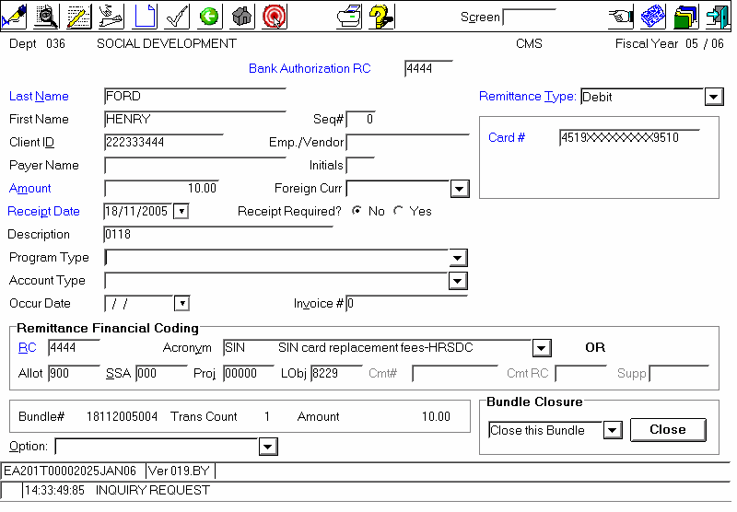

Example:

SIN REPLACEMENT FEE: (1 client = 1 SIN payment)
DEBIT CARD payment processed through Local Office’s POS terminal; therefore Bank Authorization RC# and Remittance Coding RC# must be Local Office’s RC#.

Mandatory Information to be entered on the EA201 screen:

- Bank Authorization RC - Input the appropriate authorization RC;
  - Please refer to the Bank Authorization Numbers – Bank of Nova Scotia POS Terminals section 10.4.1 for more details.
- Last Name - Input the client’s last name;
- First Name - Input the client’s first name;
- Client ID - Input the client’s identification number;
- Payer Name – Input the “payer name” if different from client name;
- Passports - Input the file number for each application:
  - C012344
  - C012345
  - C012346

Input the file number in the “Client ID” field of CMS or in the “File Locator Number” field of LWR to facilitate subsequent QA005 research;

- Initial(s) – Input the Payer’s initial(s);
- Amount - Input the amount paid;
- Receipt Date - Input the date the payment was received (date indicated on the POS terminal slip);
- Receipt Required - Select "No";
- Description - Key in a description, if needed;
- Program Type / Account Type / Acronym / Financial coding:
  - Used for DARS, ISP (CPP or OAS), EI overpayments, SUSP, SIN, Passport etc. The coding will be system generated;
  - RC# - Input the “Receiving” office;
- Type of Remittance - Select the option that corresponds to the method of payment
  - Negotiable Item
  - Post Dated: No
  - Certified: Select “Yes” if the payment is made by certified cheque
  - Cheque date: enter the date of the cheque
  - CSLP Recall (NHQ USE ONLY – Do not use)
  - Cash (Money Orders same as cash)
  - Debit
  - MasterCard
  - Visa
  - American Express

Mask Card Number Option:

We no longer use the credit card number to enter in our financial system, the authorization number or approval code number must be used.

To protect the client’s information, if the machine prints the complete credit card number, you should phone Chase Paymentech directly for instructions on how to mask the card Number on the POS machine.

Credit/Debit Card Transactions:

Credit Card Transactions:
Each credit card transaction will generate different bundles (Visa transactions in the Visa bundle, etc.) by selecting the appropriate credit card type in the “Remittance Type” field:

- Visa;
- MasterCard, or
- American Express.

Incorrect Remittance Type:

If the incorrect credit card type is selected, the transaction will be linked to the wrong credit card transaction bundle (i.e. Visa transaction in the Master Card bundle), causing reconciliation problems for RHQ Finance.

Error Detected Before Deposit:

If the above-noted error is detected before the bundle is deposited, the person who originally input the transaction must:

- Go to the QA009 screen;
- Select the bundle (Status may be “In Process” or “Closed”);
- Click OK.

When the QA006 appears:

- Select the incorrect line, and
- Click OK.

When the EA201 screen appears:

- Change “MasterCard” to ‘Visa in the Remittance Type field, and
- Click on the “Change” icon.

The above-noted transaction will automatically:

- Move the amount from the MasterCard bundle to an existing open Visa bundle, or
- Create a new 2nd Visa bundle.

This will result in the following changes to the QA009 Screen:

- The MasterCard bundle will now have an asterisk (*) in the IND column to indicate it was modified, and
- The Visa bundle with the “R” for removed will now be the receiving bundle.

To complete the correction, provide the:

- RC#;
- Bundle Number;
- Deposit date, and a
- Brief explanation to facilitate reconciliation by RHQ Finance.

Completion of CMS Revenue Screens – Multiple Payments:

SPLIT Payments

From EA201 Master Payment Record, select:

- OPTION-SPLIT CODING

This will take you to the EA005 Split Payment Screen which:

- Defaults to “Seq #1”, and
- Provides for multiple inputs for one master payment;
- Input into Sequential Tabs/Folders that are created in increments of 3 (Seq#1-2-3, Seq#4-5-6, Seq#7-8-9 etc).

Important:

Before creating the next sequence, payments must have already been input into consecutive Sequence# Tabs, as noted above.

- Navigation Seq#: Click cursor / mouse on the Seq# TAB/FOLDER.
- Create New Seq#: OPTION Field “Other Sequence, same screen” + Click OK.

- Final Split Payment Input: OPTION Field “Transaction completed end” + Click OK.

Directed/Undirected Payments in DARS:

Clients may “direct” their payment to a specific debt in the Departmental Accounts Receivable System (DARS). However, if the payment is “undirected”, DARS automatically applies the payment according to the DARS payment algorithm.
If the client chooses to split the payment between two or more debts, the client must identify the debts to which they want their payment applied.
CMS provides 2 Options for DIRECTING Payments-Use ONLY 1 Option:

- Non-Directed: DARS will apply according to the algorithm;
- Program Type: DARS will apply to OLDEST Recoverable debt for that program;

Examples - Multiple Payments – Different Payer

For the purposes of the following example, the “payer”, Henderson made a payment of $7,300.00 on behalf of the “client”, Jones, as follows:

Employment Insurance (EI) 5,000.00
SIN replacement $10.00
CDON $1,290.00
CSL4 $1,000.00
TOTAL: $7,300.00

EA201 - Input MASTER Payment Record

To input a payment made by a different payer than the client, in the EA201 Master Payment Record, complete the following fields:

- Bank Authorization RC: Input the proper authorization RC
Please refer to the Bank Authorization Numbers – Bank of Nova Scotia POS Terminals section 10.4.1 for more details.
- Last Name: Key in CLIENT’S last name;
- Payer Name: Last Name of PAYER;
- Initials: Initial(s) of payer;
- Amount: Total amount of payment;
- Receipt Date: Date payment received (Same date on envelope and POS Transaction Slip);
- Description: Key in a description if needed;
- Remittance Type: Select method of payment (CASH in example);
- Remittance Financial Coding:
  - RC#: Applicable Receiving RC#;
  - ACRONYM: Leave Blank on Master Payment.

  - Option: select “SPLIT CODING”;
  - Click on ADD button/icon (This will take you to the EA005 SPLIT payment screen).

CMS - ARADS - Screen EA201 – MASTER PAYMENT RECORD
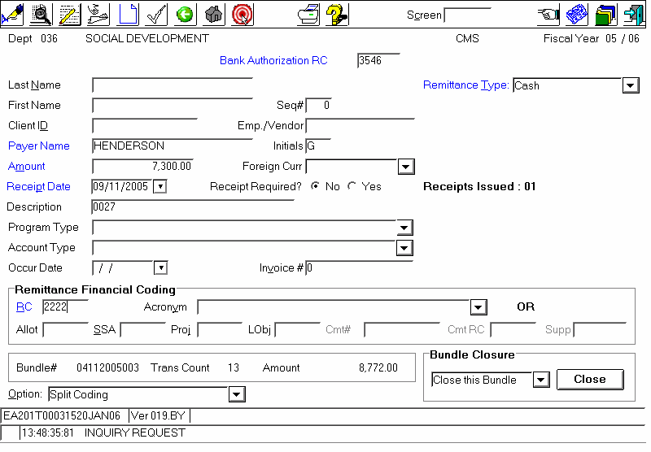

Payment # 1 - EI payment - $5,000.00:

To input the $5,000.00 EI portion of the original $7,300.00 payment made by a different payer than the client, complete the following fields in the EA005 Split Payment Screen:

- Last Name: Input individual CLIENT’S last name;
- First Name: Input individual CLIENT’S first name;
- Client ID: Client’s identification number;
- Amount: Split amount (portion for EI payment);
- Description: Key in a description if needed;
- Program Type/Account Type:
  - Select from dropdown menu “EI Employment Insurance”;

- Remittance Financial Coding:
  - RC# - Applicable Receiving RC#;
  - ACRONYM – DARS-Pymts to DARS Accounts.
- Go to Sequence #2 by clicking on the SEQ#2 Tab (DO NOT click on “OK”).

CMS - ASRADS - Screen EA005 Sequence #1- EI Overpayment

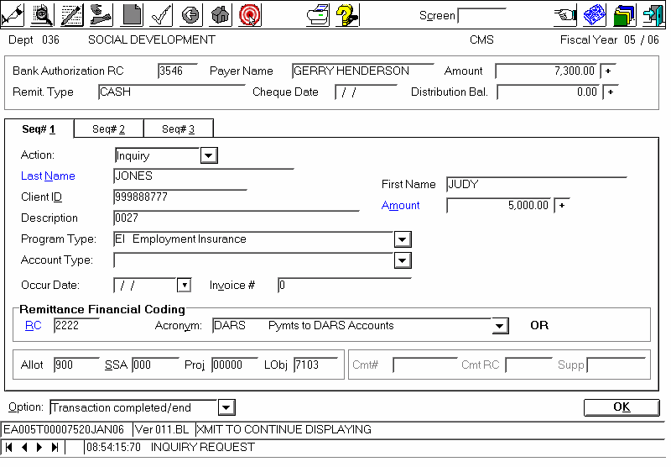

Payment #2 - SIN Replacement $10.00:

To input the $10.00 SIN Replacement fee in Seq#2 from the original $7,300.00 payment made by a different payer than the client, complete the following fields in the EA005 Split Payment Screen:

- Last Name: Input individual CLIENT’S last name;
- First Name: Input individual CLIENT’S first name;
- Client ID: Client’s identification number;
- Amount: Split amount (portion for SIN replacement fee);
- Description: Key in a description if needed;
- Remittance Financial Coding:
  - RC# - Applicable Receiving RC#;
  - ACRONYM: select “SIN – SIN card replacement fees-HRSDC.

- Go to Sequence #3 by clicking on the SEQ#3 Tab (DO NOT click on “OK”).

CMS - ARADS - Screen EA005 Sequence #2 – SIN Replacement Fee

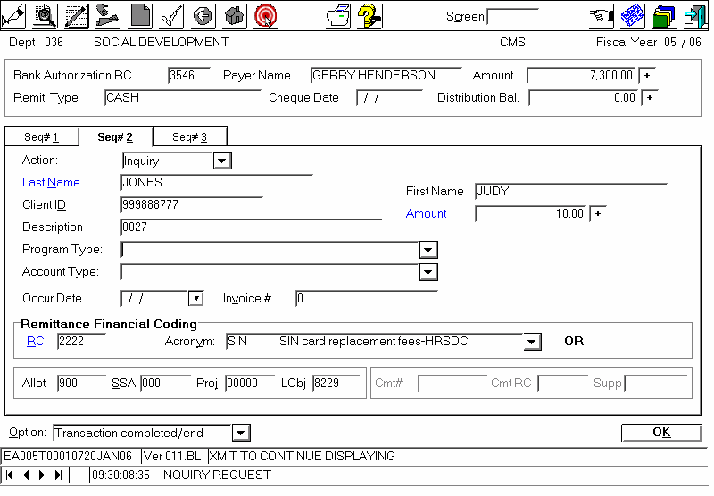

Payment #3 - CDON Student Loan $1,000.00

To input the $1,000.00 CDON payment in Seq #3 from the original $7,300.00 payment made by a different payer than the client, complete the following fields in the EA005 Split Payment Screen:
- Last Name: Input individual CLIENT’S last name;
- First Name: Input individual CLIENT’S first name;
- Client ID: Client’s identification number;
- Amount: Split amount (portion for CDON Student Loan);
- Description: Key in a description if needed;
- Program Type/Account Type:
  - Select from dropdown menu “CDON Student Loan”;
- Remittance Financial Coding:
  - RC# - Applicable Receiving RC#;
  - ACRONYM – DARS-Pymts to DARS Accounts.
- To go to Sequence #4:
  - Select the “Option” field;
  - Select “Other Sequence, Same Screen”;
  - Click on ‘OK’ (This will take you to the next sequential increment of Seq#4-5-6).

CMS - ARADS - Screen EA005 Sequence #3 – CDON Can-Ontario-Student Loan

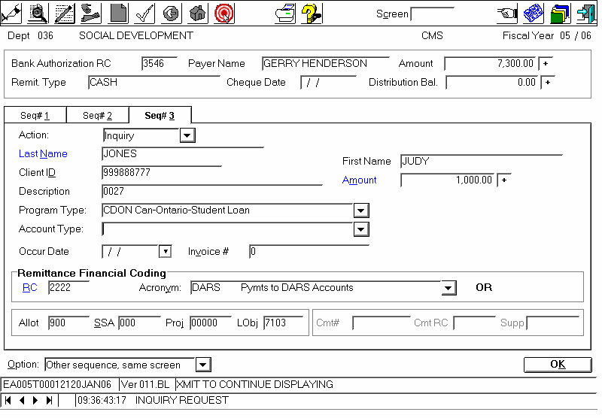

Payment #4 - CSL4 Direct Financing Loan $1,290.00

To input the $1,290.00 CSL4 payment in Seq #4 from the original $7,300.00 payment made by a different payer than the client, complete the following fields in the EA005 Split Payment Screen:

- Last Name: Input individual CLIENT’S last name;
- First Name: Input individual CLIENT’S first name;
- Client ID: Client’s identification number;
- Amount: Split amount (portion for CSL4 Direct Financing Loan);
- Description: Key in a description if needed;
- Program Type/Account Type:
  - Select from dropdown menu “CSL4 Direct Financing Loan”
- Remittance Financial Coding:
  - RC# - Applicable Receiving RC#;
  - ACRONYM – DARS-Pymts to DARS Accounts.

If additional Split Payment to input

- Go to Sequence #5 by clicking on the SEQ #5 Tab (Do not click on OK)

If sequence is the final Split Payment to input (per this example)

- Option field: Select “Transaction completed end”
- Click on “OK”
EA005 Sequence #4 – CSL4 Direct Financing Loan

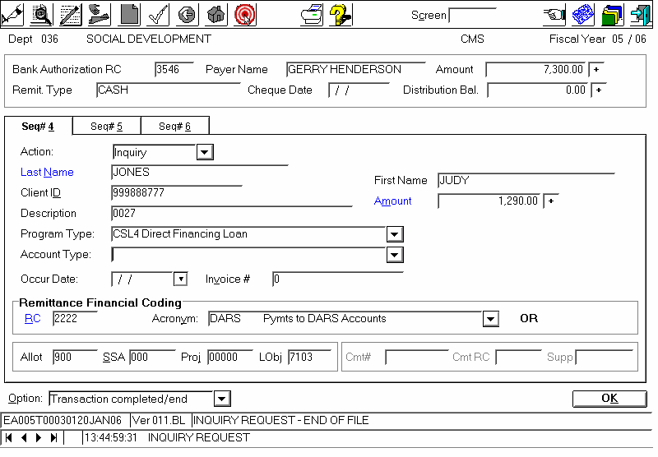

Approval / Assembling of Bundle(s):

Each deposit bundle is:
- Tallied on a calculation tape which is clipped to the bundle, and
- Given to the supervisor for Approving/Assembling of the deposit slip(s).

Locked bundle:

A “locked bundle” may occur at the input stage, however, generally the bundle locks when the user erroneously selects “EXIT, CLOSE” or changes screen on the EA005 Split Payment screen before all split payments have been input. This occurs because the total $ value indicated on the EA201 Master Payment screen does not equal the total $ value of the EA005 split payments.

EXAMPLE:

Master Payment (total amount) = $7,300.00
- Sequence 1 = $5,000.00
- Sequence 2 = $ 10.00
- User exits/closes without inputting sequence 3 and 4 for the remaining $2,290.00
- Master payment of $7,300.00 does not balance with the split payments which only total $5,010.00
- Resulting in a ‘locked bundle”.

To identify a locked bundle

- INPUT/User: Go to QA006 or QA009.
- APPROVER/Supervisor: Go to AA001.

To unlock the bundle

- Go to the QA006 for the applicable LOCKED bundle;
- LOCKED Transaction will be identified with an “L”;
- On the QA006 – in the ACTION field – Type in “X” to View the LOCKED Transaction;
- The EA201 for the LOCKED transaction will appear;
- Go to the menu line (top of screen):

  - Select ACTION;
  - Select CHANGE;
  - Ensure “SPLIT CODING” is in the Option field at the bottom of screen;
  - Click OK.

This will take you to the EA005 SPLIT PAYMENT screen for this BUNDLE:

- ADD/CHANGE the split payments input, and
- Confirm that the Split Payment Amount = the Master Payment Amount;
- Click OK and the EA201 will appear for input of the next payment.

The bundle will change from LOCKED to IN PROCESS, and you may:

- Continue inputting, or
- Delete the incorrect payment if applicable, or
- Close the bundle.

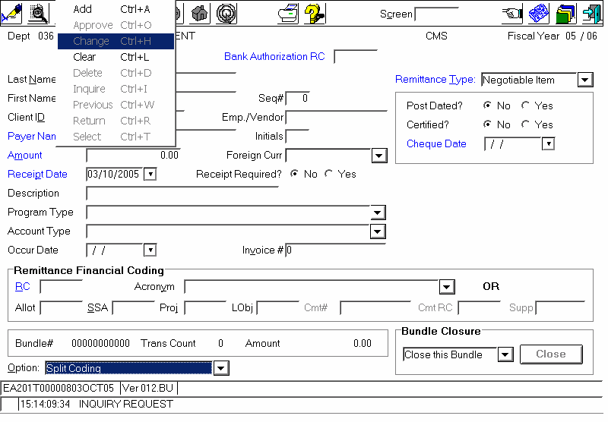

10.5.8 Returned EI Warrants

a. Go to QA006 and write the RC and the bundle # where the return warrant is input
- Select the transaction with return warrant
- Click twice to enter in the detailed transaction (EA 201)
- In the option field, select Pending transaction

- Click on the ADD icon
- The transaction will be send to QA011 screen: Pending transaction for deposit inquiry.
- Secure the warrant and documents until receiving instruction (INS3734) from EI Branch.

10.5.9 Returned CPP/OAS cheques

- Go to QA006 and write the bundle # where the return cheque is input
- Select the transaction with return cheque
- Click twice to enter in the detailed transaction (EA 201)
- In the option field, select Pending transaction
- Click on the ADD icon
- The transaction will be send to QA011 screen: Pending transaction for deposit inquiry
- Secure the cheque and documents until sending them to ISP
- The cheque and documents must be sent to ISP in a blue pouch by courier
- Delete the transaction from QA011 screen

Approval of deposit
Financial Officer will:

- GO to ARADS AA001, this screen will default to your preference RC (SEE99) which is usually where all the negotiable transactions for all RCs will be listed. The Employee’s name will be the local office RC an L at the beginning to identify that the transactions are from LWR. For the debit/credit card transaction the local office RC will have to be entered. Care must be taken to ensure that for POS Transactions the local office Bank Authorization number is inputted in screen AA002.

Cash Payments and Negotiable Items:
Deposit in the Processing Office standard account Authorization RC.

Credit and Debit Card Payments:
Deposit in the Authorization RC corresponding to the POS terminal used in the Local office.

- Go to QA006,
- Verify the individual transactions by checking the information on each negotiable item, debit/credit card transaction slip and comparing them to the screen: Name and amount should match.
- Ensure all negotiable items have correct information with a “deposit stamp” on back, and are payable to Receiver General for Canada.
- Select View by Financial Code to confirm the proper coding was selected.
- If errors are found return the bundle for verification and correction prior to approving the bundle.
- If everything is ok, go to the Option field and Select Approve Displayed Bundle and Transmit.
- The next bundle will appear for approval.
- Once all bundles are approved go to screen AA002 to assemble the deposit
- Verify the Bank Authorization RC, input it in appropriate field, be careful as the lowest authorization number automatically appears.
- When necessary, change the deposit date:
For standard deposit, use the date the money will actually be deposited in the banking institution.

For Debit/Credit card transaction, use the date the payment was made in the local office (same date as POS transaction slip). For LWR transactions, the date will be the same as the portion of the bundle number that is the date.
- Select the bundles you want to deposit
- Go to the “Option” field.
- Select “deposit selected bundles”.
- Transmit (OK).
- Wait for the deposit slip (AA02P) to appear,
- Print the screen, sign and date it.
- Return deposit bundles and signed deposit slip to Finance Clerk for deposit at the bank.

Screen AA001 – Deposit Approval Screen

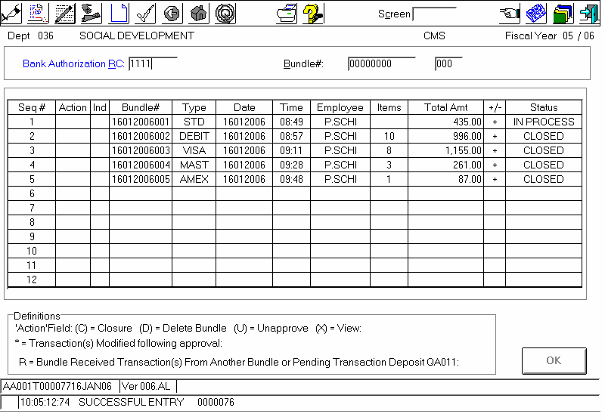

Screen QA006

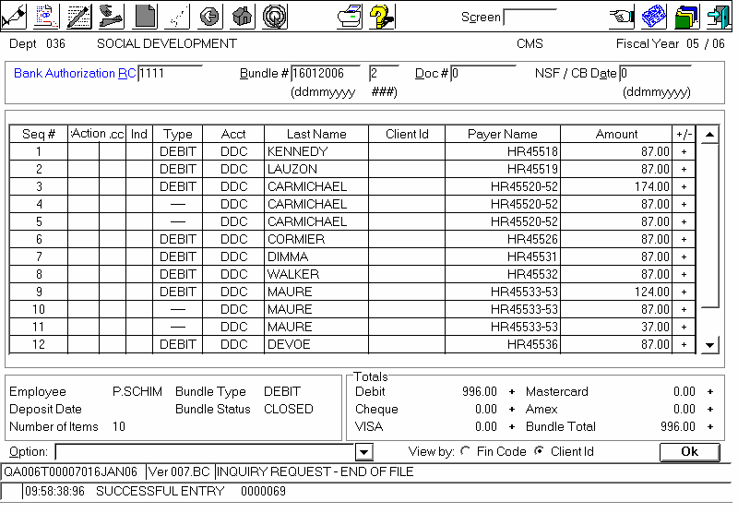
Screen AA002 – Bank Deposit Assembly

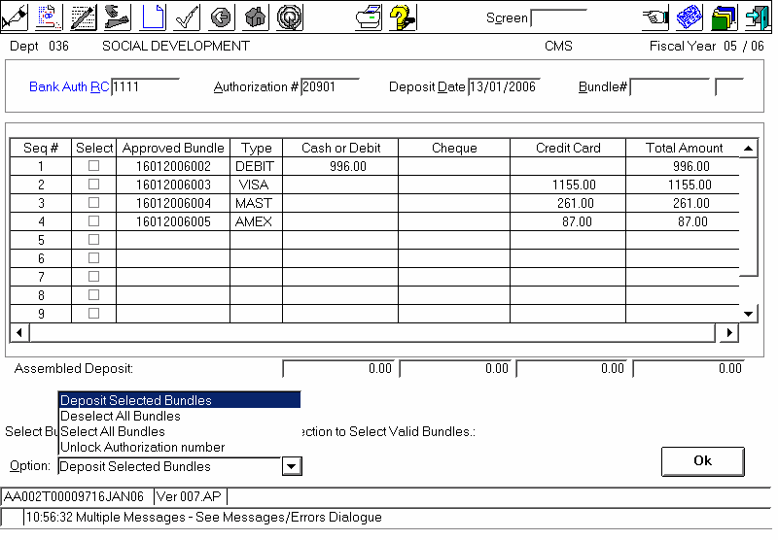

Bank Deposit Slip (Notice the Deposit Date is the date of deposit to Scotia Bank)

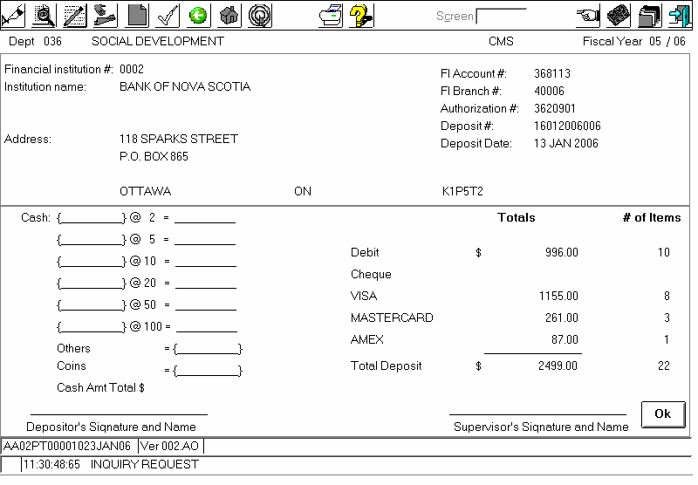

The Finance Clerk will:

- Prepare the bundles for deposit to a standard banking facility, or
- For filing, if the deposits are for debit/credit card transactions.

Note: Deposit slips may vary between financial institutions

Foreign Currency

An authorized User will:

- Enter cheques into ARADS (screen EA201);
- Fill in last name, first name, client ID (SIN), amount, and all other relevant information;
- Using drop down box under currency, indicate the appropriate currency;
- Once all of the cheques have been entered, close bundle(s), do a tape(s) and give to supervisor for approval.

Notes:
- A manual deposit (see section below – Manual Foreign Currency Deposits) is required when the payment is made in an unavailable currency.
- Foreign currencies are automatically bundled, according to currency type (i.e. All US $’s will be bundled together while all UK Pounds will be bundled in another, etc.).

An authorized Supervisor will:

- Approve the bundle(s) according to standard approval procedures (Screen AA001);
- Assemble the bundle(s) for deposit (AA002) , and
- Send to the bank for deposit.

Foreign Currency - Deposit Slips Returned by the Bank:

As noted previously on this document, although foreign currency payments may be accepted:

- No exchange or change will be given when the payment is made;
- The client may have to pay the cost of conversion;
- The payment applied will be in Canadian currency;
- If a credit card is used, the transaction must be recorded in Canadian dollars on the sales draft/slip and the credit card company will calculate the conversion and report the charge on the client’s statement in the appropriate currency.

An authorized financial institution will:

- Receive the bank deposit, and
- Verify that the deposit is correct;
- Convert the foreign currencies to Canadian Dollars, and
- Return a copy of the deposit slip to the originating Processing Office.

An authorized Finance Officer:

- Receives the copy of the deposit slip from the bank, and
- Accesses the QA008 screen in ARADS;
- Opens “View Bundles” for each type of Foreign Exchange which opens the QA107 (Bundles in a Deposit – Inquiry) screen;
- Verifies the calculation provided by bank, for accuracy, and:

a) If the deposit slip is correct, enters the following information in the QA107 screen:

- Exchange Rate (i.e. 1.5560);
- Deposit Total (Original Amount + Exchange Rate), and
- Initials the deposit slip;
- Click OK, and
- Provide to Supervisor for approval.

Or

b) If the deposit slip is incorrect, the Finance Officer:

- Initials the deposit slip, and
- Provides the incorrect deposit slip to the Supervisor to contact the financial institution.

The Supervisor:

- Double-checks the foreign currency calculation provided by bank;
- Accesses the QA008 screen in ARADS;
- Opens “View Bundles” for each type of Foreign Exchange which opens the QA107 screen;
- Verifies that the information entered by the User matches the information on the deposit slip, and
- In “Option” Box, clicks on “Approve Foreign Currency Adjustment”;
- Clicks OK to update the foreign exchange for each bundle deposited.

Foreign Currency - Manual Deposit

When a payment is received in an unavailable currency, it is necessary to prepare a manual deposit. Once the deposit slip is returned by the Bank, indicating the exchange rate and the total amount deposited, an authorized Finance Officer (User) will:

- Access the ARADS EA201 screen;
- Key in the:
  - Last Name;
  - First Name;
  - Client ID (SIN);
  - Amount in Canadian Dollars (including the exchange rate), and
  - All other relevant information for each client.

- In “Payer Name” enter : The name of the currency (dollar amount) X (exchange rate)
- Once all transactions have been entered:
  - Close the bundle;
  - Print the QA006 screen, and
  - Provide the Supervisor with the manual bundle and manual deposit slip for approval, ensuring that the QA006 bundle equals the total deposit amount.

IMPORTANT

Each manual deposit requires:
- One bundle per manual deposit;
- ARADS be updated on the same day as the deposit.

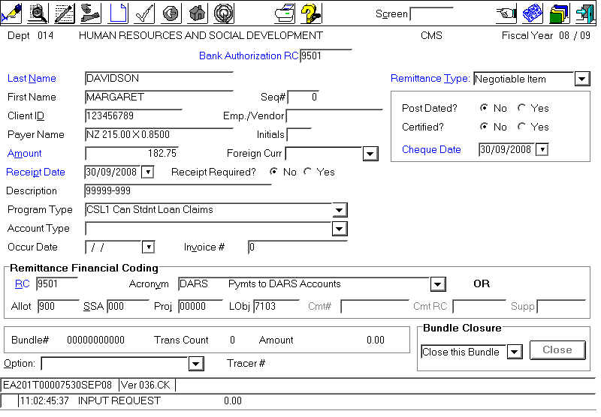
An authorized Supervisor, will:

- Approve bundle according to normal approval procedures (Screen AA001), and
- Assemble the manual bundles for deposit (AA002).

IMPORTANT:

- There will be no actual deposit to send to the bank since ARADS is only being “updated”;
- Payment information must be sent to CPP/OAS, etc, for them to update the client account in Legacy;
- There should be one deposit assembled in ARADS for each Manual Deposit done.

Locked Authorisation Number - Deposit processing

When an error occurs at the DEPOSIT ASSEMBLY stage you may encounter a LOCKED AUTHORIZATION NUMBER.

To UNLOCK a locked authorization number:
- Access the AA002 Deposit Assembly Screen, and
- In the OPTION field: Click on the drop down menu;
- Select UNLOCK AUTHORIZATION NUMBER, and
- Click OK – to UNLOCK the Authorization Number.

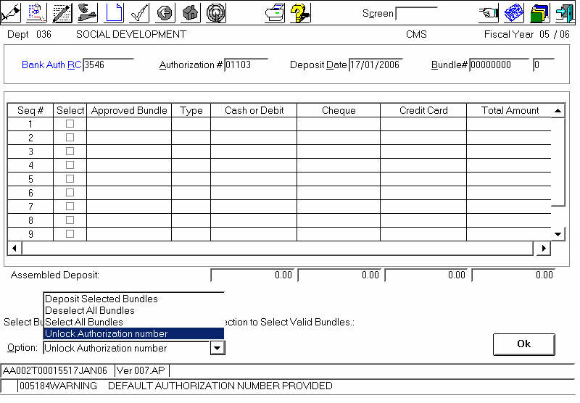

Transfer of money received to an OGD - Other than Passport

Other Government Department (OGD) and Agency Payments:

Citizen Service Officers accept payments on behalf of various programs and departments; however, wherever possible, (CSO) ’s should avoid accepting payments intended for Canada Revenue Agency (CRA) and advise the client of the advantages of using other payment methods. We must never send a payment to another government department in the mail.

Interdepartmental Settlement (IS):

In cases where a payment is accepted on behalf of an OGD or Agency, once approved, the backup documentation (copy of EA201 screen, photocopy of cheque/documents) must be forwarded to the Cashier, Finance RHQ.

Regional Office will then prepare and process the IS to transfer the money to the OGD or Agency.

Monitoring

- At least once a week:
  - The AA001 screen must be reviewed to ensure that all the bundles older than 10 days have been approved.
- On regular basis the Manager Corporate Services will:
  - Review and monitor all QA014 cash deletions;
  - Prepare and sign-off a screen print which will serve as an audit trail.
- All relevant documents (including credit/debit card receipts and deposit slips) must be:
  - Kept on file in a secure location;
  - Stamped by the bank.

Chargeback’s

The bank may send the Processing Office a chargeback notice for a number of reasons, including:

- NSF cheque;
- Non-existent or closed account;
- Post-dated or stale-dated cheque;
- Stop payment.

Corporate Services Finance receives the chargeback notices from the bank and must ensure that monthly controls or audits are carried out to ensure that the financial institution with which they deals has no outstanding NSF cheques or other charge-backs.

In this case, an authorized Finance Officer:

- Accesses the QA005 screen, and
- Identifies the bundle containing the negotiable instrument;
- Notes the bundle number;
- Enters the bundle number on the QA006 screen, and Transmits;
- Enters the letter “N” (for an NSF cheque) or “B” (for any other reason) before the transaction, and
- Transmits (OK), systematically generating a bundle;
- Closes the bundle, and
- Passes it to an authorized Supervisor for approval.

An authorized Supervisor will:

- Access the AA001 screen which will display the entry for approval;
- Select the bundle, and the QA006 will appear with that transaction;
- Input the bank notice date at the top right “NSF date”, and
- Choose from options below: “Approve this bundle”;
- Transmit (OK);
- Print this screen;
- Sign and date, and
- Attach returned negotiable item;
- File in secure location for fiscal year;
- Notify the program for which the original deposit was made.

Processing Canadian NSF in ARADS:

Note:

An NSF bundle should include only the cheques from one debit advice.
In the QA005 screen, an authorized User will:

- Obtain the bundle numbers, and
- In the QA006, insert that bundle number, and Transmit to open the original bundle with all the transactions;
- Insert an “N” or “B” in the Action Field beside the last name of client in default to create a bundle that you closed in QA009 only after the last cheque from that debit advice;
- Repeat the same procedure for the next NSF cheque on the debit advice, and
- Send for approval.

Processing Foreign NSF in ARADS:

Note:

Originals and exchange rate entries must be processed together.

In QA005 screen an authorized User will:
- Obtain the original bundle number, and
- In QA006, insert the bundle number and Transmit to open the original bundle with all its transactions;
- Insert an “N” or “B” in the Action Field beside the last name of client in default, and.
Note: The exchange rate will become NSF with it. (By default)
- Create a bundle that you closed in QA009, and
- Send to an authorized Supervisor for approval.

Systems Bugs on Foreign NSF:

In the event of a system “bug”:

- In QA005, retrieve the 2 bundle numbers;
- In QA006, insert the first bundle number, and Transmit to open the original bundle with all transactions;
- Insert an “N” or “B” in the Action Field beside the last name of client in default, creating a bundle that you closed in QA009;
- Repeat the same procedure for the second bundle (exchange rate), and
- Send to an authorized Supervisor for approval.

In the ARADS AA001 - Bundle-Forced closure/Unapproved/Inq screen, an authorized Supervisor will approve the bundle in ARADS as follows:

- In “Bank Authorization RC” input the Responsibility Code required (yours);
- Ensure that all bundles are closed;
- In Action, input an “X” on the first bundle to approve, then press OK, bringing you into the QA006 screen which indicates bundle type NDEP, and

- From the bank debit advice verify:

  - The number of cheques and amount with “Number of Items and amount” on screen (should match);
  - Spot check client name vs. cheque;
  - And reason of returns to determine if:
    - “N” = NSF cheque;
    - “B” = All other reasons.

Note:

- For ease of reconciliation, the bank reconciliation date must be input in QA006 (which should match the debit advice date);
- On occasion, banks return NSF information to the Receiver General a few days after their input has been completed.
- From screen QA006, insert the bank debit advice date that matches the bank reconciliation report in the “NSF / CB Date” field;
- Select Option: “If QA006-Approve Displayed Bundle”, and
- Press OK, resulting in:
  - The bundle being approved, and
  - The system generating a document number.
- On the debit advice:
  - Record the document number, and
  - Sign, and
  - Send to the appropriate Officer, along with the NSF cheque.

Reminder to cashier

- DARS NSF:
  - Process NSF in CMS-ARADS.
No further action required. The CMS-ARADS NSF will automatically generate a TC51 transaction in DARS, thus increasing the Clients debt for the NSF.
- ACCESS TO INFORMATION NSF:
  - Process NSF in CMS-ARADS.
  - Follow up with Client/Payer for replacement payment.
  - IF NO replacement payment provided-Establish debt in DARS.
- ISP-CPP NSF:
  - Process NSF in CMS-ARADS.
  - E-mail EA201 NSF screen to applicable ISP office to adjust debt.
- ISP-OAS NSF:
  - Process NSF in CMS-ARADS.
  - E-mail EA201 NSF screen to applicable ISP office to adjust debt.
- SUSPENSE [EA004] NSF:
  - Process NSF in CMS-ARADS.
  - E-mail EA201 NSF screen to RHQ-Cashier to update SUSPENSE-EA004 / debt where applicable. E-mail Subject Line: NSF-SUSP.
- SIN & COURT/MISCCHG/MISCREV NSF:
  - Process NSF in CMS-ARADS.
  - Follow up with Client/Payer for replacement payment.
  - IF NO replacement payment provided-Establish debt in DARS.
- REFUNDS OF EXPENDITURES – CMS-ARADS EA201 NSF:
  - Process NSF in CMS-ARADS.
  - Follow up with Client/Payer for replacement payment.
  - IF NO replacement payment provided-Establish debt in DARS.

Note:
To assist in follow-up investigations and corrective actions, for CMS-ARADS General SUSPENSE-LOBJ 8323, in addition to the EA201 screen, a copy of the actual CHEQUE received must be provided by FAX, scanned image or email.

To produce an EA201 Screen Print for attachment to E-Mail:

- From QA006/QA005, call up the EA201 screen you want to copy/print;
- Press “PRINT SCREEN” button on keyboard, Print Screen box appears;
- Click on “COPY SCREEN”, Click on CLOSE;
- On your E-mail message/word document, right-click on the mouse and click PASTE or
- EDIT/PASTE and the EA201 Screen will be pasted into you e-mail/word document.

8323 ARADS Suspense

Line Object 8323:

- Is used to temporarily record payments received which do not include enough information to identify the purpose of the payment.

Regional Offices are required to:

- Monitor all RC’s under their responsibility; and
- Research all outstanding transactions until they are cleared.

To clear a current fiscal year transaction
ARADS suspense account, an authorized Cashier:

- Accesses the EA004 screen, search the required transaction ;
- In the Action field, inputs “P”; and
- From the Option field selects ‘‘Further Processing on EA006’’;
- Transmits (OK);
- From EA006 screen, make the adjustment required on the name, ID client, etc.;
- Select the proper acronym and RC, remembering to delete the information in the “Program Type”) field;
- Transmit (OK).

In the AA001 screen, an authorized Supervisor will approve the suspense bundle with the supporting documents and will retain them.

Financial Information related to Budget Coding:

If the financial coding is related to a budget coding, the process is different. In this case, a Journal Voucher (JV) must be prepared in CMS CEE11 to debit the 8323 suspense coding and credit the appropriate coding with the Commitment Number, when available.

Note:

If linked to a budget coding:

- Approve the Journal Voucher (JV) from the CEE11 screen, and
- From EA004 screen, select the transaction, in the “Action” field, and
- Input “D” to delete the transaction.

To clear a previous fiscal year transaction

ARADS suspense account, a Cashier:

- Prepares a JV in CMS using CEE11 screen to debit the original financial coding (8323) and credit the appropriate coding.
- For an NDEP (NSF) transaction, credit the 8323 and debit proper coding.
- Prepares a manual TC50 in DARS to reflect the payments belonging to DARS (Line Object 7103).
- For an NDEP (NSF) transaction, a manual TC51 should be prepared.
- Credits payments belonging to another program (ex: CPP) against the appropriate CPP coding and informs the Regional ISP finance office (Income Security Program).

An authorized Supervisor:

- Approves the JV from CEE11 screen;
- Verifies manual TC50 or TC51 forms, and
- Send them to the Loans and Accounts Receivable section (DARS).

Note:
You must also go to the appropriate previous year in CMS EA004 screen, and:
- Delete the transaction;
- Select the transaction in the “Action” field, and
- Input “D” to delete that transaction.

This does not affect the accounting books for that year, but it will prevent someone else from taking action again on the same transaction.

Refunds of Miscellaneous Revenue

In cases where a payment cannot be identified as a result of tracing, wherever possible, a refund will be sent to the client.

In cases where it is not possible to locate the client, a JV will be prepared to deposit the money to miscellaneous revenue pending identification of the client. Refunds in the same fiscal year may be made using the same financial coding should the client request reimbursement.

551- RC -REV-00000-6979 | Miscellaneous other non-tax revenue - Miscellaneous other revenues not elsewhere specified

Refunds in a subsequent fiscal year must be made using Refund of previous Year’s Revenues coding.

For the unidentified payments (no SIN, no identifiable name):
- After one year: $100 and less = Miscellaneous revenue;
- More than one year: $300 and less = Miscellaneous revenue.
- More than three years: $500 and less = Miscellaneous revenue;
- More than four years: any amount not identified and not claimed = Miscellaneous revenue.

If we can identify the customer, the payment will be applied to his account, if the customer made a payment in error, we will refund him.

Archive - Retention Periods

The following documents must be retained for all physical/electronic deposits:

- Copy of Deposit Slip(s);
- All Deposit Envelopes (credit/debit transaction slips inside the applicable envelope) (should the old carbon envelope be used);
- All Public Money Transfer Records;

All of the above financial documents must be maintained on file for six (6) years. Corporate Services Finance Unit must keep these financial documents in a secure location for two (2) years, after which they can be archived. In high volume offices, you may consider using expandable files folders (kraft type 1-31 days) for ease of storage as each day’s deposits can be bulky. At the end of each fiscal year, transfer the records to an archive box or file cabinet and re-use the file folders for the new fiscal year.

Procedures - Bank Reconciliation / RHQ

The regional bank reconciliation must be performed by the Regional Financial Office on an ongoing basis. All non-reconciled items (discrepancies or errors) must be investigated and corrected. Transactions posted by the GBS Return File (source 160) that can not be identified by the Regional Financial Office must be reported to NHQ Corporate Accounting - National Receipt & Deposit (Lucie Potvin or Julie Connelly) who will make a request for information to the Receiver General. At year end, an explanation must be provided to NHQ Corporate Accounting - National Receipt & Deposit for all un-cleared variances remaining at the end of Period 12-1.

Step 1: Printing and understanding the new Bank Reconciliation Report

Producing the Bank Reconciliation Report
- Open Internet Explorer.
- Go to the Inquiry, Reporting and Information System (IRIS), Web site: http://intracom.hq-ac.prv/iit/en/iit/co/edssi/iris/index.shtml
- Login to IRIS_
- NOTE: OS authentication is used to access this area. You no longer see the login page or need a user id and password. You still need an authenticated Cognos web account.
- Once in your page, open the English folder, select the National Applications/Finance/Common Departmental Detailed Reports/General Ledger Accounting/Reconciliation Reports/Bank Reconciliation.
- Enter the applicable prompts to generate the required report
  - Department – by default is 000. Enter 014
  - Fiscal Year – Users may need to select the applicable fiscal year.
  - Accounting Month – default is 00 (opening balances). Enter the Starting and Ending number of the accounting month for which the reconciliation is being done. The report will include all transactions for the fiscal year up to the end of the selected month (or to the last update if the current month is selected for ongoing error correction during the month).
  - RC – default is blank. Enter the Level 6 roll-up RC for your region for the regional bank reconciliation report. (Users can also enter lower level RC codes to produce special reports concentrating on a single RC or group of roll-up RCs for working purposes.)
  - And Roll-ups – default is Yes. Do not change for the bank reconciliation reports. (Users can change this to No to produce special reports concentrating on a single RC.)
  - Display Zero Balances – default is No. Do not change for bank reconciliation. (Setting this to Yes will include all transactions for the year. Users may want to do this for specific purposes, but be aware that this may generate a very large report.)
  - Report Summary only – default is No. Do not change for the regional bank reconciliation.
  - Authorization Number – default is * (all). Do not change for the bank reconciliation report. (Users can also enter specific Authorization numbers to produce special reports focussed on a single series of deposits for working purposes.)
  - Select Financial Coding – default is 900 990 00000 7001 (RC is ignored). Do not change. (This option is included in case the financial coding is changed in a later fiscal year, to allow the report to be used for both old and new coding during the transition period at year-end.)
- Go to the bottom of the page and click Finish
- Wait a few minutes to generate or update the report. (It may take several minutes for the system to produce the report.)

Select the icon Save As, re-name the report to be save in your NewsBox. If you want to be able to refer to a report for a longer period, or to work with different periods or special reports without needing to recreate the report each time, you should save the report. Otherwise the report is automatically deleted.

Reports can be saved as a printable report document in Adobe .PDF format, as a print-formatted Excel .XLS file, or as a data “flat file” in .CSV format for import to Excel or Access for further analysis.

Understanding the Bank Reconciliation Report

- Record selection
  - The Bank Reconciliation Report selects transactions entered into the Deposits in Transit to the Bank account in CMS (line object 7001).
  - All transactions for the selected fiscal year up to the end of the selected accounting month will be included.
  - Record selection choices for a specific report are displayed at the top of the first page of the report. These will show which fiscal year, accounting month, RCs, etc. are included in the report.
  - In the standard Bank Reconciliation Report, zero values are suppressed. This means that if a Deposit Date subtotal for an Authorization is 0.00, the assumption is made that all transactions for that date have been matched
- Data display
- Region: the region of the depositing office
- RC: Responsibility Centre code of the depositing office
- Authorization Number: Authorization Number to which the deposit was made
- Document Number: Sequential control numbers generated by CMS when a deposit or chargeback is approved. Each bundle becomes a separate CMS document.
- Source: Numeric codes that are used by CMS to identify the source of all transactions that go through the system. (Examples: source 0060 = user input from ARADS or CEE11 screen Type: Revenue Deposit, source 0160 = system generated entry from BFS file of bank and RG transactions)
- AM: Accounting Month – the fiscal period to which a transaction is approved. (Some transactions in CMS are entered as post-closing entries applicable to a previous fiscal period in order to meet FIS accounting requirements. This will normally not have any impact on the bank reconciliation process.)
- Approval Date: This is the date the transaction was approved in CMS.
- Type: Type codes are used to identify the different types of Source 160 deposits and other financial institution transactions included in the daily deposit reports (e.g. DEP for deposit, CBDEP for chargeback, RG for Receiver General adjustment). Transit No: Number identifying the bank branch which originated the Source 160 transaction.
- Amount: dollar value from CMS documents or BFS file of the deposit, the chargeback and adjustment or other entry.
- Sorting and totalling
Individual transactions are sorted in the following sequence, with sub-totals displayed for all sort groups except the first:

- Document Number: sorted in ascending order by document number
- Deposit Date (yyyy-mm-dd): sorted and sub-totalled in ascending order by deposit date. The Deposit Date subtotal shows the total dollar value amount of all transactions for a specific deposit date. If the Display Zero Balances prompt is set to No, as per the standard report settings, the report will only display individual transactions and deposit date subtotals when there are unmatched transactions for that deposit date and the subtotal is therefore not equal to zero. (Note that the Deposit Date does not appear on the detail line due to lack of space.)
- Authorization # (xxxxx): sorted and sub-totalled in ascending order by Authorization number. The Authorization number subtotal shows the total dollar value amount of all unmatched transactions that are outstanding for an authorization number. If the Display Zero Balances prompt is set to No, as per the standard report settings, the report will only display Authorization number subtotals when there are non-zero deposit date subtotals for the Authorization.
- RC (xxxx): sorted and sub-totalled in ascending order by RC code. The RC subtotal shows the total dollar value amount of all unmatched transactions that are outstanding for a depositing office. If the Display Zero Balances prompt is set to No, as per the standard report settings, the report will only display RC subtotals when there are non-zero deposit date subtotals for the RC. Note that if a non-standard report is created for a specified Authorization number, this total will only include amounts for that Authorization.
- Region (xx): sorted and sub-totalled in ascending order by region. The Region subtotal shows the total dollar value amount of all unmatched transactions that are outstanding for a region. If the Display Zero Balances prompt is set to No, as per the standard report settings, the report will only display region subtotals when there are non-zero deposit date subtotals for the region. Note that if a non-standard report is created for a specified RC or RCs below the level 6 RC, this total will only include amounts for those RCs.
- Report Total: total dollar value amount of all unmatched transactions that are outstanding for a specific report. As for the subtotals, this total will only include amounts for the entries included in the user prompts.

Definitions

- Source 0060 is the transaction code in CMS for an entry from ARADS: Revenue Deposit screen to record a deposit, chargeback, etc.
- Source 0160 is the transaction code in CMS from the RG Bank Facilities System (BFS) file sent to us with the details of the entries made by the banks and by the Receiver General (RG). The type (DEP, CBDEP, RG, etc.) indicates the type of bank entry.
- Source 0051 is the transaction code in CMS for an entry from the CEE11 screen to record a correcting entry used to correct deposit date or Authorization number errors.
- The approval date is the date the transaction was approved in CMS.
- The date of deposit (or chargeback) is shown in the Sub Total Deposit date. This is the date recorded by the user in CMS (on the ARADS assembly for deposit or chargeback approval screens or in CEE11) or the date on which the financial institution credited or debited the HRSDC Authorization number.

Step 2: Outstanding Variance Analysis

- The standard Bank Reconciliation Report will display only outstanding variances, caused by unmatched transaction entries that do not balance to zero for a given combination of Authorization number and deposit date. If the total per deposit date balances to zero for the end of the month, no variances will show up. However, if the total per deposit date does not balance to zero, all transactions for the given deposit date and authorization number will be listed in the report.
- The person doing the bank reconciliation will need to investigate each variance, to determine why there is a variance, and to correct the variance or make sure that it is corrected by means of appropriate action. Note that any variances not corrected on a monthly basis will reappear in the following month’s Bank Reconciliation Report and will need to be re-explained.
- Common causes of variances which will be familiar from bank reconciliations in previous years include:
- Deposit not yet input/approved – Although the ARADS receipt & deposit procedures require that the deposit is verified and approved using AA002 prior to deposit in the bank for cash and cheques, this does not always happen. This will cause errors ranging from incorrect ARADS deposit dates to deposits entirely missing from ARADS/CMS.
- NSF/Chargeback not yet input/approved – There are always timing differences between when the bank debits our account for an NSF or chargeback and when the office receives the notification from the bank and processes it in ARADS. These can be reduced by processing the debits in ARADS as soon as possible.
- Foreign currency adjustment not yet input/approved – ARADS receipt & deposit procedures require that the Canadian dollar conversion adjustment for a foreign currency deposit is entered using the QA107 screen and approved on the same day as the deposit. If this is not done on time, it will cause variances in the bank reconciliation, as well as errors in the client accounts.
- Bank error/HRSDC error – Some variances are simply caused by errors at the bank or at HRSDC when processing transactions and deposits. These can be reduced by careful verification of ARADS entries during the approval process and quick communication with the bank to resolve bank errors.
- In addition to the normal causes of variances which will be familiar from previous years, note the following new variances which are frequently appearing in the new Bank Reconciliation Report:
- BFS File timing differences – The BFS files with the daily deposit details are not received and processed into CMS until several days after the deposit date. This means that the last few days of entries at month-end will appear as variances because the matching BFS entries have not yet been input to offset the ARADS/CEE11 input.
- LWR transactions from local offices. As the back up paper works takes a day or so to reach the processing center, it creates a delay to verify and approve them resulting of a date variance.
- Verify that timing difference variances have been cleared by checking an updated Bank Reconciliation Report for the current month. All the missing BFS entries for a month should appear within 4-5 working days after the end of the month.
- Deposit Date differences - HRSDC receipt and deposit procedures and ARADS system functionality require receipt bundles to be approved and assembled for deposit prior to deposit in the bank.
  - ARADS permits the deposit date to be changed to a date up to 5 days in the future, to allow for deposits that will be deposited or credited to the next business day.
  - If the wrong deposit date is entered in ARADS, the new Bank Reconciliation Report will treat the ARADS and BFS entries as variances because they will not have the same deposit date.

Note:
Ask your bank to confirm their cut off time in order to process a government deposit for the same business day. If, for example, the bank cut off time is 2:00 PM, you will have to make your deposit of that day before 2:00 PM for it to be credited for the same business day. If the deposit is made after the cut-off time, the correct future deposit date must be entered in ARADS when the deposit is assembled. If this is not done correctly, you are creating a discrepancy between the date of the deposit in CMS and the date the deposit is credited to the account at the bank, and this will appear as a variance in the Bank Reconciliation Report and will need to be corrected.

- Deposit Date differences (Charge-backs) – Most discrepancies for CB (chargeback) entries occur because the date of the entry in ARADS (QA006: NSF/CB date) is not the same as the date on which the bank processed the chargeback. The date shown for the chargeback on the bank debit advice must be entered on the ARADS QA006 screen as the chargeback deposit date. When possible, verify also if the chargeback date on the bank reconciliation report is the same as the debit advice.

Note:
If the date shown on the debit advice does not match the date shown for the CB entry in the Bank Reconciliation Report, inquire at your bank why the actual date of the chargeback and the one shown on the debit advice are not the same.

- Authorization Number and/or RC differences – Authorization number and RC differences can occur if an office has two active bank accounts and
  - the deposit assembly is done using the wrong one, or
  - if the ARADS processing procedures are not followed, or
  - if the ARADS deposit assembly is done at a different office than the office actually doing the deposit.
In these cases, users must be careful to change the default Authorization number displayed when the screen is opened (shows the smallest Auth. # first). If the Authorization number is not correctly changed, the entry will be done to the wrong Authorization number and RC code and will appear as a variance in the Bank Reconciliation Report, and will need to be corrected.

Step 3: Outstanding Variance correction

In addition to the normal corrections for missing entries, all of the Deposit Date, Authorization Number, and RC variances noted above will appear in the new Bank Reconciliation Report and will need to be explained, and a correction done. This requires a source 0051 JV to be done using the CEE11 Expenditures/Revenue Adjustment type.
Reverse the incorrect transaction using the original/incorrect values for the Deposit Date field, Authorization number field, and RC field (these must be the same as the original unmatched transaction for which the correction is being done)

900-RC-990-00000-7001 $999.99 CR (DR for chargeback

Re-enter the transaction using the correct values for the Deposit Date, Authorization number and RC (RC must be the correct RC for the Authorization number)

900-RC-990-00000-7001 $999.99 DR (CR for chargeback)

Remember to include a brief explanation of the JV in the Description section, and a more detailed explanation in the Comments sub-section, with the document number of the original RJ and other identifying details.

Step 4: Add corrections/explanations to the Reconciliation Report

There are two options for completing the reconciliation report, as explained below:

- Print a hard copy of the report, and on the right margin, add a written note the reason for each outstanding variance, and the action taken to correct it (for example: date error - corrected P.03 JV# 1234567)

Transactions which are actually matched, and are shown on the report because the deposit date as a whole includes unmatched transactions, should be marked as “Matched”. Note that matched items must total to zero for the deposit date.

- Alternatively, you can use the View in Excel (.xls) format option to save the Bank Reconciliation Report as an Excel document, and add the correction/explanation details to the Excel spreadsheet in the column to the right of the amounts, with the same information as noted above. The file name should be in the same format as in previous years (ex. Bank Reconciliation - NHQ 01-02 P07.xls)

If you choose to use this option, note that you cannot make any changes to the Excel file other than to add the correction/explanation details. Do not add, delete, or change any entries in the originally created parts of the file.

Step 5: Verify and approve the Reconciliation Report, and send any request for the RG to NHQ

Old Year Bank Reconciliations

All Old Year bank reconciliations must be completed and up to date for year-end. All Old Year bank reconciliation variances must be cleared before the end of Period 12-1 whenever possible. An explanation must be provided for all unclear variances remaining at the end of Period 12-1.

The completed regional bank reconciliations for the year-end period must be sent to NHQ Corporate Accounting by the approximate following dates:

Period 12 around April 20, 20XX
Period 12-1 around May 11, 20XX (together with certification)
Period 12-2 around June 4, 20XX

Note that the Period 12-1 reconciliation will show as variances any Old Year CMS Source 60 entries for receipts deposited in April, as the offsetting Source 160 entries for the bank deposits will only appear in New Year. Regions must confirm that the Source 160 in the New Year reconciliation report matches the outstanding item(s) in the Old Year reconciliation, and can then explain the Old Year item as cleared in New Year (these items will be cleared automatically once the outstanding balances in the Deposits in Transit to the Bank account are rolled over into the New Year).

The Period 12-2 reconciliation will be completed by each region, and will include any adjusting entries processed by NHQ Corporate Accounting.

Roles and Responsibilities of NHQ

The main activities of the National Receipt and Deposit Unit are:

- Perform all deposit activities for NHQ, which includes doing the Matane’s deposit. All cheques received will be deposited within 24 to 48 hours after reception.
- Perform on going bank reconciliation for NHQ and help the regions with their banking activities.
- Research the unidentified suspense for NHQ. Monitors the ARADS unidentified suspense account at a national level.
- Perform the monthly IS reconciliation and remittance to Passport within two months after the month is closed.
- Responsible for the Financial Inquiry Unit for Canada Student Loans, clients will receive an answer within 24 hours.
- Responsible for issuing replacement Statement of Crown Debt Repaid (SOCDR) and Statement of Interest Paid (SIP).
- Providing functional advice and guidance to the regions and our colleagues on receipts and deposit of public money, passports.
- Coordinate all activities in relation to the Local Web Receipt (LWR) System.
- Responsible for the accesses of the imaging Web site, PayCourier Archive (PCA).

Procedures of NHQ

Clearing Matane’s suspense account

First step

Print the EA004 screen for each of the following RC’s: 9501 (cheques), 9502 (electronic payments), 9503 (over the counter payments) and, print the images of the cheques/payments for the 2nd and 3rd research.

1st research CR-04

- Import the Excel suspense report in the Access database.
- Key in the SIN provided by the client in the DARS DC001 screen.
- If we can identify the client in DARS, we have to process the payment from suspense (8323) to the client’s account within 24 hours.

*Note: the payments marked with an asterisk (*) are post dated cheques; they will be processed via CMS QA005/QA010 (they will not be in a correction bundle).
**Note: if the client’s account is DORMANT in DARS, we can process the suspense payment (8323) to the client’s account if the payment is less than $500.

2nd research CR-04 / CR-05

- If we can not identify the client with the SIN provided at the time of the payment, we have to do a SIN, amount, name search… in all the financial systems available (DARS, CMS, CSLS, ACCESS, ISPDS, Galaxy…)

  - Do a name search in DARS screen DW009. Try to find out if the client did a spelling mistake in his/her name and in his/her SIN. If we have a match, we can try to confirm the information with the client/employer address in DARS DH002.

  - Do a search in ARADS to see if the client made a payment in the past.

  - Do a search in Matane’s imaging web site PCA (Pay Courier Archive). Go back at least one year to see if the client made a payment in the past. Do your search using the cheque information:

    - Banking information: (Routing & Transit: 03322810 ) or,
    - Client’s bank account: (MICR: 0591420-512)

  - Do a name and SIN search in CSLS (Canada Student Loan System)

  - Do a search in the ACCESS suspense database to see if the client made a payment in the past.

  - Do a name search in ISPDS (CPP and OAS system) to identify the SIN of the client. If a SIN is found, try to do an address, date of birth… match in DARS.

  - If we get a name, address, SIN match, ISPDS will confirm if the information provided at the time of the payment is accurate.

- If I do not get a match, print the images of the cheques/payments and give it to the CR-05 with the EA004 print or that day.

3rd research CR-05 / FI-01

Contact the client/company to get more information on the payment. Send a request to the region to establish a DARS account for the client.

- If we have a match in ISPDS but, no DARS account for this client, send a request to the region to establish an account.
- If there is no account to be establish for this client, contact the client/company to get more information on the payment (is the payment for CRA?). See appendix F for example of letter.
- If there is an account to be established for this client, wait for it to be created and process the payment.
- If we can not get any information in the ISPDS database, we have to contact the client/company to confirm the information provided at the time of the payment. See appendix F for example of letter.

Note: only the CR-05/FI-01 can contact a client or a company.

Second step:

- If we are in the same fiscal year, process the payment from suspense coding (8323) to the client’s account, via CMS EA004 screen. If we are in different fiscal year, process the payment from suspense coding (8323) with a JV via CMS CEE11 screen, and send a request to the region to get DARS updated.
- Update the suspense ACCESS database.

Third step:

- Send the Access suspense database corrections report to Matane. They will update the information on the PCA web site.

Fourth step:

- Refunds of Miscellaneous Revenue
In cases where a payment cannot be identified as a result of tracing, wherever possible, a refund will be sent to the client.

In cases where it is not possible to locate the client, a JV will be prepared to deposit the money to miscellaneous revenue pending identification of the client. Refunds in the same fiscal year may be made using the same financial coding should the client request reimbursement.

551- RC -REV-00000-6979 | Miscellaneous other non-tax revenue - Miscellaneous other revenues not elsewhere specified

Refunds in a subsequent fiscal year must be made using Refund of previous Year’s Revenues coding.

For the unidentified payments (no SIN, no identifiable name):
- After one year: $100 and less = Miscellaneous revenue;
- More than one year: $300 and less = Miscellaneous revenue.
- More than three years: $500 and less = Miscellaneous revenue;
- More than four years: any amount not identified and not claimed = Miscellaneous revenue.

If we can identify the customer, the payment will be applied to his account, if the customer made a payment in error, we will refund him.

Passport Applications

NHQ Finance is responsible for:

- Printing the Passport Transaction Logs from the regions and ensuring that the information is logged and cross-referenced on the following form:

  - The CMS bundle number;
  - The file number;

- Using the logs to facilitate the identification of the transactions in CMS-ARADS and reconciliation of the amounts deposited on behalf of Passport Canada;
- Initiating an Interdepartmental Settlement (IS) to transfer the funds in CMS to the Passport Office.

References

Policy on Losses of Money and Illegal Acts against the Crown
http://intracom.hq-ac.prv/en/cfob/policies/lossesmoney.shtml

Financial Records Retention Policy
http://intracom.hq-ac.prv/en/cfob/policies/recordretention.shtml

Directive on Receipt, Deposit and Recording of Money
http://www.tbs-sct.gc.ca/pol/doc-eng.aspx?id=15785

Contact person

Generic mail box: nc-fas-sfa-nrd-rdc.hrsdc-rhdcc.gc.ca

Sylvie Brunet-Potvin
Chief, National Receipt and Deposit
National Receipt and Deposit
819-953-1953
sylvie.brunetpotvin@hrsdc-rhdcc.gc.ca

Michèle Lauriault
Senior Financial Analyst
National Receipt and Deposit
819-953-2821
michele.lauriault@hrsdc-rhdcc.gc.ca

Julie Connelly
Financial Analyst
National Receipt and Deposit
819-953-2828
julie.connelly@hrsdc-rhdcc.gc.ca

Lucie Potvin
Financial Analyst
National Receipt and Deposit
819-953-2827
lucie.potvin@ hrsdc-rhdcc.gc.ca

Appendix A - STATEMENT OF RESPONSIBILITIES

STATEMENT OF RESPONSIBILITIES FOR INDIVIDUALS RECEIVING PAYMENTS ON BEHALF OF THE GOVERNMENT OF CANADA

NAME: ________________________________________________________

OFFICE: ______________

POSITION: ________________________________________________________

I acknowledge having read the policies and procedures regarding:

□ Receipt and Control of Public Money

http://intracom.hq-ac.prv/en/cfob/policies/receiptandcontrol.shtml

□ Policy on Losses of Money and Offences and Illegal Acts Against the Crown

http://intracom.hq-ac.prv/en/cfob/policies/lossesmoney.shtml

________________ ________________________ _____________________ Date Supervisor Employee

Copy 1: Employee’s file
Copy 2: Employee
Copy 3: Office

Appendix B - (LWR) – Questions and Answers

CFOB-Local Web Receipt (LWR) – Questions and Answers
Updated : September 2011

SUBJECTS:
LWR_Training_and_Help_line
Accessing_LWR
Using_LWR
Credit_Card_POS_Types_of_Payments
LWR_Reports
Passport_Related_LWR_Questions
End_of_Day_Procedures

LWR Computer-based Training (CBT) and Helpline

- What is the learning code for the LWR CBT?
The learning code is 25141. The CBT is located at http://campus.prv/

- Will LWR training replace the current on-line Financial Procedures training (Module 5)?
New (CSO) s who receives passport related payments will need to complete both Module 5 and LWR training.

- We’ve been told that managers and team leaders will have access to information beyond the current day’s transactions, for a period of up to 7 years. Will team leaders and managers be required to complete the LWR CBT in order to access information on LWR, including the reports?
Yes, anyone wishing to have access to LWR will have to successfully pass the CBT. However, Team Leaders and/or Managers can have a (CSO) print the necessary reports or more complex reports requests can be sent to RHQ Revenue Accounting.

- What is the contact information for LWR?
If you have any problems with LWR, you should open a ticket with the National Service Desk (1-800-268-0408 http://nsd.prv/ ). The National Service Desk will try to answer the question or assign a ticket to someone who will call you back to help you.

Please submit LWR procedural questions or suggestions to Sylvie Brunet-Potvin (via email to sylvie.brunetpotvin@hrsdc-rhdcc.gc.ca).
- What happens if someone does not pass the CBT with a minimum of 80%?
All (CSO) within a local office must successfully pass the exam (minimum of 80%) before they can access LWR. If a mark of less than 80% is achieved on the CBT, an email must be sent to NC-FAS-SFA-REGIST-OT-FO-GD to access the re-test.

Accessing LWR

- Will the agents require a new user code/password?
No, when the agent logs in to his/her computer, they will be given access to the LWR. The CBT explains how to create an LWR shortcut to your desktop.

- What happens when an agent works in a different office than their home RC?
When the agent logs in, he/she will be prompted to enter the RC, which will always default to the last RC used. (CSO) s will need to be careful in selecting the correct RC code when working in a different office.

- What happens if a (CSO) does not select the appropriate RC Code when logging into LWR? How can the RC code be corrected? How will corrections be made for any transactions which are completed with an incorrect RC code?
To correct the RC code, the (CSO) must exit of LWR and then go back in again through their desktop shortcut in order to select the correct RC code.

When a transaction has already gone to CMS (i.e. an LWR receipt has been completed), it can only be modified by RHQ Revenue Accounting. The following steps must be completed to ensure the necessary corrections are made:

The (CSO) (or Team Leader) in the local office where the error was made must call the other local office to advise them of the specific transaction(s) that will be showing in error on their PPTC 184 (if applicable) and PMTR.

-- For erroneous transactions that will appear only on the PMTR, the affected local office must cross out the transactions that do not apply to their RC and add the appropriate notes on their PMTR for RHQ Revenue Accounting to have those transactions applied to the correct RC code.

-- For erroneous transactions that will also appear on the PPTC 184, the affected local office must cross out the transactions that do not apply to their RC and add the appropriate notes onto their PPTC 184 for Passport Canada to advise them that those transactions apply to another RC code.
The (CSO) in the local office where the error was made must add his/her transactions on a manual PPTC 184 (if applicable) and the PMTR and provide appropriate notes on each for RHQ Revenue Accounting and Passport Canada (if applicable). RHQ Revenue Accounting will use the manual PPTC 184 they receive to correct the information in CMS and advise NHQ. There is the option to print the report for a specific agent directly through LWR. This will show the transactions made by that particular agent

When a manual PPTC 184 is needed (see the End of Day Procedures for the list of reasons), the copies are dispersed as follows:
- Top copy to Passport Canada (with stickers);
- Second copy to RHQ Revenue Accounting (when a correction to CMS is needed);
- Third copy retained in local office.

- If the system is down, what will be the back-up plan? Will the training include defined process/tools for (CSO) s to use when the LWR is not available due to system issues?
Should CMS be down and LWR be up: LWR will queue all transactions and send them to CMS when it is available again.

Should LWR be down: the offices will return to the manual process and use the old pre-numbered carbonized deposit envelope. SCCs should keep an adequate supply of envelopes (kept in a safe) for back-up purposes. NHQ recommend that you keep enough pre-numbered carbonized deposit envelopes to cover 5 days of downtime, see your RHQ for more details. The pre-numbered deposit envelopes will be sent to Revenue Accounting (RHQ) for data capture in CMS. A manually completed Public Money Transfer Record (PMTR) Log is also sent, along with the POS terminal readings. Please refer to question 57 if LWR is down at the end of the day.

This will require two separate end of day reconciliations:

- One manual PMTR for the old carbonized pre-numbered deposit envelopes, and
- One PMTR generated by LWR for the new deposit envelopes.

- What is the URL for LWR?
It is http://lwr-ser.prv/LWR-SER/ (exactly as shown here).

- Is there something we need to do about an employee’s LWR access when they leave Service Canada or when they do not need LWR anymore?
As soon as the request to remove them from the system (Email, etc) is processed, they can no longer have access to LWR; therefore there is nothing specific required.

If an employee does not need LWR anymore, an email should be sent to the following email address: NC-FAS-SFA-DEPOSIT-9263-DEPOT-GD
We will deactivate the user’s access.

Using LWR

- What are the benefits of implementing LWR for a local office?
LWR will reduce errors as some of the data entry fields will be pre-filled. Errors should also be reduced because LWR will transfer the information on to the receipt, as well as to CMS, and on to both the Public Money Transfer log and Passport Log. It also creates a more professional-appearing receipt for the client.

- When providing a receipt for the client, will LWR allow for the printing of two receipts – one for the client and one to include in the envelope with the payment received?
The Local Web Receipt system will allow the user to select the number of copies to be printed however, it will only be necessary to print one copy of the receipt for the client. It will not be necessary to include a copy of the receipt inside the payment envelope with the payment. Note, some regions may prefer to add a second copy in the envelope. You may contact your RHQ for more information. It is no longer necessary to record the payment amount or the POS machine number on the envelope.

- When printing my receipt, I get this error message: “Invalid characters in Payer's family name. Please refer to the list of accepted characters”. But the Payer’s family name is spelled correctly, what does it mean?
This LWR field does not accept spaces at the end of a name, payer name and initials.

- Will special envelopes be required? If regular envelopes are to be used, are side-loading envelopes preferred? What information, if any, should be written on the outside of the envelope?
Special envelopes (ADM 5069) have been ordered by NHQ and are available. Post implementation, envelopes will be ordered by each local office. If an office runs out of ADM 5069 envelopes, it can use our standard ADM 2070 envelopes and document the outside of the payment envelope with the:
  - LWR Receipt #
  - Payer’s Last Name
  - (CSO) ’s Initials

- Will data input screens be pre-filled when fields are always the same?
Yes. For example, if you select an Adult Passport, the $87 fee will show up in the appropriate field(s) on all relevant screens.

- Do we put the accents of French names in the input screens of LWR?
No. The issue is in ARADS (CMS), LWR is a Web application that can accept them, but not CMS.

- Will Integrity staff in the SCC be required to take this training if they process SIN replacement cards for clients?
No. Integrity or other staff can request that a (CSO) trained in the local office assist with the receipt of payments for replacement SIN or any other type of payment. All Integrity staff will need to be aware of the change.

- If the fee for passports is generated by the type of service, how does the agent enter a mixture of payment types? For example a money order of $85.00 and a cash payment of $2.00 for the same service.
There is a payment screen at the end of the process that will allow for the selection of different methods of payment for all products and services.

- What will be the mechanism for error correction in LWR?
If the error is found before printing the receipt (while the client is still with the (CSO) ) the (CSO) can go back to the appropriate screen and make the corrections prior to printing the receipt.

Once you click “OK” on the dialog box that says “You are about to send data to CMS. Do you wish to continue?” that appears before printing the receipt, the transaction is accepted by CMS and the agent will no longer be able to modify the transaction. Before sending the transaction to CMS, the agent will be prompted to review the transactions with the client.

Should a minor modification (e.g.: spelling mistake) be required, the agent should explain the mistake on the deposit envelope for RHQ Revenue Accounting. The error remains in LWR. Revenue Accounting will correct/delete the transaction in CMS, based on the information on the amended receipt, before the bundle is approved.

Should a major modification (e.g.: client requested a Child passport and we chose an Adult passport) be required while the client is still there with the receipt, the agent would need to get the receipt from the client; put it in the plain envelope and identify to RHQ Revenue Accounting that this transaction must be cancelled. A new transaction would need to be entered in the LWR system from scratch.

If the client is no longer in the office and an error is caught, an email is sent to the Revenue Accounting general email explaining the situation or, the information is put on the deposit envelope.

Should RHQ notice an error that wasn’t identified at the SCC, they will be able to correct it in CMS only (not in LWR). The security function set up in CMS will prevent the same employee from approving a transaction that he/she modified.

- How will Third Party payments be entered?
When 3rd party makes payment for any of our Service Offerings (SIN replacement, overpayments for EI, CPP, OAS), select “Other” Product/Service. DO NOT enter the SIN in the Client ID field – record the SIN and the name of the Service Offering in the Comment section. We are not authorized to give 3rd party a SIN and the info in Comment section does not print on the clients receipt.

When entering data into LWR for services paid by a third party, there are different fields that will capture both the payer and payees information:
- The name of the client is recorded in the product screen;
- The name of the payer is recorded in the payment screen.

- Is there a security concern with the LWR receipt containing personal information (i.e. SIN #, name, etc) and should we be giving it the client in a “Protected B” double envelope?
NHQ has advised that there is no concern regarding security since the receipt contains the same information it did in the past (except it was hand-written). The implementation team is looking at eliminating the printing of the client ID (SIN #) on the receipt as a security precaution.

- What do we do when a client does not know their SIN or client ID (in the case of an overpayment-related payment)? Can we still take the payment?
We should not refuse any payment from a client. The (CSO) will need to select “OTHER” under products/services and enter all additional information on the appropriate screen (i.e. first and last name of client, full address, phone #, description of payment and comments). Note: the phone number, description and comment fields for “OTHER” products/services are mandatory. RHQ Regional Accounting will use this information when they receive it to match the payment to the correct account.

Note: If the client does not have a phone number, you will need to fill in this field using a series of zeros i.e. 000 000 0000. In this instance, (CSO) s are asked to include as much other information as possible, such as the client’s date of birth, in the Comments field.

- If the client does not know their SIN, can we look it up for them so that we can then specify the service in LWR rather than selecting “OTHER” under products/services?
(CSO) s are asked to select “OTHER” for all cases when the client does not know their SIN or other Client ID. If the (CSO) is able to look up the client’s SIN, the SIN can be recorded in the Comments field so that it will not appear on the Receipt for the client.

- The Client ID field for DARS O/P allows a maximum of 9 digits. Does this mean that a different ID can be entered in that field?
Yes, for some types of payments (like G&C’s overpayments), the client may present a different Client ID, other than their SIN. Therefore the field does not edit for the number of digits entered.

- What do we do when the client does not know what type of Student loan he has?
If the client has his Monthly Statement of Account with him, it will be identified. If he doesn’t, the agent should select “Any program” and let the system distribute the payment to the appropriate program.

- What are the Save/Same and Save/New buttons used for?
SAVE/SAME is used when for the same client you want to process the same type of service, for example two passports.
SAVE/NEW is used when for the same client you want to process a new type of service, for example one passport and one DARS overpayment.
If you only have one type of service for a client, after completing the information you can immediately select the Payment option.

- For payments regarding one of our Service Offerings (SIN replacement, overpayments for EI, CPP, OAS…) individual clients, who are on social assistance, may sometimes present a cheque which has been issued by the Provincial Government. Which payment type should be selected in LWR for these cheques?
Negotiable Personal is the payment type to select for these instances. Please note: if the provincial cheque is dated over six months ago (stale-dated), it cannot be accepted as it will be returned by the bank. Certified cheques or drafts issued by a bank can be accepted even if stale-dated. Personal cheques (which can be used for OASOP, CPPOP, DARS, and OTHER payments) cannot be dated more than six months ago.

- How do we enter a company payment, which has a DARS account, in LWR?
You must enter the company’s name in the “Last Name” field, the company’s initials or its full name in the “First Name” field, and its account number in the “Client ID” field.

- Once I click “OK” on the dialog box that says “You are about to send data to CMS. Do you wish to continue?”, I get a popup connecting to the LWR server and a login window. When I click to cancel that window, I get a message saying “You are not authorized to view this page, what does it mean?
This is a problem with your computer, you must do the following:
- Open Internet, and select
- Tool;
- Internet Option;
- Advanced;
- Restore Default;
- Apply.

- When I click on the “Back” button on The Internet toolbar I get this error message: Warning: Page has expired, what does it mean?
We can not navigate using the “Back and Forward” buttons of the Internet toolbar. To go to the “Product/Service” entry screen, you have to click on “Edit / Edit Payments” on the payment screen. This will allow you to view, change or delete the transaction.

Credit Card/POS/Types of Payments

- Can you view the credit card authorization number and receiving agent name in ARADS or does that stay in the LWR? If it stays in LWR, can the Revenue Accounting staff view the LWR information for each RC?
Yes, we will now be able to view the Authorization number and receiving agent name in ARADS.

- When paying with a credit/debit card, it appears the authorization number* is mandatory in LWR, but not the credit card number and expiry date. Should we enter this credit card number information?
You are correct, the authorization number is mandatory, as is the Payer name. (CSO) s should not enter the credit card number into LWR as it is not required by RHQ Regional Accounting. NHQ is working to remove the credit card number field from the LWR system entirely. The concern is that should the client lose their receipt, the credit card number should not appear on it.

Note: For credit/debit cards, the “authorization number” to be entered in LWR is the authorization number written on the POS terminal receipt. In some regions the debit card terminology is different. Instead of “authorization number” the POS terminal receipt can read “approval number”. In those cases, this is the number to be entered in LWR.

- When entering the POS transaction the machine prompts for an Invoice Number. We normally entered the Deposit Envelope Receipt number. With the LWR, we do not have the receipt number at the time we process the payment through POS. What information do we enter in the invoice field?
You can either enter your 4 digit RC number or contact Chase Paymentech directly for instructions on how to remove the invoice number requirement from the payment process on your POS machine.

- I have entered the wrong dollar amount into the POS terminal but the information was entered correctly into LWR. What do I do?
The transaction can be voided on POS and re-entered with the correct amount. Revenue Accounting encourages staff to make corrections in POS while the client is still available. If the client is no longer in the office and a discrepancy between POS entries and LWR reports is caught, Revenue Accounting needs to be notified – either via email or via a notation on the deposit envelope.
If an error occurs that is not related to POS, please see additional guidance for error correction under category “Using LWR” above.

- LWR advises the (CSO) which type of payments are allowed for each product/service. If a person gives us a personal cheque for a product that cannot be paid for by personal cheque, can we select “cash” instead?
No. We must be diligent in selecting the right payment type. We are not permitted to force the transaction by selecting an inappropriate or incorrect payment type.

- What are the ramifications if we select MasterCard in LWR, when it should have been Visa?
RHQ Revenue Accounting will have to perform extra work to correct the transaction. Therefore, care must be taken when selecting the correct payment type so that these errors do not occur. The transaction should be re-entered using the correct payment type. Revenue Accounting needs to be notified – either via email or via a notation on the PMTR report to cancel the original incorrect transaction and reason why.

- Are personal cheques allowed as payment for SIN Replacements?
Yes - LWR does allow for personal cheques as payment for SIN Replacements.

- Can we accept EI Warrants* with LWR?
Yes, you can. In the Product/Service, select “Other” and enter all the required field. In the description field put “Returned Warrant”. In the comment field put as much information as you can (for example: tax reversal required).
On the payment screen you must select “Nego Cert”. Put the warrant with all the supporting documents (ex. INS3734) as per the EI Benefit Manual in the envelope.

*Please note that we can accept returned cheques for Old Age Security and Canada Pension Plan. They are processed the same way has the returned EI Warrants.

- We used to have to write some information on the POS transaction slip, for example SIN or Passport #, is this still required?
No you do not have to provide any information on the POS transaction slip.

- Can we accept provincial and federal government cheques for a payment regarding one of our Service Offerings (SIN replacement, overpayments for EI, CPP, OAS…)?
Yes, we can accept government cheques. The cheque needs to be made to the Receiver General for Canada or it has to be endorsed by the client. Every government cheques need to be entered in LWR under “Negotiable personal”.

LWR Reports

- Will there be a function for the manager/team leader to search for a particular record, for example, by the Passport file (barcode) number? Will the information entered daily be available to the managers/team leaders beyond the current day’s transactions? There is a 7 year date retention on the server/CMS – please clarify if this information will be available to the front end management team.
The information will be available from the LWR for seven years and a search function will be available. Users can search for and re-print any receipt or report during that period (will also be able to extract to Excel).

- Is there a mechanism to determine the number of Passport applications that were processed in an office?
The reports can be exported to Excel and can be used as a reporting tool.

- Are there any special instructions for printing the PPTC 184?
Caution must be used when selecting the correct Starting Time and Ending Time for this report. The very first time the Report is accessed, the designated (CSO) must change both the Starting Time and the Ending Time (both based on a 24-hour clock). The Starting Time for this first Report should reflect the start of that first LWR workday i.e. 8:30 or 9:00 etc. The Ending Time is to reflect the actual time that the Report is printed.

Following the first time that the PPTC 184 is printed, the designated CSO must continue to ensure that the correct Starting Date and Starting Time are selected. The start time and end time will be pre-filled with the current date and time. However, the Starting Date and Starting Time must reflect the last time that the Report was printed. For example, if an office used 16:00pm as the Ending Time on a Monday, the Starting Time for the Report printed the next day (Tuesday) should be “16:01 pm, Monday.” Alternately, if an office printed the Report at 16:30 on a Wednesday, the Starting Time for the Report printed the next day (Thursday) should be 16:31, Wednesday.

As stated in the end-of-day procedures, the designated CSO will print one copy of both reports available for the Receiving Agent (RA) Transaction Log (PPTC 184) – one for the New Passports, and one for Renewals. The transactions will be listed ‘by Agent’ within the local office in numerical sequence on these reports. Note, the CSO has 2 options of sorting: 1) by agent then by numerical sequence or 2) by numerical sequence only. In order to facilitate the placement of the barcode stickers on to the logs, they must be printed on legal-size paper. Both reports will be photocopied and retained by the SCC after they are completed and the stickers have been added.

- When I printed the Public Money Transfer Record (PMTR) it printed in Portrait 81/2 x 11, instead of Landscape 11 x 81/2 format. The portrait format cuts off information from Report. What should I do?
To print the PMTR at the end of each day, the designated CSO is asked to complete the following steps:

- Select "Generate Report" from LWR
- Select "Acrobat (PDF)" from the drop-down menu
- Click on "EXPORT" and then click on "Open" when the report appears
- Select "File" from the top menu and "Print"
- If required, change the printer properties to print in landscape. CSO can see an example in the LWR training.

Please do not use the “Print Scrn” button on your keyboard to print the PMTR as it does not print the full report. Please follow the instructions above.

- We've had situations where one payer has paid for three transactions. They are all listed on one receipt, which goes into the payment envelope for that receipt number. How do we reconcile the PMTR at the end of the day?
The PMTR will list the three transactions separately on three separate lines. The receipt number on the report will be the same for all three transactions. Therefore, RHQ Revenue Accounting will know that the payment for each transaction will be in the one envelope. The daily reconciliation is done to ensure that all the receipt numbers listed on the PMTR match the receipt numbers on the payment envelopes for that day.

- How long do we have to keep the photocopy of the PPT184 and the PMTR in the local offices?
For LWR, as the information is kept for seven years in the LWR system, the local offices can keep the printed copy for three months and then shred them.
For the manual carbon version they must be kept for six years, we recommend they be kept for 2 years in the local office, then archive for the remaining period.

Passport-Related LWR Questions

- Is the Passport Canada Transaction Log (PPTC 184) to be printed by agent or by office?
The Passport Canada Transaction Log (PPTC 184) is to be printed by office. The transactions will be listed “By Agent” within the local office in numerical barcode sequence. The CSO has the 2 options of sorting: 1) by office, agent, file number or 2) by office, file number.

- There are instances when “other” passport information (i.e. supporting documentation, photos, etc) is dropped off for Passport Canada, and a payment is not required / received. The transaction is still included on the day’s Passport Log per Passport Canada’s requirements. How will these particular transactions be captured / reported by LWR?
Receiving Agents will continue to manually write those on to the carbonized version of the PPTC 184 (Transaction Logs) as LWR will only be used when a payment is received. Agents will not need to enter these particular transactions on the Barcode Tracking Sheet as a barcode is not required for these types of transactions (the barcode originally assigned to the passport application still applies).

- What do we do when we select the wrong product for Passport? We mistakenly selected ‘New’ instead of ‘Renewal’.
CSO’s should use caution when making their selection to avoid errors and extra documentation. When a receipt is processed and the passport product was incorrect (or other errors are made such as the barcode being keyed incorrectly in LWR; voided barcodes, etc), NHQ’s advice is:
- Draw a line through the error on the printed PPTC 184 from LWR;
- Use a carbonized version of the old PPTC 184 to manually advise Passport Canada of the error (e.g. selected “New” when should have selected “Renewal” in our automated payment system). Send the third copy of the carbonized PPTC 184 to RHQ Revenue Accounting per the End of Day Procedures so that reconciliation is done in LWR and other systems.

- The previous PPTC 184 contained the fields for client name and phone number. This was particularly important for Passport Canada in case shipments went missing. They would have a way of contacting the client directly. Is this information still required by Passport Canada?
LWR has now been changed to make these fields (i.e. first name, last name and phone number) mandatory, so they will record in the LWR database and print via a ad hoc report when required.

- What do we do if we are an exact change only office, and a client gives us more money than the rate, for example the client gives us $90 cash for a $87 passport?
The extra $3.00 must be entered as “Other” for Product and Service. As a description identify the service, in this instance Passport, and in Comments provide an example, for example: $3.00 surplus due to exact change only region. Finance will have to change the coding to declare this $3.00 has miscellaneous revenue.

End of Day Procedures

- Will existing end-of-day procedures continue after the implementation of LWR (i.e. the reconciliation process and the blue bag process)? What will the end-of-day procedures/individual responsibilities for each SCC be?
Consult the “End of Day Process with LWR” on the LWR Web page http://intracom.hq-ac.prv/sc-college/eng/finance/LWR/lwr.shtml

- Some smaller SCCs currently do not submit payments received every day. Are all offices now required to reconcile and submit payments daily even if the total payments received are very little? Is there an established guideline to clarify the expectations regarding this?
LWR transactions are sent live to CMS. Offices are required to submit payments received when the total amount reaches $500 or more, or minimum of one payment submission per week. Payments related to DARS overpayments or Passport payments should not be held as this will delay the processing of these transactions.

- Currently, the agents are putting “post-dated” cheques in a Receipt and Deposit envelope and sending them to Regional Accounting, who forwards the cheque onward without entering it into the system. How will this work with LWR – will the agent hand-write a receipt to the client and send to Revenue Accounting?
LWR will not be used for post-dated cheques. The agent should not be providing a receipt for those products or services where a post-dated cheque is allowed (e.g. a DARS overpayments). LWR is not to be used for post-dated cheques. The agent should not be providing a receipt for those products or services where a post-dated cheque is allowed (e.g. DARS overpayments). The post-dated cheque(s) will be inserted into one deposit envelope which has been completed as follows:

- Agent’s initials;
- Client’s name;
- Reason for payment (e.g. Canada Student Loan or DARS overpayment);
- Client id, if not already on the cheque;
- Number of post-dated cheque(s) contained in the envelope.

In the case of only post-dated cheque(s) being presented, the CSO will:
- Not record the cheques in LWR and will not provide the client with a receipt; and
- Immediately place the deposit envelope containing the cheque(s) in the lock box.
- At the end of the day, the designated CSO who performs the reconciliation will manually record the information regarding the post-dated cheque(s) deposit envelope on the Public Money Transfer Record generated by LWR.

In cases where a client presents both a negotiable cheque (with a current date) and post-dated cheque(s), the CSO will:
- Use two deposit envelopes (one deposit envelope for the cashable cheque that has been recorded in LWR, and one deposit envelope for the post-dated cheque(s) and should not be combined with any other payments received;
- Provide the client with the receipt from LWR (for the negotiable cheque);
- Place the remaining post dated cheque(s) in the second envelope, as per the instructions above; and
- Immediately place the deposit envelope containing the cheque(s) in the lock box.
- At the end of the day, the designated CSO who performs the reconciliation will manually record the information regarding the post-dated cheque(s) deposit envelope on the Public Money Transfer Record generated by LWR.

- When completing the End of Day LWR tasks, should we settle the POS Machine manually when the Public Money Transfer Record (PMTR) is printed and reconciled with the payment envelopes?
Please note that the End of Day Procedures has changed. Staff should manually settle the POS machine at the end of the day. The printed POS tapes should be included with the PMTR and payment envelopes being sent to Revenue Accounting. Specific instructions to settle the POS machine can be obtained by contacting Chase Paymentech directly. Please see the updated “End of Day Process with LWR” for full instructions.

- What do we do if we have not received any payments by the end of the day? Should we still print a Public Money Transfer Record (PMTR) to send to RHQ Revenue Accounting? What about when we have small dollar amounts that do not warrant sending a blue bag every day?
This may occur more in the smaller offices. The LWR is not able to produce reports with a zero balance. In this instance, the SCC will not need to send any notification or records to RHQ Revenue Accounting (as they can see from LWR that there were no transactions). For those cases where you have transactions on any given day but will not be sending it in because the amounts are not great enough, you would still print the PMTR for each day and collect the POS receipts for those days but submit all of them at one time (following the normal “End of Day Process with LWR”). In these situations, a notification email is sent on the given day that a blue bag is being shipped to RHQ Revenue Accounting, to let them know it is on the way.

- If LWR is down at the end of day, how do we print the PMTR?
If LWR is down at the end of day and you can not print your PMTR, you must do a manual PMTR using the information hand written on the envelopes. The only information that is required is the LWR receipt numbers written on the envelopes that you have, the payer name, the signature of the agent and a witness.

You can use the PMTR template provided on the LWR Web site.

Please see question 9 if LWR goes down during the work day.

59 – An error occurred while inputting a passport transaction into LWR, the type of product used was wrong and needs to be changed (for example: child application versus adult application). The transaction was cancelled using the Cancel Request link, however when trying to re-input the passport transaction, an error message indicate that the barcode # was already used and it will not allow to continue.
In order to correct the issue described above, the agent should re-do the transaction but with changing the first letter of the Bar code # with an '”X”' (RD12345 would become XD12345). At the end of the day, he needs to notify his RHQ of the situation and they will re-correct it to it's original number.

Appendix C - PPTC184

Receiving Agent Transaction Log PPTC184

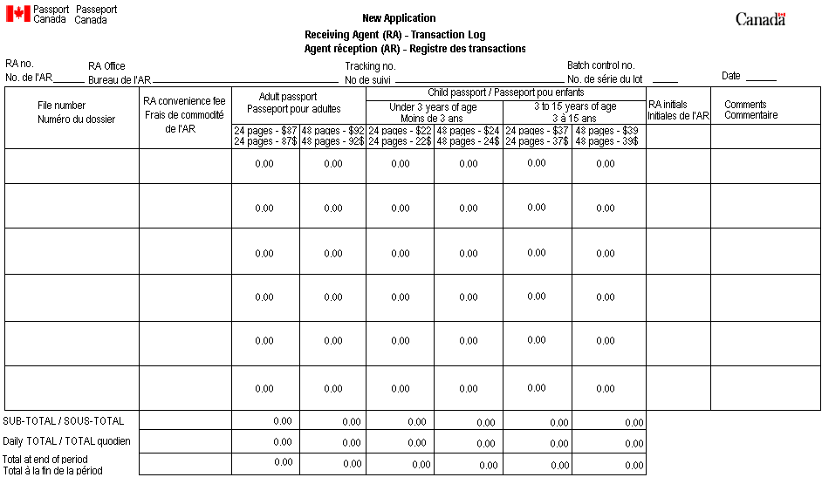

Appendix D - Old Receipt and Deposit envelope instructions

Procedures for the Receiving Agents

Each Receiving Agent should have acces to:
- a series of numbered envelopes – to be kept in a secure location
- Desk Log sheet

Never destroy an unusable envelope. Mark CANCELLED on both the envelope and the detachable receipt. Record the information or the reason for cancellation on your desk log sheet beside the applicable envelope number. Drop the envelope with the receipt attached in the lock box. This will ensure the numerical sequence of your assigned envelopes is not broken.

Receiving Agents will also have available, in a central location:
- a ScotiaBank POS – Electronic Card terminal
- Passport Application Transaction Log forms (PPT 184) (if applicable)

A new envelope must be used for each client, following the numerical sequence.

Completion of Deposit Envelopes:
a) For each payment received, and pressing hard with a ball-point pen the following information must be completed on the envelope. Note that the removable part of the pre-numbered deposit envelope will be the client’s official receipt and must be accurate and legible on both the receipt and the envelope:
- The department on behalf of which the payment is received (e.g. Passport Canada)
- The client’s SIN (if applicable – not required for passports applications)
- The receipt date of the payment (today’s date)
- The client’s last and first name (if payment is received for more than one passport application, one envelope can be used, inscribe the last and first name of all applicants - e.g. family);
- The payer’s last and first name; if different from client;
- The total payment amount;
- The payment type (Cash, VISA, etc.);
- The reason for payment, check off one or write information.
- if for Passport, choose payment to other department and write the complete file number(s) of the application(s);
- Signature of the Receiving Agent;
- Responsibility Centre (RC) of the Receiving Agent.

N.B. Complete file number corresponds to the 7 digits bar code number that should start by a letter Examples: R123456, RH12345

b) After counting cash and/or verifying the negotiable item, place the payment and all supporting documentation, e.g. monthly statement, in the deposit envelope and seal. For debit or credit card payments, place the transaction slip (merchant copy) in the envelope.

c) Check for accuracy and legibility on the envelope/receipt. Ensure that the payment amount is completed as this is the client’s official receipt. Then give the removable part (receipt) to the client. Encourage the client to check the receipt for accuracy.

d) Complete your Desk Log Sheet and the Passport Transaction Log (if applicable).

e) Place the sealed deposit envelope in the lock box immediately. This box can be opened only by the employee responsible for the transfers to the PROCESSING OFFICE.

Passport Applications:

The Transaction Log (Passport Office form PPT 184 (03-09)) is used to record each transaction processed. It is important that the log be filled in accurately, completely and that all writing is legible.
The form comes in three copies:
- Copy 1 white: mailed daily to Passport Office with all applications received
- Copy 2 yellow: sent daily or at least weekly to the PROCESSING OFFICE with the deposit envelopes
- Copy 3 pink: kept by the HRSDC.
If Passport applications were processed that day, all three copies are put in the lock box.

It is important to complete the following information for each passport application on the Transaction Log (the Passport Office will instruct you on the completion of their forms, and the process used to identify the client) items:
- The file number (bar code sticker - 7 digits code)
- The amount paid (fill in the amount in the appropriate column)
- The method of payment and the number of the pre-numbered deposit envelope (in the column “Comments”)
NOTE:
The same deposit envelope number can be recorded on more than one line as one payment can cover more than one passport application (e.g. for several family members).

The numeric sequence of the file numbers (bar code) must be respected on the Transaction Log. If a bar code number is cancelled or voided, it must be clearly indicated on the Transaction Log that the file number is cancelled and the reason for the cancellation.

Appendix D - Old Receipt and Deposit envelope instructions –cont’d
End of day

Employee responsible for transferring envelopes to the Processing Office:

1. This employee is in charge of:
- sending the deposit to the PROCESSING OFFICE
- monitoring, controlling, and distributing of the HRCC deposit envelopes
- the lock box
- the POS electronic card terminal (supplies, deposit settlement slips)
- the Passport Transaction Log
- ensuring supplies are always available for the Receiving Agent
- mailing the correct copy of any Transaction Logs to the Passport Office
- filing office copy of passport form.

2. Closing the Scotia Bank terminal for all credit card and debit card transactions.
All transactions processed on the Scotia Bank terminal must be closed at the end of every day, as follows:
- Total the day’s transactions
To receive detailed information by card type:
  - Press SETTLE
  - Select #1
  - Select #0 – detailed information will print.
- Press the SETTLE key:
  - Select # 2 for TOTALS, the totals will print.
- Press the SETTLE key:
  - Select #3 for DEPOSIT, the information on the deposit will be printed.

In case of difficulty, refer to the Merchant’s manual, or if necessary, to Client Services at the Scotiabank Help Desk toll-free at 1-800-265-5158.

3. Reconciliation/preparation of deposit envelopes removed from the lock box at the end of each day:
- At the end of each day, with a witness, the employee in charge of shipments to the PROCESSING OFFICE empties the lock box and collects the log sheets.
- Draw a diagonal line through any unused lines on the page.
- The employee must complete the Public Money Transfer Record and ensure the numbers are in numerical order.
- Reconcile the total of all payments received on your Transfer Record and the envelopes
- When totals match, the employee and the witness sign and date the Public Money Transfer Record. Any discrepancy must be investigated immediately, with the witness.
- On the Transfer Record, write the number of the lock-clip to be used and the security pouch number.
- Photocopy the Transaction Record, retain.
- Place envelopes and Transfer Record(s) in the security pouch, ensure the label indicates the PROCESSING OFFICE, close the pouch and attach the assigned numbered lock-clip.
- Place in a safe until the envelopes are sent to the PROCESSING OFFICE.
- Send the payments received to the PROCESSING OFFICE every day or, if it is not cost-effective to do so, at least once a week (one security pouch). The PROCESSING OFFICE will input the transactions in the financial system and deposit the funds at the bank.
- No payments or documentation should be kept in the lock boxes overnight.

4. Sending payments received to the Processing Office.
- Either fax a copy of the Public Money Transfer Record(s) or email the pouch number, lock-clip number and number of envelopes to the PROCESSING OFFICE to indicate that a shipment is on the way.
- Place the blue security pouch in a departmental plain envelope marked ‘Personal and Confidential' or “To be Opened by Addressee Only”, addressed to the PROCESSING OFFICE – Revenue Cashier.
- The envelope must be kept in a safe until ready to be shipped to the PROCESSING OFFICE.
- Send by bonded courier service.

NOTE:
The bonded courier service will probably deny any liability in regards to the potential loss of money related to transportation of cash. In that aspect, the department will accept the risk and liability for any losses.

Appendix E - Barcode Tracking Sheet

Barcode Tracking Sheet

Barcode Sticker | CSO Initials

Appendix F – All purpose letter

Date

Name
Complete Address
SIN

Following the receipt of your payment, additional information is required before we can credit the proper account. Please respond the checked box (es).
□ Additional information is required before we can credit the proper account.
(To whom this payment applies)

Person’s name: __________________________________
(Print name in full)

Social Insurance Number: _________________________
□ Program(s) to which this payment applies (check where applicable):
□ Canada Student Loan
□ Canada Pension Plan
□ Old Age Security
□ Employment Insurance
□ Family Allowance
□ Immigration
□ Other: _____________

□ As discussed enclosed the payment sent to us by error.

Your payment is being returned to you for the following reason (s). Please make the corrections on your cheque as requested and return it to us.
□ Amend your cheque so that the written amount corresponds with the numerical amount and initial changes made.
□ Make your payment payable to The Receiver General for Canada.
□ Sign your cheque(s).
□ Write the date on your cheque(s).
□ The payment are now staled-dated (over 6 months). Send us a replacement cheque.
□ Others: __________________________________________________________

Regards,

Your address

21 Appendix G –Payment Money transfer record

Citizen Service Officer (CSO) - Front-end client-service staff responsible for processing applications and receiving payments from in-person clients
Service Canada Centres (SCC) - Strategically located offices across Canada, offering a wide range of government services and benefits to all Canadians. Please refer to the following URL for the locations in your region: http://www1.servicecanada.gc.ca/en/gateways/where_you_live/menu.shtml
Processing Offices - Responsible for controlling Pre-numbered Envelopes, receiving logs and envelopes with money from CSO’s for input into the Corporate Management System (CMS). Processing Offices may be located at Regional Finance Headquarters.
The Statement of Responsibilities for Petty Cash Fund or Change Float Custodian, Alternates and Designated Employees protects both the employee and the employer. The original signed statement is retained in the employee’s file; a copy is provided to the employee; and the third copy is sent to Accounting Operations, Regional Office to be placed on file.
Transfer of Change Fund transfers the change fund between the custodian and an alternate for a temporary period during the day. The form must be completed and signed in the presence of the two employees and retained in the office. This involves a verification of the monies being transferred and protects both parties.
Remittance Types include: Amex, Debit, Visa and Master Card
Receiving Agent Transaction Log (form PPT 184) – Form issued by the Passport Office and used to record all passport transactions processed.
Post dated cheques are cheques drawn on a future date. As such they are not deemed to be a negotiable payment.

