ESDC Official Marks Inventory

For questions, contact the Intellectual Property Centre of Excellence

Author: | Investment, Procurement and Project Management (IPPM), CFOB
Revision Date: | 2018-05-17
Document Status: | Final

Branch | Mark (in the language in which it is registered) | Number | Date
HRSB | Compétences de tâche (pyramide)  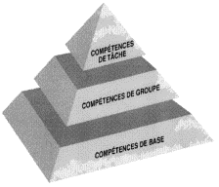 | 910757 | 1999-04-21
HRSB | Competency Profile & Design (Pyramid, Circle)  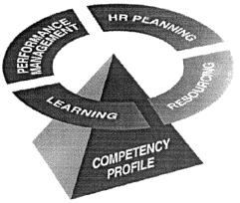 | 910758 | 1999-04-21
HRSB | Profil de compétences (pyramide, cercle)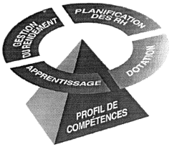 | 910759 | 1999-04-21
HRSB | Task Competencies & Design (Pyramid)  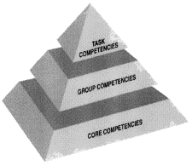 | 910760 | 1999-04-21
ISSD | OAS (for Old Age Security) | 911139 | 1999-09-08
ISSD | CPP(for Canada Pension Plan) | 911140 | 1999-09-08
ISSD | GIS (for Guaranteed Income Supplement) | 911141 | 1999-09-08
ISSD | SV (for Sécurité de la vieillesse) | 911163 | 1999-09-08
ISSD | RPC (for Régime de pensions du Canada) | 911164 | 1999-09-08
ISSD | SRG (for Supplément de revenu garanti) | 911165 | 1999-09-08
ISSD | The Canadian Retirement Income Calculator | 911878 | 2000-11-15
ISSD | La calculatrice du revenu de retraite canadienne | 911879 | 2000-11-15
ISSD | HIFIS / SISA (for Homeless Individuals and Families Information System / Système d’info sur les personnes et les familles sans abri) | 1619363 | 2014-12-03
Labour | Major Wage Settlements (Grand règlements salariaux) | 904542 | 1991-01-02
Labour | Directory of Labour Organizations in Canada (Repertoires des organisations de travailleurs et travailleuse au Canada) | 904544 | 1991-01-09
Labour | Hands in Triangular Design   | 909599 | 1998-02-11
Learning | Canlearn | 910123 | 1998-09-09
Learning | Ciblétudes | 911697 | 2000-03-01
Learning | Centre de service national de prêts aux étudiants | 915011 | 2003-05-28
Learning | National Student Loans Service Centre | 915013 | 2003-05-28
PASRB | Service Canada | 916431 | 2005-03-02
PASRB | Service Canada (colour)   | 919011 | 2009-03-11
PASRB | Service Canada (black on white)   | 919012 | 2009-03-11
PASRB | Service Canada (white on black)   | 919013 | 2009-03-11
POB |  | 0925111 | 2018-05-09
POB | 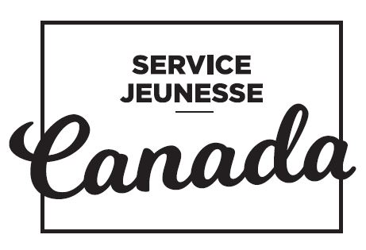 | 0925112 | 2018-05-16
POB | Canada Service Corps | 0925113 | 2018-04-18
POB | Service jeunesse Canada | 0925114 | 2018-04-18
SEB | Interprovincial Standard Red Seal (Sceau Rouge)   | 906377 | 1994-04-13
SSPB | COPS  (for Canadian Occupational Projection System) | 900334 | 1985-10-23

