**Portal Entry Process – Create Budget Document Procedures**

**For Fund Centre Managers**

The purpose of this document is to outline the process for Fund Centre Managers (FCM) or Branch Management Service (BMS) to follow when creating a budget transfer document for operating funding using the Portal for MyEMS. Budget transfers relating to Grants and Contribution (G&C) will need to be processed by the Financial Management Advisor (FMA).

The following print screens outline the step by step process for how to create a budget transfer entry in the Portal. The screens used for this demonstration are based on an open access, thus the screens the FCM has access to may differ slightly based on their access roles.

These procedures should be read in conjunction with the materials or guidance documents provided by the FMA areas.

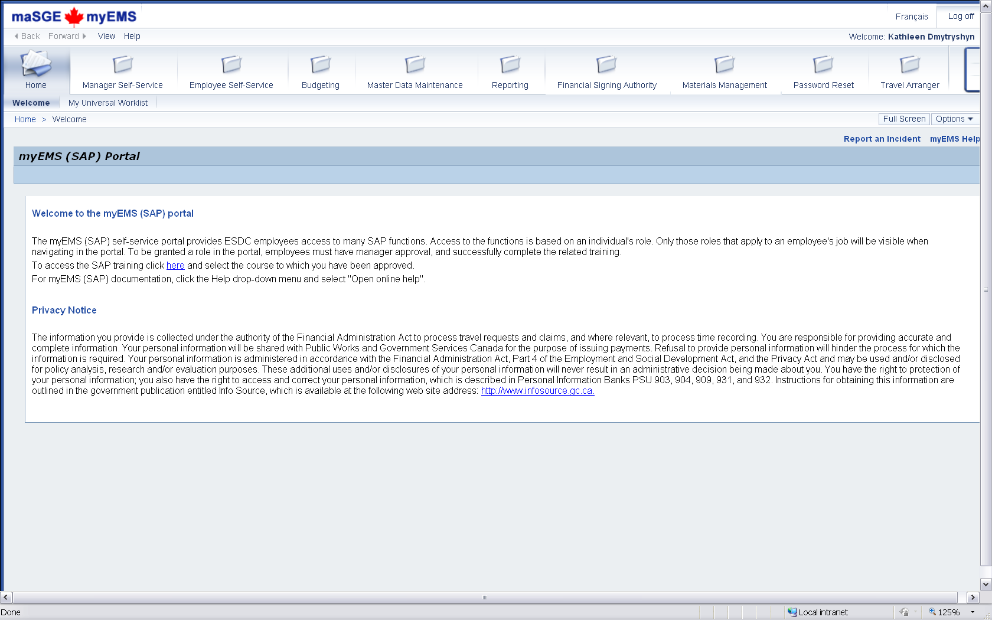

1

1. For BMS, any budget transfers not affecting Budgets Controls; within Branches (under level 3)/ Fund/Commitment Item groups and between or within Functional Areas will need to be performed under the folder Budgeting and then Budget manager (1.a)

3

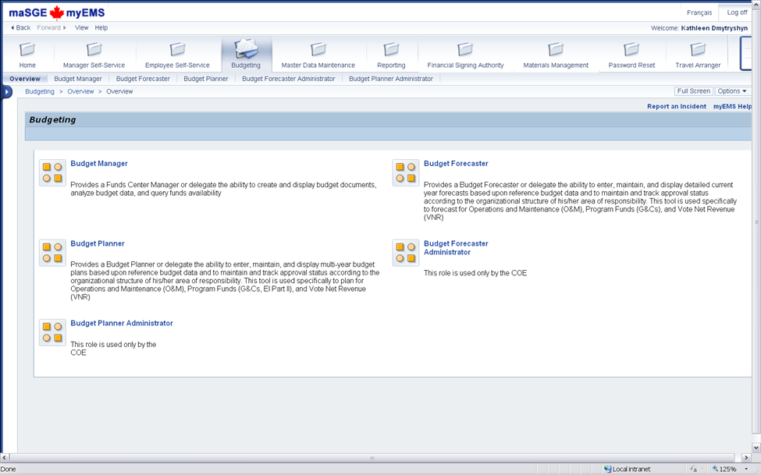

1.a

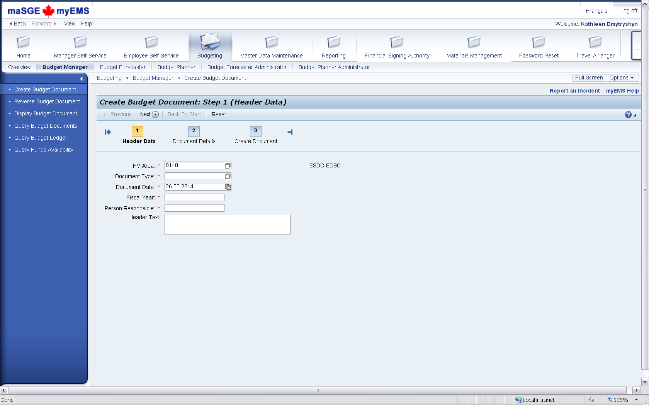

3

2

1. **Document types** are to be used in the following fashion:
   1. B10 –Direct post by BMS for transfers between FC below level 3
   2. B01 – Direct post by BMS for transfers between FA (NHQ FC only) or between CI (within the same CI group)
   3. B02 – Post by BMS; approve by FMA* (for transfers affecting 2 FC at Level 3- DGs )
   4. PR1 – Proj Bgt Orig; Direct Post by BMS for transfer to a Funded Program
   5. PR2 – Proj Bgt Supp; Direct Post by BMS for supplement to a Funded Program
   6. PR3 – Proj Bgt Rtn; Direct Post by BMS for transfer from a Funded Program

*Only options available for G&Cs

1. **Fiscal year** =2017 (for year 2016-2017)

**Person Responsible** = Lead BMS or FCM / Transferring BMS or FCM

**The Text** can be a maximum of 40 characters long.

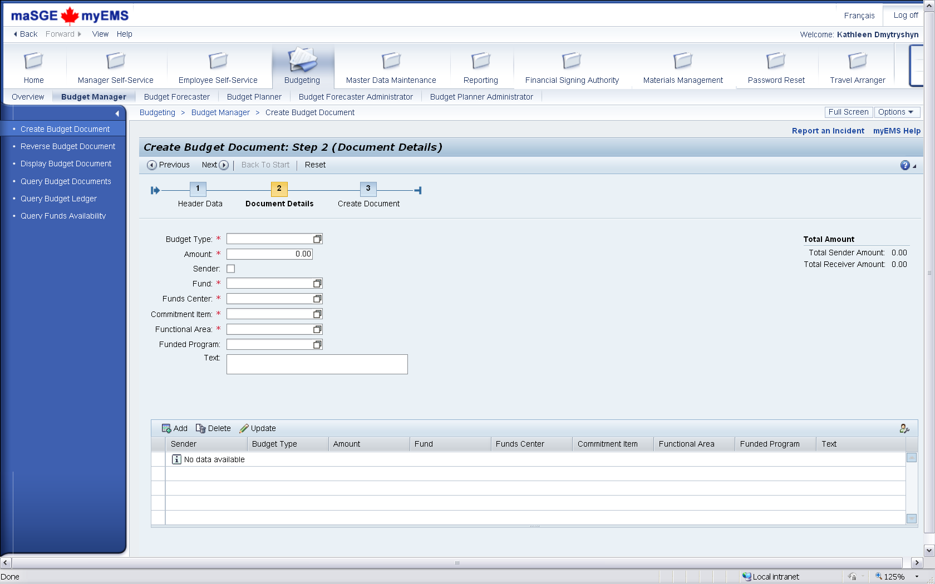

4.b

4.a



4

1. Enter the appropriate budget type and amount.

**Budget type could be**:

* + BBGT – Budget Transfer Non-Personnel, G&Cs
  + BPER – Budget Transfer Personnel
  + BREV – Budget Transfer Revenue

Click √ the Sender check box to enter the sender financial information. Enter coding elements (Fund, Funds Center, Commitment Item, Functional Area and Funded Program (if applicable)) and text. A coding reference sheet can be found following the link: <http://dialogue/grp/CRM-GRM/Coding/Forms/AllItems.aspx>



Please refer to “16-17 SAP FM Coding FMA.xlsx”.

**The text box** should indicate “what” the transfer is for (i.e. for P03 forecast).

Once this is completed, click the Add button (4.a) and then enter the Receiver financial information. When the transfer is completed, click (4.b) Update.

Revised: March 11 2016