1. **Application**

This process applies to all Grants and Contributions (G&Cs) projects within the Common System for Grants & Contributions (CSGC) for which a project would require a payment to be manually processed directly through myEMS (SAP) and not via the CSGC interface, due to exceptional circumstances.

Exceptions to this process are listed in **Appendix C**.

1. **Context**

CSGC is the official departmental system for managing G&C’s. CSGC supports the management and administration of the Department's Gs&Cs programs. CSGC is designed to address the needs of the Department's business lines, following the Project Life Cycle (PLC), and the Client Module (CM). All Gs&Cs payments must be issued out of CSGC. In exceptional circumstances for which a CSGC project would require a payment to be manually processed directly through SAP, this step-by-step process must be adhered to.

1. **Objectives**

The objectives of this process include:

* Ensuring proper internal controls and standardize procedures are utilized for the issuance of CSGC manual payments;
* Strengthening CSGC’s position as the official system for managing G&Cs;
* Reducing the number of manual payments going through SAP to a minimum;
* Improving reporting and integration by reducing reconciliation efforts between CSGC and SAP.

These objectives are in line with Treasury Board and Departmental policies and directives, such as:

* Sections 32, 33 and 34 of the [*Financial Administration Act*](http://laws-lois.justice.gc.ca/eng/acts/F-11/index.html) *(FAA)*
* [*Directive on Accounting Standards: GC 5100 Payables at Year-End (PAYE)*](https://www.tbs-sct.gc.ca/pol/doc-eng.aspx?id=32530)
* *[TBS Policy on Transfer Payments](https://www.tbs-sct.gc.ca/pol/doc-eng.aspx?id=13525)*
* [*TBS Directive on Transfer Payments*](https://www.tbs-sct.gc.ca/pol/doc-eng.aspx?id=14208)
* *Departmental Grants and Contribution Policy* *(rescinded and archived - currently being revised)*
* [*TBS Guideline for the “Policy on Internal Control”*](https://www.tbs-sct.gc.ca/pol/doc-eng.aspx?id=27260)

1. **Summarized steps to complete a CSGC manual payment request**

The following procedure must be adhered to:

* Before initiating a request, all possibilities must be looked at to ensure issuing a payment directly in SAP is truly the only viable option. All efforts must be made to update and maintain accurate and updated project information in CSGC directly. Please refer to the [CSGC intranet](http://esdc.prv/en/service-canada/pob/coegc/csgc/index.shtml) for further instructions and guidance.
* Once the Grants and Contributions Practitioner (GCP) has discussed with the CSGC representative (CSGC Rep) and has made all efforts to remediate CSGC and properly update the system, if both agree that issuing a payment directly in SAP is the only option, the G101 form must be completed. This form is available on the [iService Catalog](http://iservice.prv/eng/service_catalogues/finance_services.shtml)ue by selecting “Grant and Contribution (G&C) Manual Payment Request” and then “G101 Form”:
* The GCP completes the G101 form;
* The CSGC Rep ensures that the G101 form is accurate and complete;
* The appropriate delegated officer (pursuant the Section 34 of the FAA) signs the form and sends it to the CSGC Rep;
* When required, the CSGC Rep must request an update to the funds commitment(s) in SAP with the CFOB-FMA (Financial Management Advisor);
* The CSGC Rep validates the G101 form with the Program Operations Branch - Center of Expertise (POB-COE);
* The CSGC Rep submits the G101 form to CFOB through the [iService Catalogue](http://iservice.prv/eng/service_catalogues/finance_services.shtml);
* CFOB-NAP (National Accounts payable, within the Integrated Corporate Accounting and Accountability Directorate ICAAD)) issues a manual payment through SAP and provides the relevant payment information (SAP document number) to the CSGC Rep;
* Once the manual payment is issued, both the CSGC Rep and the GCP ensure that the CSCG system is updated with the payment information via note to file (closed projects) or data fix (for open projects).

Refer to **Appendix A** (Detailed Process with Roles and Responsibilities) and **Appendix B** (Flowchart) for further details.

1. **Monitoring and oversight**

* CFOB- ICAAD will perform periodic reconciliations between SAP and CSGC to ensure ongoing synchronization of both systems. If a discrepancy is noted between SAP and CSGC, CFOB will follow-up with the appropriate teams to ensure that all variances are corrected on a timely basis;
* CFOB-ICAAD will prepare a periodic report detailing all CSGC manual payments issued directly through SAP, for inclusion within the CSGC system by POB;
* CFOB-ICAAD will monitor the usage of CSGC manual payments (frequency and amounts) and report significant changes to trends when deemed necessary.

1. **Reporting**

* POB will be responsible for presenting the periodic monitoring reports to the appropriate Gs&Cs governance bodies. The reports will include approved manual payments and any concerns.
* POB will also perform analysis of trends and statistics on the manual payments to see if it is an appropriate practice to issue payments under these special circumstances (i.e. when a project is closed in CSGC).

**Appendix A**

**Issuance of Manual Payments - Detailed Process with Roles and Responsibilities**

|  |  |
| --- | --- |
| **Manual Payment Process Steps** | **Roles & Responsibilities** |
| GCP seeks confirmation from CSGC Rep (Region or NHQ) that there is no other way to issue the payment (e.g. via CSGC). | CSGC Rep |
| GCP sends the [G101 form](http://iservice.prv/eng/service_catalogues/finance_services.shtml) to the CSGC Rep for review. | GCP |
| After review, the CSGC Rep submits the completed G101 Form to the appropriate delegated officer for signature of the Section 34 of the FAA.   * Funds issued must not exceed signed agreement(s) and amendment(s). If the cumulative amendment value is less than 25% of the last agreement amount approved (minor[1] amendment), the CSGC Rep must ensure that the G101 form is also certified pursuant to the column B[2] (minor amendment) of the section 3 of the financial delegation instrument. * Refer to the financial delegation instrument for more details: (<http://iservice.prv/eng/finance/DELEG/2016/esdc_programs_section3.pdf>). | CSGC Rep |
| If the CSGC project is closed or if a minor amendment is included with the payment request, the CSGC Rep must request an update to the funds commitment(s) in SAP with the CFOB-FMA. | CSGC Rep |
| When required, the CFOB-FMA proceeds to the required adjustments to the funds commitment(s) in SAP. | CFOB-FMA |
| The CSGC Rep needs to validate with the POB-COE by sending the completed G101 Form to the following email address: [NC-GCCE-CESC-GD](mailto:NC-GCCE-CESC-GD?subject=Paiement%20manuel%20/%20Manual%20Paiement) (write in the subject “Manual Payment”). The payment must not be submitted to CFOB without an acknowledgement from the COE. | CSGC Rep |
| Once G101 form is signed, the CSGC Rep submits the payment request to CFOB-NAP through the [iService Catalogue](http://iservice.prv/eng/service_catalogues/finance_services.shtml), selecting Grants & Contributions as the category.   * The CSGC Rep must pay special attention to the closing notification from the ticket in iService. When CFOB-NAP receives the documentation via iService, if some documents are missing or not compliant with their process, the ticket will be closed with a comment without any payment being issued. In those situations, the CSGC Rep will need to submit a new request. | CSGC Rep |
| CFOB-NAP issues the manual payment | CFOB-NAP |
| CFOB-NAP advises CSGC Rep when the payment is issued, with the relevant payment information (SAP document number), by means of closing the iService ticket with notification. | CFOB-NAP |
| CSGC Rep advises the GCP with the payment information. | CSGC Rep |
| The GCP uploads the G101 form payment information in the CSGC system under the project “Supporting Document”. GCP advises the CSGC Rep once documentation is included in CSGC. | GCP |
| For open projects, the CSGC Rep opens a National Service Desk (NSD) ticket requesting a data fix adjustment to reflect the exact manual payment amount in CSGC.  For closed projects, the GCP adds a note to file in CSGC since adjustments directly in CSGC are no longer possible. | CSGC Rep and GCP |
| Once the adjustment (data fix) or the note to file is completed, the GCP and the CSGC Rep ensure that they are properly reflected in CSGC. | GCP & CSGC Rep |

**Appendix B - Manual Payments Process - Roles and Responsibilities flowchart**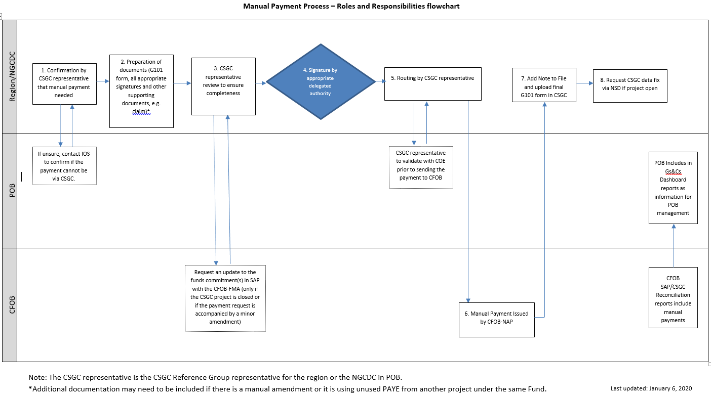

**Appendix C**

**List of current exceptions for CGSC manual payments**

* All payments not related to the Department’s Gs&Cs programs.
* Payments to provinces and territories (such as Workforce Development Agreements, Early Learning and Child Care, Canada Job Fund).
* Labour payments to international addresses and direct deposits to financial institutions outside of Canada, as CSGC is not capable of processing international payments.

1. ***Minor:*** *Cumulative amendment value of less than 25% of the last agreement amount approved by column A. Minor amendment may be approved by the appropriate delegated authority of column B for the total value of the amended agreement.*
2. ***“Column B” - B. Signing of agreements / Minor Amendment:*** *All funding agreements between the department and a recipient of a G&C must be signed by an individual with delegated authority pursuant to Column B of the Delegations of Authority Instrument. Signature of the agreement by the department can only occur after approval of the application/ proposal by the appropriate delegated authority. Minor amendments as described below may also be approved in accordance with column B of the Delegations of Authorities Instrument.*