**Reference Guide for Managers   
Completing and submitting staffing requests in myEMS (PeopleSoft)**

This reference guide is intended to help managers find information in myEMS (PeopleSoft) to complete and submit staffing requests via the Human Resources Service Centre (HRSC) portal.

For details on a specific topic, select it from the following list:

* **National ID**
* **Job Code**
* **Department Information (Dept ID)**
* **Position Security Requirement**
* **Position Exclusion Information**
* **Position Language Requirement****s**
* **Employee Second Language Evaluation (SLE) Results**
* **Employee Bilingualism Bonus**
* **Security Clearance and Expiry Date**
* **Submitting Work Schedules**

**National ID**

The National ID field in myEMS (PeopleSoft) represents the employee’s Personal Record Identifier (PRI). Managers can view the National ID of their direct reports within the Manager’s Dashboard under the Direct Reports section at the top of the page.

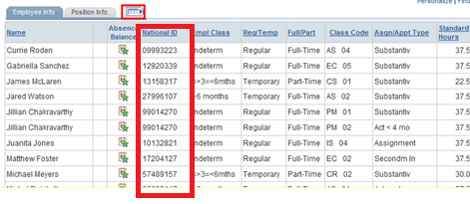

**Job Code**

When completing a staffing request via the HRSC portal, managers will need to enter a job code, i.e. a six-digit code, which will be requested to identify the type of work performed for temporary staffing actions (e.g. casuals, students, assignments, secondments in and part-time workers who will not be required to supervise employees). Managers may view job code information in the Manager’s Dashboard of myEMS (PeopleSoft), by consulting the Position Information section at the bottom of the page.

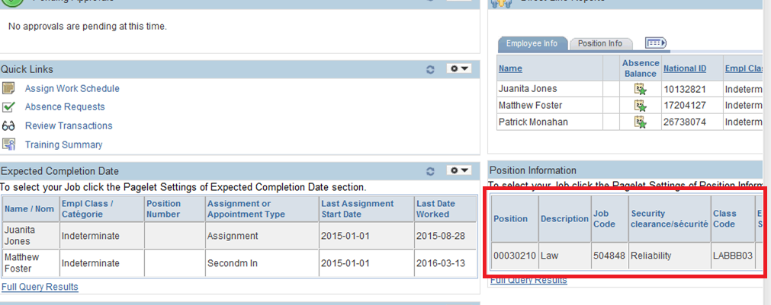

Note: If, as a manager, you’re missing the job code for an employee within your organisation, you may conduct a search in the Position Management module of myEMS (PeopleSoft) (by selecting *Organizational Development / Position Management/Maintain Positions / Budgets / Job Code Table*).

**Department Information (Dept ID)**

In myEMS (PeopleSoft), the four-digit Responsibility Centre (RC) field is replaced by a six-digit Department ID (Dept ID) field. Department IDs have been defined to the lowest supervisory level. Managers will be able to locate the Dept ID for a specific position in the Position Management module of myEMS (PeopleSoft) (by selecting *Organizational Development / Position Management / Maintain Positions/Budgets / Add/Update Position Info*).

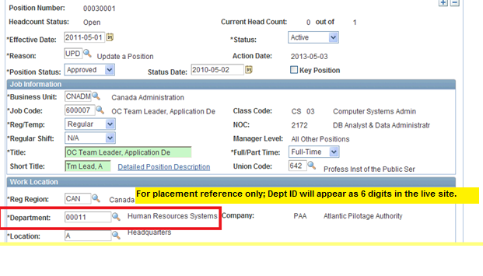**Position Security Requirement**

In myEMS (PeopleSoft), managers can view security information on direct positions reporting to them in the Manager’s Dashboard by consulting the Position Information section at the bottom of the page.



**Position Exclusion Information**

Due to a defect in myEMS (PeopleSoft), managers currently cannot view accurate exclusion and essential services information for positions in the Manager’s Dashboard. Managers can view exclusion information and essential services information regarding direct and indirect positions reporting to them in the Position Management module of myEMS (PeopleSoft) (by selecting *Organizational Development / Position Management / Maintain Positions/Budgets / Position – Labour Relations*).

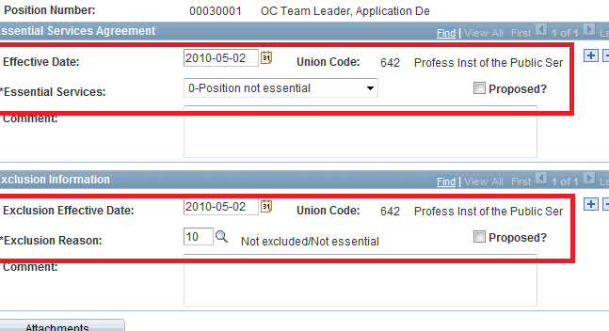

**Position Language Requirements**

Managers can view language requirement information for positions that report directly to them in the Manager Dashboard of myEMS (PeopleSoft) by consulting the Position Information section at the bottom of the page.

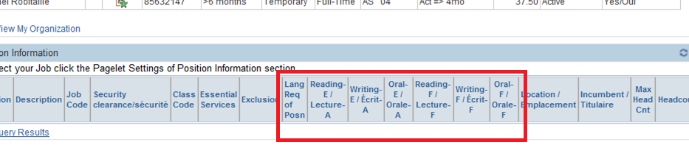

**Employee Second Language Evaluation (SLE) Results**

Managers can view SLE test results and expiry dates for direct and indirect reports in the Manager Self-Service section of myEMS (PeopleSoft) (by selecting *Learning and Development / Current Team Profiles*).

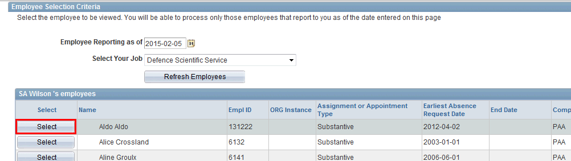

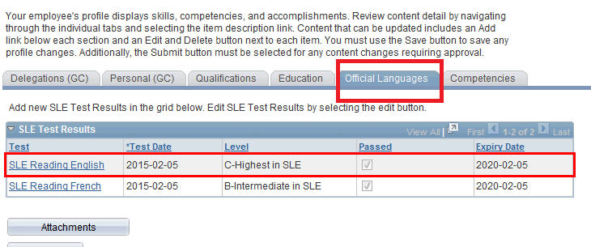

**Employee Bilingual Bonus**

To see whether a direct report is currently receiving a bilingual bonus (in the case of short-term acting appointments), consult the Direct Line reports section of the Manager Dashboard’s in myEMS (PeopleSoft).

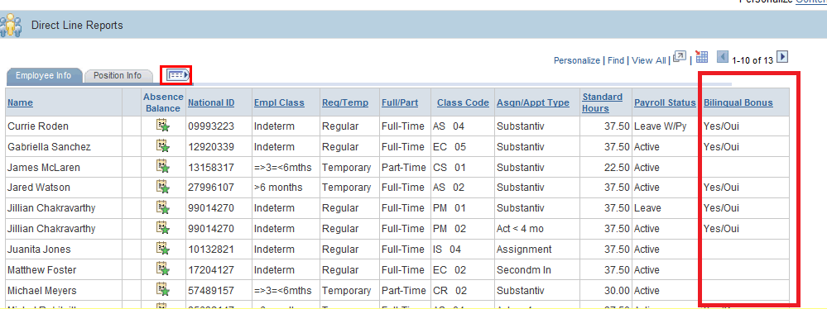

(***Note:*** *For an employee in another organization, request confirmation from the employee’s manager prior to submitting the short-term acting request.)*

**Security Clearance and Expiry Date**

Due to a defect in myEMS (PeopleSoft), managers currently cannot view information regarding an employee’s security clearance level or expiry dates. Options to obtain this information include:

* For existing ESDC employees within your organization, ask an identified [designate](http://iservice.prv/eng/esrp/erp_ps/topics/designates.shtml) to access this information in myEMS (PeopleSoft).
* For new-to-ESDC employees or for an employee from another organization within ESDC, proof of an employee’s security clearance and expiry date must be received from the Integrity Services Branch and submitted in support of the staffing request.

**Submitting Work Schedules**

After submitting a signed letter of offer or contract, once the HR staff has made the entry in myEMS (PeopleSoft), the employee information will appear on the Manager’s Dashboard.

At this time, managers must add or update the employee’s work schedule in myEMS (PeopleSoft). The work schedule entry is required for all types of schedules, including employees who are working full-time or part-time hours, shift work or variable shift work or an Alternate Work Arrangement schedule. This step is required to complete the action so that the employee can be paid.

The work schedule entry can be completed under the Manager Self-Service section of myEMS (PeopleSoft) (select *Time Management / Manage Schedules / Assign Work Schedule*).

