# **Request Employee Absence**

## **Concept**

Use this procedure to request an absence on behalf of an employee who is a direct report.  In addition, this procedure will result in the request being approved.

Managers can access and use absence self-service pages as well.  You can request an absence on behalf of an employee, view employee absence requests, view absence balances, approve and deny absence requests, and review absence request history.

**More Information**

If the employee is on leave without pay, you will not be able to submit a leave request on his or her behalf.

## **Training Scenario**

Your goal is to enter an absence request for an employee that reports to you.

**Procedure**

| **Step** | **Action** |
| --- | --- |
|  | Navigate to the **Request Absence** page.  Click the **Main Menu** dropdown button to activate the menu. |
|  | Click the **Manager Self-service** menu. |
|  | Click the **Time Management** menu. |
|  | Click the **Report Time** menu. |
|  | Click the **Absence Request** menu. |
|  | The **Employee Reporting as of** date is for determining the list of who were your direct reports at that moment in time.  Defaults to today's date. Update, if required, and then click on the **Refresh Employees** button. |

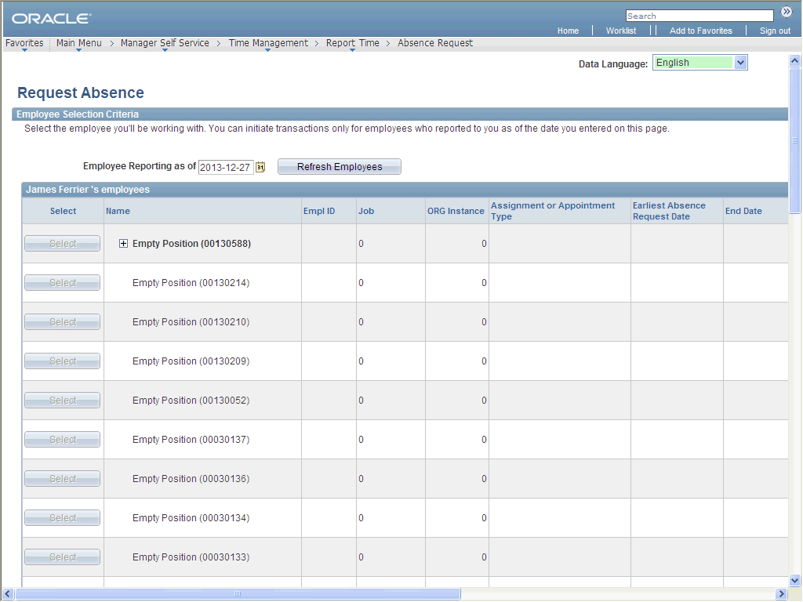

| **Step** | **Action** |
| --- | --- |
|  | Scroll through the list until you find the employee for whom you are making the request.  Click the **Vertical** scrollbar. |
|  | Click the **Select** button next to the name of the person for whom you wish to submit the absence request.  Click an entry in the **Select** column. |
|  | The **Request Absence** page is set up as it is for the employee absence request. |
|  | View the employee's absence request history before submitting a new request.  Click the **View Absence Request History** link. |
|  | The **Absence Request History** page displays all absence events based on the specified date range.  This page functions exactly the same as the employee self-service version. |
|  | Click the **Return to Absence Request** link. |
|  | View the employee's absence balances before submitting a new request.  Click the **View Absence Balance** link. |
|  | The **Absence Balances (GC)** page opens in a new window and displays the employee's current balances for the types of absences for which he/she is entitled. |

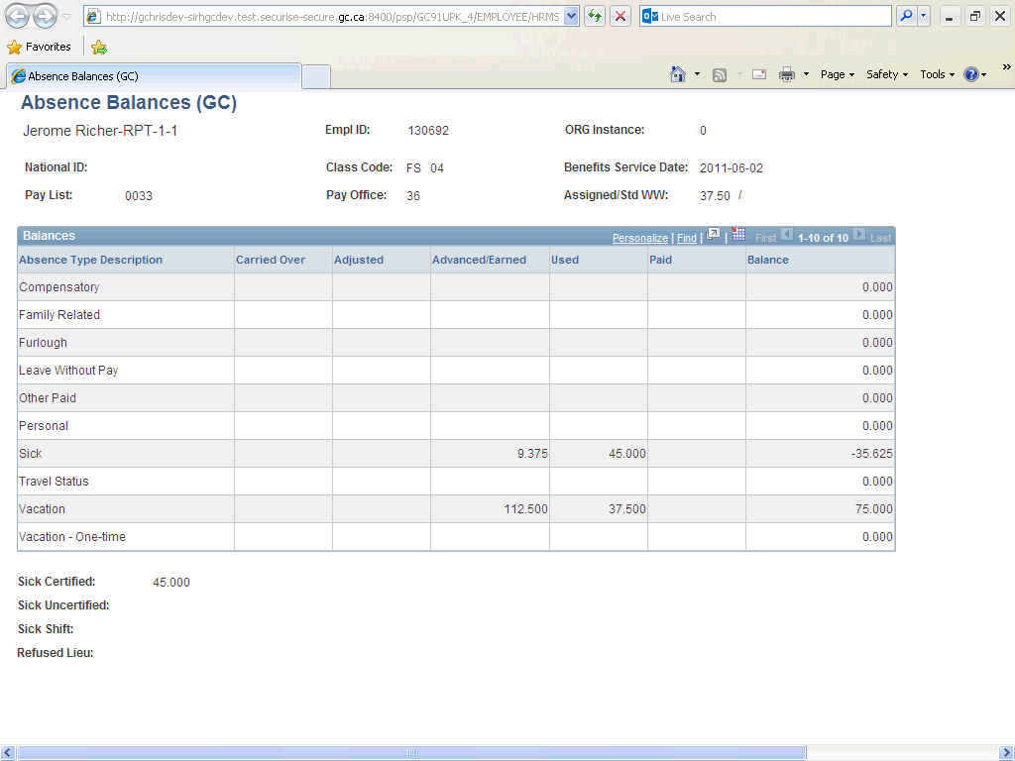

| **Step** | **Action** |
| --- | --- |
|  | Return to the **Request Absence** page.  Click the **Close** button. |

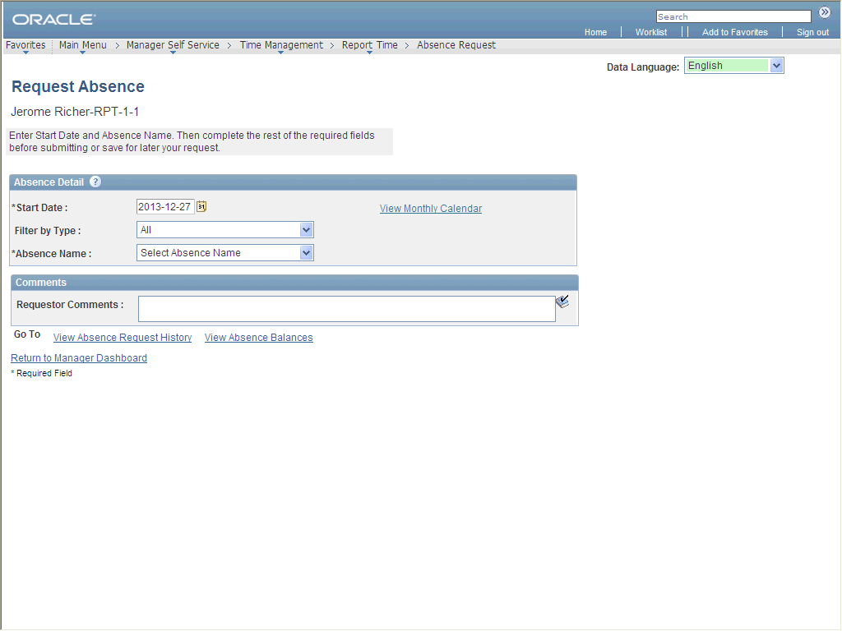

| **Step** | **Action** |
| --- | --- |
|  | **Start Date**- the first day on which the employee will be absent.  Enter the desired information into the **Start Date** field. Enter "**2013-03-11**". |

|  |  |
| --- | --- |
|  | The date format in myEMS (PeopleSoft) is YYYY-MM-DD.  For example, January 19, 2013 will show as 2013-01-19.    To ensure you enter the right date format, use the **Choose a Date** button (C:\Users\theresa.mcquilkin\AppData\Local\SUPDev9\D\Content_EN\W\5e46b330bde140a787d2c1acd1046cba\Parts\images\calendar.gif) to access an interactive calendar from which you can choose the date.    C:\Users\theresa.mcquilkin\AppData\Local\SUPDev9\D\Content_EN\W\5e46b330bde140a787d2c1acd1046cba\Parts\images\Calendar_final2.png |

| **Step** | **Action** |
| --- | --- |
|  | Click the **Filter by Type** list. |
|  | Click an entry in the list. |
|  | Click the **Absence Name** list. |
|  | Click an entry in the list. |
|  | You can indicate if any of the days in the range are to be partial days of absence by using the **Partial Days** field.  For example, if the employee works two hours on the start day and is absent for the rest of the day (5.5 hours), select **Start Day Only** in the **Partial Days** field.  A new field will appear allowing you to enter 5.5 hours for this day.  **Note:** Click on the icon below for more information on entering full or partial days. |
|  | **Decision:**Do you want to enter a partial day or days?   * No Go to step 23 * Yes Go to step 36 |
|  | You can enter either the **End date** (i.e., the last day of absence), the number of hours of absence in the **Duration** field, or both.  myEMS PeopleSoft can then calculate the other value. |
|  | **Decision:**Which of the following do you want to enter?   * End Date Go to step 25 * The number of hours of absence Go to step 40 |
|  | Enter the desired information into the **End Date** field. Enter "**2013-03-13**". |

|  |  |
| --- | --- |
|  | The date format in myEMS (PeopleSoft) is YYYY-MM-DD.  For example, January 19, 2013 will show as 2013-01-19.    To ensure you enter the right date format, use the **Choose a Date** button (C:\Users\theresa.mcquilkin\AppData\Local\SUPDev9\D\Content_EN\W\5e46b330bde140a787d2c1acd1046cba\Parts\images\calendar.gif) to access an interactive calendar from which you can choose the date.    C:\Users\theresa.mcquilkin\AppData\Local\SUPDev9\D\Content_EN\W\5e46b330bde140a787d2c1acd1046cba\Parts\images\Calendar_final2.png |

| **Step** | **Action** |
| --- | --- |
|  | Click the **Calculate End Date or Duration** button. |
|  | The **Duration** field is updated to reflect the requested number of hours based on the start and end dates, as well as any partial days, if applicable. |
|  | Click the **Forecast Balance** button. |
|  | If the employee has sufficient hours in his balance, the request will be deemed to be eligible (but not yet approved). |
|  | Enter the desired information into the **Requestor Comments** field. Enter "**Comments**". |
|  | Submit the request.  Click the **Submit** button. |
|  | Click the **Yes** button. |
|  | Click the **OK** button. |
|  | Note that the request has been both submitted and approved. |
|  | You have successfully submitted and approved an absence request on behalf of an employee who reports to you.  **End of Procedure.** Remaining steps apply to other paths. |

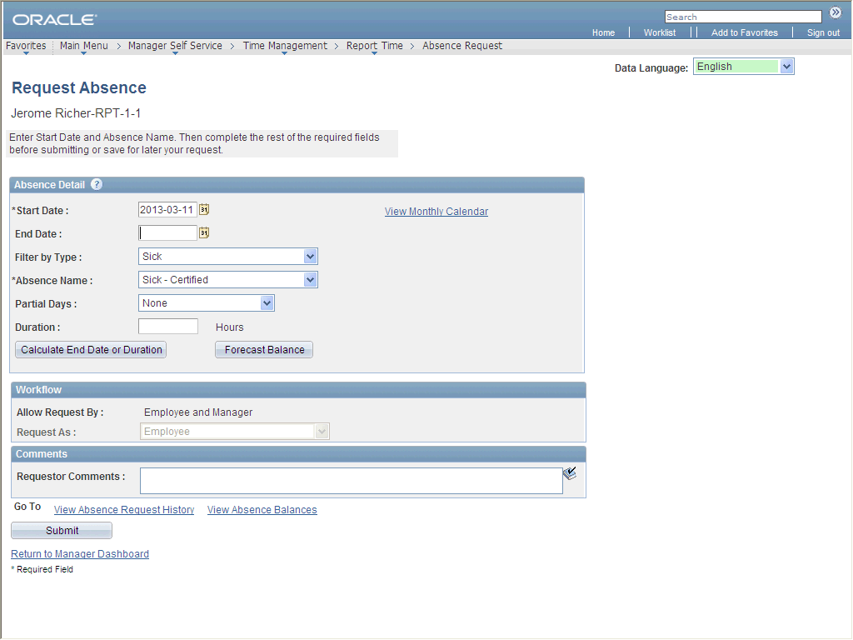

| **Step** | **Action** |
| --- | --- |
|  | Click the **Partial Days** list. |
|  | Click an entry in the list. |
|  | Enter the desired information into the **Start Day Hours** field. Enter "**5.5**". |
|  | You can enter either the end date (i.e., the last day of absence), enter the number of hours of absence in the **Duration** field, or both.  myEMS (PeopleSoft) can then calculate the other value.  Go to step 24 |

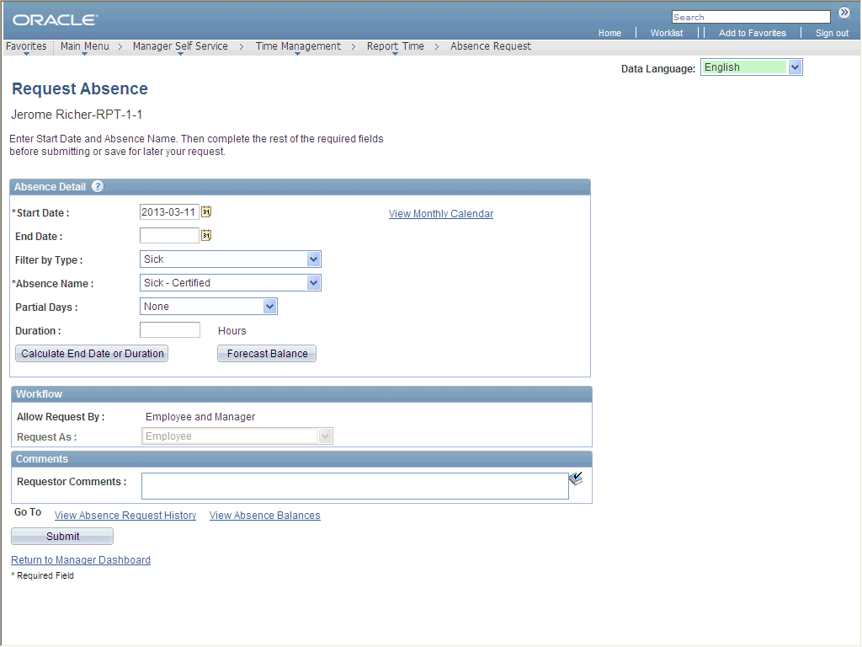

| **Step** | **Action** |
| --- | --- |
|  | Enter the desired information into the **Duration** field. Enter "**22.5**". |
|  | Click the **Calculate End Date or Duration** button. |
|  | The **End Date**field is updated based on the **Start Date** and the number of hours in the **Duration** field, as well as any partial days.  Go to step 28 |