# **Request Absence**

## **Concept**

Use this procedure to submit a request for an absence.

### **Absence Events and Phoenix**

The Absence Management module is integrated with Phoenix, the Government of Canada Pay System. Employee Schedules and certain Leave Events that impact pay will flow directly to Phoenix and have a direct impact on employee pay.

**Voluntary Leave Cash-out Requests -** New Process effective March 1, 2019, please see topic Voluntary Leave Cash Out

**Leave Without Pay (LWOP) 5 days or less** will be available to entitled employees via Employee and Manager Self Service (ESS / MSS).  In addition, Leave Administrators will have the ability to recover unearned leave.

Section 34 Approval of submitted LWOP events will have a direct impact an employee pay, benefits and entitlements.  Employees and Managers are cautioned to carefully review details of absence events that have an impact on pay, prior to submitting and/or approving an event.

Following Section 33 Approval, the employee will see the expected result (outcome) for the event on a regular pay issued in the **following** month.  (Examples provided below)

**IMPORTANT!** Employees and Managers are responsible for ensuring expected results are realized.  Errors, questions and/or concerns regarding employee pay must be directed to the Public Service Pay Centre (PSPC).

**Contact the Public Service Pay Centre**:

https://www.tpsgc-pwgsc.gc.ca/remuneration-compensation/services-paye-pay-services/paye-centre-pay/cn-cu-eng.html (<https://www.tpsgc-pwgsc.gc.ca/remuneration-compensation/services-paye-pay-services/paye-centre-pay/cn-cu-eng.html>)

**Example 1:** Employee submits a LWOP event in May & Manager Approves LWOP event in May.

Outcome: Employee will see LWOP salary recovery on one of the regular pays issued in June (the month following Section 34 Approval).

**Example 2:** Employee submits LWOP event in May & Manager Approves LWOP event in June.

Outcome: Employee will see the LWOP salary recovery on one of the regular pay days issued in July (the month following Section 34 Approval).

To delete an absence request, refer to the topic Delete Absence.

To request overtime in lieu, refer to the topic Request Compensatory (Banked) Overtime.

## **Training Scenario**

Your goal is to learn about keys.

**Procedure**

| **Step** | **Action** |
| --- | --- |
|  | Navigate to the **Request Absence** page.  Click the **Main Menu** dropdown button to activate the menu. |
|  | Click the **Self-service** menu. |
|  | Click the **Time Reporting** menu. |
|  | Click the **Report Time** menu. |
|  | Click the **Absence Request** link. |
|  | **Decision:**Do you have more than one job (Empl Record)?   * Yes Go to step 7 * No Go to step 9 |
|  | Use the **Select Job** page to select a job when there are multiple jobs assigned to a person.  **Note:** The **Select Job** page will display if you are assigned to multiple jobs. You will be asked to select the job in which to request your absence. |

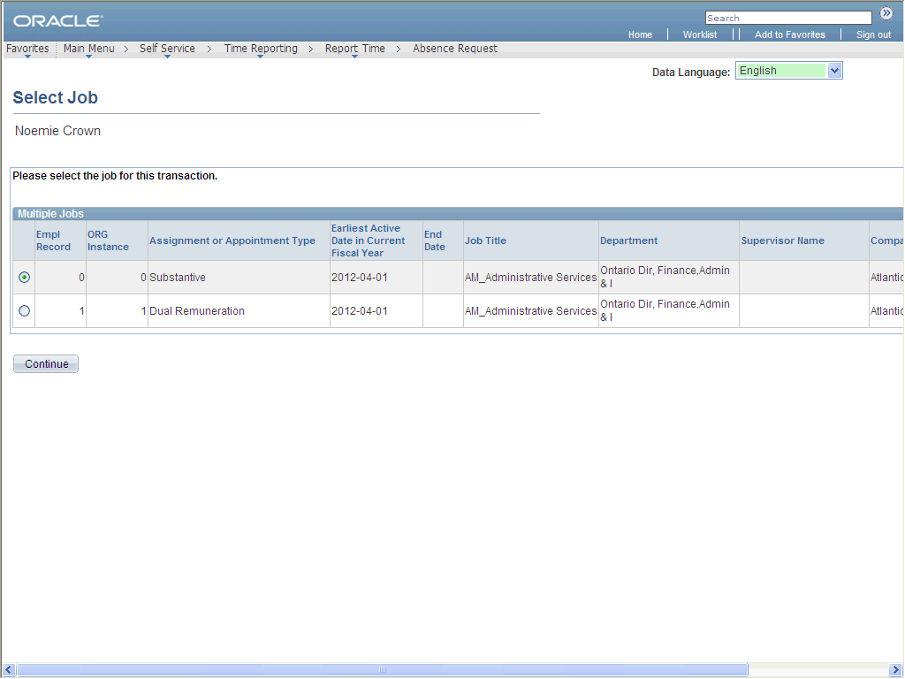

| **Step** | **Action** |
| --- | --- |
|  | Select the appropriate job using the radio button.  Click the **Continue** button. |
|  | View your absence request history before submitting a new request.  Click the **View Absence Request History** link. |
|  | The **Absence Request History** page displays processed or pending absence events (submitted, approved or denied absences) based on the specified date range.  **Note:** The instructional text indicates that you can modify the absence request. MyEMS (PeopleSoft) has not delivered this functionality.  Reminder: This page is a view only copy of the Absence Request History page. Should you want to delete the absence, refer to the topic Delete Absence. |
|  | Click the **Return to Absence Request** link. |
|  | View your absence balance before submitting your absence request.  Click the **View Absence Balances** link. |
|  | The **Absence Balances (GC)** page opens in a new window and displays the current balances for the various absence types entitled to you. |

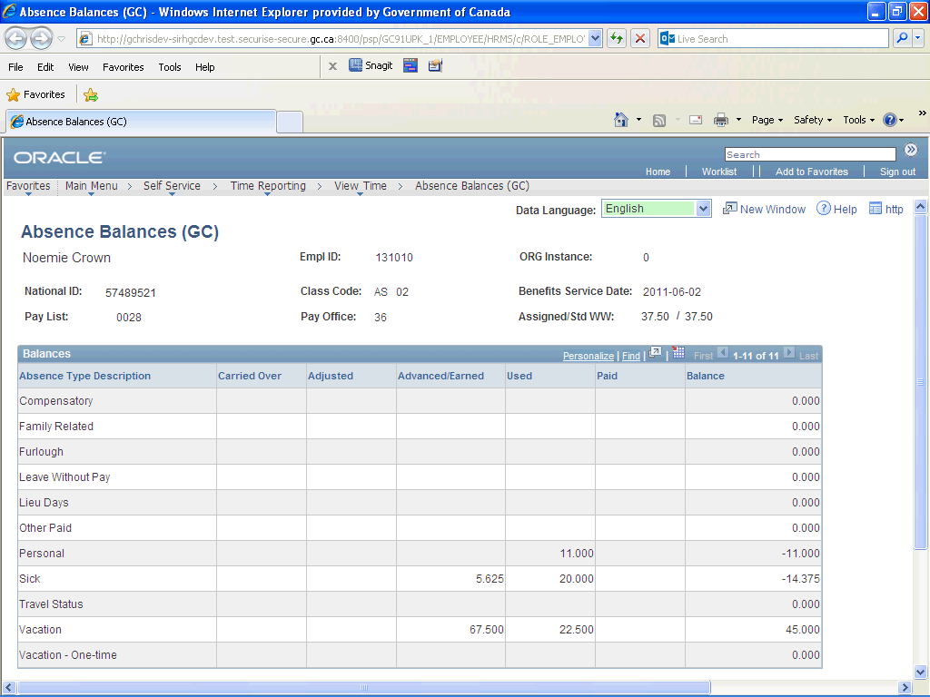

| **Step** | **Action** |
| --- | --- |
|  | **Note:**  **Assigned/Std WW:** Assigned work hours/standard work hours  **Benefits Service Date:** based on the date having been entered in the system, the system calculates your total years, months, and days of service; this date is used to calculate your absence eligibility.  Return to the **Request Absence** page.  Click the **Close** button. |

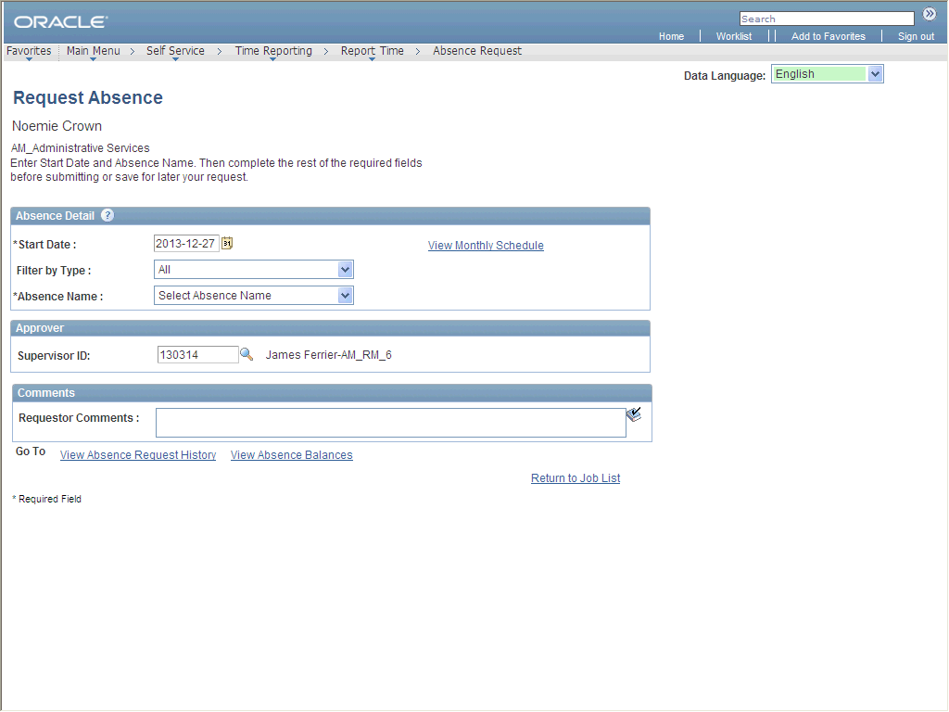

| **Step** | **Action** |
| --- | --- |
|  | **Start Date**- the first day on which you will be absent.  **Note:** You cannot request an absence on a scheduled day off or a Statutory Holiday.  Enter the desired information into the **Start Date** field. Enter "**2013-03-18**". |

|  |  |
| --- | --- |
|  | The date format in myEMS (PeopleSoft) is YYYY-MM-DD.  For example, January 19, 2013 will show as 2013-01-19.    To ensure you enter the right date format, use the **Choose a Date** button (C:\Users\theresa.mcquilkin\AppData\Local\SUPDev9\D\Content_EN\W\726900e6d0a4445e838f97fda831b202\Parts\images\calendar.gif) to access an interactive calendar from which you can choose the date.    C:\Users\theresa.mcquilkin\AppData\Local\SUPDev9\D\Content_EN\W\726900e6d0a4445e838f97fda831b202\Parts\images\Calendar_final2.png |

| **Step** | **Action** |
| --- | --- |
|  | **Note:** You can also select directly from the **Absence Name list.**  Click the **Filter by Type** list. |
|  | Click an entry in the list. |
|  | Click the **Absence Name** list. |
|  | Click an entry in the list. |
|  | The **Partial Days** field is used to indicate whether you are absent for part of a day, if any of the requested days of absence are partial days.  For example, if you work two hours on the start day and are absent for the rest of the day (5.5 hours), select the value **Start Day Only**in the **Partial Days** field.  A new field will appear allowing you to enter 5.5 hours for this day.  **Note:** Click on the icon below for more information on entering full or partial days. |
|  | **Decision:**Do you want to enter a partial day or days?   * No Go to step 22 * Yes Go to step 37 |
|  | You can enter either the **End Date** (i.e., the last day of absence), or you can enter the number of hours of absence in the **Duration** field, or both.  If required, myEMS (PeopleSoft) can then calculate the other value once the **Calculate End Date** **or Duration** button is clicked. |
|  | **Decision:**Which of the following do you want to enter?   * The end date Go to step 24 * The number of hours of absence Go to step 41 |
|  | Enter the desired information into the **End Date** field. Enter "**2013-03-20**". |

|  |  |
| --- | --- |
|  | The date format in myEMS (PeopleSoft) is YYYY-MM-DD.  For example, January 19, 2013 will show as 2013-01-19.    To ensure you enter the right date format, use the **Choose a Date** button (C:\Users\theresa.mcquilkin\AppData\Local\SUPDev9\D\Content_EN\W\726900e6d0a4445e838f97fda831b202\Parts\images\calendar.gif) to access an interactive calendar from which you can choose the date.    C:\Users\theresa.mcquilkin\AppData\Local\SUPDev9\D\Content_EN\W\726900e6d0a4445e838f97fda831b202\Parts\images\Calendar_final2.png |

| **Step** | **Action** |
| --- | --- |
|  | Click the **Calculate End Date or Duration** button. |
|  | The **Duration** field is updated to reflect the requested number of hours based on the start and end dates, as well as any partial days, if applicable. |
|  | Click the **Forecast Balance** button. |
|  | If you have sufficient hours in your balance, the request will be deemed to be eligible (but not yet approved). |
|  | **Note: Supervisor ID** is populated based on the reporting relationship entered in the system.  Ensure that the **Supervisor ID** listed is the correct one. |
|  | **Decision:**Does the Supervisor ID need to be changed?   * No Go to step 31 * Yes Go to step 44 |
|  | Enter the desired information into the **Requestor Comments** field. Enter "**Family vacation**". |
|  | **DIRECT IMPACT ON YOUR PAY**  If you are submitting either a LWOP or Leave Cash-out Event, **please review the details of your event for accuracy before submitting** the request for Approval by your Manager.  Section 34 Approval will generate a recovery of hours from your pay (LWOP) or result in salary payment (Cash Out).  Submit the request for approval.  Click the **Submit** button. |
|  | **Note:** This will save the information and generate the workflow approval process that routes the request to managers whose roles are defined to enable them to approve, deny or forward the absence request. |
|  | Click the **Yes** button. |
|  | Click the **OK** button. |
|  | You have successfully submitted an absence request.  The system has generated an email notification to the supervisor listed below advising of the submitted request.  If you have submitted either a LWOP or Leave Cashout Event, following Section 34 Approval, the expected result for this request will appear on a regular pay issued in the **month following** the month of Approval.  You should monitor your regular pay to ensure your request was properly processed.  **End of Procedure.** Remaining steps apply to other paths. |

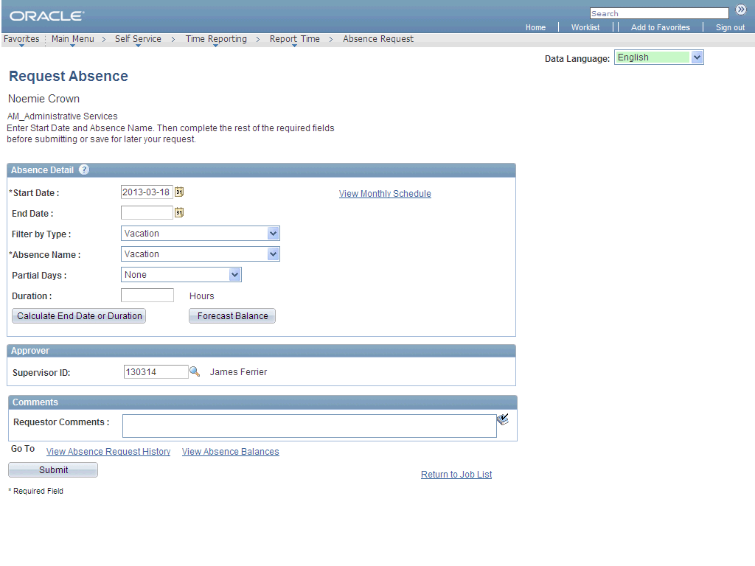

| **Step** | **Action** |
| --- | --- |
|  | **Note:** For more information on how to indicate Partial Days or the Half Day Checkbox, refer to iService, via: http://iservice.prv/eng/esrp/erp\_ps/topics/information\_employees.shtml#processing\_leave (<http://iservice.prv/eng/esrp/erp_ps/topics/information_employees.shtml#processing_leave>)  Click the **Partial Days** list. |
|  | Click the **Start Day Only** list item. |
|  | Enter the desired information into the **Start Day Hours** field. Enter "**5.5**". |
|  | You can enter either the end date (i.e., the last day of absence), or you can enter the number of hours of absence in the **Duration** field.  myEMS (PeopleSoft) can then calculate the other value.  Go to step 23 |

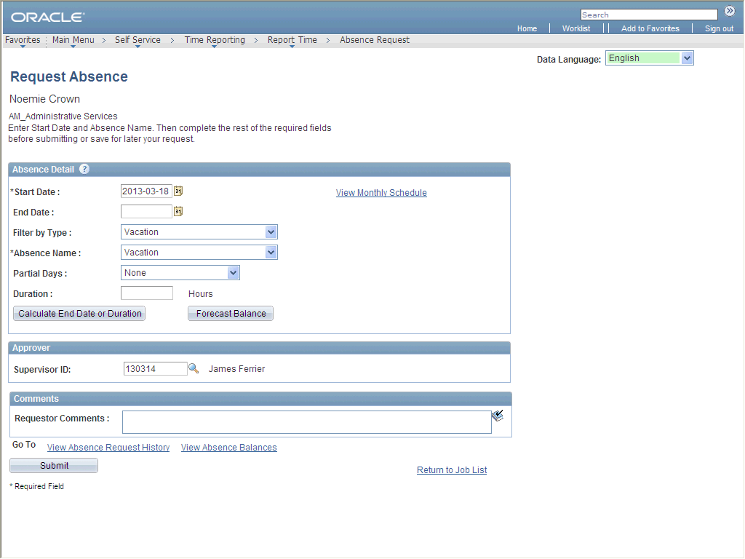

| **Step** | **Action** |
| --- | --- |
|  | Enter the desired information into the **Duration** field. Enter "**22.5**". |
|  | Click the **Calculate End Date or Duration** button. |
|  | The **End Date**field is updated based on the Start Date and the number of hours in the **Duration** field, as well as any partial days.  Go to step 27 |

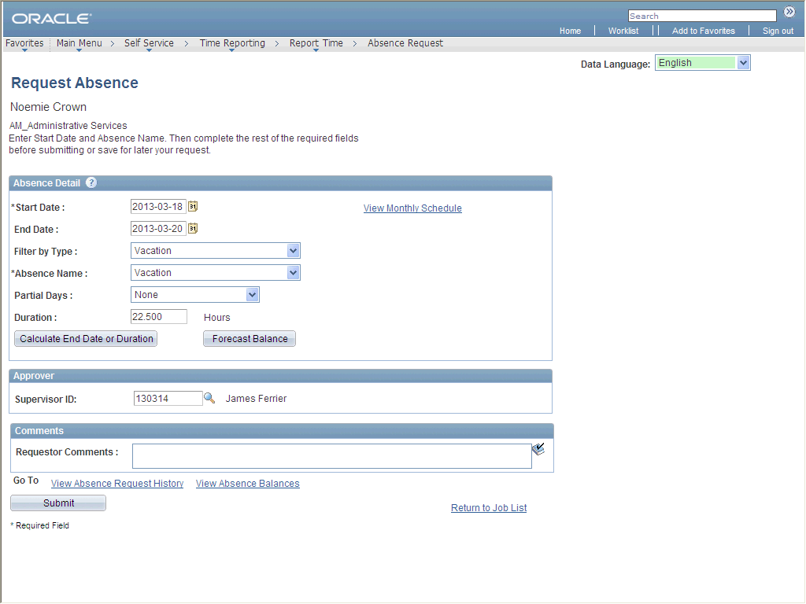

| **Step** | **Action** |
| --- | --- |
|  | Enter the **Empl ID** for the **Supervisor**, or use the **Look Up** button to find the Empl ID.  Enter the desired information into the **Supervisor ID** field. Enter "**5001**". |

|  |  |
| --- | --- |
|  | When using the look up option to retrieve information, you can search using multiple fields.  It is also important to capture the field format to ensure a greater chance of results.    You can also use the following search wildcards:   * **%** (percent sign) - Match one or more characters:  For example, if you search for a country, you could enter **An%la** and it would retrieve the following countries Angola and Anguilla. * **\_** (underscore) - Match any single character:  For example, if you search for a country, you could enter **An\_ \_ la** and it would retrieve Angola. * **\** (back slash) - Escape character - don't treat the next character as a wildcard: This option is used if you are using one of the above mentioned search wildcards that is not being used in a specific search as a wildcard.  You would add the \ in front of the wildcard symbol.   You can also use the **Begins with** dropdown menu option to assist in your search.  The following options are available: **begins with, contains, =, not =, <, <=, >, >=, between, in.**    A Business Unit must be entered in order to conduct a search using Department or Job Code.    The most common way of searching for the employee is to use the National ID (PRI). If you don’t know the National ID (PRI), use one of the following:        C:\Users\theresa.mcquilkin\AppData\Local\SUPDev9\D\Content_EN\W\0a71eaa8fcf1489799d896afc8289714\Parts\images\EmplID.png |

| **Step** | **Action** |
| --- | --- |
|  | Tab out of the **Supervisor ID** field.  Press **[Tab]**. |

|  |  |
| --- | --- |
|  | When using the look up option to retrieve information, you can search using multiple fields.  It is also important to capture the field format to ensure a greater chance of results.    You can also use the following search wildcards:   * **%** (percent sign) - Match one or more characters:  For example, if you search for a country, you could enter **An%la** and it would retrieve the following countries Angola and Anguilla. * **\_** (underscore) - Match any single character:  For example, if you search for a country, you could enter **An\_ \_ la** and it would retrieve Angola. * **\** (back slash) - Escape character - don't treat the next character as a wildcard: This option is used if you are using one of the above mentioned search wildcards that is not being used in a specific search as a wildcard.  You would add the \ in front of the wildcard symbol.   You can also use the **Begins with** dropdown menu option to assist in your search.  The following options are available: **begins with, contains, =, not =, <, <=, >, >=, between, in.**    A Business Unit must be entered in order to conduct a search using Department or Job Code.    The most common way of searching for the employee is to use the National ID (PRI). If you don’t know the National ID (PRI), use one of the following:        C:\Users\theresa.mcquilkin\AppData\Local\SUPDev9\D\Content_EN\W\0a71eaa8fcf1489799d896afc8289714\Parts\images\EmplID.png |

| **Step** | **Action** |
| --- | --- |
|  | Enter the desired information into the **Requestor Comments** field. Enter "**Family vacation**". |
|  | **DIRECT IMPACT ON YOUR PAY**  If you are submitting either a LWOP or Leave Cash-out Event, **please review the details of your event for accuracy before submitting** the request for Approval by your Manager.  Section 34 Approval will generate a recovery of hours from your pay (LWOP) or result in salary payment (Cash Out).  Submit the request for approval.  Click the **Submit** button.    Go to step 33 |