SEARCHING THE LEARNING CATALOGUE
DID YOU KNOW:
The Learning Catalogue allows you to search for
specific Courses, Classes, Curricula or Certifications.

PROCEDURES | IMAGES
- To perform this task, log into Saba. |  Select your language preference by clicking English or Français canadien (French Canadian) at the bottom of the screen BEFORE entering your Username and Password.
- You can search the Catalogue:  - By using the Magnifying glass; or  - By using the Browse option.  The Browse feature is intended to browse the entire Saba system, with the Learning Catalogue only being one component. The “Search” feature is much simpler and is the recommended option. | 
- In the SEARCH field, enter keywords that could be found in the title or description, or the Course or Class ID (if known)  Please pay special attention to spaces, apostrophes, and accents. For example, the keyword “employee” would not show any result for a course entitled Employee’s assessment – in such a case, the keyword to use would be “Employee’s”. | 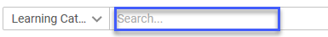
- When entering search criteria, a drop down list may appear with potential course names.  - If you select a course from this list, the system goes directly to that course.  - If you want to view all potential courses that meet the criteria, hit Enter or click See all results.  - Prior to initiating the Search, additional filters may be added to refine the search. Select in the Filters drop down menu to indicate any additional filters (such as Learning Event Types - Course, Certification, Curriculum, and/or Delivery Types - Web-based, Instructor-Led, Virtual Classroom, etc.)  (From the College@ESDC iService page,  click on any category on the left menu  to find a specific course title). | 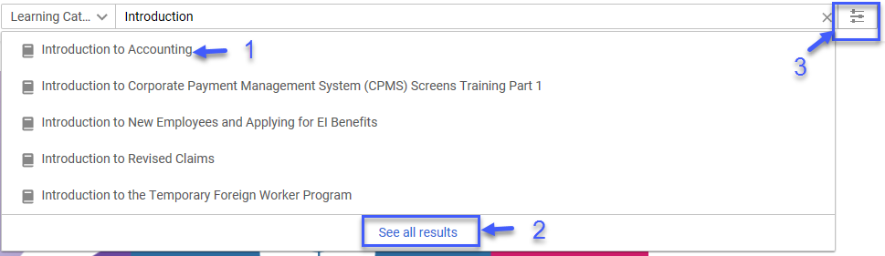  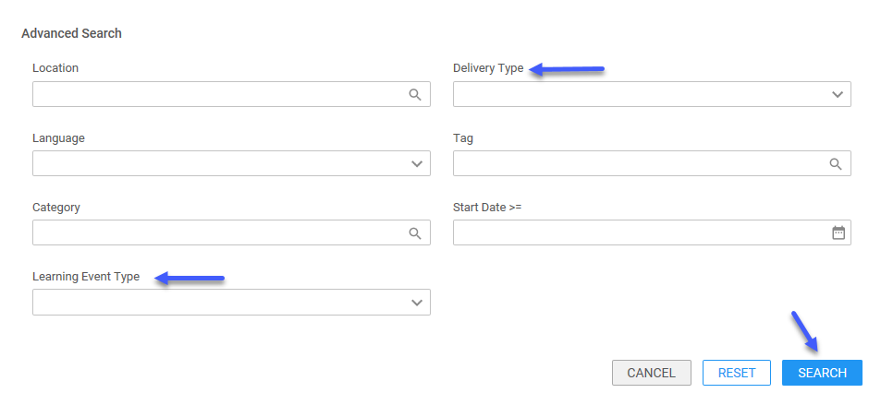
- The search results can be further refined, either by using the Sort field and/or checking filter boxes on the left side of the window. | 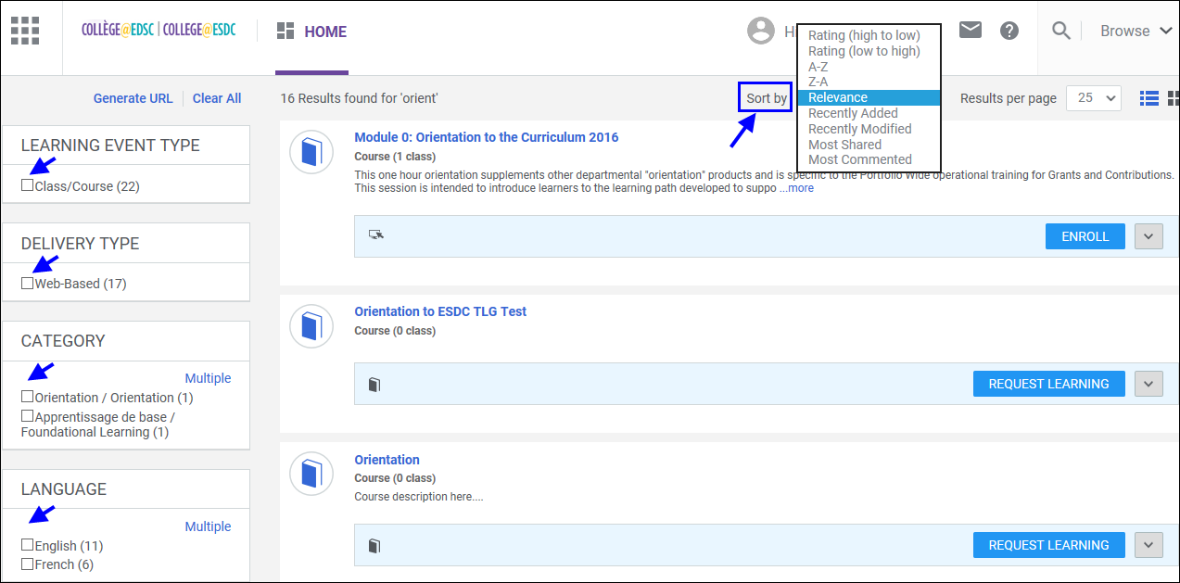
- You may click on the “Course Title” to view course details, your status, and any available classes.  - To view more classes, click on “Find more classes” at the bottom of the window.  - To register to a class, click on the ENROLL button.  - Should you not want to register at this time, you can add the course to your learning plan by clicking the ADD TO PLAN button.  If no classes are currently scheduled, the course will indicate “0 class”. In such a case, or if no suggested classes meet your needs, you can submit a learning request.  (Please refer to the Job Aid –  Requesting a Learning Activity) | 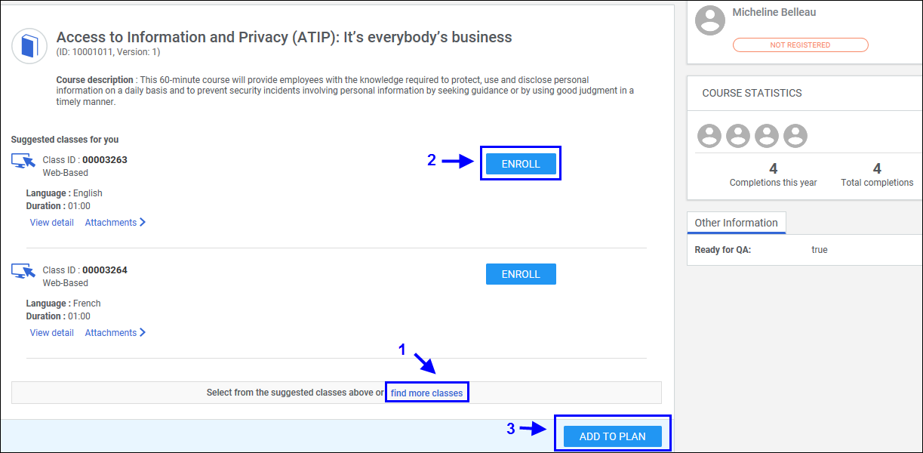
- You may also click on the VIEW CLASSES button at the right of the window to display all available classes for a said course.  - To register to a class, click on the ENROLL button.  - Should you not want to register at this time, you can add the course to your learning plan by clicking the ADD TO PLAN button. | 