Add Completed Learning to Members of your Team
DID YOU KNOW:

Managers can add a completed learning activity to team members.

PROCEDURES | IMAGES
Access My Team Page

If necessary, reference the job aid – Manager: View and Update my team in Saba.
Access the Add Completed Course Window  - Select Add Completed Course from the Team Actions menu.  The Add Completed Course window will display. | 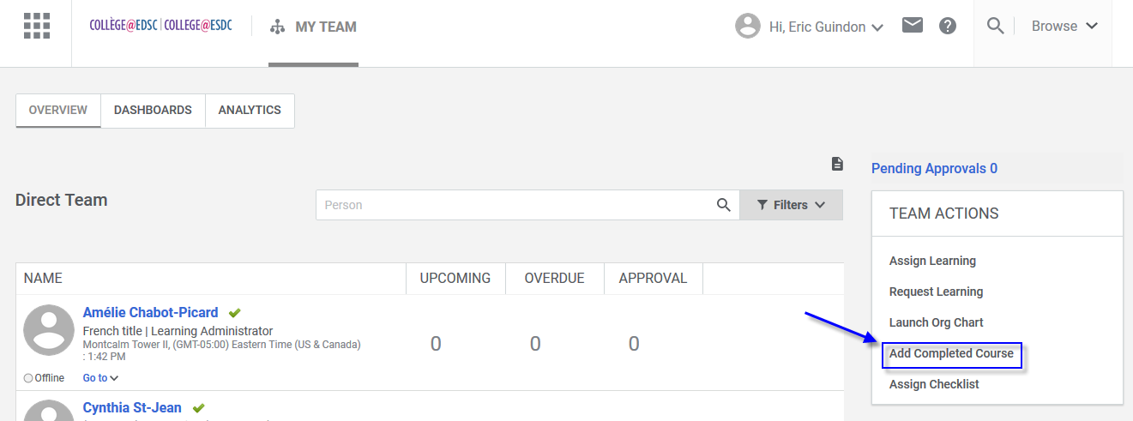
Select Learning from the Catalog  - Search the catalog by typing the Title of the learning activity.  - Select the check box next to the course title.  - Select the Save and Next button at the bottom of the window.  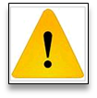  If the course is not in the catalog, select the button Add New button. You will have to capture the course details. | 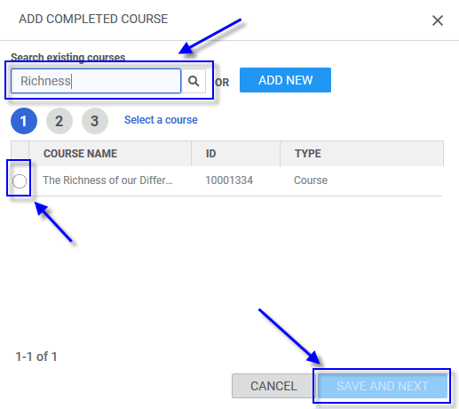
Validating/Capturing Course Details  If a course is selected from the catalog, course detail fields will already be populated.  - Course Name: Validate or capture the name of the course.  - Description: Validate or capture the course description.  - Business Owner: Validate or capture the name of the course owner.  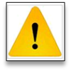  If Business Line Owner is unknown, type N/A in the Business Line Owner field.  - Scroll down and select the Additional Details at the bottom of the window.  - In the Additional Details Options, capture the following information:  - Delivery type: Choose from the dropdown menu  - Location: Indicate where the activity occurred  - Duration: Capture duration in HH:MM format  - Select the Save and Next button at the bottom of the window. | 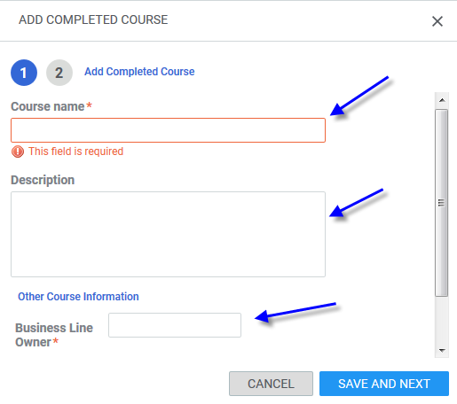  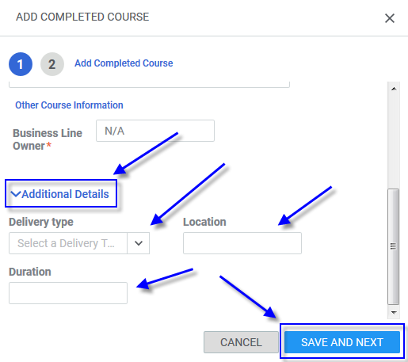
Add Learner(s)  - Select the Class End Date, using the Calendar Icon.  - Check the check-box next to an employee’s name to add the learning to this employee’s completed learning.  - Use the Select Date next to the employee’s name to identify when the course was completed.  Note: The Class End Date identify the last day of the class. The Completion Date is the date when the employee completed all the components of the learning activity.  - Add the Score if there is a score for this activity.  - Select the Save button at the bottom of the window. | 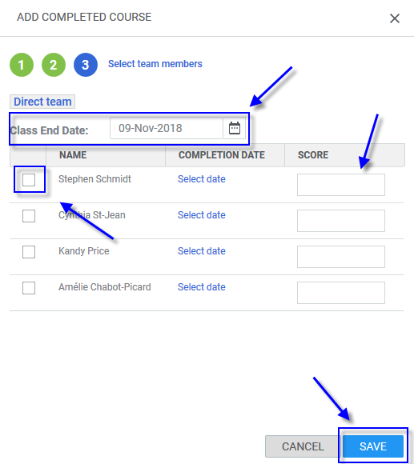
Confirmation  - A confirmation window will be displayed confirming the action that has been done. Select the Close button to close this window.  The learning activity has been added to the selected members of my team and will appear under their Completed Learning in their Saba profile. | 